SMART-BIN: AN ESP32-BASED IoT WASTE BIN MONITORING SYSTEM WITH FILL, WEIGHT, AIR-QUALITY AND TAMPER DETECTION
FOR PRIORITY-BASED COLLECTION

WASTE MANAGEMENT AND CLEANLINESS
PROBLEM: Overflowing Garbage Bins and Inefficient Waste Collection Routes

Technological University of the Philippines - Manila
Bachelor of Engineering Technology major in Computer Engineering Technology

Embedded Systems: Final Project
BET-CPET 4A-M, Group 2

Submitted By:
Brian Jay Celeste
Genesis Walter D. Reyes II
Jade C. Gunayan
King Perth G. Pepito
Rodel S. Banogbanog

Submitted To:
Prof. Jonel R. Macalisang

November, 2026
TABLE OF CONTENTS
TITLE PAGE i
TABLE OF CONTENTS ii
LIST OF FIGURES iii
LIST OF TABLES vi
I. INTRODUCTION 1
1.1 Introduction and Problem 1
1.2 Sustainable Development Goal (SDG) Addressed 2
1.3 Review of Related Literature 3
1.4 Objectives 54
1.5 Conceptual Framework 55
1.6 Target Beneficiaries 59
II. PROTOTYPE DESIGN AND DEVELOPMENT 60
2.1 Prototype Design 60
2.2 Block Diagram 61
2.3 System Flowchart 63
2.4 Schematic Design 69
2.5 Component Materials 72
III. TESTING, RESULTS, AND CONCLUSION 83
3.1 Test Cases 83
3.2 Results and Discussion 83
3.3 Conclusion 83
3.4 Recommendations 83
REFERENCES 84
APPENDICES 94
Appendix A: Gantt Chart 95
Appendix B: Bill of Materials of the Smart-Bin Prototype 96
Appendix C: User Interface Screens 97
Appendix D: Source Code 98

LIST OF FIGURES
Figure 1. Sustainable Development Goal 11: Sustainable Cities and Communities 2
Figure 2. Patents Reviewed by Priority Year and Region 6
Figure 3. Remote Status Units Linked to a Central Unit 7
Figure 4. Compacting Ram and Chambers of the Solar Compactor 8
Figure 5. Path of a Full Message From the Compactor Monitor to the Service Provider 9
Figure 6. Trash Can With a Motor-Driven Lid 10
Figure 7. Container With a Bag Between Capacitive Plates 11
Figure 8. Waste Collection System of Containers, Server and Vehicles 12
Figure 9. Refuse Container With Scale, Display and Lights 13
Figure 10. Sensor Device Mounted Under the Lid Behind a Thermal Barrier 14
Figure 11. Gauge Mounted Under the Lid of a Container 15
Figure 12. Smart Garbage Bin With a Lid-Mounted Sensor Device 16
Figure 13. Pay-by-Weight Food Waste Processor With a Load-Cell Hopper 17
Figure 14. Infrared Beam Across a Container 18
Figure 15. Circuit of the Induction Flip Lid With a Settable Sensing Distance 19
Figure 16. Overall Smart Waste Management System 20
Figure 17. Garbage Cans and the Monitoring Center 21
Figure 18. Waste Measurement System With Weighing Devices and Reports 22
Figure 19. Block Diagram of the Capacity-Detecting Bin 23
Figure 20. Electrical Block Diagram of the Bin Intelligent Controller 24
Figure 21. Automatic Alerting System for a Trash Can 25
Figure 22. Network of Waste Bins, Cloud Server and Vehicles 26
Figure 23. Block Diagram of the Smart Waste Management System 29
Figure 24. Circuit Setup of the LoRa Bin Unit 30
Figure 25. Proposed System Architecture for Hospital Waste Monitoring 32
Figure 26. Proposed Network Architecture for Waste Collection in Bukavu 34
Figure 27. Prototype of the Smart Dustbin 35
Figure 28. Block Diagram of the Arduino-Based Smart Dustbin 37
Figure 29. Data Communication Structure of the Smart Waste Management System 38
Figure 30. Prototype of the SmartTrashBin 39
Figure 31. Data Flow of the Garbage Monitoring System 40
Figure 32. Power Chain of the ESP32-CAM Node 44
Figure 33. SWOT Analysis of Smart-Bin 49
Figure 34. Features Found in the 30 Related Studies 52
Figure 35. Input-Process-Output Model of Smart-Bin 55
Figure 36. System Architecture of Smart-Bin 57
Figure 37. Block Diagram of the Smart-Bin System 61
Figure 38. System Flowchart of the Smart-Bin 63
Figure 39. Operator Flowchart of the Smart-Bin Apps 65
Figure 40. Collector Flowchart of the Smart-Bin Apps 67
Figure 41. Schematic Diagram, Sheet 1: Microcontroller 69
Figure 42. Schematic Diagram, Sheet 2: Actuators and Outputs 70
Figure 43. Schematic Diagram, Sheet 3: Sensors and Inputs 71
Figure 44. ESP32 DevKit V1 (38-Pin, ESP32-WROOM-32D) 72
Figure 45. HC-SR04 Ultrasonic Distance Sensor 73
Figure 46. HC-SR501 PIR Motion Sensor 74
Figure 47. BME680 Environmental Sensor 75
Figure 48. BMI160 Six-Axis Inertial Measurement Unit 76
Figure 49. HX711 Load Cell Amplifier and 5kg Load Cell 77
Figure 50. SG90 Micro Servo Motor 78
Figure 51. 2.4-in. TFT Touchscreen (ILI9341 With XPT2046 Touch Controller) 79
Figure 52. KY-016 RGB LED Module 80
Figure 53. Passive Buzzer Module (MH-FMD) 81
Figure 54. 18650-Battery Shields for Bin A (4-Cell) and Bin B (2-Cell) 82
LIST OF TABLES
Table 1. Related Patents, by Priority Year 4
Table 2. Related Studies From 2023 to 2026 27
Table 3. Commercial and Student Systems as Described by Their Own Pages 47
Table 4. Technical Basis of the Main Design Choices 48
Table 5. The Four Closest Patents Compared With Smart-Bin 51
Table 6. The Research Gap by Capability 53

I. INTRODUCTION

1.1 Introduction and Problem
An effective waste management plays a crucial role in creating and sustaining healthy, clean and prosperous communities. With the rising amount of waste that is being generated, it has become a problem for the local government and commercial waste collectors in the Philippines. The Philippines is estimated to be producing a total of 60.76 thousand tons of garbage every day in 2025, according to the Philippine Statistics Authority (PSA, 2026). Despite the significant actions taken by the City of Metro Manila, its garbage is projected to reach 9,498 MT/D in 2020, making it the country's waste capital (World Bank, 2022). This was projected to rise to 10,368 MT per day by 2025 (World Bank, 2022). Hence, a high priority of improving waste management and collection practices in the country. Most garbage collection systems are conducted on a fixed schedule, causing bins to overflow when they are picked up or not to be filled to capacity when collected. Additionally, the smell, pollution levels, temperature, tilting of garbage bins, and unauthorized access should also be monitored as they are important indicators of environmental conditions and the efficiency of garbage management.
The researchers propose the Smart-Bin which is an Internet of Things (IoT) based bin monitoring system based on the ESP32 microcontroller with the aim of improving garbage collection performance. Sensors will be used by Smart-Bin to determine the level of fullness, weight, temperature, humidity, and air quality. It'll also be tracking bins that tilt irregularly, and any unauthorized bin openings, through a web dashboard and mobile application. Smart-Bin includes a touchscreen at the bin for employees to view and acknowledge the collection instructions, as well as to set up PIN codes to select who can access the bin, and to make collection setting changes. The project will include the development of two Smart-Bin prototypes built at the table size that will feature the ESP32 boards, local Wi-Fi, ThingSpeak, web dashboard, Android app, and screen at the bin. Smart-Bin will arrange the list of collection priorities based on fill levels and how long they will take to fill up, with the aim of optimizing garbage collection and fuel consumption rates.

1.2 Sustainable Development Goal (SDG) Addressed
Figure 1
Sustainable Development Goal 11: Sustainable Cities and Communities

The project Smart-Bin is connected to one of the Sustainable Development Goals (SDGs) of the United Nations (Agenda 2030), namely SDG 11: Sustainable Cities and Communities. Smart-Bin is specifically targeting the environmental impact of cities, per capita, with particular attention to air quality and municipal and other waste management (United Nations Department of Economic and Social Affairs [UN DESA], n.d., Target 11.6).
Smart-Bin can contribute to achieve the target of Sustainable Development Goal 11. It is achieved by monitoring and control of waste state with help of sensors installed in smart-bins and collecting information to make timely decision to ensure waste management collection process. As part of the project, a dashboard and application are developed and send a notification to the operator regarding of the bins state (levels, weight, temperatures, humidity, air quality around bins).
This could be helpful when it comes to optimizing the collection process as priority could be given to those bins that contained more trash and should be emptied before the trash overflows. Moreover, it can also be employed to avoid the effects on the environment, e.g., when the temperature or air quality (sign of rot) is not acceptable. This can help to streamline the collection process by prioritizing bins and reducing vehicle and fuel usage.

1.3 Review of Related Literature
This review covers three kinds of sources. Patents show what has already been claimed, in any year. Studies from 2023 onward show what researchers have built lately, and a handful of commercial products show what is already on sale. The patents were found and read on Google Patents which also provided the legal status listed in Table 1. Every research study was followed up with its DOI or its publisher page and each element in the reference list was verified with the research. Each patent and each study has its own entry, and figure (where present) from the source that can be reused, and each one has a comparison with Smart-Bin. The synthesis of those comparisons is made in the synthesis, the SWOT analysis and the research gap at the end of the section.

Prior Art
Review of 20 patents. They are in effect through 2023 and their owners are in the United States, Europe, China and Korea. They are listed in priority year order in Table 1, and their coverage and differences from Smart-Bin are summarized. Google classifies these labels as assumptions and not legal conclusions, it's not until someone checks with the patent office whether their status is Active or Expired, that they should rely on it. Figure 2 puts the twenty into a time line. Most of the activity is recent, as five are priority years before 2012 and fifteen are priority years in 2012 or after.
Each of the patents is discussed individually below, in the order of the table. The numbers for each entry are the first images of the patent released as published on Google Patents, and the text below in each are what the patent claims and how it relates to Smart-Bin. The four closest patents are Kurani (2023), Sait et al. (2025), Shahabdeen (2016) and Yan and Chen (2021) and the synthesis in the end of this section makes a side-to-side comparison of the features of the two Smart-Bins.

Table 1
Related Patents, by Priority Year
No. | Patent | Priority year | Status | What it covers | How Smart-Bin differs
1 | US 5,016,197  (Neumann & Allison, 1991) | 1986 | Expired | Remote status units judge how full compactor containers are from hydraulic pressure or weight, and report over a telephone line to a central unit that calls the hauler. | A phone-line system for hydraulic compactors. It has no gas, tilt, lid, display, wireless link or phone app.
2 | US 7,124,680  (Poss et al., 2006) | 2003 | Expired | A public trash compactor powered by a solar panel and a battery, with a removable bin, so it is emptied less often than an ordinary bin. | It compacts rather than senses. It has no weight, air-quality or tilt sensing, touchscreen, PIN mode or priority list.
3 | US 7,145,450  (Brown, 2006) | 2004 | Expired | A processor reads the pressure on a compactor ram, flags the unit as full after a preset time and emails a work order to a service provider. | Fullness is inferred from pressure only. It has no fill level, weight, gas, lid, local display or app.
4 | US 7,781,995  (Yang & Sandor, 2010) | 2005 | Expired | A trash can whose electric drive opens the lid when a sensor detects an object near the lower part of the can. | The trigger is a foot-level sensor. There is no fill, weight, air-quality, tilt, wireless or collection feature.
5 | EP 2 516 974 B1  (Di Giugno et al., 2016) | 2009 | Not in force | A container that holds a bag has capacitive plates that give several fill levels. Its status goes wirelessly to stations that plan the emptying routes. | The sensing is capacitive around a bag. There is no weight, gas, tilt, powered lid, PIN mode or phone app.
6 | WO 2014/079586 A1  (Kekalainen & Engstrom, 2014) | 2012 | Ceased | Containers with sensors report their status over a wireless network to a server, which plans the collection vehicles and can run bidding for the jobs. | It is a fleet-level planning platform with sensors only. There is no weight, tamper detection, powered lid, PIN mode or on-bin display.
7 | US 9,347,821 B1  (Mullaney, 2016) | 2012 | Expired | The refuse container has a scale on it that indicates the weight of refuse in the container and alerts to a maximum weight. | It is capable to sense weight. Fill level, air quality, tamper alarm, PIR lid, PIN mode and dashboard are not present.
8 | US 9,927,278 B2  (Kekalainen & Engstrom, 2018) | 2013 | Expired | A sensor device fixed under the container lid, behind a thermal barrier, measures the amount of waste and the conditions inside and sends them to a remote location. | Its novelty is the heat-insulated lid mounting of a cellular sensor module. There is no weight, tamper alarm, powered lid, PIN mode or priority list.
9 | US 9,930,429 B2  (Kekäläinen, 2018) | 2014 | Active | A gauge compares the fill rate with limits set by a server and contacts the server only when a limit is crossed, which saves battery. | It is a battery-saving reporting scheme. No motorized lid, tamper alarm, PIN mode, touchscreen or phone app is described.
10 | US 2016/0176630 A1  (Shahabdeen, 2016) | 2014 | Abandoned | A bin carries a lid-mounted range finder or a weight sensor at the base, with optional hydrogen sulfide, ammonia and methane sensing, and a controller that sends the data wirelessly. | It has no tamper detection, powered lid, lock, on-bin display, PIN mode or priority list. Temperature and humidity are not mentioned.
11 | KR 10-1581944 B1  (Shin, 2016) | 2015 | Active | The hopper of a pay-by-weight food waste processor sits on a load cell and rotates to drop the waste into a crushing tank. | It is a weighing and payment machine. There is no fill sensing, gas sensing, tilt sensing, wireless reporting or priority list.
12 | US 11,054,545 B2  (Devitt & Walsh, 2021) | 2016 | Active | Two low-power ways to detect a full container: an infrared beam across the container, or the resting tilt angle of the lid. | The output is only full or not full. There is no weight, gas, temperature, powered lid, PIN mode or tamper alarm.
13 | EP 3 620 405 A1  (Wang, Chen, et al., 2020) | 2017 | Withdrawn | An induction flip-lid can whose infrared sensing distance the user can set, built into a single microcomputer chip. | It only opens the lid. There is no fill, weight, gas, tilt, display or wireless link.
14 | US 11,702,280 B2  (Kurani, 2023) | 2018 | Active | 12 sensors, including those measuring fill level, weight, air quality, temperature, humidity and pressure, along with an accelerometer, are installed on the bin and communicate with a cloud server, which generates statistics and works out collection routes, also notifying mobile apps. | Focuses on litter, biohazard and pathogen sensing, with a sterilizer. There was no PIR servo lid, no remote lock or no PIN collect mode or latched tamper alarm.
15 | CN 109324552 B  (Yan & Chen, 2021) | 2018 | Active | Each can has weight, infrared height, odor and smoke sensors and a positioning unit. A monitoring center decides which cans to visit and builds the truck route. | It plans city-wide truck routes with GPS. No powered lid, tamper detection, PIN mode, on-bin display or phone alert was found.
16 | US 11,788,877 B2  (Balachandran & Talavera, 2023) | 2018 | Active | Load cells under a platform weigh the waste of two or more bins, and cameras with image analysis identify the contents for waste audit reports. | It is a waste audit and reporting service, not a single bin with fill, tilt, lid and lock control, a PIN collect mode and a collection priority list.
17 | CN 210504152 U  (Yang et al., 2020) | 2019 | Expired | A bin with an infrared induction module, an ultrasonic ranging module and a programming module lets users see how much capacity is left. | It is a stand-alone local device. There is no weight, gas, tilt, lid actuator, wireless link or phone app.
18 | CN 111559590 A  (Wang, Zhang, et al., 2020) | 2020 | Withdrawn | A controller for top or side installation measures the distance to the garbage and uploads it to a supervisory platform, which has an early-warning unit. | It comprises of one laser ToF sensor. No weight, gas, temperature, tilt, lid control or touchscreen collect mode or priority list.
19 | US 12,125,361 B2  (Keller et al., 2024) | 2021 | Active | Two calibration setpoints enable a processor to convert distance readouts to a fill percentage and signal a user device when it exceeds a threshold, which varies depending on the can owner. | It uses a single laser time-of-flight sensor. There is no weight, gas, temperature, tilt, lid control, touchscreen collect mode or priority list.
20 | US 12,450,575 B1  (Sait et al., 2025) | 2023 | Active | Each bin has methane, fill level and temperature/humidity sensors that provide data to neural networks which calculate the time required to reach the methane and fill limits; a scheduler creates routes considering the vehicle emissions. | It revolves around the sensing of methane by air quality. There is no load cell, tilt alarm, PIR lid, remote lock or PIN collect mode.
Note. Status is as reported by Google Patents in October 2026. The differences are those found in the patent text read for this review.
Figure 2
Patents Reviewed by Priority Year and Region
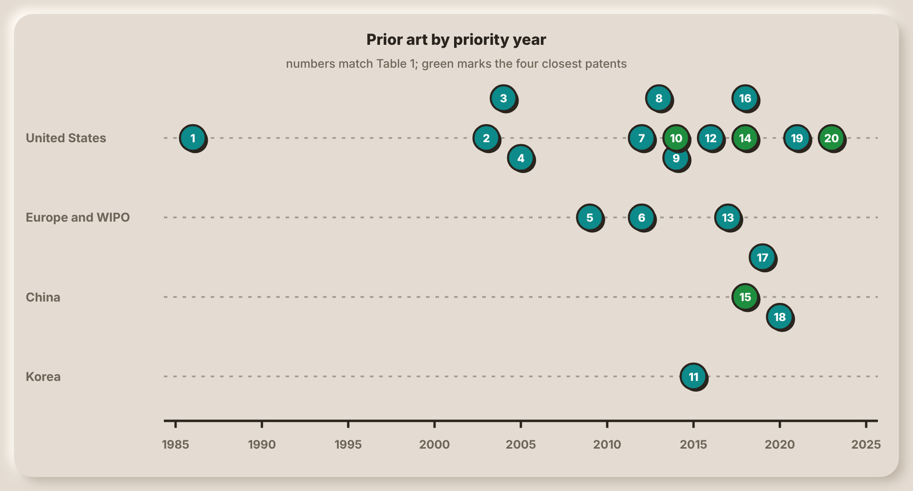
Note. Numbers match Table 1. The four patents in green are the closest to Smart-Bin.
Automated Trash Management System (Neumann & Allison, 1991)
Figure 3
Remote Status Units Linked to a Central Unit
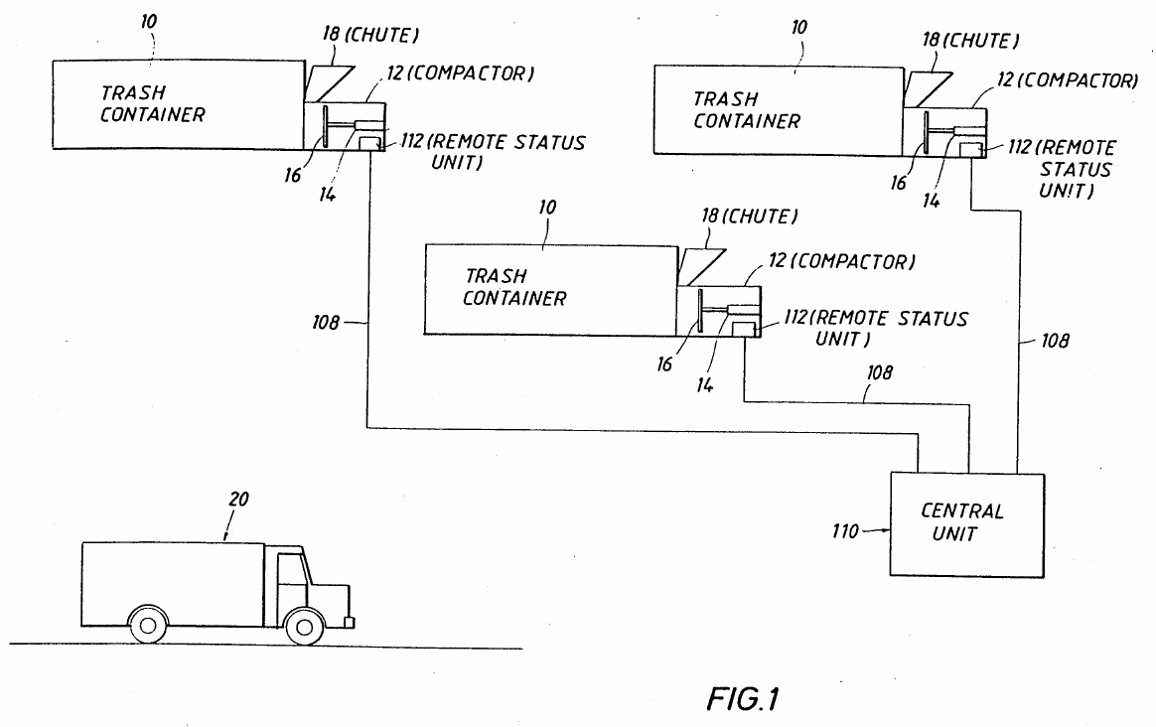
Note. From Automated trash management system (U.S. Patent No. 5,016,197), by R. H. Neumann and C. B. Allison, 1991, U.S. Patent and Trademark Office.

Figure 3 shows the layout of the system that Neumann and Allison (1991) patented for MGM Services. Each remote status unit serves three containers, each with its own compactor, and all units are linked by a communications line, typically a telephone line, to a central unit that keeps a database. The hauler sends a truck only to the containers that report full. For compactors, fullness is inferred from the hydraulic pressure during the packing stroke, from the work done per stroke or from the current drawn by the pump motor, and for any container a measured weight can be compared with a preset full weight.
Calling for a pickup only when a container is full is the idea behind the priority tags of Smart-Bin, and the load cell is a signal that both systems can use. The differences come from the era. The data travel by modem, a person calls the hauler, and no alert or route is generated. The patent describes no gas, temperature or tilt sensing, no lid, no display on the container and no phone app. Smart-Bin also measures the fill directly with an ultrasonic sensor and does not infer it from the work of a compactor.
Solar Powered Compaction Apparatus (Poss et al., 2006)
Figure 4
Compacting Ram and Chambers of the Solar Compactor
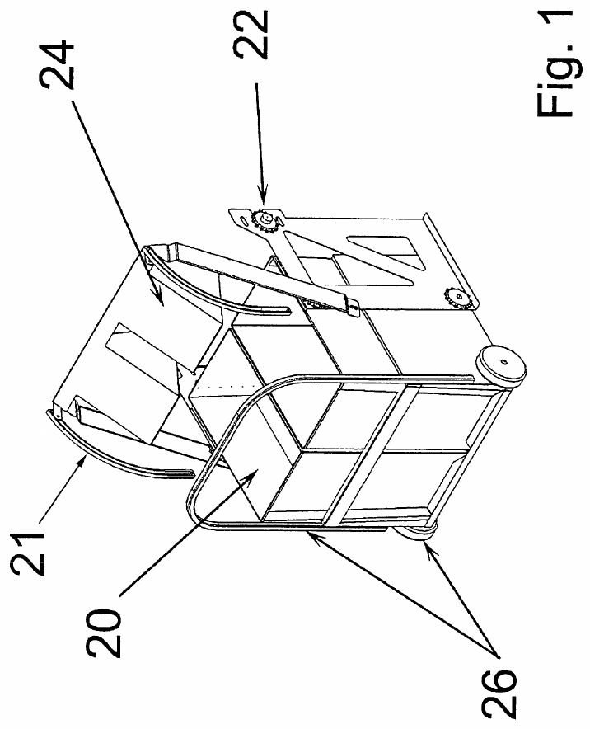
Note. From Solar powered compaction apparatus (U.S. Patent No. 7,124,680), by J. Poss, J. Satwicz, B. Richmond, and M. Taylor, 2006, U.S. Patent and Trademark Office.

Poss et al. (2006) of BigBelly Solar patented a public compactor that a photovoltaic array powers, so that it can stand where there is no mains power but many people pass. Figure 4 shows the compacting ram with its chain drive and guide track and the compaction chambers. One of the roof panels charges a battery, which causes a compaction cycle to be skipped if the battery has low charge. The trash is compacted, which means that it will not need to be emptied as frequently as a regular trash bin. Fullness is sensed by a photo-eye, by the ram motor current (the stall time) and by pressure sensors, and a wireless transmitter reports to sanitation staff.
The patent attacks the same public-space problem as Smart-Bin, a bin that overflows and is costly to visit, but it answers with compaction and solar power instead of sensing. Scales are named only as an alternative fullness sensor, and the only display is a set of status lamps. No weight or air sensing, tilt alarm, touchscreen, PIN mode or phone app is described. One remark does bear on the project: the patent says that real-time fill data could feed routing and scheduling software, which is the use that Smart-Bin makes of its fill ranking.
Compactor Service and Monitoring System (Brown, 2006)
Figure 5
Path of a Full Message From the Compactor Monitor to the Service Provider
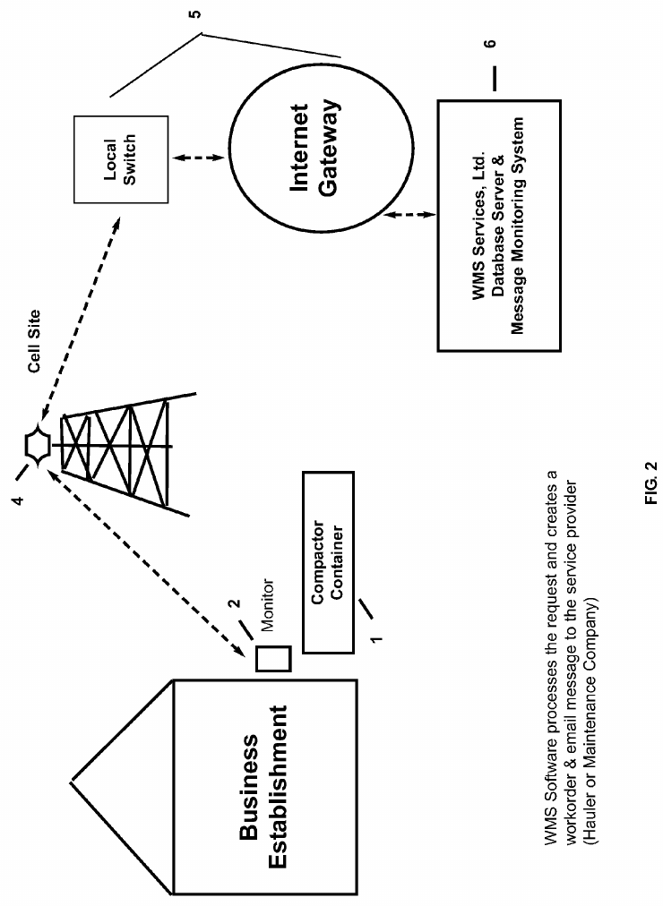
Note. From Compactor service and monitoring system (U.S. Patent No. 7,145,450), by W. J. Brown, 2006, U.S. Patent and Trademark Office.

Brown (2006), an individual inventor, patented a monitor that is added to an existing compactor. A pressure sensor on the hydraulic system of the ram measures the pressure during each cycle, and when the pressure stays at or above a preset value for a preset time the unit is flagged as full. Figure 5, which is Figure 2 of the patent, shows the path of a message. The monitor at the compactor reaches a cell site, an internet gateway and a server that runs the message monitoring software, which creates a work order, emails it to the service provider (a hauler or maintenance company) and supplies a tracking web link.
Like Smart-Bin, the system detects a full container by itself and notifies the people who must empty it. Fullness is inferred from pressure, though, and the patent has no level or weight sensor, since the tonnage is typed in by hand after a pickup. Alerts go out as email work orders, with fax as an option, and not as phone notifications, and the only local indication is a set of LEDs. Overdue work orders are flagged for staff, which is a rough counterpart of the priority tags of Smart-Bin, except that Smart-Bin bases its tags on the measured fill rate.
Trash Can With Power Operated Lid (Yang & Sandor, 2010)
Figure 6
Trash Can With a Motor-Driven Lid
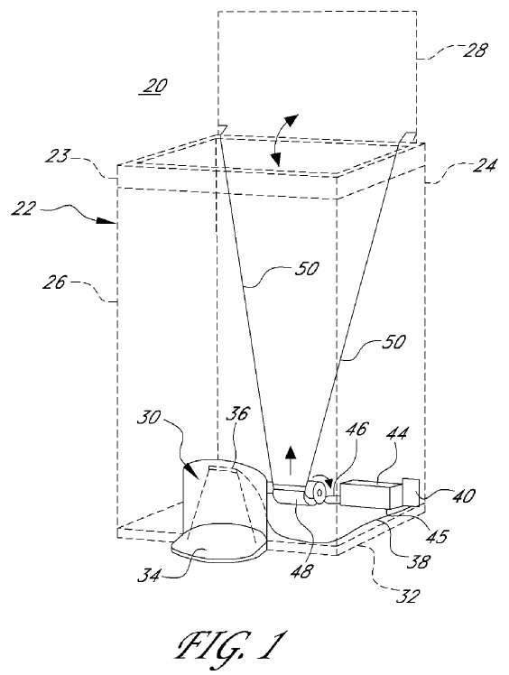
Note. From Trash can with power operated lid (U.S. Patent No. 7,781,995), by F. Yang and J. Sandor, 2010, U.S. Patent and Trademark Office.

Yang and Sandor (2010) patented the power-operated lid of Simplehuman. Figure 6 shows the can with its lid open. There's a recess in front that houses the sensor, two link rods on the back wall connect a motor-operated lifting bar to the lid, and the circuit board, batteries and motor gear all reside in the base. If the sensor senses an object in the proximity of the bottom of the can, the electric drive opens the lid and the lid remains open for a predetermined period (2 seconds, for example). Claim 1 relates to the motor for the door. The controller on each command verifies the supply voltage, regulates the motor power to maintain the speed of the door within a certain range, stops the motor by reversing it for a short time, and if the corresponding motor is running for too long, the motor stops and a fault is output.
Smart-Bin also opens its lid by motor when a sensor notices a user, so that nobody has to touch the lid, but it uses a PIR sensor and a servo and not a foot-level light beam. Everything else in the patent concerns lid mechanics. It has no fill, weight, air-quality, tilt, lock, display or wireless feature, and nothing on the collection side. The patent shows that a hands-free lid is old, so the contribution of Smart-Bin cannot be the lid itself. It lies in the sensing and reporting behind the lid.
Measuring Device and Monitoring System for Containers (Di Giugno et al., 2016)
Figure 7
Container With a Bag Between Capacitive Plates
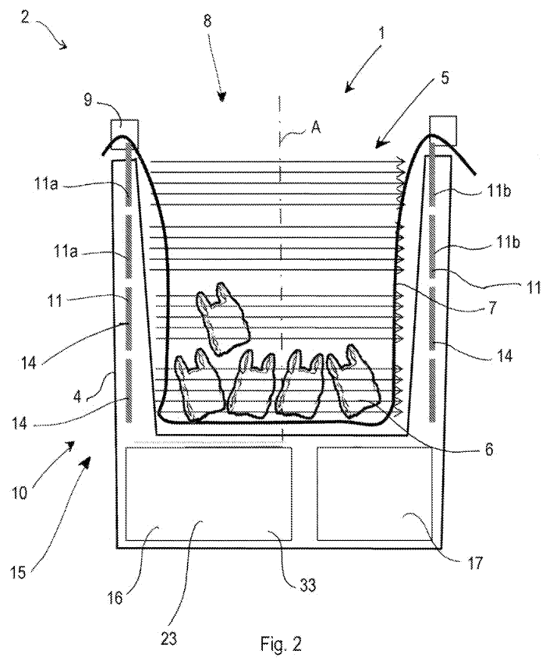
Note. From Measuring device, container means and system for monitoring and managing container means (European Patent No. 2516974), by M. Di Giugno, F. Giovanelli, S. Tiraboschi, and P. Villa, 2016, European Patent Office.

Di Giugno et al. (2016), from Cefriel and the Milanese environmental services company AMSA, describe a container whose casing holds a bag. Figure 7, which is Figure 2 of the patent, shows the container: the casing, the bag that the lid element holds in place and the plates at the sides of the cavity. Claim 1 places capacitive plates on opposite sides of the cavity, spaced along its length, so that the change in electrical capacity caused by the waste gives several progressive fill levels, with the bag lying between the plates. Status goes by GPRS or short-range wireless to an internet server, and stations plan the paths of the vehicles.
What matches Smart-Bin is the chain and not the sensor: measure the fill inside the bin, send it to a back end with a user interface, and use it to plan the collection of full bins. The sensing is different. Capacitive plates around a bag give levels in steps, while Smart-Bin measures distance by ultrasound and converts it to a percentage with two calibrated distances. It has no gas, temperature, tilt or weight sensing, no powered lid or lock, no PIN collect mode and no phone app.
Smart Waste Collection System and Method (Kekalainen & Engstrom, 2014)
Figure 8
Waste Collection System of Containers, Server and Vehicles
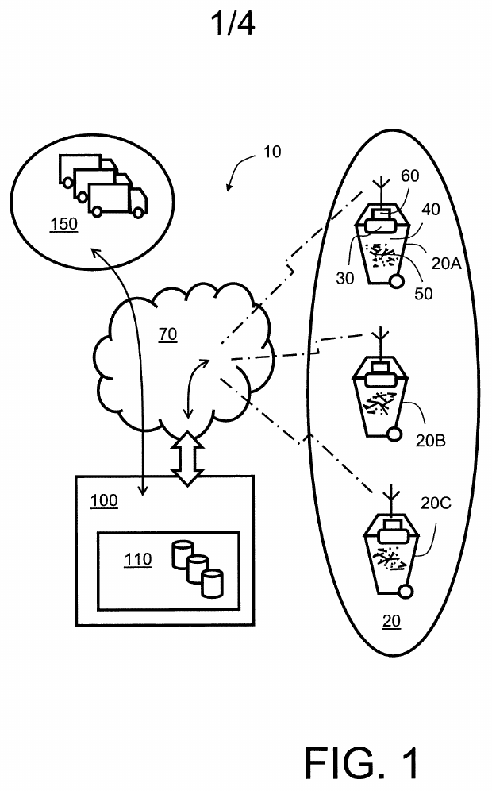
Note. From Smart waste collection system and method (International Patent Application Publication No. WO 2014/079586 A1), by F. Kekalainen and J. Engstrom, 2014, World Intellectual Property Organization.

Figure 8 shows the system in the application that Kekalainen and Engstrom (2014) filed for Enevo. The status is transmitted via a wireless network (GSM/3G) to a central server, which maintains the information in a database and arranges collection for vehicles on the way to collection or recycling facilities. The sensors are located in a rotating lid to measure fill level, gasses (methane, CO2 and CO type) and temperature. Weight is not measured. The server forecasts container fill times and routes them using a Monte Carlo simulation based on GPS data of the vehicles.The application also describes a marketplace in which haulers bid for collection jobs.
This is an early statement of the idea that fill data should decide which bins are collected first, and Smart-Bin carries it out on a much smaller scale with its priority tags. The patent works at fleet level, with bidding, simulated models and vehicle tracking, and the bin is only a sensor. It has no weight sensing, tilt or tamper alarm, powered lid, PIN mode or display on the bin, and humidity and odor are not measured.
Refuse Container With Weight Indicator and Danger Alerting (Mullaney, 2016)
Figure 9
Refuse Container With Scale, Display and Lights
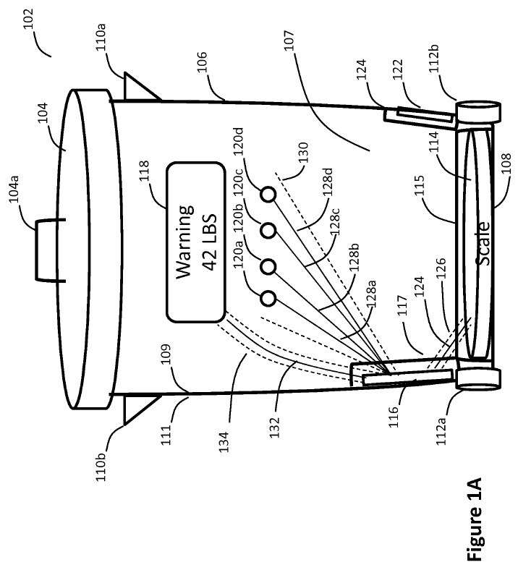
Note. From Refuse container with weight indicator and danger alerting (U.S. Patent No. 9,347,821), by G. Mullaney, 2016, U.S. Patent and Trademark Office.

Mullaney (2016), an individual inventor, patented a refuse container that shows how heavy its contents are. Figure 9, which is Figure 1A of the patent, shows a container with a floor scale, a controller, a display and four lights. The lights track the percentage of the maximum weight, and all of them light, with one flashing, once the limit is exceeded. The maximum weight can be set by location (a city or ZIP code lookup), by the user or by default, and an optional beep is mentioned. Claim 1 adds a memory that stores a history of readings, a controller that sends that history to a service provider, and a lock that locks the lid once the refuse reaches a predetermined weight. An inversion sensor releases the lock for emptying.
The container weighs its contents, shows the weight and warnings on the bin, locks the lid under a condition and can report to a remote party, and Smart-Bin does all four. The lock is the point of difference. It closes at a weight limit to stop overloading, where the lock of Smart-Bin is controlled remotely or by a PIN. The patent does not measure fill level or air quality, has no tamper alarm, PIR lid or collection priority list, and uses the mobile app only for configuration.
Sensor Device for Smart Waste Collection Systems (Kekalainen & Engstrom, 2018)
Figure 10
Sensor Device Mounted Under the Lid Behind a Thermal Barrier
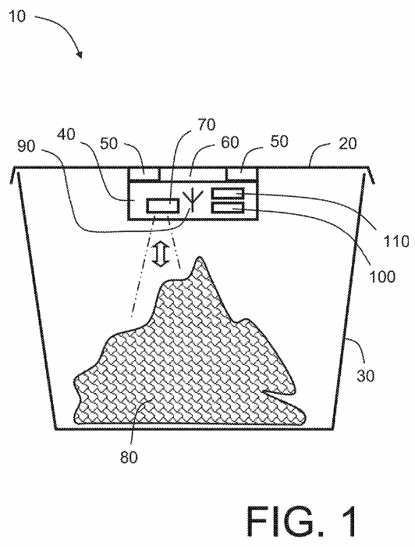
Note. From Sensor device for smart waste collection systems and method (U.S. Patent No. 9,927,278), by F. Kekalainen and J. Engstrom, 2018, U.S. Patent and Trademark Office.

Kekalainen and Engstrom (2018) patented the sensor module itself and not the system around it. Figure 10 shows a container with a pivoting lid and the sensor device under the lid, held off its surface by spacers that leave an air gap. The spacers and a heat-reflecting metal foil layer form a thermal barrier between the lid and the electronics. The module has an ultrasonic sensor for the amount of waste and sensors for temperature, humidity and a hydrocarbon or methane gas that indicates decomposition. The data is sent constantly, periodically or when a threshold is reached via a cellular modem (GSM or 3G), and the fasteners can be designed to avoid unauthorized removing.
This is the nearest match to the sensing side of Smart-Bin. Ultrasonic fill, temperature, humidity and gas are all on the bin, and the data go wirelessly to a remote location. The novelty lies in the insulated lid mounting and not in the sensors. The data support collection scheduling, but the device does not compute routes, and no weight sensor, powered lid, PIN mode or priority list is described. The anti-removal fasteners are a mechanical measure, where Smart-Bin senses the tilt and sounds an alarm.
Monitoring and Communicating the Fill Rate of a Container (Kekäläinen, 2018)
Figure 11
Gauge Mounted Under the Lid of a Container
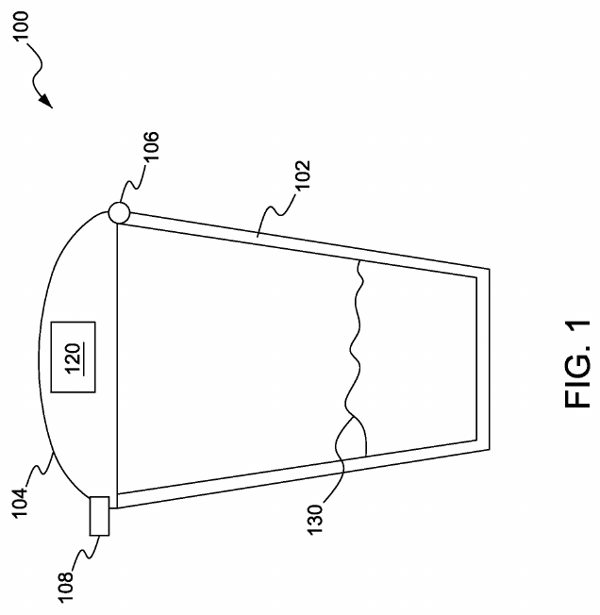
Note. From Method and system for monitoring and communicating fill rate of container (U.S. Patent No. 9,930,429), by F. Kekäläinen, 2018, U.S. Patent and Trademark Office.

Kekäläinen (2018), also for Enevo, is about how often the gauge talks and not about what it measures. Figure 11 shows a garbage container with a hinged lid and the gauge attached under the lid. The model of how the gauge is supposed to function is sent to the gauge by a server that includes the maximum and minimum fill-rate limits and a communication schedule. The gauge maintains the microcontroller and transceiver in sleep mode, sensing the fill rate and waking only if the fill rate is at, or exceeds, a limit, transmitting the fill rate measurement and receiving an updated model. A lower number of transmissions equals a longer battery life.
Smart-Bin takes the opposite path over the same issue. It reports on a fixed schedule, with a write to ThingSpeak every 30s. A bin that is left outside for weeks could be threshold driven. The parts read the patent describes no motorized lid, tamper alarm, PIN mode, touchscreen or phone app. Its user device is a laptop or desktop.
Smart Garbage Bin (Shahabdeen, 2016)
Figure 12
Smart Garbage Bin With a Lid-Mounted Sensor Device
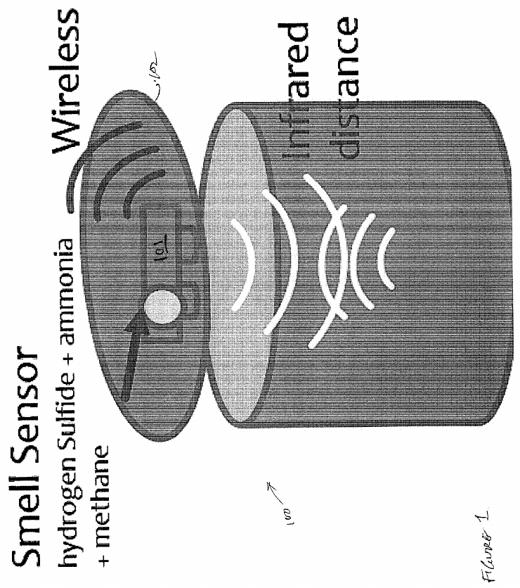
Note. From Smart garbage bin (U.S. Patent Application Publication No. 2016/0176630 A1), by J. A. Shahabdeen, 2016, U.S. Patent and Trademark Office.

Shahabdeen (2016) filed this application for Zan Compute. Figure 12 shows the bin with a battery-powered wireless sensor device on its lid. The sensor is a reflective infrared range finder (a Sharp GP2Y0A41SK0F) aimed at the waste, and the description adds MQ-136, MQ-137 and MQ-4 gas sensors for hydrogen sulfide, ammonia and methane. A weight sensor at the base is the alternative way to measure how much has been deposited. A local controller sends the data wirelessly to a remote controller (MQTT in claim 17), and claim 13 sends an alert when a sensed value passes a threshold. The application says that an ultrasonic sensor was a possible alternative to the infrared range finder but judged it too power-hungry.
It's the closest to Smart-Bin in hardware: the distance to the trash from under the lid, the weight under it, gas sensing, and wireless reporting. It does not provide tamper detection, powered lid, lock, display, Pin mode, priority list and does not talk about temperature and humidity. The lid only carries the sensor. Google Patents lists the application as abandoned.
Input Device for a Pay-by-Weight Food Waste Processor (Shin, 2016)
Figure 13
Pay-by-Weight Food Waste Processor With a Load-Cell Hopper
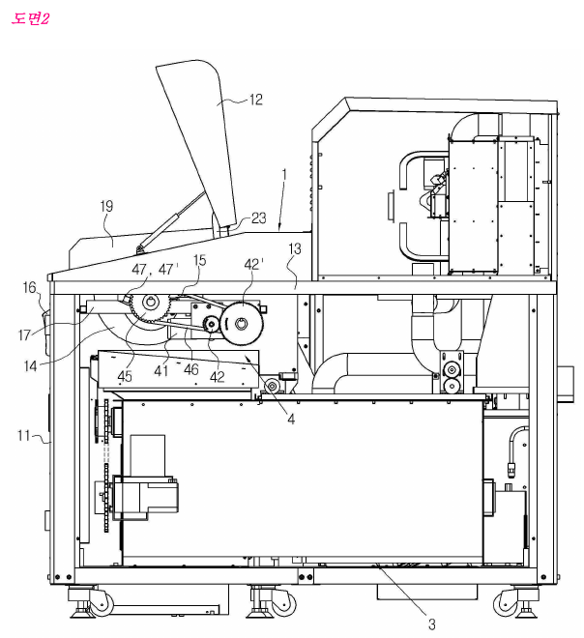
Note. From Inputting device for quantity and weight loss of food garbage container (Korean Patent No. 10-1581944), by H. Shin, 2016, Korean Intellectual Property Office.

Shin (2016), for Concoftech, patented the waste input device of a pay-by-weight food waste processor. Figure 13 is a perspective view of part of the machine, with some parts omitted and separated. The waste is dropped into a hopper which sits on a load cell, the user pays electronically on the display, and the hopper then rotates approximately 170-180 degrees and releases the waste into a crushing and stirring tank. The guide member with rollers allows hopper to be turned within the space of the lid without snagging, maintaining the machine compactness and convenient loading height. Drawings show that payment data is sent to a primary server not shown in the drawing.
The load cell, a powered lid and a display for the user are shared with Smart-Bin. It is not for the same purpose. The Korean device crushes the garbage and charges according to its weight, while Smart-Bin weighs to verify the garbage level. There is no fill-level, gas, tilt or tamper sensing, no wireless or cloud reporting in the text read, no collection priority list and no mobile alerts in the patent. The reason for earlier deodorant sprayers and sterilizing lamps is that the odor is only in the background.
Techniques for Optimally Sensing Full Containers (Devitt & Walsh, 2021)
Figure 14
Infrared Beam Across a Container
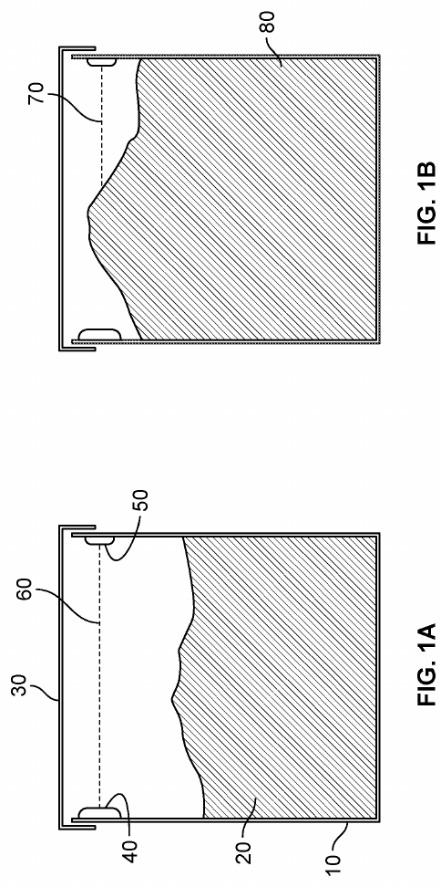
Note. From Techniques for optimally sensing full containers (U.S. Patent No. 11,054,545), by S. Devitt and B. Walsh, 2021, U.S. Patent and Trademark Office.

Devitt and Walsh (2021), for Oneplus Systems, give two ways to detect a full container while keeping very low the current drawn by battery-powered wireless circuitry. Figure 14, which combines Figures 1A and 1B of the patent, shows the first: an infrared emitter and receiver mounted on the side walls, so that the line between them marks the full level. The emitter transmits a wake-up signal and coded pulses, the receiver waits in sleep mode until the wake-up signal is received, and at the end of a specified period of time, if the coded signals are not received, the container is considered full. The second method checks the resting tilt angle of lid in three axes since a lid that overfull waste holds up is set at a different angle. The data from fullness is sent to a cloud server.
The patent only gives full or not full, with Smart-Bin providing a calibrated percentage and a time to full. No weight, gas, temp, powered lid, PIN mode/tamper alarm is displayed in parts read. The tilt here is the angle of the lid, used as a sensing element, and it is not a tamper check, so it should not be confused with the BMI160 tilt alarm of Smart-Bin, which watches the whole bin.
Trash Can With a Sensing Flip Lid (Wang, Chen, et al., 2020)
Figure 15
Circuit of the Induction Flip Lid With a Settable Sensing Distance
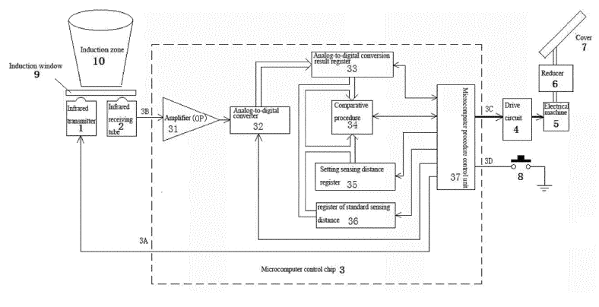
Note. From Trash can having sensing flip lid having settable sensing distance and control method therefor (European Patent No. 3 620 405 A1), 2020, European Patent Office, X. Wang et al. (sensing flip lid).

A clamshell trash can with an infrared sensing distance set by the user is described by Wang, Chen and Lin (2020) of Fujian Nashida Electronic. The circuit diagram is shown in figure 15. The major components are an infrared transmitter and receiver underneath an induction window, a single microcomputer chip for the amplifier, analog-to-digital converter and distance registers, and a drive circuit to operate the motor and reducer. Only when the reading is above the standard distance value, the motor will flip the cover open and when the user selects a distance by pressing a setting button, it will be stored and used for comparison later.
This is the closest equivalent of the servo-lid of Smart-Bin that is triggered by a PIR. A hand near the induction window opens the lid and how near is up to the user. As no fill or weight, gas, tilt, display or wireless link or monitoring is involved in the project, nothing else is addressed in the patent. It was listed as a published application (kind code A1) on Google Patents and withdrawn in 2021, meaning that it was not granted.
Smart Waste Bin Sensor Device and Methods (Kurani, 2023)
Figure 16
Overall Smart Waste Management System
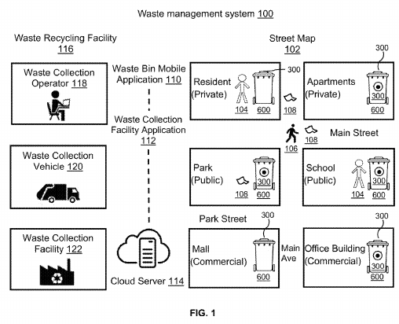
Note. From Smart waste bin sensor device and methods for waste management system (U.S. Patent No. 11,702,280), by H. B. Kurani, 2023, U.S. Patent and Trademark Office.

Kurani (2023) is the broadest patent of the twenty on sensing. Figure 16 gives the whole system for monitoring bins continuously to optimize collection and reduce littering. The bin is equipped with a battery powered smart sensor device carrying approximately a dozen sensors, including fill level, temperature, humidity/pressure, air quality, smoke, gas, motion, a pathogen biosensor and sterilizer, and an accelerometer. Readings are transmitted via a wireless network to a cloud server which creates real-time bin statistics and optimizes collection routes. The data is displayed in a bin app and a facility app, and biohazard and biosafety alerts are sent to nearby phones. The accelerometer detects when the bin has been tilted, and resets the fill level to zero when the bin tips over.
It matches Smart-Bin on sensing, cloud, apps and routes: fill, gas, temperature and tilt data go to a cloud server with mobile alerts and an optional touchscreen on the device. Its centre of gravity lies elsewhere, in litter, biohazard and pathogen sensing with a sterilizer. The parts read show no PIR-actuated servo lid, remote lock, PIN collect mode or tamper alarm with a latch, and the tilt serves to reset the fill level and does not sound an alarm.
Smart City Garbage Management System (Yan & Chen, 2021)
Figure 17
Garbage Cans and the Monitoring Center
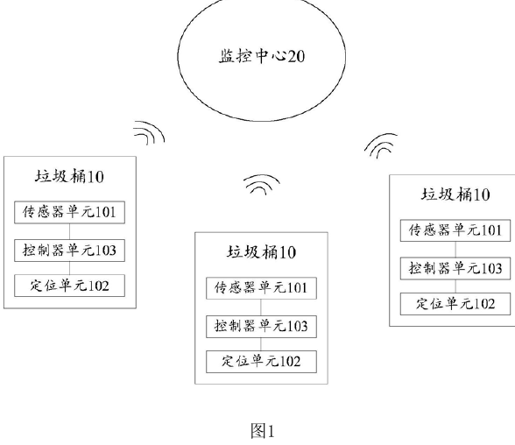
Note. From Smart city garbage management system (Chinese Patent No. CN 109324552 B), by S. Yan and J. Chen, 2021, China National Intellectual Property Administration. The labels in the original are in Chinese.

Yan and Chen (2021), for Shanghai Shuncom Smart Technology, patented a city-wide system. Figure 17 is the schematic of the garbage cans and the monitoring center. Each can has a positioning unit, a controller and sensors for weight, infrared height, odor and smoke, and the controller uploads the readings to the monitoring center. The center decides which cans need inspection (weight, height or odor above a threshold, or any smoke), generates the route of the truck. When a special-condition signal arrives, a nearby truck is rescheduled by priority, in the order fire, fault, pollution and full bin.
This patent is the closest in purpose. Weight, height and odor decide which cans are serviced first, as the priority tags of Smart-Bin do. It goes further by building routes for trucks with GPS, and Smart-Bin stops at ranking the bins. It also includes smoke sensing, which Smart-Bin does not have. No powered lid, tamper detection, PIN mode, on-bin display or phone alert appears in the text read.
Apparatus and Method for Waste Monitoring and Analysis (Balachandran & Talavera, 2023)
Figure 18
Waste Measurement System With Weighing Devices and Reports
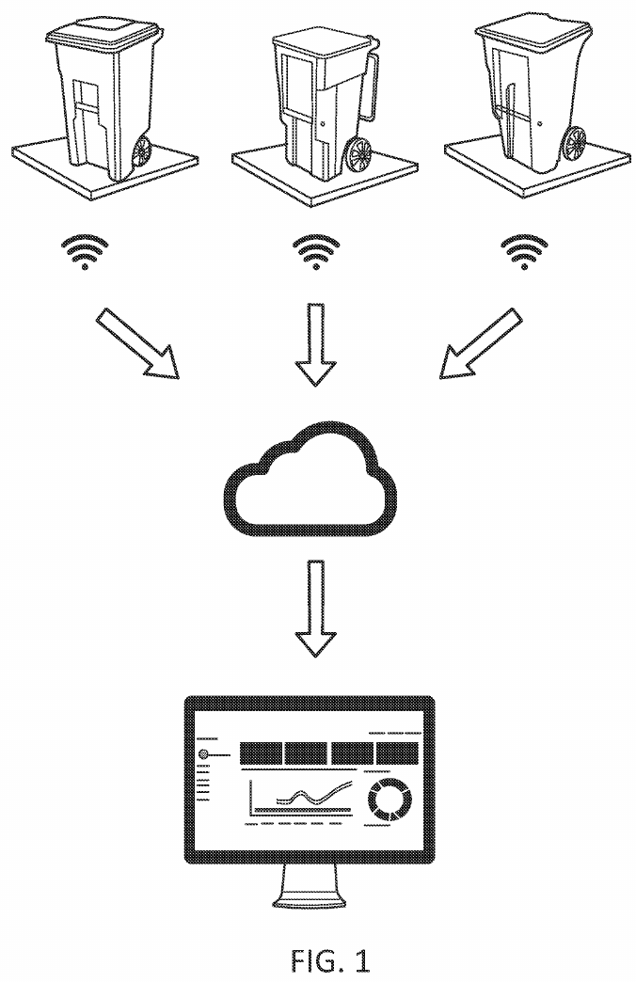
Note. From Apparatus and method for waste monitoring and analysis (U.S. Patent No. 11,788,877), by N. Balachandran and O. Talavera, 2023, U.S. Patent and Trademark Office.

Balachandran and Talavera (2023), for Zabble, cover waste audits. Figure 18 gives an overview of the measurement system: a series of weighing devices record the weight of the waste, the data go to networked storage, and the stored data are turned into visual reports for an operator. Claim 1, though, is about images: a method that acquires images of the contents of at least two containers of a waste generator, identifies characteristics of the contents and generates a report by computer. The disclosure adds load cells under a platform for two or more bins and gas sensors for compost bins.
The shared ground with Smart-Bin is remote monitoring of bin contents, with cloud upload and dashboards, and gas sensing in one special case. The aim is different. This patent is an audit and reporting service that tells a waste generator what is being thrown away, while Smart-Bin is a single bin that works out when it needs emptying. The claims do not cover a bin with fill, tilt, lid and lock control, a PIN collect mode or a collection priority list.
Capacity Inspection Garbage Bin With Infrared Induction (Yang et al., 2020)
Figure 19
Block Diagram of the Capacity-Detecting Bin
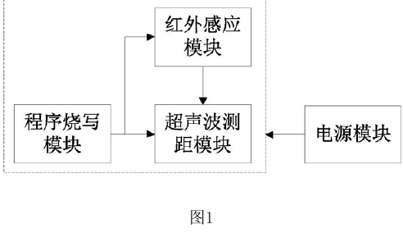
Note. From Capacity automated inspection garbage bin with infrared induction function (Chinese Patent No. CN 210504152 U), by S. Yang, D. Liao, R. Li, and Y. Yu, 2020, China National Intellectual Property Administration. The labels in the original are in Chinese.

Yang et al. (2020), for Sichuan Grid Environmental Protection Technology, is a utility model for a bin that shows how much capacity it has left. Figure 19 is a block diagram of the inside of the bin. The body holds an infrared induction module, an ultrasonic ranging module, a programming module and a power module. The ultrasonic module is connected to the infrared and programming modules, and the power module supplies all three. The ultrasonic module measures the remaining capacity and two nixie-tube digits show it on the bin, while the infrared module detects a nearby user to wake the system. Google Patents lists the rights as terminated for non-payment of fees.
This utility model matches the local side of Smart-Bin: an ultrasonic ranging module, a wake-up by a nearby user, and the capacity shown on the bin itself, where Smart-Bin shows it as a percentage on its touchscreen. Little else carries over. The device is stand-alone, with no weight, gas, tilt, lid actuator, wireless link, server, route planning or phone app.
Garbage Bin Intelligent Controller and Supervisory System (Wang, Zhang, et al., 2020)
Figure 20
Electrical Block Diagram of the Bin Intelligent Controller
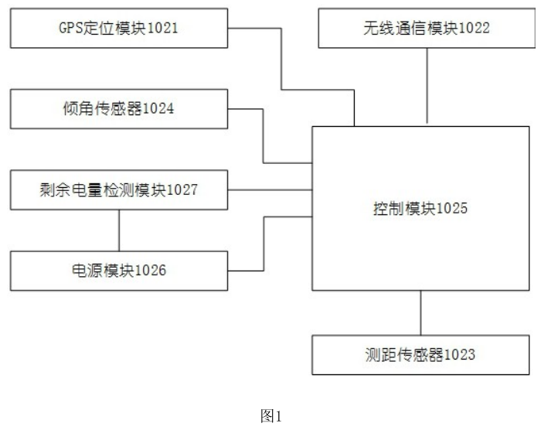
Note. From Garbage bin intelligent control ware and garbage bin supervisory systems (Chinese Patent No. CN111559590A), by X. Wang, Y. Zhang, and Z. Wang, 2020, China National Intellectual Property Administration. The labels in the original are in Chinese.

Wang, Zhang, and Wang (2020), for Weihai Jingxun Changtong Electronic Technology, published an application for a bin controller that can be installed on top of the bin or at its side. Figure 20 is its electrical block diagram, with a wireless communication module, a control module and a distance sensor in one housing. In top mode the controller works out the height of the garbage, in side mode it reports the distance to the opposite wall, and either value is uploaded to monitor whether the bin is full. In the description, an ultrasonic module measures the distance, an inclination sensor raises a tip-over or movement alarm, the data go by NB-IoT and alerts reach the phones of workers.
The overlap with Smart-Bin is strong on the alert side: a distance sensor for fill, an inclination sensor for tip-over alarms, wireless upload and alerts on a phone. The patent has no weight or gas sensing, powered lid, lock, PIN or touchscreen collect mode, priority list or time to full, and in the parts read the inclination alarm has no countdown or latch, which Smart-Bin adds. Google Patents lists the application as withdrawn.
Measuring the Fill Level of a Trash Can Using a Sensor (Keller et al., 2024)
Figure 21
Automatic Alerting System for a Trash Can
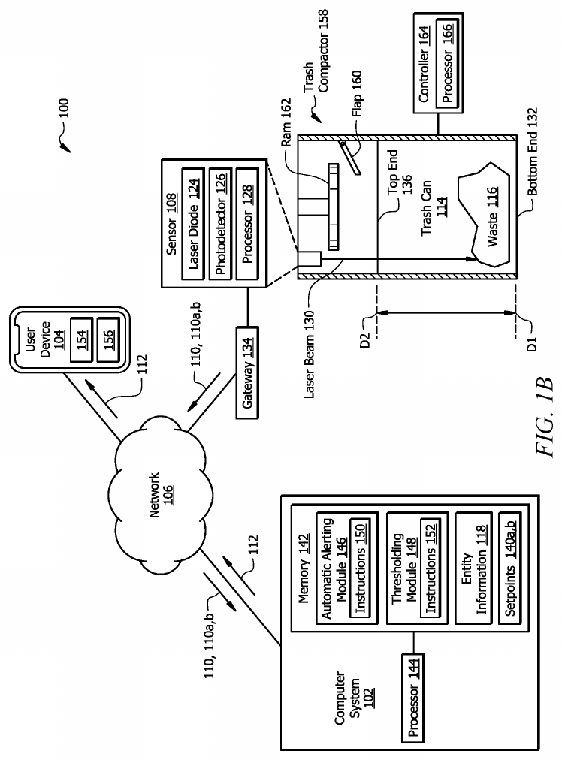
Note. From System and method for measuring the fill level of a trash can using a sensor (U.S. Patent No. 12,125,361), by J. R. Keller, M. O. Redmond, and S. A. Mirza, 2024, U.S. Patent and Trademark Office.

Keller et al. (2024), for 7-Eleven, patented a way to turn a distance reading into a fill percentage. Figure 21 shows the automatic alerting system: a sensor above the container, a gateway and network, and a computer system with its modules and a user device. In claim 1 a sensor above the can holds a laser diode that sends a pulse toward the bottom and measures the time of flight. A computer converts the distance to a percentage of waste with two calibration setpoints, picks a threshold for the current time period from stored information about the owner of the can, and alerts a user device when the threshold is exceeded. Alerts can be email or text on a smartphone.
The two setpoint calibration is identical to that of Smart-Bin: the empty distance (default: 30cm) and the full distance (default: 5cm) are programmed from the interface, and the fill percentage is programmed to the distance between. A threshold-based alert reaches a phone in both. Everything else in the patent is narrower: a single laser sensor, no weight, gas, tilt or tamper sensing, no lid control or lock, no touchscreen collect mode and no priority list.
Waste Bin Collection and Monitoring Method Using Bin Sensors (Sait et al., 2025)
Figure 22
Network of Waste Bins, Cloud Server and Vehicles
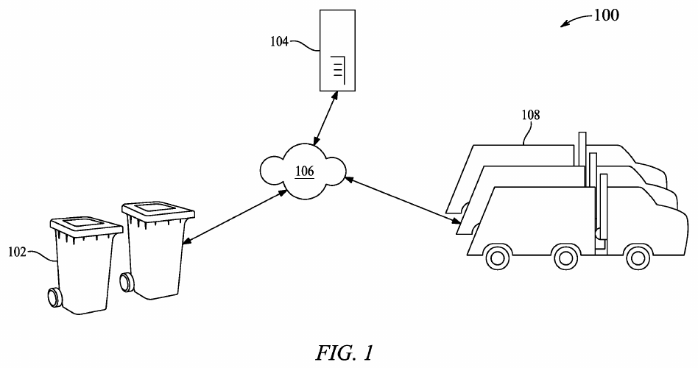
Note. From Waste bin collection and monitoring method using waste bin sensors (U.S. Patent No. 12,450,575), by S. Sait, F. M. Aliyu, S. Bukar, B. S. Maina, and D. U. Lawal, 2025, U.S. Patent and Trademark Office.

Sait et al. (2025), from King Fahd University of Petroleum and Minerals, is the newest patent in the set. Figure 22 is a network diagram of the waste bins, the cloud server, the cloud network that connects them and the waste vehicles. Claim 1 describes a method to monitor and control the CO2 and CH4 emissions of a collection system. The methane, humidity, waste level, location and temperature are sensed under every separate bin lid and transmitted to a cloud server. One processor calculates the time in which the methane limit will be reached and a second processor calculates the time in which the fill limit will be reached, and a third processor, based on the CO2 and CH4 readings of the vehicles, prepares the collection schedule and routes. Two neural networks make the time estimates, and a mobile app sets parameters and shows data.
It is the nearest to Smart-Bin in using a time to full, in sensing fill, gas, temperature and humidity inside the bin, and in sending them to a cloud server with a display and a mobile app. The estimate is made differently. Neural networks work from methane and fill data, while Smart-Bin uses the fill rate of the last 15 minutes with no trained model. The patent is centered on methane prediction and routing based on emissions. It has no load cell, tilt or tamper alarm, PIR lid, remote lock or PIN collect mode, and weight and tilt appear only in a list of possible sensors.

Related Literature and Studies
Thirty studies were reviewed between 2023 to 2026. Each of them is listed in Table 2 with its hardware, the main reported result and what it is lacking in comparison with Smart-Bin. If a figure is derived from training data or is a synthetic data set, this is indicated in the table as these figures are not representative of the actual system in use. Each study is then taken in turn under one of four headings, according to what it puts the most weight on: level-sensing bins with lids and alerts, bins that add weight, gas or access control, collection routes and priority, and cameras, sorting and system design. A figure is shown wherever the source is open access and has a drawing or photograph that helps, with the licence of the figure in the note under it. The other studies are text only, because their publishers do not allow the figures to be reused.
Table 2
Related Studies From 2023 to 2026
Study | Hardware and platform | Reported result | What it lacks
Saad et al. (2023) | NodeMCU ESP8266 and Arduino Nano, HC-SR04, HX711 load cell, GPS, SG90 lid, WhatsApp through Twilio | Lid opens within 50cm. Full at 3cm of free space or 4,000g. Height error 0.4%, weight error 0.15%, message in 2.61s. | Dashboard, air quality, tamper detection, cloud history, roles
Abdullahi et al. (2024) | Arduino with HC-SR04 and SIM800L GSM, servo lid, cloud server | Lid opens only when the bin is not full. Full at 20cm. No performance figures are given. | Weight, air quality, tamper detection, dashboard, app
Alnuaimi et al. (2024) | Simulation of smart-bin collection as a travelling salesman problem (AnyLogic) | Shorter travel distance and lower emissions than static routes. No figures are given. | Bin hardware, alerts, app
Ayyanagoudar et al. (2024) | Ultrasonic and weight sensors, web page for each bin level | Real-time level tracking for each bin on a web page. No measured results are given. | Air quality, tamper detection, app, alerts
Azmi et al. (2024) | Arduino Uno with LoRa, HC-SR04, DHT11, GPS, ThingSpeak dashboard | Ultrasonic accuracy 89.9% at half full, humidity 96.9%, temperature 94.4%. Alerts are dashboard indicators only. | Weight, app, push alerts, on-bin display
Enache et al. (2024) | ESP32-CAM nodes with solar cell, ESP-MESH, server image processing | Fill ratio estimated from hourly bin photographs. Relative error 11.43% to 30.00% on five bins. | Weight, air quality, tamper detection, app
González et al. (2024) | ESP32 and ESP32-CAM, ultrasonic fill, simulated weight, Oracle APEX dashboard, App Inventor app | Camera classifies waste; weight is simulated with potentiometers. No accuracy figures. | Real weight sensing, air quality, tamper detection, priority list
Kuzhin et al. (2024) | IoT sensors with route analytics; no hardware described | The results are 20% fewer overfilled bins, 15% fewer collection trips, 25% shorter trips, and 10% less fuel. | Any bin hardware; setting and sample are not given
Mehta and Rathour (2024) | Ultrasonic, temperature, weight and tilt sensors and data software. | 6-month pilot: approximately 50% improvement in collection efficiency, 25% reduction in cost, and 83.3% reduction in overflows. | Detail on site and method; air quality, app, on-bin display
Muthukumar et al. (2024) | Camera-based AI segregation bin with a staff app for fill level and temperature and humidity | Classifier test accuracy 92.3% (training accuracy 71.8%). The scalability claim is not tested. | Weight, air quality, tamper detection, collection priority; main aim is segregation
Rathnayake et al. (2024) | Three ESP32 bins with ultrasonic and methane sensors, Node-RED cloud, machine learning | 4-month pilot: fill accuracy 95%, methane detection 92%. Route simulation 15% more path-efficient. | Weight, tilt, app, on-bin display
Salleh et al. (2024) | Using NodeMCU ESP8266, ultrasonic sensor and ThingSpeak dashboards. | Live container levels support need-based collection scheduling. Proteus simulation and PCB layout are included. | Weight, air quality, tamper detection, app
Shaharil and Po’ad (2024) | Arduino, ultrasonic lid sensor, IR fill sensor, load cell, MQ-2, LCD, Blynk | Weight errors of −5g to +10g on four items. The Blynk app shows a full-bin notification. No numbers for the IR or gas sensors. | Web dashboard, collection priority, tamper detection
Thangam et al. (2024) | Use of ESP8266, ultrasonic and soil-moisture sensors | Analytics are meant to let authorities adjust routes. No results are reported. | Weight, air quality, tamper detection, app
Aasish et al. (2025) | Dual-core ESP32 on FreeRTOS, ultrasonic, DHT sensor, RFID bin tags, LCD or OLED, cloud server | Splits sensing and cloud communication across tasks. No measured results. | Weight, tamper detection, app, test data
Alnanih et al. (2025) | Arduino Uno and ESP8266 with GSM, HC-SR04, flame sensor, GPS, LCD, Firebase, web app, Flutter app | 6-month, 50-bin campus pilot: 99.5% uptime, fill error within ±3%. Smoke Test fire alarm in 5s. | Weight, humidity, tamper detection, time to full, UI calibration
Alourani et al. (2025) | Arduino Nano and ESP8266, ultrasonic sensor, Firebase, Android app, VGG-19 classifier | App alerts collectors at a fill threshold. Classifier 99.7% training accuracy. | Weight, air quality, tamper detection, priority list
Banciu et al. (2025) | GPS and RFID bin locations; Nearest Neighbor, OR-Tools and genetic algorithm | Three real routes with 735 locations: up to 52% shorter distance, over 14kg less CO₂. | Any bin sensing; the study is about routing
Gajula et al. (2025) | ESP32, HC-SR04, Moisture sensor, Servos and Arduino IoT Cloud. | Separates dry and wet waste by moisture. No figures are given. | Fill-level role of the ultrasonic sensor, weight, tamper detection, app
Gupta et al. (2025) | Microcontroller with ultrasonic sensor and Wi-Fi, cloud platform | 30-day, 50-bin pilot: 58.9% less distance, 59.2% less fuel, 95% fewer overflows, 99.8% uptime. | Weight, air quality, tamper detection, app detail
Ishaq et al. (2025) | Ultrasonic sensors in bins at ten hospitals, cloud monitoring station | Alerts led to pickups 3 to 16 minutes later. Biomedical waste about 43.6% to 52.5% of hospital waste. | Weight, air quality, tamper detection, app (proposed only)
Karthi et al. (2025) | ESP32, RFID reader, ultrasonic sensor, metal detector, MQ135, Blynk | 95% fill accuracy, 92% RFID reliability, 40% less manual intervention. | Weight, tamper detection, priority list, web dashboard
Kumar et al. (2025) | Using ESP32, ultrasonic sensors, Ant Colony Optimization, machine learning, and map. | Prioritizes filled bins and builds depot-to-depot routes. No numbers are reported. | Weight, air quality, tamper detection, app, alerts
Maulida et al. (2025) | ESP32, HC-SR04, MQ-2, HX711, SG90 lid, Firebase, Android app | Level accuracy about 95%, weight about 93%, 92% of spoiled-food cases flagged, usability score 86 (15 officers). | Tamper detection, collection priority, web dashboard, roles
Mehta et al. (2025) | ESP8266 with ultrasonic sensor, MQ4, MQ136, MQ137 and GPS, Firebase and React Native Application | Gas sensors 96% to 98% accurate against a reference. Field test of 28-bin samples cut trucks from 3 to 2. The 100-bin results are synthetic. | Weight, tilt, on-bin display; some tables conflict
Sadikin et al. (2025) | ESP32 with ultrasonic, infrared and GPS, Firebase, Kotlin Android app | Ranking by distance, vehicle capacity and fill level (greedy). 69 respondents: 92.37% effectiveness, 89.92% satisfaction.. | Weight, air quality, tamper detection, on-bin display
Shahibollah et al. (2025) | ESP32, ultrasonic sensors, servo lid, tri-colour LED, Blynk | Tested by simulation and on hardware. No figures are given. | Weight, air quality, tamper detection, priority list
Yogesh et al. (2025) | ESP32, HX711 load cell, ultrasonic sensor, Firebase, App Inventor app, LCD | Weight and fill percentage with full-bin alerts. No measured results are reported. | Air quality, tamper detection, priority list, test data
Awotayo and Dodo (2026) | ESP32, two HC-SR04, MG90S servo lid, LEDs and buzzer, Blynk email | Fill zones at 40% and 60%; email when full. No accuracy or response-time results. | Weight, air quality, tamper detection, dashboard, app
Mugaruka et al. (2026) | LoRaWAN-style network of ultrasonic sensors in seven 120-L bins | 12-week pilot: 57% of sensors at or below −107dBm; mass and route times are estimates. | Weight, air quality, tamper detection, app
Note. Results are as reported by the authors. Lacks means that the feature is not described in the study.
A. Level-Sensing Bins With Lids and Alerts
Smart Bin With Automatic Lid Control (Abdullahi et al., 2024)
Figure 23
Block Diagram of the Smart Waste Management System
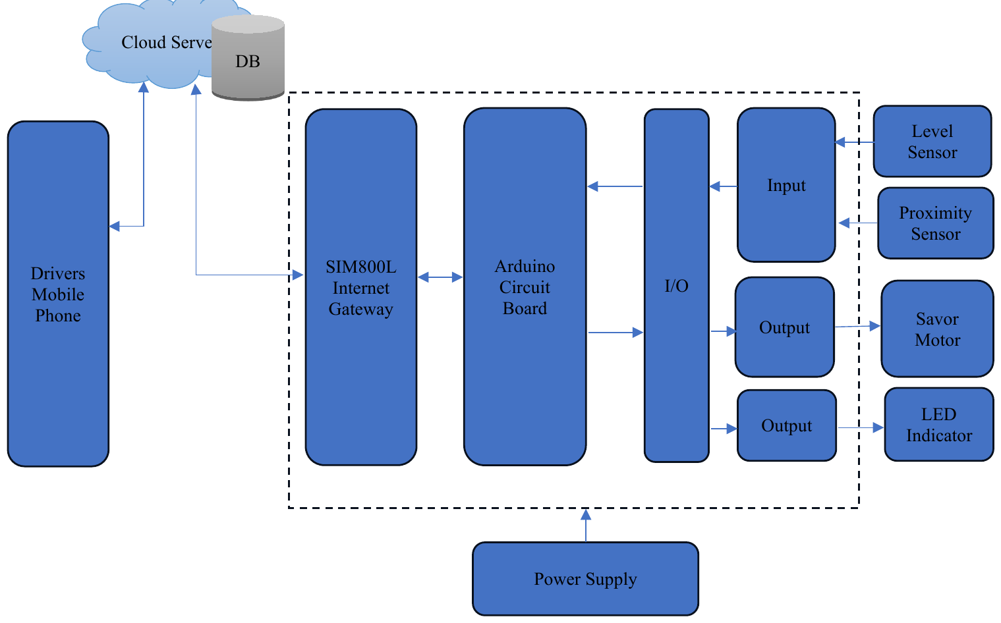
Note. From “Development of a smart waste management system with automatic bin lid control for smart city environment,” by A. Abdullahi, A. Mohammed, M. U. Bonet, A. El-Suleiman, R. B. Ahmad, and T. D. Chollom, 2024, EAI Endorsed Transactions on Smart Cities, 7(3). CC BY-NC-SA 4.0.

Abdullahi et al. (2024), of the Air Force Institute of Technology in Kaduna, Nigeria, built a bin whose lid opens only when the bin is not full. Figure 23 is their block diagram. The fill level is measured by an ultrasonic sensor (HC-SR04) and an Arduino, which also detects the approaching user, and the lid is opened by a servo motor that rotates 0-90 degrees. The thresholds are 20cm for a full bin, and 12cm for a user. Status connects to the cloud server via a SIM800L GSM module where data is stored and full bin notifications are sent to the collection team.
There are no figures for performance and it is inconsistent regarding the board as one figure shows Uno and the other shows Nano. There's a phone block in the diagram, but the app is never mentioned. Smart-Bin includes the ultrasonic fill sensor, a servo lid and weight, air sensing, tilt, a dashboard, and a phone app, all of which this study lacks.
Smart Waste Management System Using LoRa (Azmi et al., 2024)
Figure 24
Circuit Setup of the LoRa Bin Unit
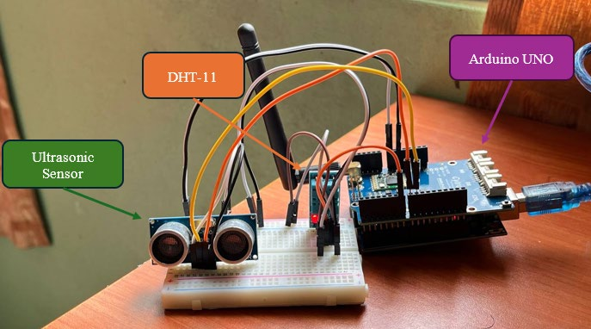
Note. From “Smart waste management system using LoRa technology,” by A. Z. Azmi, N. M. Sahar, and M. T. Islam, 2024, E3S Web of Conferences, 599, Article 04007. CC BY 4.0.

Azmi et al. (2024) installed a LoRa connection between the bin and the receiver. The setup for their circuit is shown in Figure 24. The ultrasonic fill distance, DHT11 temperature and humidity and GPS position are transmitted through a bin-side Arduino Uno with LoRa shield to a second Arduino Uno with LoRa receiver, and then relayed to a NodeMCU which updates a ThingSpeak dashboard with indicators when thresholds are reached. The tests indicated an ultrasonic accuracy of 89.9% at half full, a humidity accuracy of approximately 96.9% and a temperature accuracy of approximately 94.4%.
The authors report that the ultrasonic sensor was not successful in a narrow, shallow bin, and the DHT11 temperature sensor error exceeded the sensor's specified error. They state that they have a LoRa range of several kilometers, but they did not measure it, and the abstract mentions air quality monitoring, but does not go into any detail about it in the body of the paper. Also, Smart-Bin senses temperature and humidity (BME680 used instead of DHT11) and uses ThingSpeak. The study has no weight sensing, push alerts, phone app or display on the bin.
Ultrasonic Trash Can Surveillance With ThingSpeak Dashboards (Salleh et al., 2024)
Salleh et al. (2024) developed a prototype for waste collection based on demand at a low cost. An ultrasonic distance sensor mounted in each container is read by a NodeMCU ESP8266 module which uploads the fill level to ThingSpeak so that live dashboards indicate the status of each container and enable container status-based scheduling. Also included is a Proteus simulation and a PCB layout. No results are reported, and the authors view this work as a scheduling tool, rather than a validated route planning method.
Smart-Bin also employ ThingSpeak for charts and analysis, but only as a second cloud besides Firebase, as optional. It provides the weight, air quality, tamper detection and a phone app, things this study doesn't.
ESP8266 Waste Monitor With Moisture Sensing (Thangam et al., 2024)
Thangam et al. (2024) of Amrita Vishwa Vidyapeetham, Bangalore, have developed an ESP8266 monitor that utilizes ultrasonic fill sensors, soil-moisture sensors to assess the waste composition. The real-time data is supposed to enable the authorities to modify routes and reduce trips and gas. The route claim is a stated aim but not a measured result, as no quantitative results are reported in the abstract.
Smart-Bin senses are filled by the same type of ultrasonic sensor with the addition of weight, air quality, tamper detection and a phone app. It makes no attempt to judge the composition of the waste.
Smart Bins for Hospital Waste in Kaduna (Ishaq et al., 2025)
Figure 25
Proposed System Architecture for Hospital Waste Monitoring
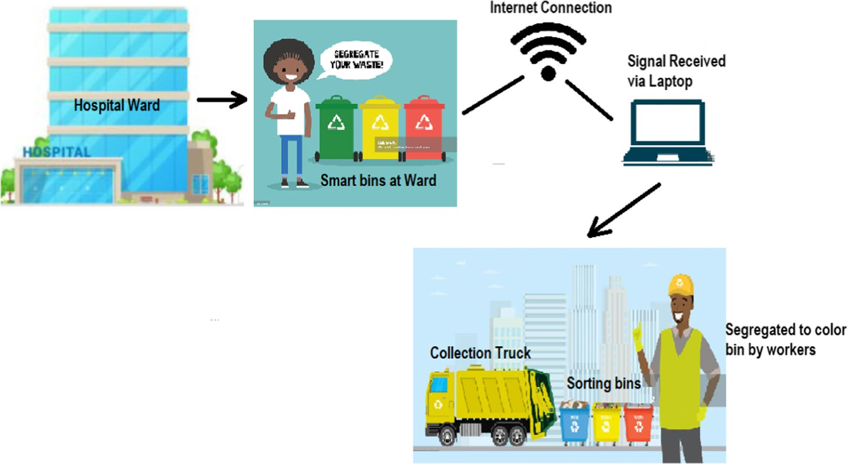
Note. From “Smart waste bin monitoring using IoT for sustainable biomedical waste management,” by A. Ishaq, S. J. Mohammad, A. D. Bello, S. A. Wada, A. Adebayo, and Z. T. Jagun, 2025, Environmental Science and Pollution Research, 32(32), 19434–19449. CC BY 4.0.

Ishaq et al. (2025) put ultrasonic fill-level sensors in bins at ten hospitals in Kaduna, Nigeria. Figure 25 is the proposed system architecture, from the hospital ward to the smart bins, an internet link, a laptop at the monitoring station and the collection truck. The bins connect wirelessly through the routers of the hospitals to a central cloud monitoring station, which alerts waste collectors when a bin is full. The authors also measured waste generation. Biomedical waste made up about 43.6% to 52.5% of hospital waste, at an average of 69.14kg per day and 1.52kg per bed per day, and they analysed the data with principal component analysis.
Alerts led to pickups 3 to 16 minutes later. The phone app appears only in the proposed system and is not described as built, and no microcontroller is named for the bins of the authors. The study shows what level sensing is worth in a place where overflow carries a health risk. Smart-Bin senses more than level, but it has not been tested in any such site.
IoT-Enabled Smart Dustbin for Real-Time Monitoring (Shahibollah et al., 2025)
Shahibollah et al. (2025), from Universiti Teknologi MARA in Terengganu, built an ESP32 dustbin with ultrasonic sensors for fill level and for proximity, a servo-driven lid and a tri-colour LED for local status. Data go over Wi-Fi to the Blynk platform, which alerts the maintenance staff. The authors tested the bin by simulation and with hardware, but the abstract gives no ranges or accuracy figures and describes the result as prototype function and not as municipal-scale reliability.
Smart-Bin uses the same ESP32 family and a servo lid. Its touchscreen takes the place of the LED, and it adds weight, air quality, tamper detection and a priority list.
IoT Smart Bin for Real-Time Fill Level Monitoring (Awotayo & Dodo, 2026)
Awotayo and Dodo (2026) of Baze University, Abuja designed and implemented an ESP32-based bin equipped with two HC-SR04 sensors. One of these is facing outwards and will open a servo lid (MG90S 0 to 90 degrees) when someone is in range of 30cm. The other indicates the level of fill, with a green LED when the fill level is between 0 and 39%, a yellow LED when the fill level is between 40 and 59%, and a red LED and buzzer when the fill level is between 60 and 100%. An e-mail is sent by Blynk when the bin is full. Two 3.7V Li-ion cells (7.4V, 3500mAh) power the unit. There are no accuracy or response-time results reported.
The local feedback is LEDs and a buzzer and not a screen. Smart-Bin also includes a touch screen, weight detection, air quality, tamper detection, dashboard and a phone app, none of which were identified in this study.
LoRaWAN Network for Waste Collection in Bukavu (Mugaruka et al., 2026)
Figure 26
Proposed Network Architecture for Waste Collection in Bukavu
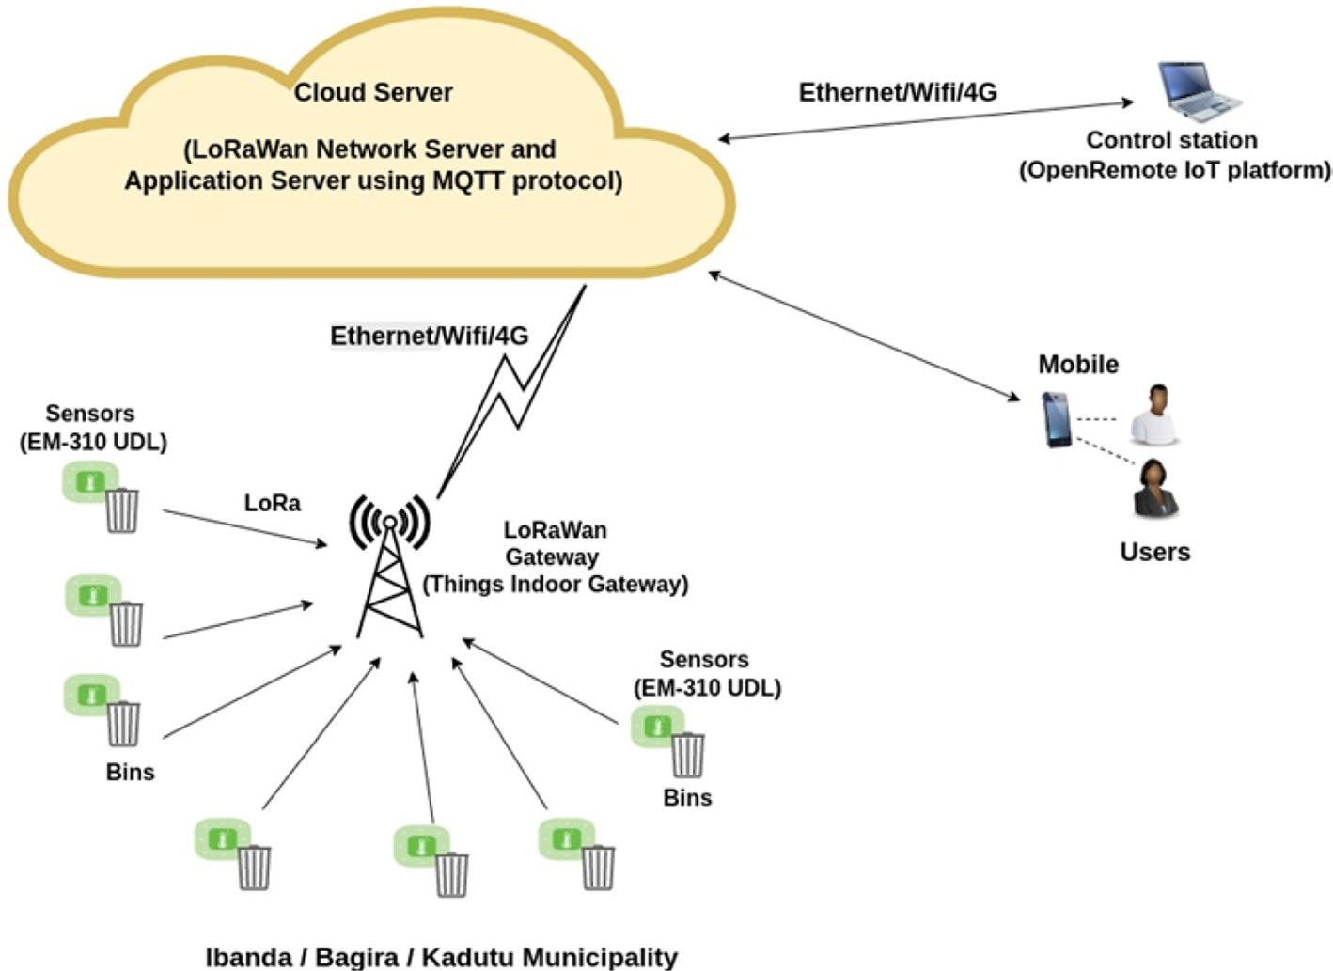
Note. From “Design of an IoT sensor-based network architecture for waste collection in Bukavu city (DRC),” by O. M. Mugaruka, J. R. Kala, J. Ndikumagenge, R. van Schadewijk, and R. Nibitanga, 2026, Discover Internet of Things, 6(1), Article 168. CC BY-NC-ND 4.0.

Mugaruka et al. (2026) designed a LoRaWAN-style network for waste collection in Bukavu, in the Democratic Republic of the Congo. Figure 26 shows the proposed network. EM310-UDL ultrasonic sensors on the bins talk over LoRa to a gateway, the gateway reaches a cloud server by Ethernet, Wi-Fi or 4G, and users view the data on a control station and on mobile phones. The authors tested it in a 12-week pilot with seven 120-litre prototype bins in residential, dense and peri-urban areas.
The results concern the network more than the bins. Of the sensors, 57% had a signal at or below −107dBm, and the mass collected (an estimated 641kg over 14 days in one area) and the route times are estimates from sensor data and not direct measurements. The authors also report an energy autonomy above 90% for most units after 11 months, a period that the paper does not clearly tie to the 12-week pilot. Smart-Bin does not use LoRa at present, and the study is a reminder of the opportunity listed in the SWOT analysis: LoRa for places without Wi-Fi.
B. Bins That Add Weight, Gas or Access Control
IoT-Based Smart Dustbin Prototype (Saad et al., 2023)
Figure 27
Prototype of the Smart Dustbin
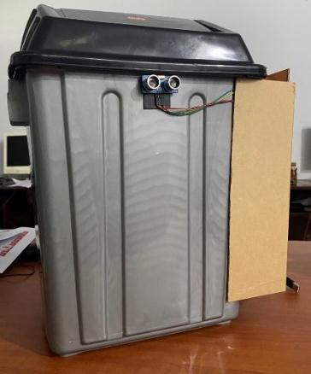
Note. From “IoT-based smart dustbin prototype,” by A. M. Saad, B. O. Jul, A. Basalamah, and S. Sayuti, 2023, PROtek: Jurnal Ilmiah Teknik Elektro, 10(2), 120–125. CC BY-NC-SA 4.0.

Saad et al. (2023) built the smart dustbin shown in Figure 27. An Arduino Nano with an ultrasonic sensor opens an SG90 servo lid to anyone who is within 50cm, while a NodeMCU ESP8266 reads the waste height with an HC-SR04, the weight with an HX711 load cell and the position with a NEO-6M GPS. Once the bin is full (either by level (3cm free space) or weight (4,000g), the NodeMCU will send a WhatsApp message via Twilio with a Google Maps link.
The tests reported a height error of 0.4%, a weight error of 0.15% and a message delay of 2.61s. This is the nearest study to the pairing of fill and weight with a servo lid in Smart-Bin. Its lid is triggered by an ultrasonic sensor, where Smart-Bin uses a PIR sensor. The study has no dashboard, air quality sensing, tamper detection, cloud history or roles.
Smart Bin With Real-Time Garbage Level Tracking (Ayyanagoudar et al., 2024)
Ayyanagoudar et al. (2024) propose a smart bin that uses weight sensors and ultrasonic transducers to track the fill level in real time and shows the level of each bin on a web page. The abstract also states that it can classify trash based on its weight, which is used for planning transportation. The abstract does not mention any microcontroller or cloud platform and does not provide any results of measurements.
Smart-Bin also correlates weight to an ultrasonic level. It includes air sensing, tamper detection and a mobile phone app, which are not included in this study.
Efficiency of IoT-Enabled Smart Bins (Mehta & Rathour, 2024)
Mehta and Rathour (2024) present the description of IoT smart bins, which are equipped with ultrasonic, temperature, weight and tilt sensors and software to collect and process the data. They claim a 6-month pilot in one city where collection efficiency has improved by approximately 50%, operating costs have decreased by approximately 25% and there have been approximately 83.3% fewer overflow incidents, while also offering reduced emissions through route optimization and increased satisfaction of citizens. Abstract makes no mention of the location or nature of these measures or of the number of samples collected, these figures are merely the authors' claims.
This is the only study to mention a tilt sensor but does not indicate a tamper alarm. Smart-Bin does exactly that, a 10 second (latched) countdown followed by a siren that latches.
Dual-Sensing Bins for Fill Level and Methane (Rathnayake et al., 2024)
Rathnayake et al. (2024) developed the dual sensing bins which combined the ultrasonic fill sensor with methane sensor for detection of spoilage. The ESP32 modules transmit the data via Wi-Fi to a cloud platform where the data is processed by the Node-RED software and ML algorithms predict the waste and optimize routes. Three bins were deployed in a four month pilot in Dehiwala, Sri Lanka and reported a 95% fill-level accuracy; methane-detection accuracy was 92% and simulated routes were 15% more path-efficient than fixed routes. There is no definition of the accuracies in the abstract and 15% is obtained from a simulation.
The ESP32 and the ultrasonic level are shared between Smart-Bin. It is not a methane reading, but rather an air-quality estimate as it is a gas channel. This study doesn't include any weight sensing, tilt alarm, phone app or on bin display.
Arduino-Based Smart Dustbin (Shaharil & Po’ad, 2024)
Figure 28
Block Diagram of the Arduino-Based Smart Dustbin
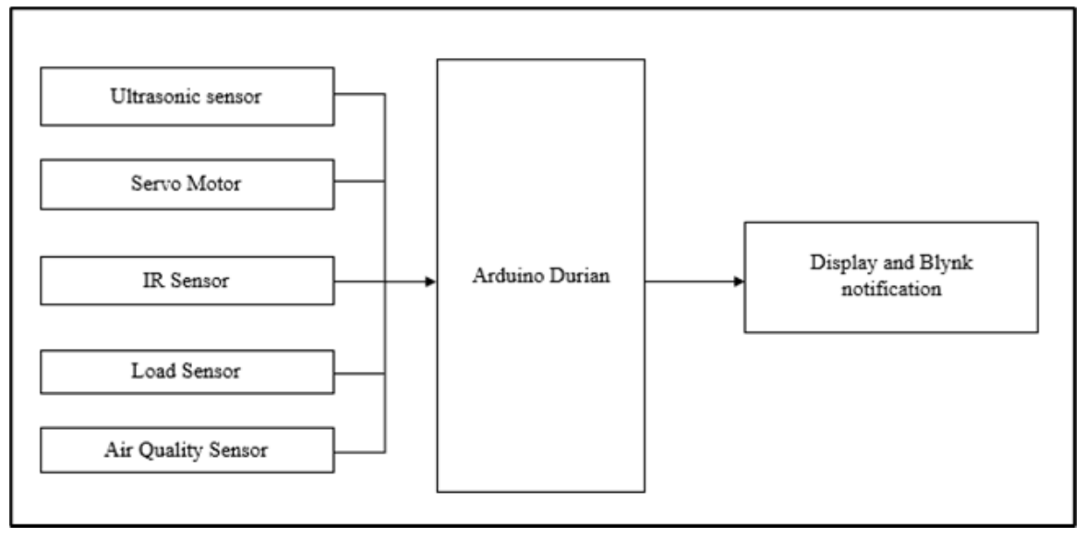
Note. From “Arduino-based smart dustbin with ultrasonic sensor for efficient waste management,” by M. H. F. Shaharil and F. A. Po’ad, 2024, Evolution in Electrical and Electronic Engineering, 5(2), 92–97. CC BY-NC-SA 4.0.

Shaharil and Po’ad (2024) built a household-scale bin and show its block diagram in Figure 28. The ultrasonic sensor opens up the servo lid if a person is within 30cm, the infrared sensor detects the level of fullness of the bin, the weight is displayed on the LCD using a load cell, and finally, a buzzer alerts when air quality is poor with the help of an MQ-2 sensor. The Blynk app shows a notification when the bin is full.
The testing is small: 15 distance trials and four weighed items with errors from −5g to +10g, and no numbers for the infrared or gas sensors. The bin is the closest study to the local side of Smart-Bin, with a lid, weight, gas and a display on the bin. It has no web dashboard, no collection priority and no tamper detection.
IoT-Driven System With Fire Detection and Role-Based Apps (Alnanih et al., 2025)
Figure 29
Data Communication Structure of the Smart Waste Management System
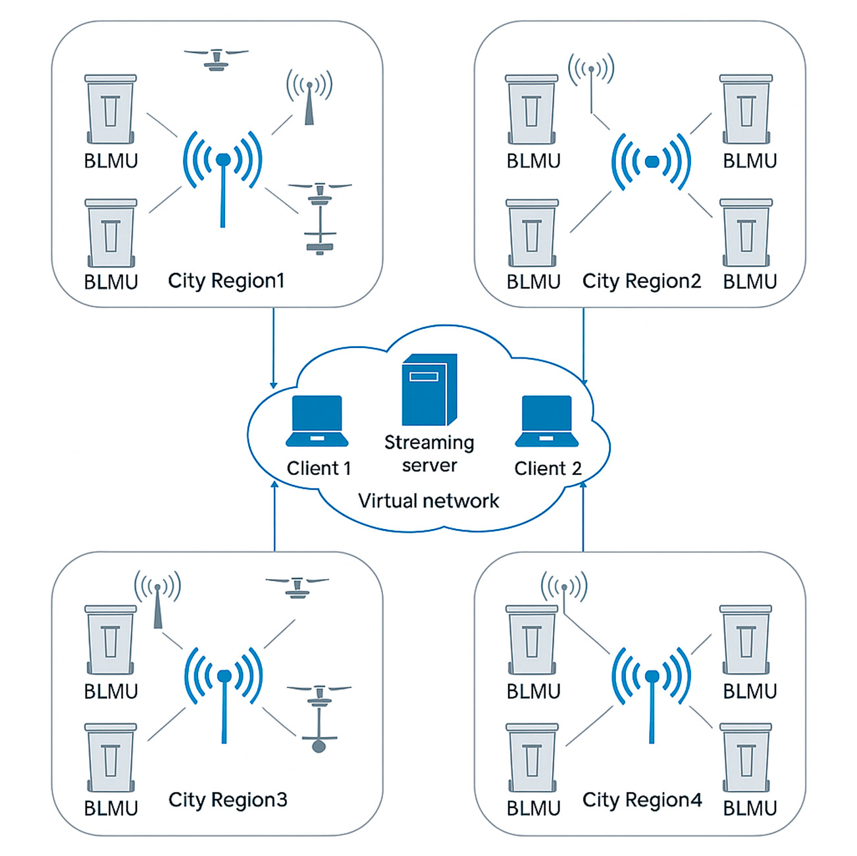
Note. From “Advancing sustainability through an IoT-driven smart waste management system with software engineering integration,” by R. Alnanih, L. Elrefaei, and A. Al-Ahwal, 2025, Sustainability, 17(21), Article 9803. CC BY 4.0.

Alnanih et al. (2025) combine fill and fire sensing in one bin unit. Figure 29 shows their data communication structure. An HC-SR04 is used to measure the fill level, a flame sensor detects fire, smoke and gas and an Arduino Uno with an ESP8266 and GSM receives the sensor data and an LCD, buzzer are added. Firebase and Firestore are used to launch alerts, coordinating collection routes from a central command center. A desktop web application is used by administrators and a Flutter Android application for workers based on their roles.
6-months pilot on campus with 50 bins achieved 99.5% uptime with fill error within ±3%, and a fire alert within 5s (smoke test). This is one of the longest field pilots of the studies which constructed their own bins. It's similar to Smart-Bin, it has Firebase, a web app, a phone app and different views for different users. There is no weight, tilt or lid feature and nothing is calibrated from the interface in the hardware list.
ESP32 Smart Trash Bin With Firebase (Maulida et al., 2025)
Figure 30
Prototype of the SmartTrashBin
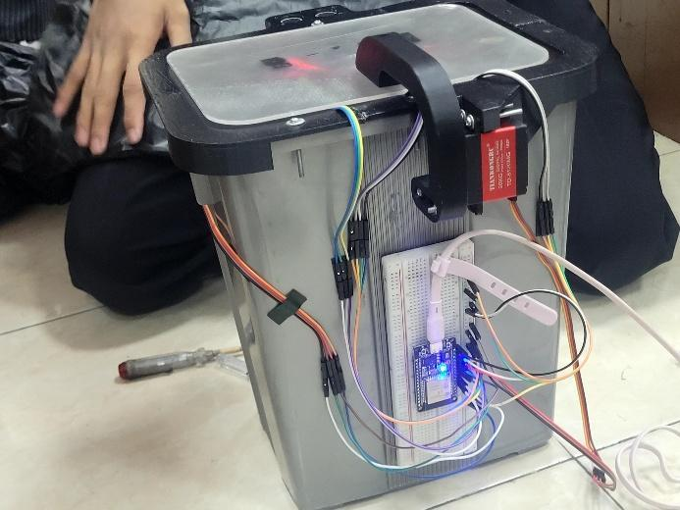
Note. From “Design of IoT-based smart trash bin monitoring using ESP32 and Firebase,” by A. Maulida, C. S. Fayzalmi, F. A. C. Anaam, D. Ardiansyah, M. A. Gunawan, and N. Ridwan, 2025, Jurnal Komputer, Teknologi Informasi dan Sistem Informasi (JUKTISI), 4(2), 420–428. CC BY 4.0.

The SmartTrashBin in Figure 30 was created by Maulida et al. (2025) from Politeknik Negeri Semarang. The hand detection & fill level is read using HC-SR04, while MQ-2 is used to detect the odour and the load cell (HX711) detects the weight that is then fed to ESP32, which controls the opening of the lid using a servo (SG90). Data is stored in Firebase Realtime Database and sent to an Android application that includes notifications.
They claim a level accuracy of approximately 95%, a weight accuracy of approximately 93% (+/- 320g on 20kg), 92% of cases of spoiled food identified and 98% of notification reliability and a System Usability Scale score of 86 from 15 sanitation officers. The numbers require carefulness as the paper mentions both of Android Studio and Flutter and also provides two notification thresholds. The closest of the studies to Smart-Bin is the following: ESP32, ultrasonic sensor, load cell, servo lid, firebase and an android app. No tamper detection, collection priority or web dashboard/roles.
Real-Time Sensing and Methane Mapping (Mehta et al., 2025)
Figure 31
Data Flow of the Garbage Monitoring System
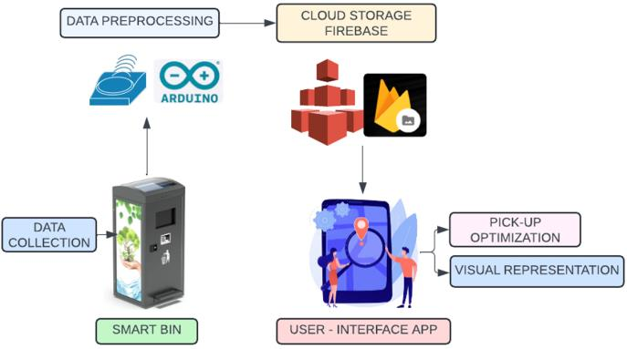
Note. From “Smart bins, smarter cities: IoT-driven waste collection with real-time sensing and methane mapping,” by H. Mehta, V. Deriya, D. Sankhe, P. Kanani, G. Pandya, and V. Shelke, 2025, Mathematical Modelling of Engineering Problems, 12(6), 2110–2122. CC BY 4.0.

Mehta et al. (2025) show the data flow of their system in Figure 31. Each bin has the ESP8266 equipped with an ultrasonic fill sensor, MQ4, MQ136 and MQ137 gas sensors, GPS and uploads data to Firebase every 10s. A React Native application displays a bin map, a methane and odor heatmap and truck routes that are ranked based on a priority score derived from fill and gas.
Gas sensors accuracy was 96% - 98% with reference. There are a number of trucks that are different – field samples of 28 bins in Malad v. 100 bins in the results (which use synthetic data), and some tables in the paper clash. The study is like Smart-Bin, which is based on Firebase, a mobile application and implements role-based views and priority-driven collection. No weight sensing and no tilt sensors and no display on the bin.
ESP32 Smart Dustbin With Weight and Level Monitoring (Yogesh et al., 2025)
Yogesh et al. (2025) created an ESP32 dustbin that includes an HX711 load cell and an ultrasonic sensor, which is called “Eco Bin”. Weights and fill percentage are sent to Firebase Realtime Database and a phone app, designed with MIT App Inventor, for full-bin alerts, and a 16×2 I2C LCD displays the alerts on the bin. However, since the paper doesn't report any actual results, it is here as a hardware precedent, not as a performance metric.
It's almost the same as in Smart-Bin, which is ESP32, load cell, ultrasonic sensor, Firebase, Android app and local display. Smart-Bin brings in air quality, tamper detection, a priority list and a web dashboard.
RFID Access Control and Blynk Integration (Karthi et al., 2025)
Karthi et al. (2025) developed ESP32 dustbin with servo lid which will open only for the authorized RFID user. A fill level sensor (ultrasonic sensor), a metal detector, and an air-quality sensor (MQ135) are used to perform measurement checks, with the data sent to the Blynk platform. Abstractly, the authors state 95% fill level accuracy, 92% RFID authentication reliability, 40% less manual work and 35% more efficient collection.
It is the only one study, which can open the bin, that is found. On the collecting side, however, Smart-Bin provides control via a PIN collect mode and remote lock, plus weight, tamper detection and a priority list. The web dashboard is not available for this study.

C. Collection Routes and Priority
Smart-Bin Collection as a Travelling Salesman Problem (Alnuaimi et al., 2024)
The paper by Alnuaimi et al. (2024) from University of Sharjah, UAE, considers the problem of municipal waste collection as a travelling salesman problem (TSP). The fill level of the bins is reported and the route is planned using the Nearest Neighbor heuristic within an AnyLogic simulation. The abstract claims that there are savings in travel distance and carbon emissions when compared to traditional static routes, but it does not provide figures and there is no description of hardware. The work is not a field deployment, but rather a simulation.
The results of this study is where the Smart-Bin ends. It is a list of bins sorted by fill and sorted by time to fill; and a planner such as this one might use that list as input.
Waste Management Optimization Through IoT and Analytics (Kuzhin et al., 2024)
According to Kuzhin et al. (2024), a case study of IoT sensor real-time data and analytics for route optimization has resulted in a 20% reduction in overfilled bins, a 15% reduction in collection frequency, a 25% reduction in the distance traveled, a 10% reduction in fuel consumption, and a 15% increase in recyclables collected. The abstract does not identify a location, sample size, hardware, time frame, and fails to specify whether the values are from a field experiment; the evidence is weak.
The study shows the size of the gain that people expect from collecting by priority. It gives no design that Smart-Bin could borrow.
Route Optimization With GPS and RFID Bin Locations (Banciu et al., 2025)
Banciu et al. (2025), from Lucian Blaga University of Sibiu, collect bin locations with GPS and RFID, build distance matrices and compare the Nearest Neighbor heuristic, Google OR-Tools and a genetic algorithm on three real routes with 735 locations. The genetic algorithm did best, with up to 52% shorter travel distance and more than 14kg less CO₂. RFID here only records the location of a bin when it is emptied, and the study senses no fill level.
It sits entirely on the routing side. Smart-Bin supplies the part that this study takes for granted, which is knowing which bins are worth a visit now.
IoT E-Tracking System for Waste Management (Gupta et al., 2025)
Gupta et al. (2025) propose an IoT system in which bins carry an ultrasonic fill sensor, a microcontroller (Arduino-based, going by the figure captions) and a Wi-Fi module that sends data to an unnamed cloud platform for on-demand routes. They say that in a 30 day trial with 50 bins they achieved 58.9% less distance, 59.2% less fuel, 95% less overflows and 99.8% uptime..
These are some of the highest figures in the entire review, and no pilot dates are mentioned, and no method of routing nor protocol for accuracy tests, so as a result this is what the authors report, but not an independent result. Only level sensing. Smart-Bin builds upon the same level reading with weight, air, tilt and user interface.
Ant Colony Route Optimization With Machine Learning (Kumar et al., 2025)
In Kumar et al. (2025), a system is designed where ultrasonic sensors are mounted on ESP32 boards to send fill level data to a central database. On one hand, Ant Colony Optimization is used to plan routes from the depot to the depot, only stopping at the bins that are filled; on the other hand, machine learning is used to forecast waste from past data; and the collection teams are provided with a Folium map as an interface. The abstract does not provide any actual figures, so there is no actual saving in fuel or cost that can be quoted from the abstract.
Smart-Bin also has the ESP32, the ultrasonic fill sensing and the concept of only going to bins that need it. It sets that priority from the fill and the time to full and not from a learned model. Weight, air quality and tamper detection and phone app not included in this study.
TrashTrack Collection Ranking (Sadikin et al., 2025)
Telkom University (Bandung) Researcher, Sadikin et al., (2025) developed an Android application using Kotlin and Jetpack Compose called TrashTrack. ESP32 bins are equipped with ultrasonic, infrared and GPS sensors and upload the collected data to a Firebase database; a modified constraint-based greedy algorithm is used to rank the collection based on the distance of the bin, vehicle capacity and fill level. The results of the usability test with 69 respondents showed that 92.37% were effective, 92.29% were useful and 89.92% were satisfied.
Smart-Bin is powered by the same ESP32, Firebase and a kotlin android app. It ranks by fill and time to full (no dist or vehicle capacity – it doesn't plan roads). Weight, Air Quality, Tamper Detection and Display on bin are not included in this study.
D. Sorting and System Design
Camera-Based Fill Level Detection (Enache et al., 2024)
Figure 32
Power Chain of the ESP32-CAM Node
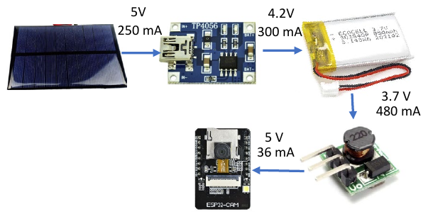
Note. From “Intelligent trash level detection for sustainable urban waste management,” by B.-A. Enache, C.-K. Banica, and A. G. Bogdan, 2024, The Scientific Bulletin of Electrical Engineering Faculty, 24(1), 56–59. CC BY-NC-ND 4.0.

Enache et al. (2024), from the University Politehnica of Bucharest, estimate the fill level from photographs. Figure 32 shows the power chain of one node. A 5V solar cell feeds a TP4056 charger, which charges a 3.7V LiPo battery of 850mAh, and a step-up converter brings the voltage back to 5V for the ESP32-CAM. The battery was sized for 24 hours of operation. The fill ratio is estimated by a Python script with OpenCV and an SQL database, each node takes one image per hour and sends it over an ESP-MESH network to a server.
On five test bins the relative error of the estimated fill ratio ran from 11.43% to 30.00%, and the authors name the angle of the camera, the light, the kind of waste and the placement of the bag as causes. The figure matters to Smart-Bin because it shows what a stand-alone node needs between the source and the board: a charger, a battery and a converter. Smart-Bin builds the same chain with its battery shields and 18650 cells. It is not camera based, it is based on distance and weight and this study has no weight, air quality, tamper detection, or phone app.
AI-Based Waste Segregation With Monitoring (Muthukumar et al., 2024)
At M. Kumarasamy College of Engineering in Karur, Muthukumar et al. (2024) developed a bin fitted with a camera that can identify plastic, glass, metal and paper using AI and place them in separate compartments. A mobile application displays the level of fill, plus the temperature and humidity levels, and notifies cleaning personnel and allows for one team to use the application to claim each task. The number of images used is about 1500 images per class and the paper reports 71.8% training accuracy and 92.3% test accuracy, but does not explain the difference between these. The microcontroller and the cloud service are not named.
Segregation is outside the scope of Smart-Bin. The claim-a-task feature of the app echoes the collector role in Smart-Bin, and the study has no weight, air quality, tamper detection or collection priority.
Smart Trash Bins With IoT and AI (González et al., 2024)
González et al. (2024) constructed a bin made of ESP32 and ESP32-CAM. This includes ultrasonic sensors that measure fill level, an AI that detects waste from images from the camera, and potentiometers that replace the weight sensor. Events are captured by readings, which are transmitted over Wi-Fi to a central server and displayed on Oracle APEX dashboards; and an MIT App Inventor app is used to manually record the status. The abstract does not contain any accuracy figures.
The weight is simulated and the study indicates a dashboard design without any actual weighing. Smart-Bin offers a real load cell, and always offers a simulation as an option for testing, all set from the interface. This study has no air quality sensing, tamper detection or priority list.
Smart Waste Classification With IoT and Deep Learning (Alourani et al., 2025)
Alourani et al. (2025) propose iSSWMs, a framework that joins an IoT smart bin to a deep-learning classifier. The bin has an ultrasonic level sensor on an Arduino Nano and an ESP8266 that sends its status to Firebase, and an Android app alerts the collectors at a threshold. A VGG-19 classifier sorts plastic, glass and metal and reached 99.7% accuracy on about 1,530 TrashNet images over 100 epochs. That figure is training accuracy, and the authors report no field test.
Smart-Bin shares the ultrasonic level, Firebase and an Android app with alerts for collectors. Image classification is outside its scope, and this study has no weight, air quality, tamper detection or priority list.
ESP32 Smart Bin That Separates Dry and Wet Waste (Gajula et al., 2025)
Gajula et al. (2025) developed an ESP32 dust bin which detects the wetness of the waste deposited and separates dry and wet waste with the help of SG90 servo and MG90 servo. The HC-SR04 ultrasonic sensor and the moisture sensor provide information to the Arduino IoT Cloud that triggers the separation mechanism. Abstract does not provide any numbers that were measured.
It's not about monitoring the bin, it's about sorting, and shares only the ESP32, a servo and the cloud link with Smart-Bin. No weight measurement, tamper detection or phone application.
FreeRTOS-Based Smart Waste Management (Aasish et al., 2025)
Aasish et. al (2025) presents a system on a dual core ESP32 based on FreeRTOS. It has an ultrasonic sensor to track the level of the bin, as well as a DHT11/DHT22 to measure temperature and humidity, it has an optional LCD or OLED display and can upload to a cloud server via Wi-Fi for alerts and dashboards and dynamic collection scheduling using RFID modules to identify each bin. The basic concept is to separate the sensor acquisition and actuation tasks, from the cloud communication tasks, so that a slow upload does not block a reading. No actual results are stated and the RFID is not used for access control, it is merely used to identify bins.
The task split is a design to consider for the Smart-Bin firmware, as it is also based on the ESP32 family. The study has no weight sensing, tamper detection or phone app.

Commercial Systems
Commercial systems are available. Bigbelly's CLEAN software provides the data from the bins on a console and uploads it to a collector app (Bigbelly, n.d.). According to its website, Ecube Labs offers ultrasonic fill sensors and a cloud platform that provides fire event notification and route optimization, and claims to predict bin status up to 24 hours in advance (Ecube Labs, n.d.). Sensoneo's platform displays a map of each bin's fill and predicted full time, and plans routes from them (Sensoneo, n.d.), Nordsense's driver app with dynamic routing (Nordsense, n.d.), and Evreka's sensor enhances temperature and motion to flag fires (Evreka, 2020). Compology monitors containers with cameras (Compology, n.d.), and Bin-e is a segregating bin with a touch-free lid (Greenwalt, 2020). In the Philippines, students of the University of the Cordilleras built the Baraki bins for the DOST-TAPI Regional Invention Contest, which open automatically and report to an information center (Asido, 2024). Table 3 summarizes what the vendor pages state.
Table 3
Commercial and Student Systems as Described by Their Own Pages
System | Sensing described | Who sees the data | Collection priority or route
Bigbelly | Fill level, collection events and GPS; sensor type not named | Management console and collector app | Not stated
Ecube Labs | Ultrasonic fill level, battery level and fire events | Cloud dashboard | Route optimization; predicts status up to 24h ahead
Sensoneo | Ultrasonic or radar fill level | Dashboard with a map and predicted full time | Semi-automated route planning
Nordsense | Page covers routing, not sensors | Driver app | Dynamic routing
Evreka | Ultrasonic fill level, temperature, motion and location | Web platform with SMS and email alarms | Route optimization
Compology | Camera: fullness, location and motion | Web dashboard | Not described
Bin-e | Fill level, motion for the flap and waste type | Mobile app | Not covered
Baraki | Automatic sensors; types not stated | Information center | Not stated
Note. Sources: Bigbelly (n.d.), Ecube Labs (n.d.), Sensoneo (n.d.), Nordsense (n.d.), Evreka (2020), Compology (n.d.), Greenwalt (2020) and Asido (2024).
All of them sell via quotation: none of these pages mentions weight, gas or tilt sensing, or a price. That doesn't mean that the products don't have these characteristics, just that vendor pages are concise and designed to sell. What it shows is that a small system with those features at about ₱4,900 for two bins (Appendix B) occupies a different place from these services. Smart-Bin does not compete with them on scale, and it cannot, but it can show what a bin that senses more costs to build.

Technical Merit
Seven design choices in Smart-Bin decide how much its readings can be trusted. Table 4 gives the reason for each. Each one is also a place where a measured result could differ from the real condition of the bin, which is what the tests of the project will have to check.
Table 4
Technical Basis of the Main Design Choices
Design choice | What Smart-Bin does | Why it is sound
BME680 for the air check | One I2C chip gives temperature, humidity, pressure and a gas resistance reading, from which the firmware estimates an air-quality index. | In Table 2, the studies that sense gas use MQ-series modules, which only provide a reading for the gas. Bosch Sensortec (n.d.) states that the BME680 uses 0.09 to 12mA during its different modes. The index is an estimate and needs about 5 minutes to settle.
Median distance reading is calculated from five distance readings. | The firmware makes five measurements using the HC-SR04 and uses the middle measurement. | When the echo bounces off an edge or soft material, a single reading from the ultrasonic can be spiked. One or two of such readings will be ignored without delaying the update, this is the median.
Two-point calibration | The full distance (5cm by default) and empty distance (30cm by default) are defined from the interface and the fill percentage is the distance between them. | The two setpoints are the same as in Keller et al., 2024. Other heights of bins do not require new firmware.
Weight as a second check | The HX711 and a 5kg load cell weigh the contents next to the fill percentage. | Level and weight are also combined in Saad et al. (2023) and Maulida et al. (2025). A loose pile in a bin is light but a full bin is heavy.
Tilt with a countdown | If the tilt is over 30° a countdown of 10s begins. When the bin is steady again the alarm will clear, or if not, the alarm will latch and need to be reset by an operator. | Countdown will not allow for a bump or moving bin to cause a false alarm and an overturned bin or carried away bin will still sound.
Local and cloud together | The bin responds on its local WiFi within ~1s, and to Firebase and ThingSpeak. | Fast control and calibration with local path, history, remote commands and alerts when phone is away with cloud path. The data is uploaded every 30s, which is half the frequency ThingSpeak can accommodate on its free plan of 1 write every 15s
Calibration and simulation from the interface | Distances, limits can be changed, without re-flashing, any sensor can be set to a test value. | None of the 30 studies describes this. It lets a test be repeated at a chosen reading and keeps demonstrations safe.
Note. Defaults are those set in the firmware and can be changed in the settings.

SWOT Analysis
The strengths, weaknesses, opportunities and threats of Smart-Bin are presented in Figure 33. The strengths and weaknesses are related to the construct itself, while the opportunities and threats are related to the literature mentioned above and to the situation in the Philippines. The count of studies that sense tilt or offer role-based views comes from this review. RA 9003 puts segregation and collection at the barangay level and leaves the collection of non-recyclable and special waste to the municipality or city (Ecological Solid Waste Management Act of 2000, 2001), and the World Bank (2022) puts the share of Metro Manila waste that is collected at about 60%.
Figure 33
SWOT Analysis of Smart-Bin
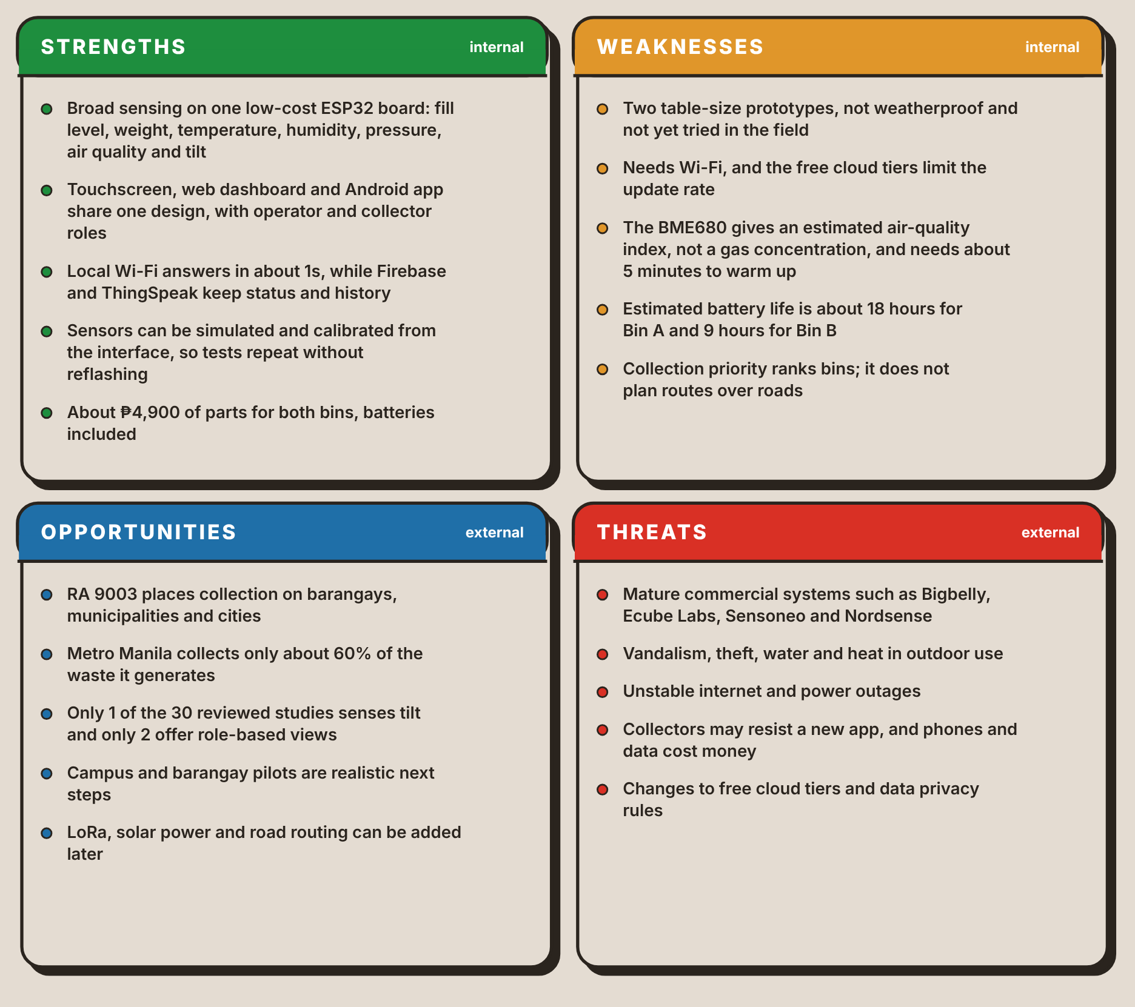
The weaknesses set the limits of what the tests of this project can claim. The tests demonstrate that it works on a bench, but not that the prototype can last on the street for 18 hours in Bin A and 9 hours in Bin B and that it is a table-size prototype that has never been outside. The opportunities are on the other side, the weaknesses: pilots on campus or in a barangay hall, LoRa for where there is no Wi-Fi, solar power and road routing.

Synthesis of the Review
The patents, studies and products reviewed above converge on four points. First, the problem is a documented one. The Ecological Solid Waste Management Act of 2000 (2001) leaves the collection of non-recyclable and special waste to the municipality or city, and the World Bank (2022) puts the share of Metro Manila waste that is collected at about 60%. A bin that overflows between collections is therefore an expected condition of the system that these sources set out to monitor.
Second, sensing the fill level is a solved problem. It is measured by 27 of 30 studies, often using an HC-SR04: Patents have done it with hydraulic pressure (Neumann & Allison, 1991), capacitive plates (Di Giugno et al., 2016), an infrared beam (Devitt & Walsh, 2021) and an ultrasonic sensor (Kekalainen & Engstrom, 2018) and a laser (Keller et al., 2024). The commercial services in Table 3 sell the same measurement with a cloud console on top.
Third, the other sensors exist, but they are added one or two at a time. Saad et al. (2023) and Maulida et al. (2025) add weight, Mehta et al. (2025) add gas, Alnanih et al. (2025) add a flame sensor and Azmi et al. (2024) add temperature and humidity. There is only one reference by Mehta and Rathour (2024) who mention a tilt sensor but do not mention any alarm. In the patents, Mullaney (2016) weights contents, Kurani (2023) mentions around a dozen sensors, but one is based on litter and pathogens, not the user of the bin.
Fourthly, the work is directed more into the route than into the bin. Twelve of the 30 remaining studies report on routes or priority of collection, and have the biggest improvements: up to 52% shorter distance in Banciu et al. (2025) and 58.9% in a pilot of Gupta et al. (2025) with no date or method provided. The bins in these studies stay simple, ten studies have a phone app, two give different users different views, and none of them describes calibration or simulation from the interface of the bin.
None of the sources brings these pieces together in one bin. The studies that weigh the waste have no tilt alarm, the one that lists a tilt sensor describes no alarm, the ones with phone apps and roles have no weight, and the route studies take the readings of the bin for granted. Table 5 sets the four closest patents against Smart-Bin, feature by feature, and Figure 34 counts the features found in the studies. None of the twenty patents, as far as their text was read, combines a latched tamper alarm, a PIN collect mode on a touchscreen, a remote lock and sensor simulation and calibration from the interface with fill, weight and air sensing in one bin. A search of this size cannot prove that no such patent exists, so this is a statement about what was found and not about what exists.

Table 5
The Four Closest Patents Compared With Smart-Bin
Feature | Shahabdeen  (2016) | Yan and Chen  (2021) | Kurani  (2023) | Sait et al.  (2025) | Smart-Bin
Fill level | Yes (range finder) | Yes (infrared height) | Yes | Yes | Yes
Weight | Yes (or fill level) | Yes | Yes | Not found | Yes
Gas or odor | Yes | Yes | Yes | Yes (methane) | Yes
Temperature and humidity | Not found | Not found | Yes | Yes | Yes
Tilt or tamper alarm | Not found | Not found | Accelerometer listed | Not found | Yes
Motorized lid | Not found | Not found | Not found | Not found | Yes
Remote lock or PIN collect | Not found | Not found | Not found | Not found | Yes
On-bin display | Not found | Not found | Not found | Not found | Yes
Phone alert | Not found | Not found | Yes | Not found | Yes
Priority or route | Not found | Yes (truck route) | Yes (route) | Yes (route) | Yes (priority)
Note. Counts are derived from the hardware and the function described in each study (Table 2).
Figure 34
Features Found in the 30 Related Studies
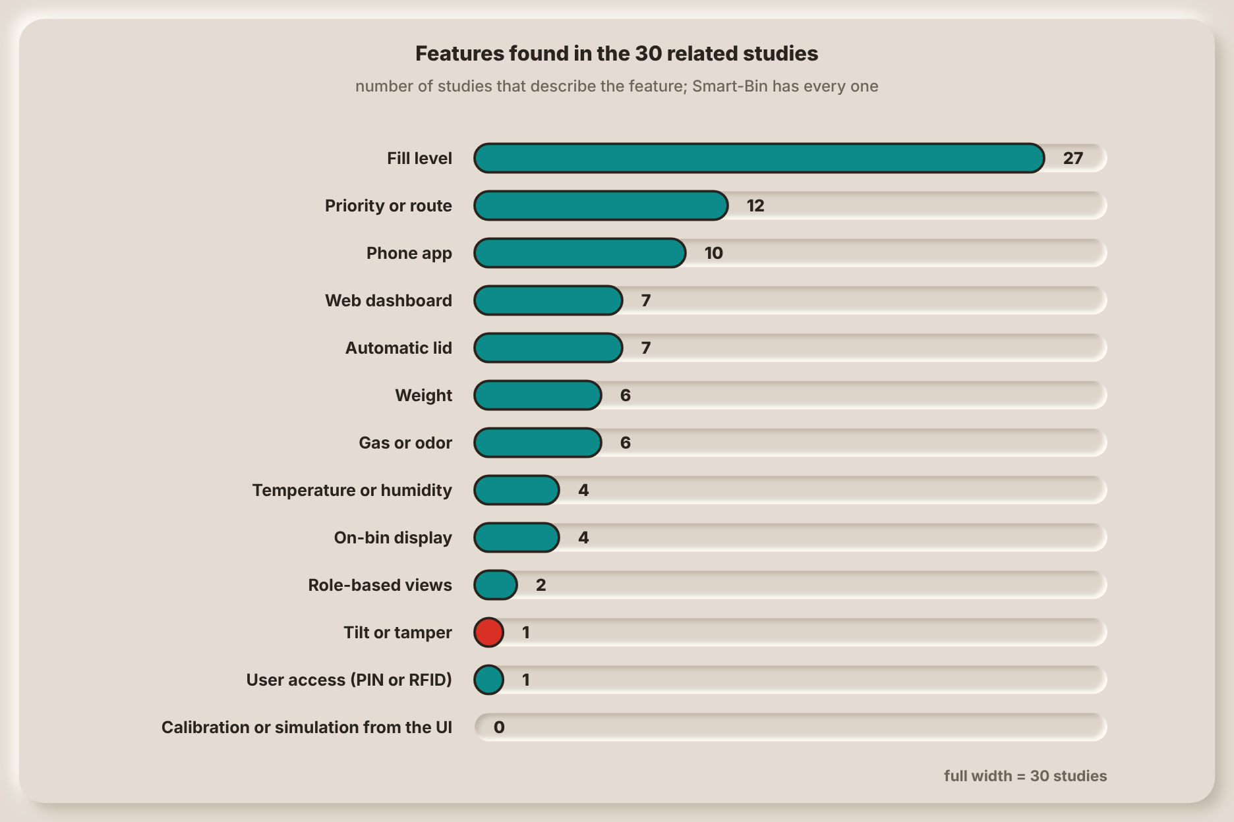
Note. Counts come from the hardware and function each study describes (Table 2).

Research Gap
There are 30 studies; 27 sense fill level. None has all of weight, gas, temperature, humidity and tilt in one bin; 6 add weight, 6 add gas, 4 sense temperature/humidity and 1 senses tilt. Two studies are providing role-oriented perspectives, one of which is using an RFID-based access control mechanism. None indicates simulation / calibration from the interface. The bin indicates its fill level, and the focus is on routes and fleet software in the patents and commercial systems. None of the four most closely related patents have all ten of the features listed in Table 5.
So, it's not a sensor, it's a gap. These factors: fill, weight, air and tilt sensing, alerts to the operator, collector and person at the bin, collection priority from the fill and time to fill, interfaces to allow bin calibration and testing without need to re-flash, are all combined in one single low-cost bin. The gap by capability and the specific objective in Section 1.4 which addresses it is provided in Table 6.
Table 6
The Research Gap by Capability
Capability | Related studies | Patents and products | Smart-Bin | Objective
Sensing breadth on one board | 27 fill, 6 weight, 6 gas, 4 temperature or humidity, 1 tilt; none has all | Kurani (2023) lists about a dozen sensors; the others are narrower | Fill, weight, temperature, humidity, pressure, air quality and tilt on one ESP32 | SO1
Tamper detection | One study lists a tilt sensor | No latched tamper alarm found in the four closest patents | Tilt beyond 30° starts a 10s countdown, then a latched siren until RESET TAMPER | SO1
Alerts to each kind of user | 10 studies have a phone app and 7 a web dashboard | Phone alerts in Kurani (2023) | Buzzer, LED and touchscreen on the bin, web dashboard, Android app and push alerts | SO2
Roles and access | 2 studies have role-based views; 1 uses RFID | None found | Operator and collector views, remote lock, PIN collect mode | SO2, SO3
Collection priority | 12 studies are about routes or priority, mostly with GPS and algorithms | Route planning in the closest patents | Fullest first, with a time to full from the recent fill rate; no road routing | SO3
Testing and demonstration | No study describes simulation or calibration from the interface | None found | Per-sensor simulation and calibration from the dashboard and app | SO3

1.4 Objectives

General Objective
To design and develop Smart-Bin, an IoT based Waste Bin Monitoring System which will monitor the fill level, weight and air quality of the waste bin, detect tampering and give real time monitoring and alerts to the concerned entities via Web Based Dashboard, Android App and On-Bin Touchscreen.

Specific Objectives
- Sensor Monitoring and Detection
To develop 2 Smart-Bin units, which include sensors to measure fill level, weight, temperature, humidity and air quality, as well as to detect bin tilting and tampering and open the lid automatically when hand movement is detected.
- Real-Time Monitoring and Alerts
To develop a web dashboard and an Android application to display real-time data from the sensors, bin status, retrieve data from Thingspeak/Firebase and notify the operators and collectors when the bin is full, poor air quality, high temperature, tampered sensor reading and when the bin is not online.
- Bin Control and Collection Prioritization
To implement Collection Prioritization, based on bin fullness and estimated time to fullness, remote bin locking and unlocking, on-bin collection functions (via PIN), sensor simulation and system interface sensor calibration. This will lead to the prioritization of collections and will also help with efficient collection routes and fuel gas efficiency.

1.5 Conceptual Framework
The framework of Smart-Bin is shown in two parts. The first one which is below describes the process of a reading going from the sensor to the person who is going to respond to it and it is known as the Input-Process-Output (IPO) model. The second, under IoT Level, shows how the parts are deployed and connected. Both refer to the same system and both result in the three specific objectives listed in Section 1.4 above.

Input-Process-Output Model
Figure 35
Input-Process-Output Model of Smart-Bin
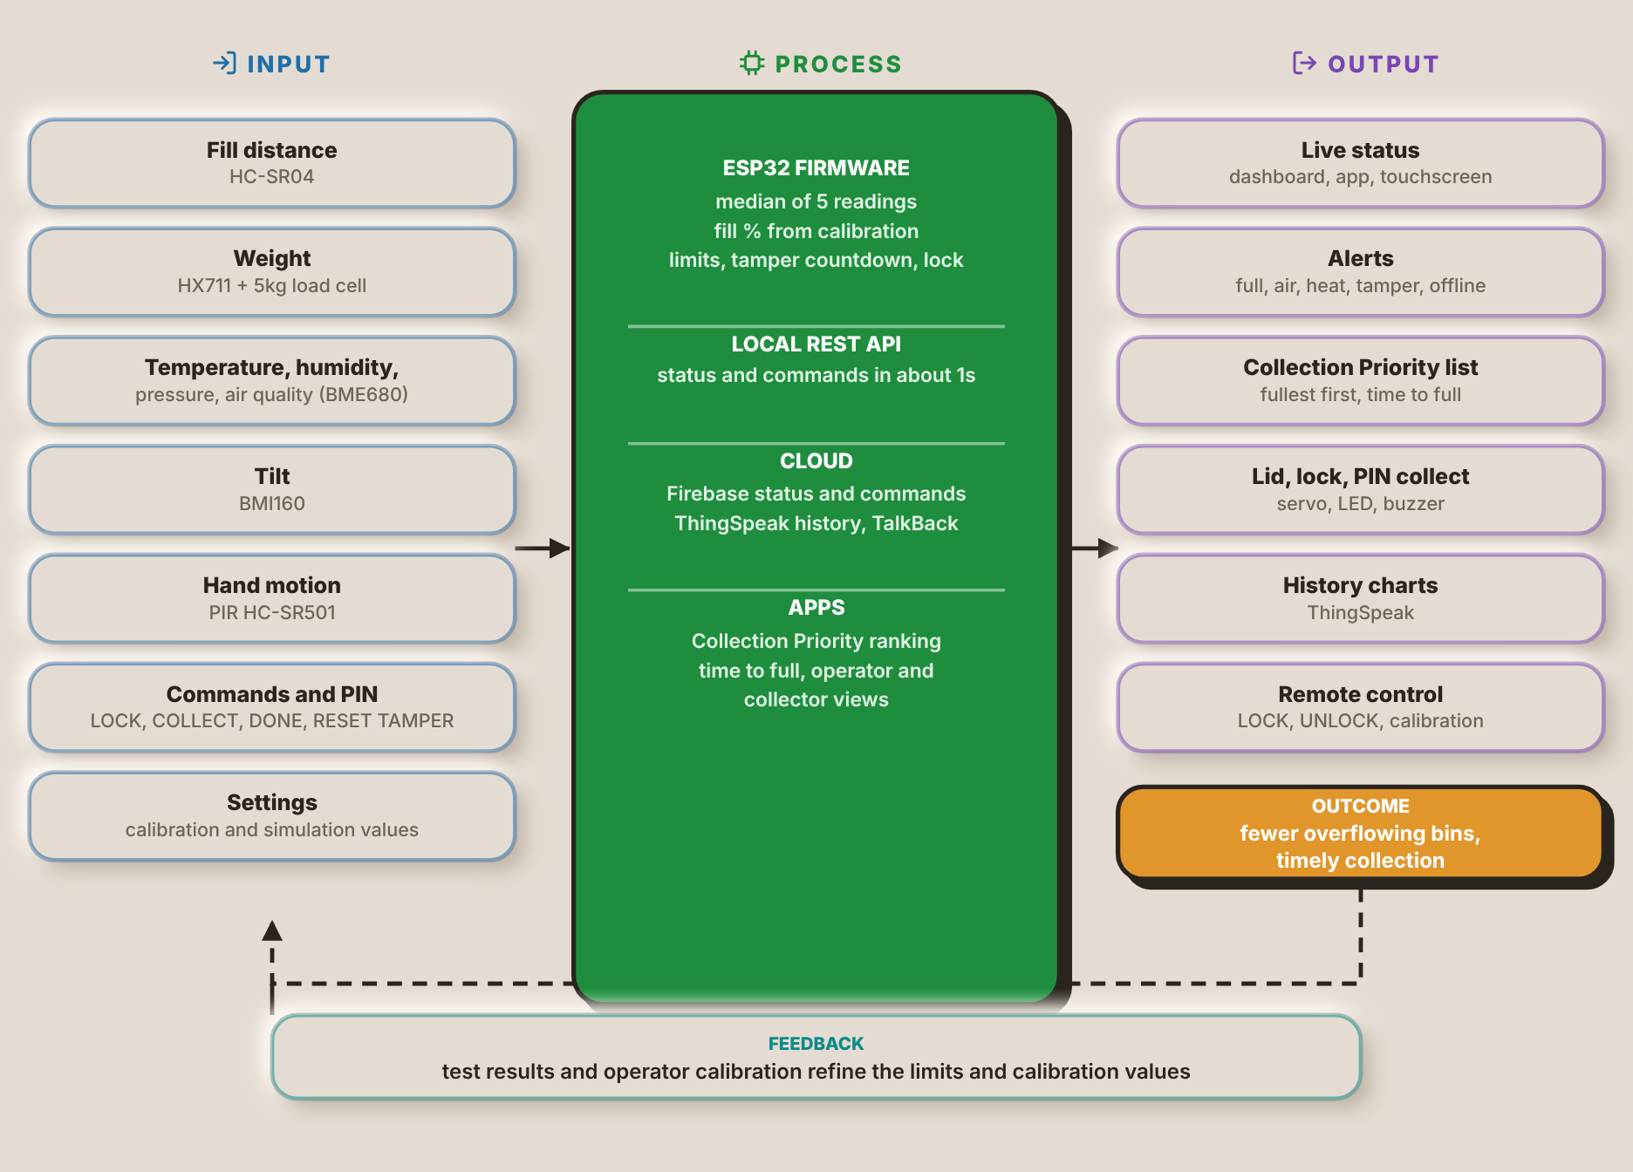
The input column has seven items. The distance to the trash is measured by the HC-SR04 sensor, the weight is measured by the HX711 sensor (which includes a 5kg load cell), the BME680 sensor provides temperature, humidity, pressure and an estimate of the air quality, the BMI160 sensor gives the tilt, and the PIR sensor detects a hand. The final two inputs are from the people: commands input on the touchscreen, in the dashboard or in the app, and the settings, which contain the calibration and simulation values. All of these inputs are related to Specific Objective 1, and commands and settings are related to Specific Objective 3.
The process column is how the ESP32 firmware and the cloud use them. The firmware takes the median of five readings, converts the distance to a fill percentage from the calibration limits, compares the readings with their thresholds, runs the tamper countdown and applies the lock. Local REST API provides response in ~1s and status is stored in Firebase while the commands are stored in thing speak where the history is stored. The apps rank the bins by fullness, by time until they are full and give the operator or collector views. Specific Objectives 2 and 3 are addressed in this column.
Live status on the touch screen, the dashboard and the app, alerts for a full bin, bad air, heat, tamper, or bin being offline, Collection Priority list, live status for the lid, lock, and PIN collect on the bin, history charts, and remote control, are all things people see and do, which is the output column. The result is reduced overfilling bins and timely collection, which is the problem stated in Section 1.1. Feedback closes the loop; the results of the test and the operator's calibration will improve the limits and calibration values used by the firmware next.

IoT Level
Figure 36
System Architecture of Smart-Bin
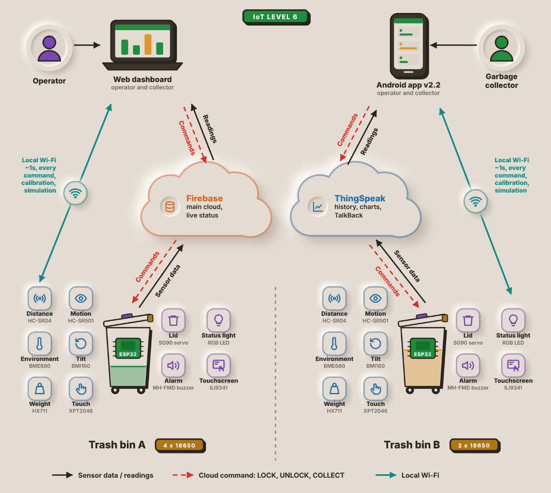
The connections between the parts of Smart-Bin are shown in Figure 36. The readings are sent from the cloud to the two apps at the top: the web dashboard (primarily for the operator) and the Android app (primarily for the garbage collector). Both apps can also reach a bin directly over the local Wi-Fi in about 1s for any command, calibration, or simulation.
There are two end nodes at the bottom: Trash bin A and Trash bin B. All are equipped with the same ESP32 and six input sensors (HC-SR04, PIR sensor, BME680, BMI160, load cell, touch panel) and four output actuators (servo, RGB LED, buzzer, TFT). Bin A is powered by 4x 18650 cells, Bin B by 2x.
Each bin sends its sensor data up to two cloud services and receives the LOCK, UNLOCK and COLLECT commands from them. Firebase is the primary cloud and stores the live status, ThingSpeak stores the history and charts and relays commands via TalkBack.
Smart-Bin fits IoT Level 6 of the deployment templates in Bahga and Madisetti (2014). A Level 6 system has several independent end nodes that sense or actuate and send their data to the cloud, where it is stored and shown by a cloud-based application. An analytics component works on that data and keeps its results in the cloud as well, and a centralized controller knows the status of every end node and sends control commands back to them. Trash bin A and Trash bin B are the end nodes in Figure 36. Both have their own ESP32, they read their own sensors and update their own status to Firebase and ThingSpeak, they don't depend on each other and there is no gateway between them and the cloud.
Cloud side is Firebase for live status, and ThingSpeak for stored history. ThingSpeak keeps the readings of every bin and plots and analyses them over time, and the apps use the same data to rank the bins by fill level and estimated time to fill in the Collection Priority list. The web dashboard and the Android app take the role of the centralized controller. They show the state of both bins side by side and send LOCK, UNLOCK and COLLECT back through the cloud, and calibration and simulation commands go to a bin directly over the local Wi-Fi.

1.6 Target Beneficiaries
- Waste Collectors and Utility Staff
Smart-Bin will assist waste collectors and utility workers by notifying them which bins are fullest and need to be emptied first. It could also prevent visits to bins that are not full and offer PIN access to the bin during collection.
- Facility Managers and Operators
The web dashboard can be used by facility managers or barangay hall, school, office or mall operators to monitor the status of the bins, make assessment of the data and set thresholds for the sensors, apart from the messages they receive on overflowing bins, poor air quality, high temperature, and even possible tampering.
- Barangay and Local Government Unit (LGU) Sanitation Offices
The sanitation offices of barangays and LGUs can utilize Smart-Bin's data readings to aid in garbage collection scheduling and management. The percentage of fullness and time to be full will help them optimize their collection routes and minimize the amount of fuel they need to use by making fewer unnecessary collections.
- Filipino Citizens
How about if the environment is cleaner, trash bins are not overflowed and there is increased awareness about waste among Filipino citizens who are residents, employees or students of schools, offices or other places? The hands-free lid would also improve the disposal of waste; making it easier and sanitary.

II. PROTOTYPE DESIGN AND DEVELOPMENT

2.1 Prototype Design
[Describe and show the physical design of the Smart-Bin prototype here.]

2.2 Block Diagram
The block diagram of one Smart-Bin unit and the network around it is shown in Figure 37. It has two separate ESP32 microcontrollers, one in each of the two bins, both bins reporting to the same cloud services and user apps.
Figure 37
Block Diagram of the Smart-Bin System
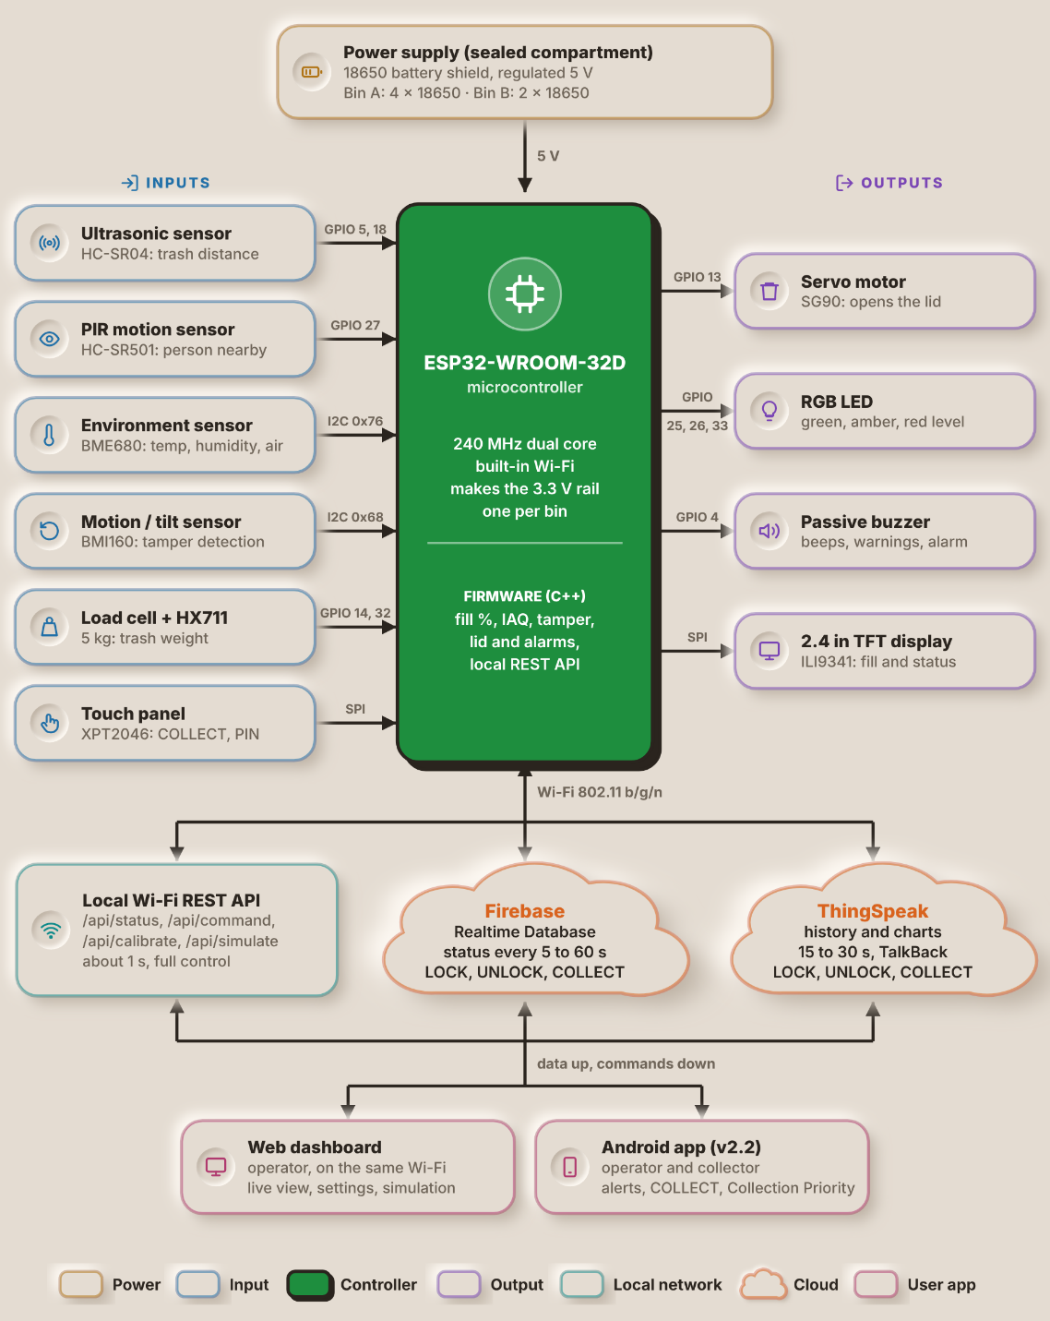
The power supply is located in the top portion of the diagram, consisting of an 18650-battery shield in a closed compartment providing the circuit a regulated 5V. Bin A is powered by 4x 18650 cells and Bin B by 2x. The 5V is fed to the ESP32-WROOM-32D which supplies the 3.3V needed by the sensors, display and buzzer; the servo, HC-SR04 and PIR sensor operate directly from the 5V. ESP32 is a 240MHz dual-core Wi-Fi enabled micro-controller. It has firmware written in C++ and uses that to determine the fill percentage, indoor air quality (IAQ) estimate and tamper state, as well as controlling the lid and alarms and providing a local REST API.
The inputs are on the left. The HC-SR04 Ultrasonic sensor on GPIO 5 and 18 can be used to detect the distance between the lid and the garbage bin, and output the fill level information, the HC-SR501 PIR sensor on GPIO 27 can be used to sense whether a person approaches the garbage bin. Two sensors, BME680 (address 0x76) for temperature, humidity and air quality and BMI160 (address 0x68) for motion and tilt for tamper detection share this I2C bus. Using a 5kg load cell, it is connected to GPIO 14 and 32 via an amplifier module named HX711 to measure the weight of the trash. On the SPI, the touch panel XPT2046 accepts the COLLECT and PIN inputs.
The outputs are to the right. The lid is opened and closed by the SG90 servo on GPIO 13 (PWM). The fill level is indicated by an RGB LED (GPIO 25, 26 and 33) in green, amber or red. Beeps, warnings and the tamper siren come from a passive buzzer on GPIO 4. The fill level and the bin status are displayed on the 2.4 in. ILI9341 TFT display (also SPI).
Three paths of data exit the bin via Wi-Fi (802.11 b/g/n) as shown in the bottom half of the image. The local REST API (/api/status, /api/command, /api/calibrate and /api/simulate) responds in ~1s and provides full control of the bin. The status is sent to the Firebase Realtime Database every 5 to 60s and to ThingSpeak every 15 to 30s, as well as the LOCK, UNLOCK and COLLECT commands (the latter via ThingSpeak's TalkBack feature). Data goes up and commands come down to two user apps. The web dashboard runs in a browser on the same Wi-Fi and gives the operator a live view, settings and simulation, while the Android app gives operators and collectors alerts, the COLLECT command and the Collection Priority list.

2.3 System Flowchart
Figure 38
System Flowchart of the Smart-Bin
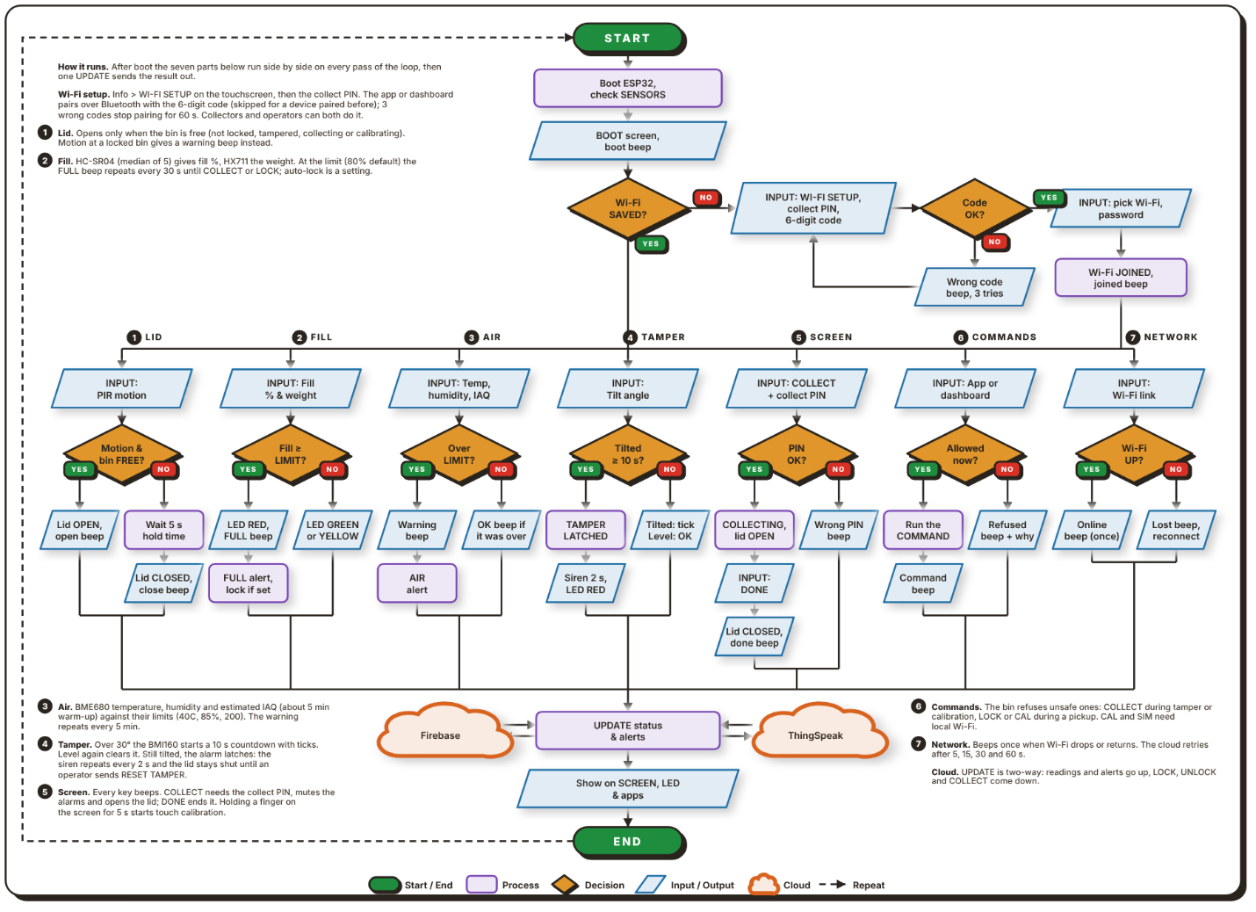
Note. Figure 38 shows the main program loop that runs on each bin. After start-up, seven parts run side by side on every pass of the loop, and their results meet at one update step.
Upon powering on the bin, the ESP32 starts, checks its sensors and loads its saved settings, with a boot screen and a beep. It then examines if a Wi-Fi network is saved. If not, the user opens WI-FI SETUP on the touchscreen and enters the collect PIN, and the app or dashboard pairs with the bin over Bluetooth. The 6-digit code on the bin's screen is typed into the pairing box (a device paired before skips it, and three wrong codes stop pairing for 60s). The bin returns a list of all the Wi-Fi networks within its range, and the user selects one and enters its password, after which the bin beeps to join. This loop is split into 7 parallel sections (1-7 on chart).
The lid part (1) reads the PIR sensor. If the bin is free (not locked, tampered with, collecting or being calibrated), it beeps to open the lid. Otherwise, bin lid remains closed and a beep is heard when motion occurs with the lid closed. The lid beeps and closes 5 seconds after the movement is stopped. The fill part (2) reads the weight from the HX711, and takes the median of 5 HC-SR04 readings for the fill percentage. At the default setting of 80%, the LED flashes red and an alert message is sent every 30s until the bin is collected (or locked) when the fill is at the limit. When set to auto-lock, the bin itself locks as well. If lower than the limit the LED is green or yellow. The air part (3) compares the measured temperature, humidity and estimated air quality of the BME680 with their limits (40C, 85% and an index of 200). The air quality is an approximation based on the gas reading and should be warmed up for approximately 5 minutes. When over a limit the buzzer sounds and an alert is sent every 5 minutes, whilst a short beep indicates when the reading is back under.
The BMI160 tilt angle is monitored by the tamper part (4). If the tilt exceeds 30°, a countdown of 10 seconds begins with a "tick" every second. The alarm automatically resets if the bin is steady once more. Until an operator sends RESET TAMPER, the alarm latches when it remains tilted: the siren sounds every 2s, the LED is red, the lid remains closed and an alarm message is generated. The screen part (5) is used for handling the COLLECT touch command. Once collect PIN is entered lid will open and alarms will be muted until DONE is pressed and the lid is closed and the fill level is reset, or if the collect PIN is wrong, an error beep is provided. Finger on screen for 5s to start touch calibration. The command’s part (6) receives the following commands from the app or dashboard: LOCK, UNLOCK, COLLECT, calibration (CAL) and simulation (SIM). Bin beeps if an unsafe one is attempted such as COLLECT during tamper alarm and CAL and SIM are Wi-Fi only. The network part (7) beeps once when the Wi-Fi is lost and once when it returns.
All seven paths then lead to an UPDATE step. The two arrows between this step and each cloud reflect that the reading and the alerts are sent to Firebase and the ThingSpeak, and the LOCK, UNLOCK and COLLECT commands are returned to it. This new status is then reflected on the screen, on the LED and in the apps and the process is repeated.
Figure 39
Operator Flowchart of the Smart-Bin Apps
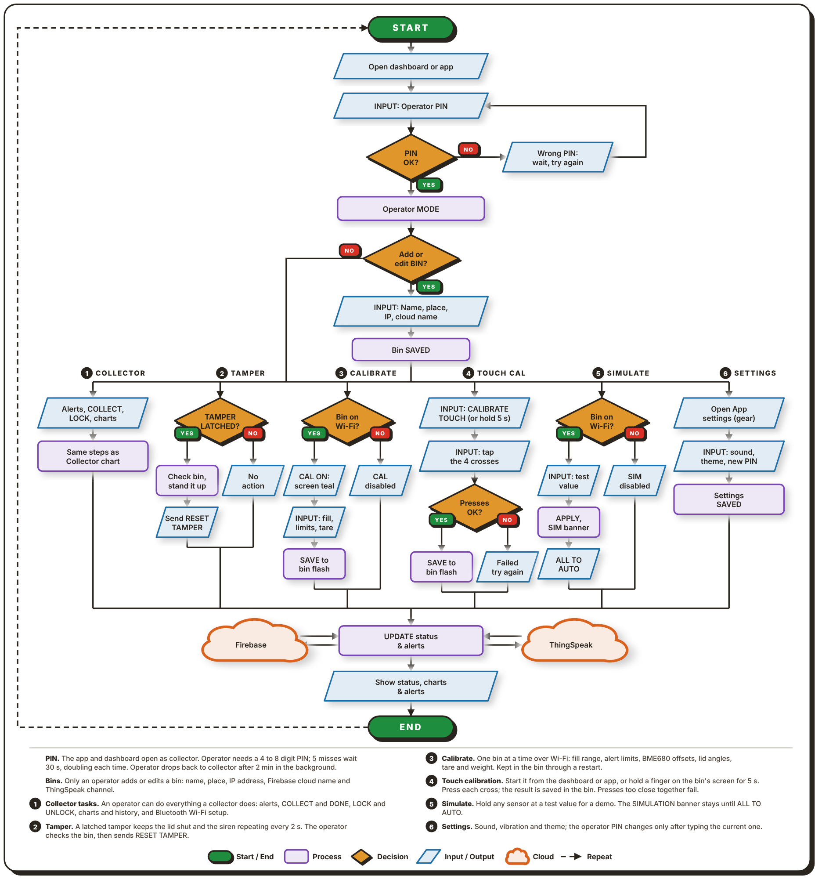
Note. As seen in Figure 39, an operator can do the following actions in the Web Dashboard or in the Android App
.
In both apps, the collector mode is the default, and the operator enters his 4- to 8-digit PIN. A wrong PIN requires a delay between attempts, with 30s after 5 failed attempts and the delay for subsequent failed attempts doubling. The app puts itself in operator mode with the appropriate PIN. The operator can then add or edit a bin, giving it a name, a place, the IP address and cloud name for Firebase and ThingSpeak, and the bin is saved in the app.
There are five tasks branching out from there. Everything that a collector can do is Collector (1), as shown in Figure 40: alerts, COLLECT and DONE, LOCK and UNLOCK, charts and history, and setting up the Wi-Fi over Bluetooth. Tamper (2) is for a bin with an alarm that latched. The operator checks the bin and stands it up and then sends a RESET TAMPER to clear the alarm. Calibrate (3) requires bin to be on same Wi-Fi. The operator sets new limits (fill range, alert limits, BME680 offsets, lid angles, weight tare and more) and these limits are stored in the flash memory of the bin. Calibration is disabled if the bin is not connected to Wi-Fi. The touch calibration (4) can be initiated from the dashboard or app or by holding a finger on the bin's screen for 5s. Operator presses four crosses sequentially and result is stored on the bin (if pressed too close, it is a fail and the operator retries).
Simulate (5) keeps the value of any sensor for demonstration purposes. A SIMULATION banner will appear on the screen while it is on until the operator returns everything to AUTO. The sound, vibration and theme are set by Settings (6) and the operator can change the PIN in the settings after entering the PIN. The result of whichever task is used then iterates through the same 2-way UPDATE process with both the Firebase and the ThingSpeak services and the app will display the new status, plus the charts and alerts.
Figure 40
Collector Flowchart of the Smart-Bin Apps
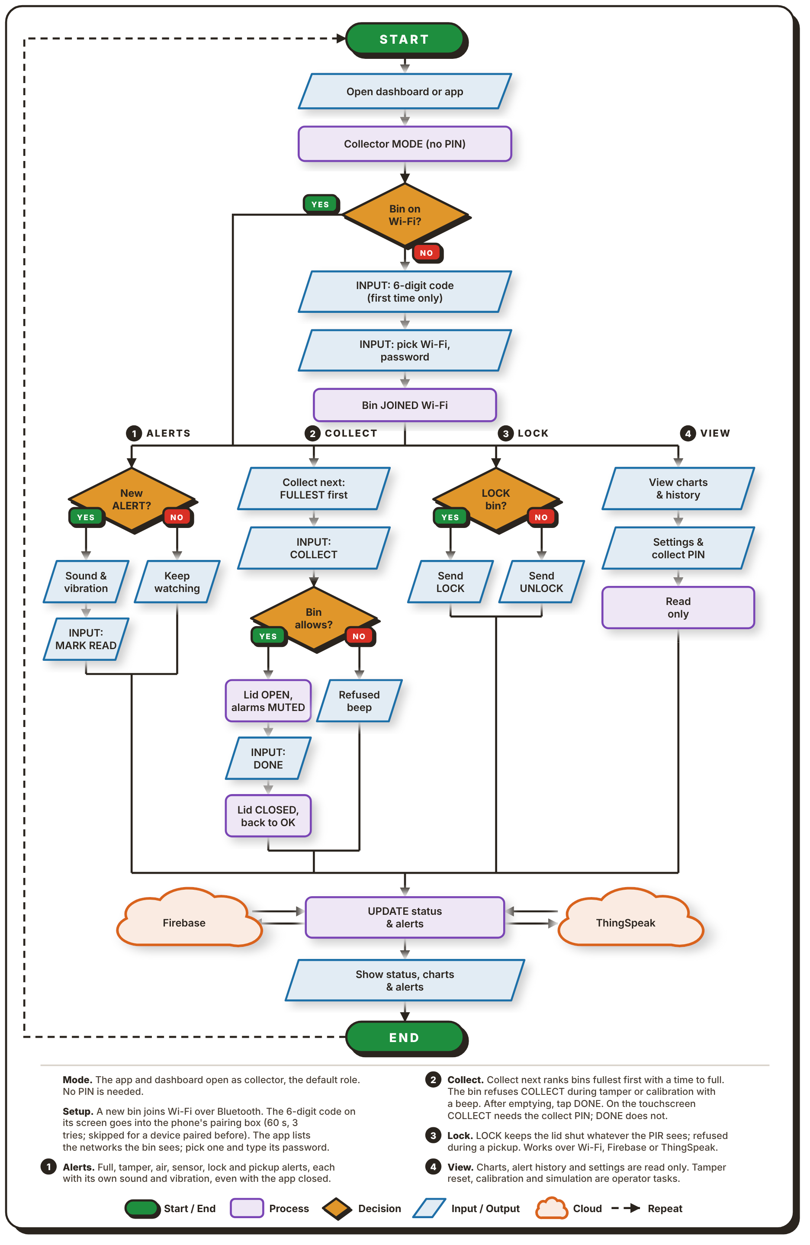
Note. As seen in Figure 40, the collector's job in the web dashboard or in the Android app.
The apps are opened to collector mode which is the default mode and no pin is required. The collector uses Bluetooth to set up the bin if not already connected to Wi-Fi. The 6 digit code displayed on the screen of the bin is entered into the pairing box of the phone (code will be valid for 60s, 3 failed attempts will lock pairing for 60s, a device that has been paired before will not require a code). The app then lists the Wi-Fi networks the bin can see, and the collector picks one and enters its password. After the bin joins the network, there are four tasks available.
Alerts (1) are issued for a full bin, tampering, bad air, lock and pickup. Each has its own sound and vibration and they come even when the app is not in use. The primary task is collect (2). The Collection priority list is a ranking of the bins, with the first bin in the list being the one with the most capacity, and the time to fill each bin is shown. The collector taps COLLECT in the app or on the screen, and enters the collect PIN at the bin. Lid opens and alarms stop. The collector then empties the bin and taps DONE (no PIN required) and the lid will then close and the fill level will reset. A bin refuses COLLECT, with a beep, while a tamper alarm or a calibration is on.
Lock (3) allows the collector to lock or unlock a bin, while resetting a tamper alarm, calibration and simulation stay with the operator. View (4) displays the charts, alert history, and status and collect PIN in read-only mode. All tasks are completed with the same step in Firebase and ThingSpeak and the app updates the status.

2.4 Schematic Design
The circuit of each unit is drawn as one schematic split into three sheets: the microcontroller, the actuators and outputs, and the sensors and inputs. The order of the sheets is: Figures 41, 42, 43. Instead of long wires between sheets, each connection to the ESP32 has a net label (IO25, etc.) and a bunch of pins with the same net label are grouped together.
Figure 41
Schematic Diagram, Sheet 1: Microcontroller
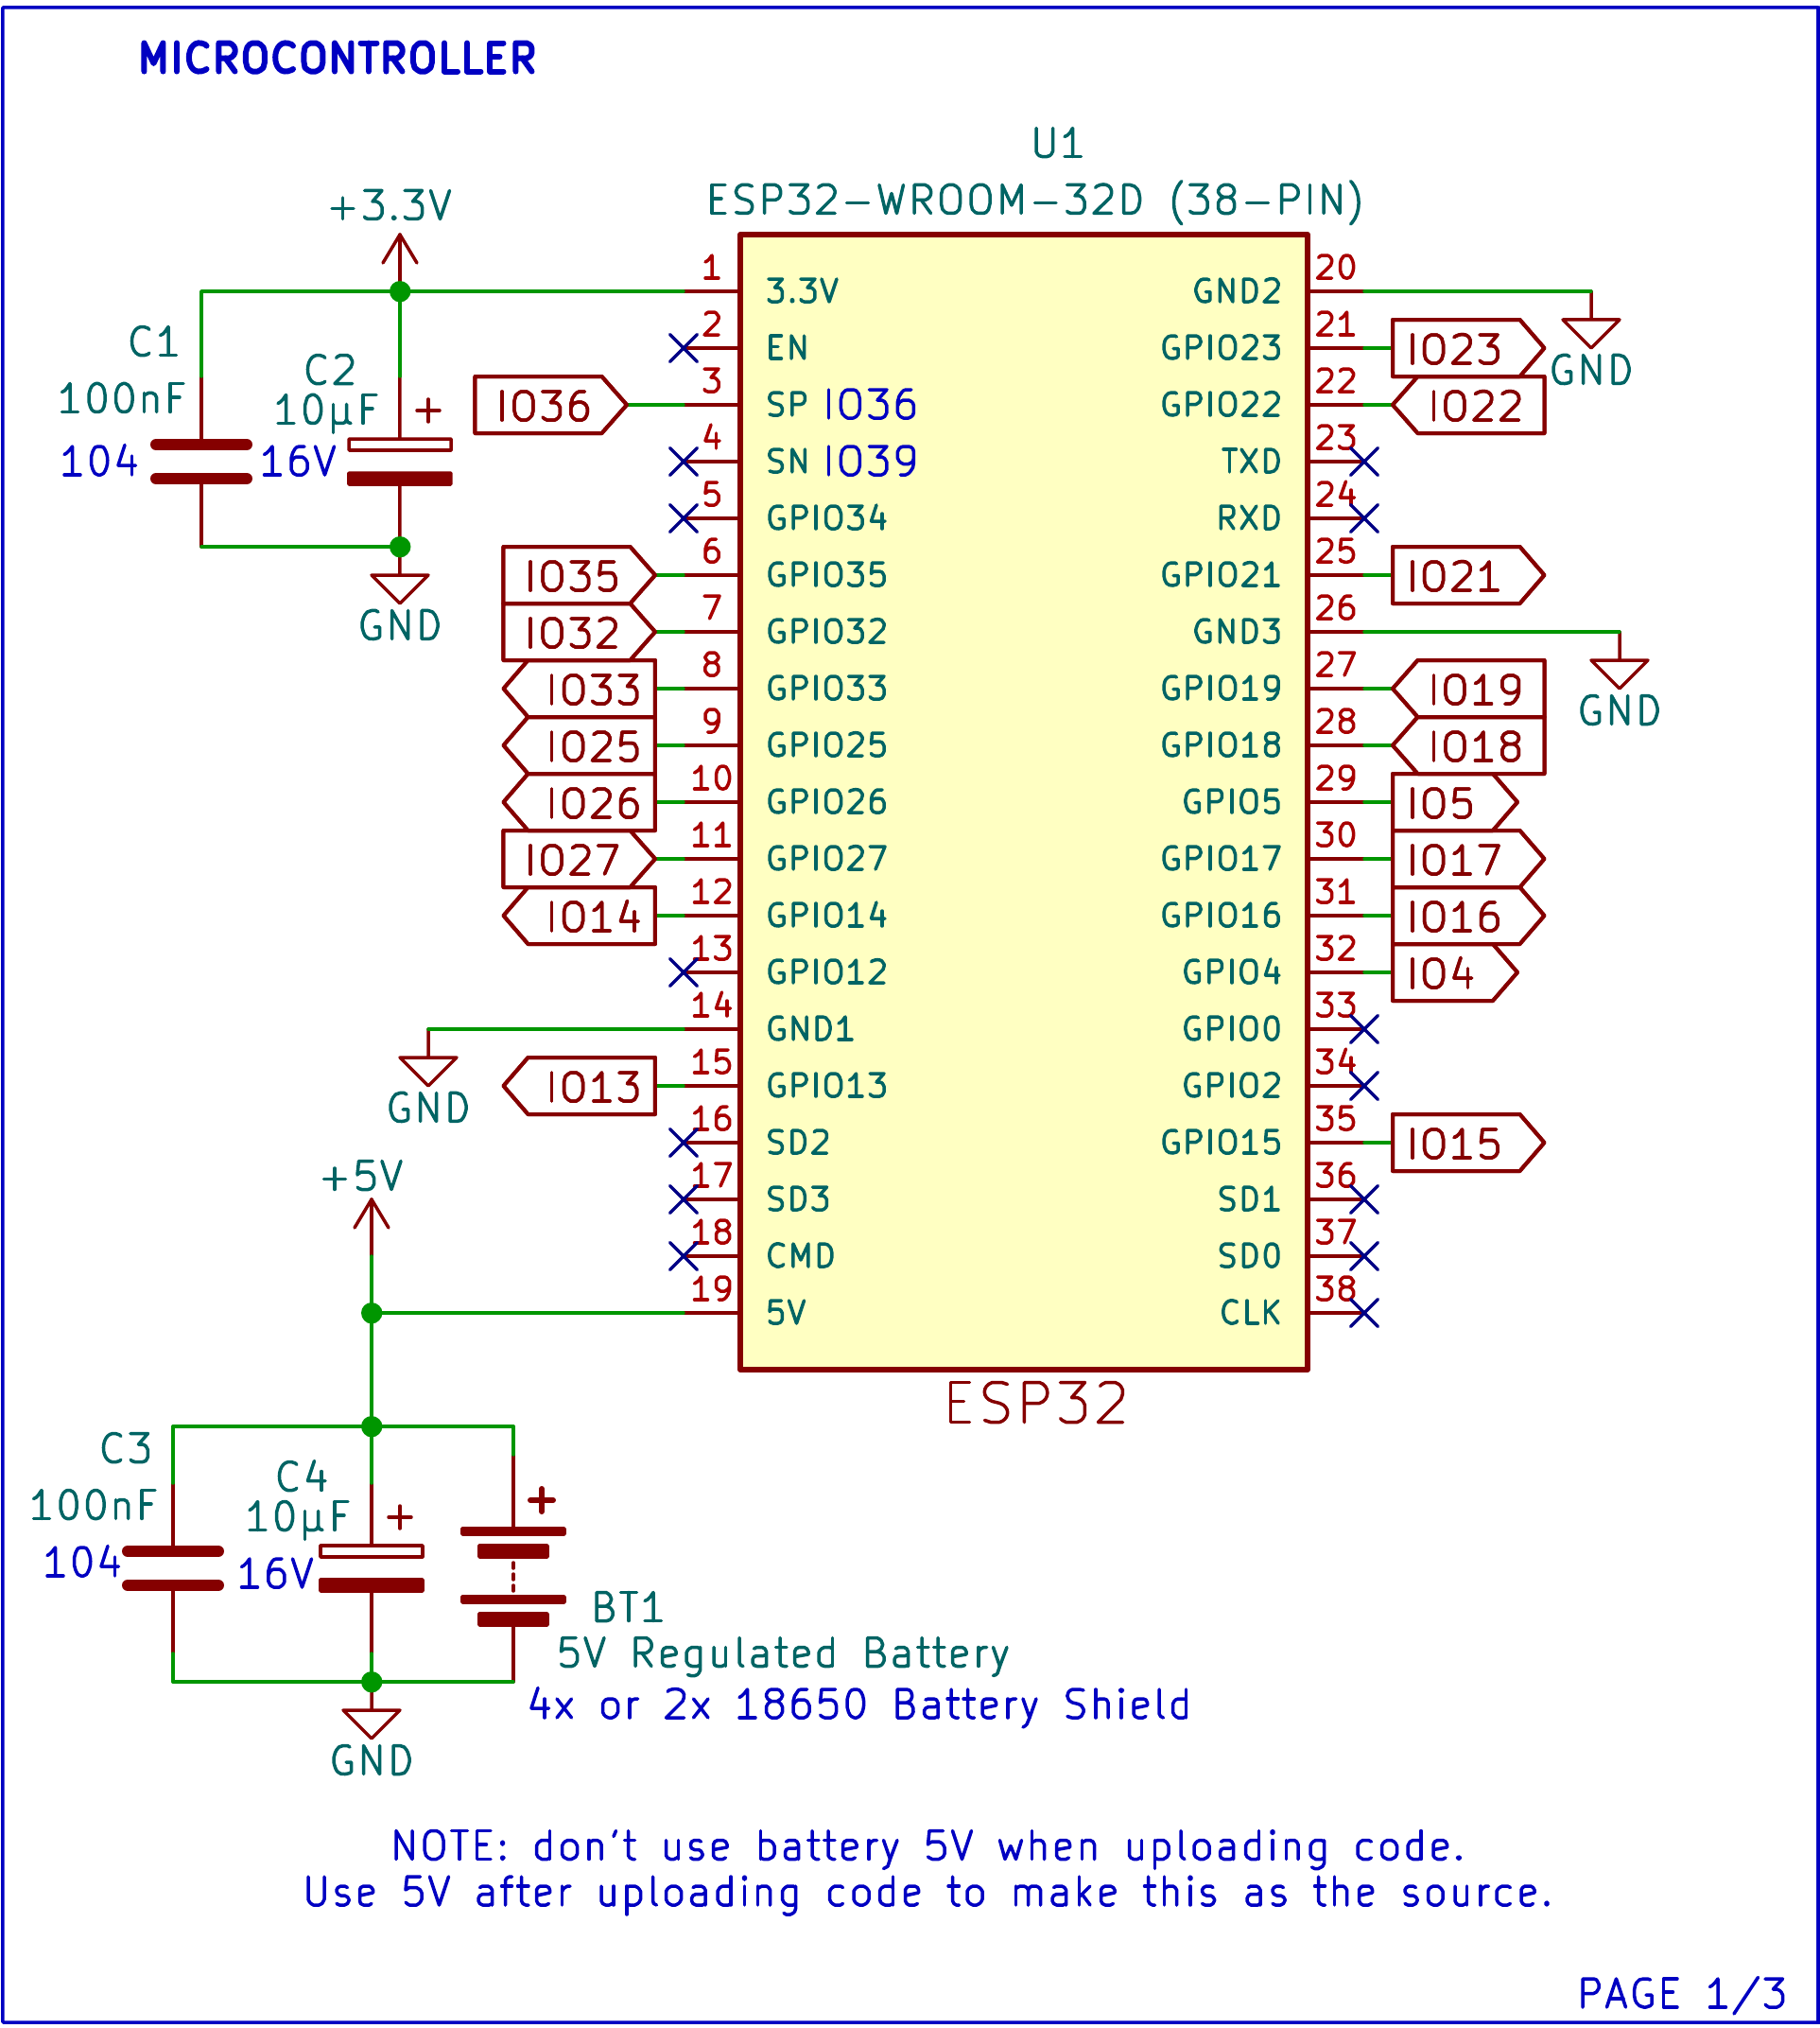
U1 is the ESP32-WROOM-32D on a 38-pin board. The 4x or 2x 18650-battery shield, BT1, provides the 3.3V rail for the sensors, the display and the buzzer (pin 1) and a regulated 5V to pin 19. C1 and C2 (100nF and 10µF) smooth the 3.3V rail, and C3 and C4 (100nF and 10µF) do the same at the battery input. The ground pins share one GND net. Pins which are not configured in the design (such as EN, TXD, RXD, GPIO0, GPIO2) are identified as "no-connect". According to the note on the sheet, the battery's 5V should not be used while code is being uploaded; rather, it should only be used after the code is uploaded.
Figure 42
Schematic Diagram, Sheet 2: Actuators and Outputs
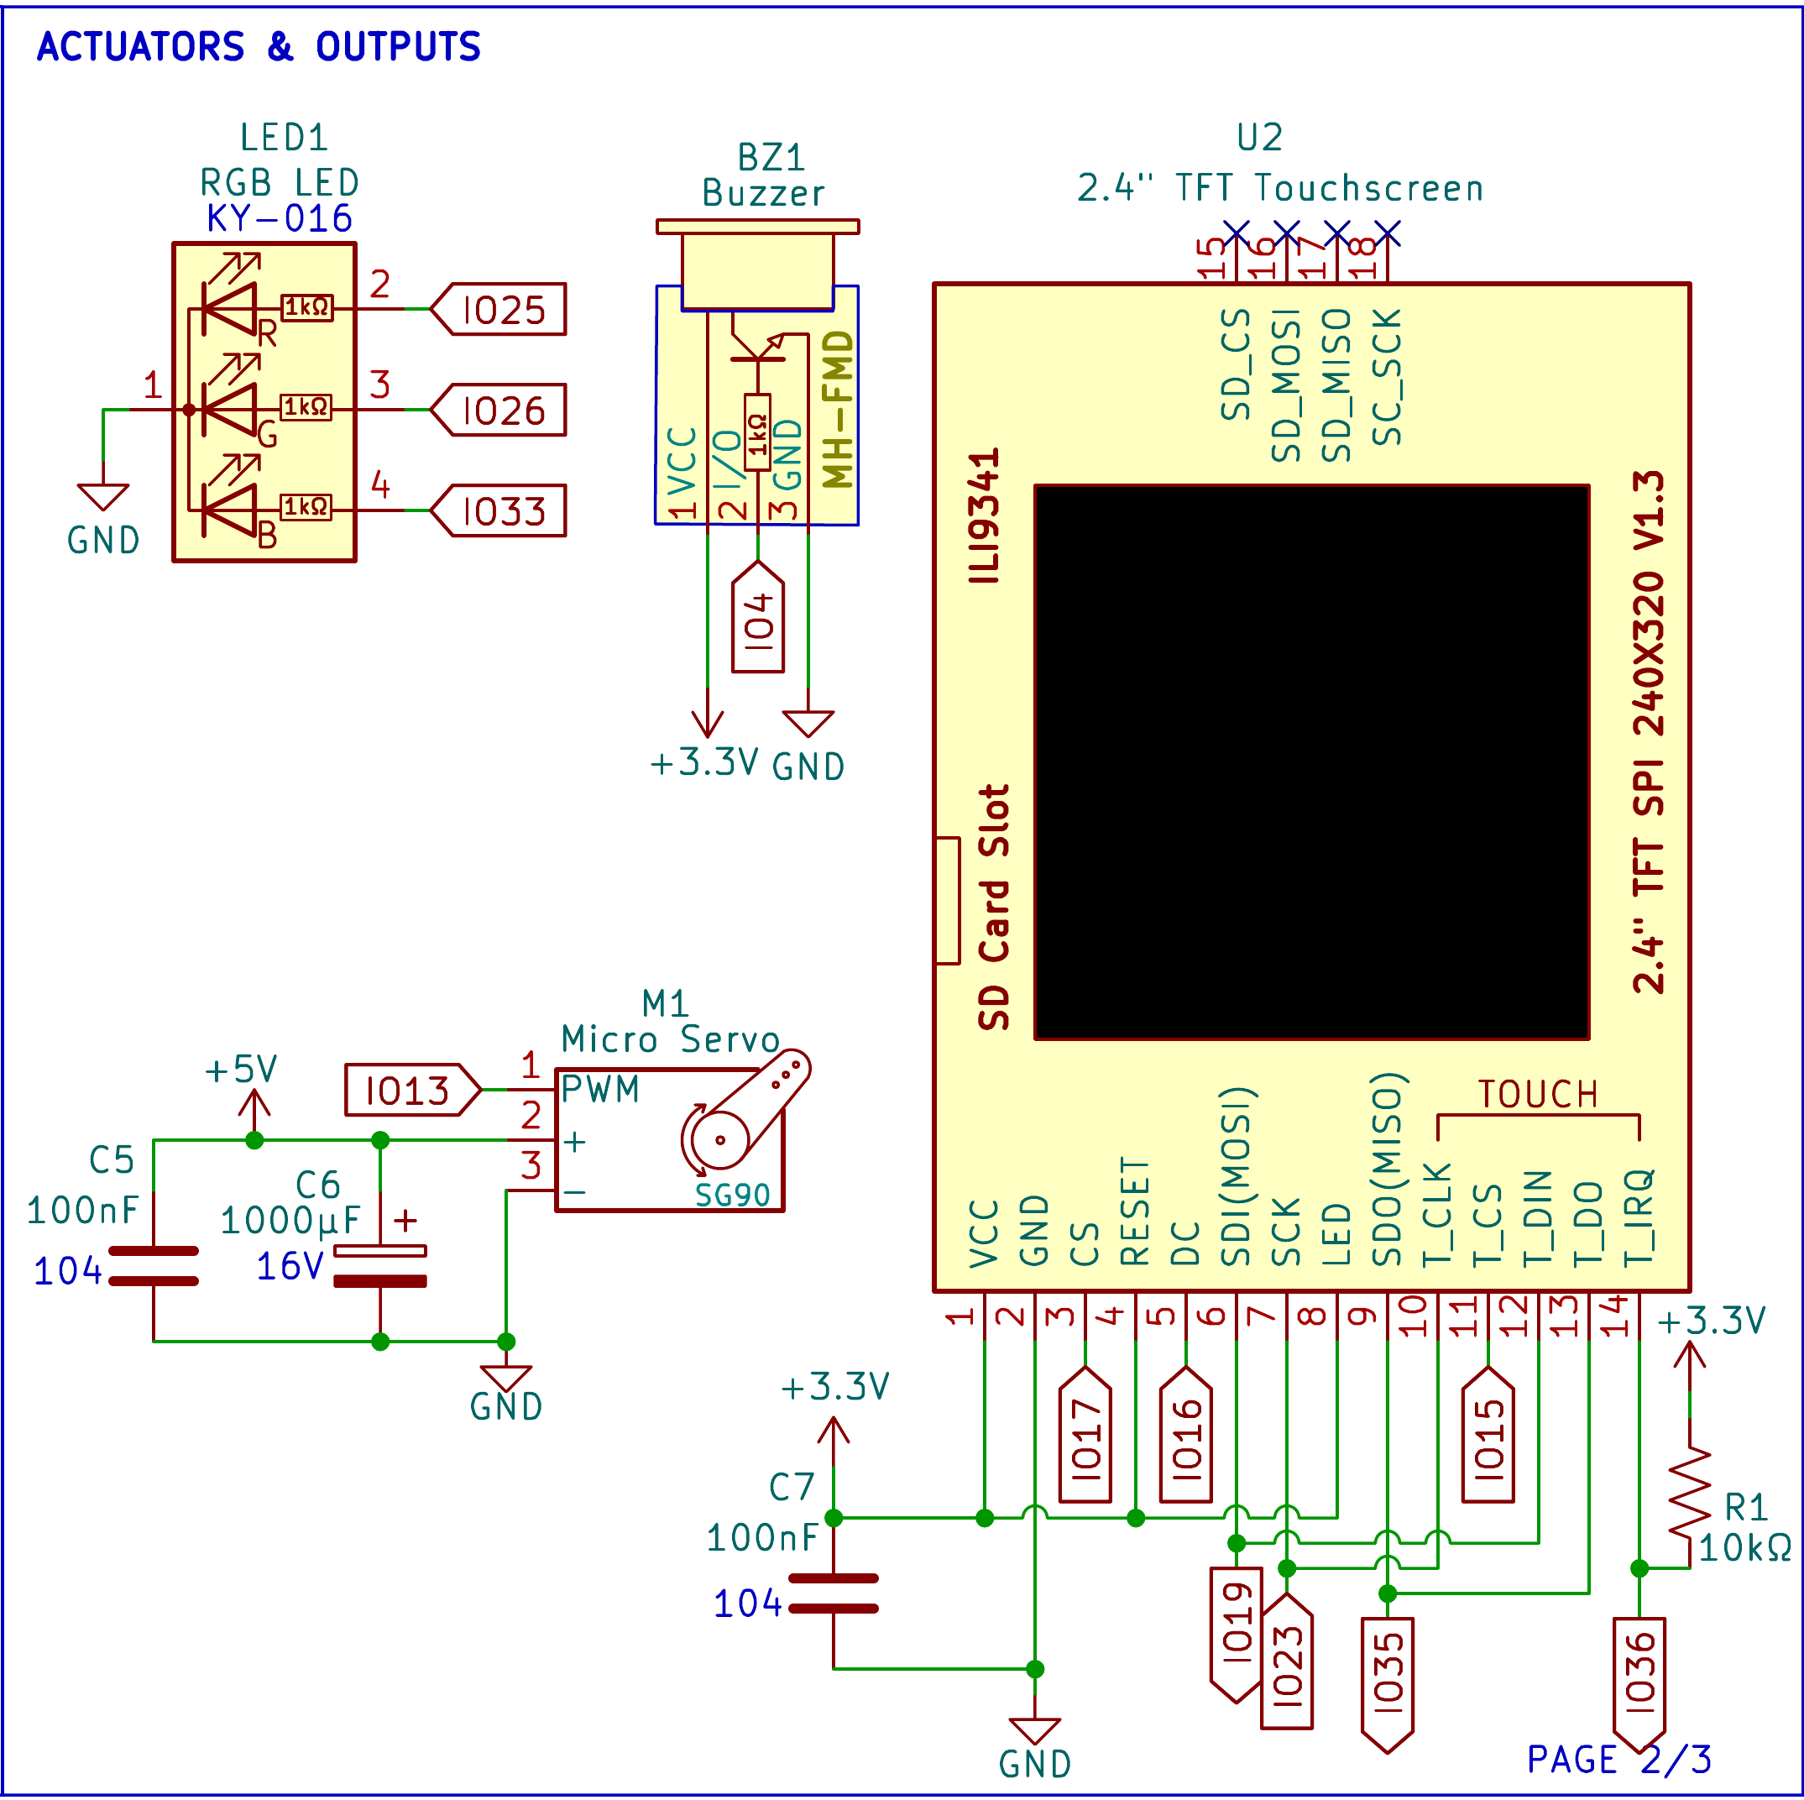
LED1 is a common cathode RGB LED KY-016. Its red, green and blue legs have 1kΩ resistors connected to IO25, IO26 and IO33. BZ1 is a buzzer module (MH-FMD) that operates on 3.3V and is controlled by IO4. The SG90 micro servo (M1) operates on the 5V power supply, and is controlled by IO13 via PWM, with C5 (100nF) and C6 (1000µF) placed across the power supply to filter current spikes as the servo moves.
U2 is the 2.4 in. ILI9341 touchscreen (240 × 320, SPI). It runs on 3.3V, with C7 (100nF) across its supply. The display and its touch controller share the SPI clock and data lines on IO19, IO23 and IO35, and each has its own chip select: IO17 for the display and IO15 for touch. DC goes to IO16 and the touch interrupt T_IRQ to IO36. R1 (10kΩ) pulls T_IRQ to 3.3V, the line remains high until a touch pulls it down. The RESET and the backlight pin (LED) are connected to 3.3V and the SD card pins are not connected.
Figure 43
Schematic Diagram, Sheet 3: Sensors and Inputs
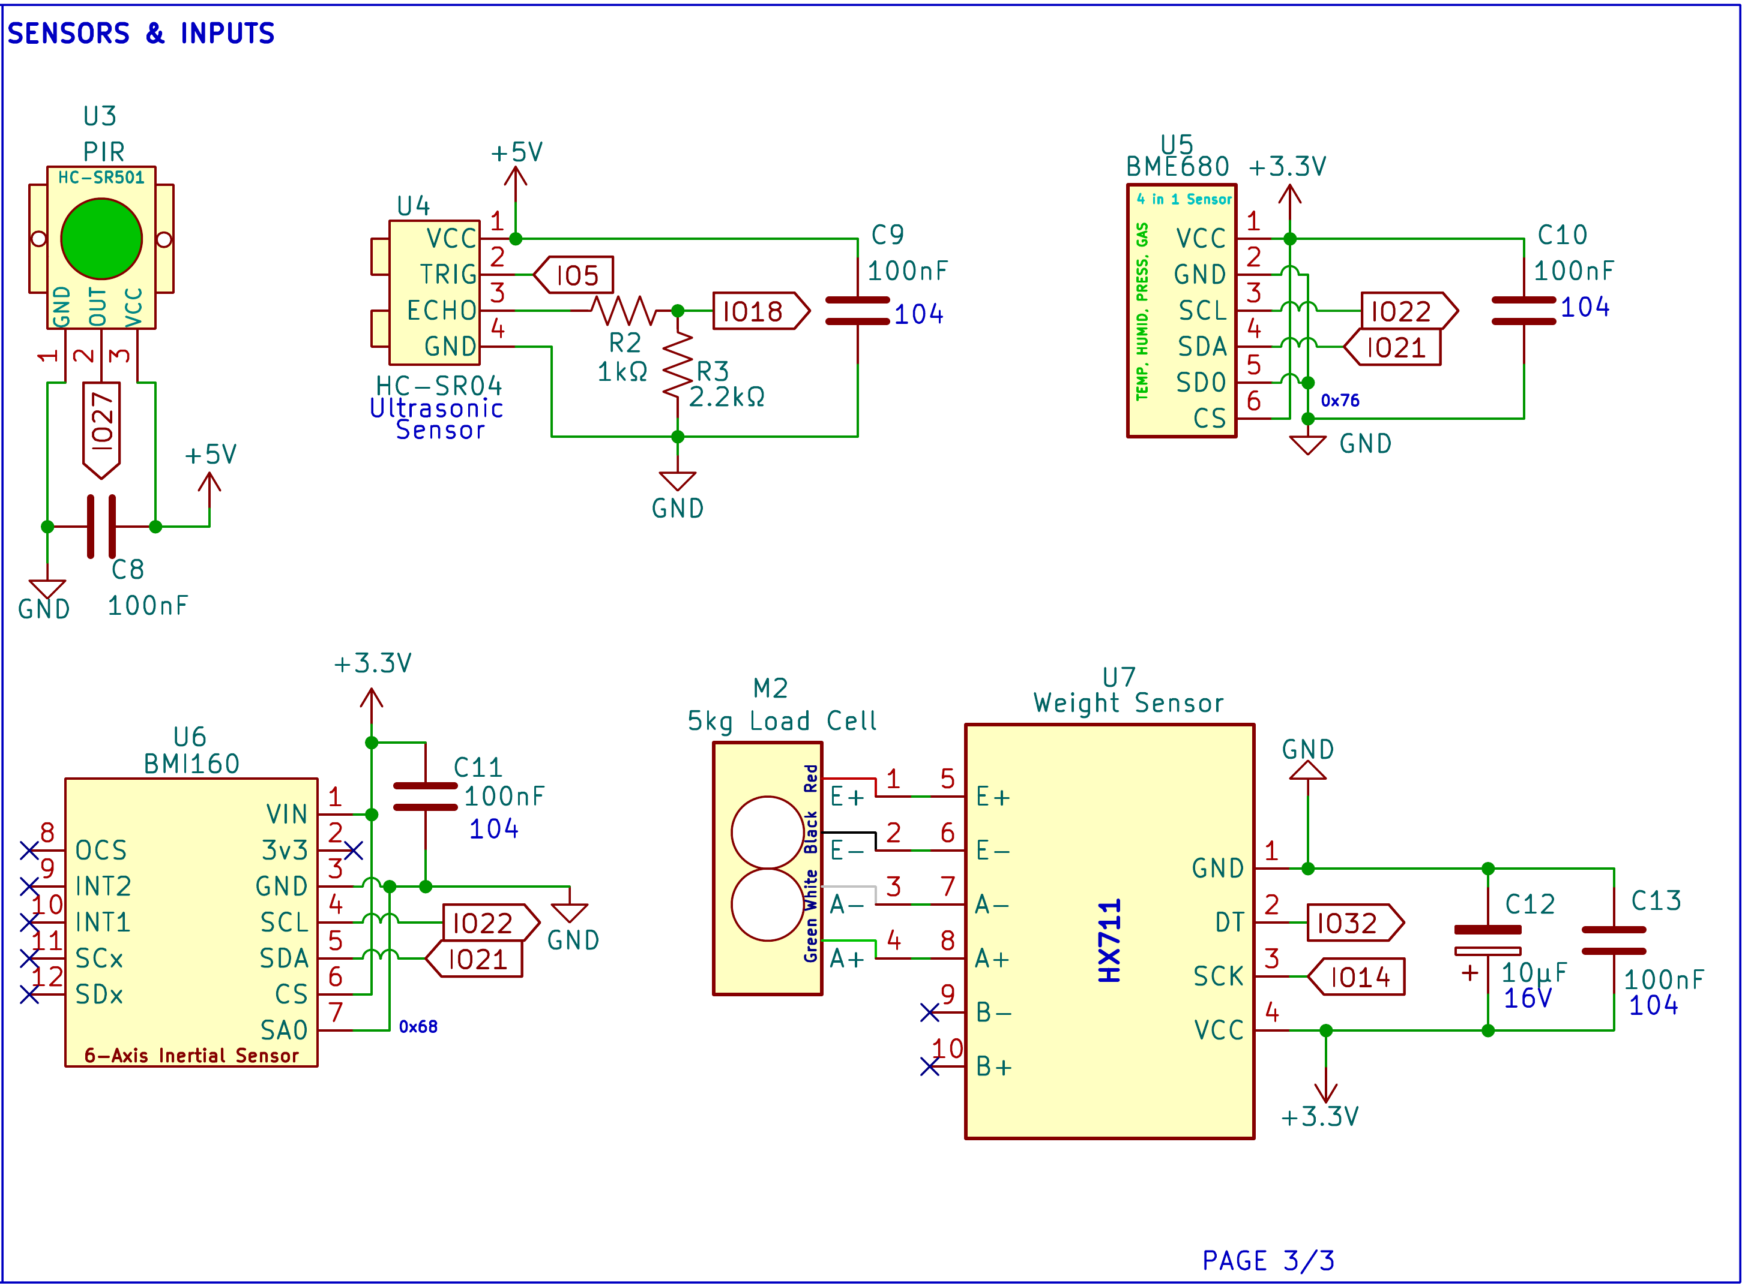
U3, the HC-SR501 PIR sensor, runs on 5V and sends its output to IO27, with C8 (100nF) across its supply. The HC-SR04 (U4) operates on 5V also with the C9 (100nF) from supply and TRIG on IO5. It outputs a 5V pulse to its ECHO pin, which is then divided by R2 (1kΩ) and R3 (2.2kΩ) to produce ~3.4V before reaching IO18, and is thus very close to the 3.3V level that the esp32 input expects for it can tolerate up to 3.6V.
U5 (BME680) and U6 (BMI160) both run on 3.3V, with C10 and C11 (100nF each) across their supplies, and share the I2C bus, with SCL on IO22 and SDA on IO21. Tying the BME680's SDO pin to ground sets its address to 0x76, and tying the BMI160's SA0 pin to ground sets its address to 0x68, so the two do not clash. M2, the 5kg load cell, connects its red, black, white and green wires to the E+, E−, A− and A+ inputs of U7, the HX711. The HX711 runs on 3.3V, with C12 (10µF) and C13 (100nF) across its supply, and sends its data on IO32 with its clock on IO14.

2.5 Component Materials
This section describes the main electronic parts used in each Smart-Bin unit. Both bins use the same parts except for the battery shield. Figures 44 to 54 show each part, followed by what it does and how the system uses it.
Figure 44
ESP32 DevKit V1 (38-Pin, ESP32-WROOM-32D)
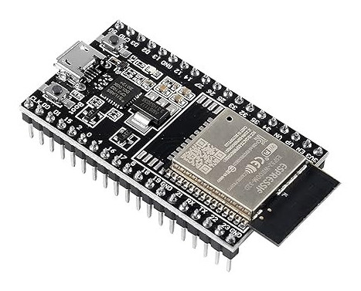
Note. Image from Sigmanortec (n.d.).
The ESP32 DevKit V1 is a development board built around the ESP32-WROOM-32D module. The module has a dual-core processor that runs at up to 240MHz, with Wi-Fi and Bluetooth on the same chip. The 38-pin board provides an additional USB connector for uploading code and power, a voltage regulator for 3.3V power and pin headers for breadboarding.
There is one board for each bin and each board governs all of the contents of that bin. It reads all six inputs (the HC-SR04, PIR sensor, BME680, BMI160, load cell and touchscreen), calculates the fill percentage, air quality reading and tamper state, and controls the servo, LED, buzzer and display. Providing the local REST API over Wi-Fi, it receives the status update command from the dashboard and the Android application and sends status update to Firebase and ThingSpeak.
Figure 45
HC-SR04 Ultrasonic Distance Sensor
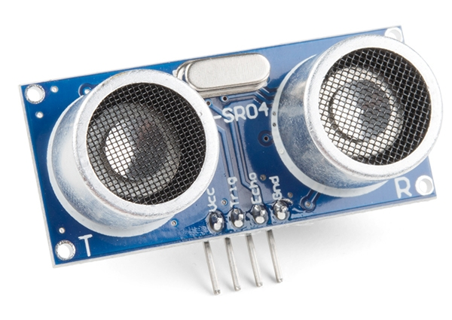
Note. Image from SparkFun Electronics (n.d.).
The HC-SR04 is a sound-based distance sensor. It outputs a 40kHz ultrasonic burst when a short pulse is received at its TRIG pin and will keep its ECHO pin high until the echo is received. The distance is determined by the width of that pulse which varies in the range of 2cm to 4m. The sensor runs on 5V.
In Smart-Bin it is installed under the lid and points downward, and thus measures the distance between the lid and the top of the trash. The firmware converts that distance into the fill percentage displayed on the LED, touch screen and the apps and once the fill level reaches the fill limit (80% by default), the full-bin alert is activated. TRIG is wired to IO5, and ECHO is wired to IO18 through a divider of R2 (1kΩ) and R3 (2.2kΩ), which brings the 5V pulse down to about 3.4V, close to the 3.3V input level of the ESP32.
Figure 46
HC-SR501 PIR Motion Sensor
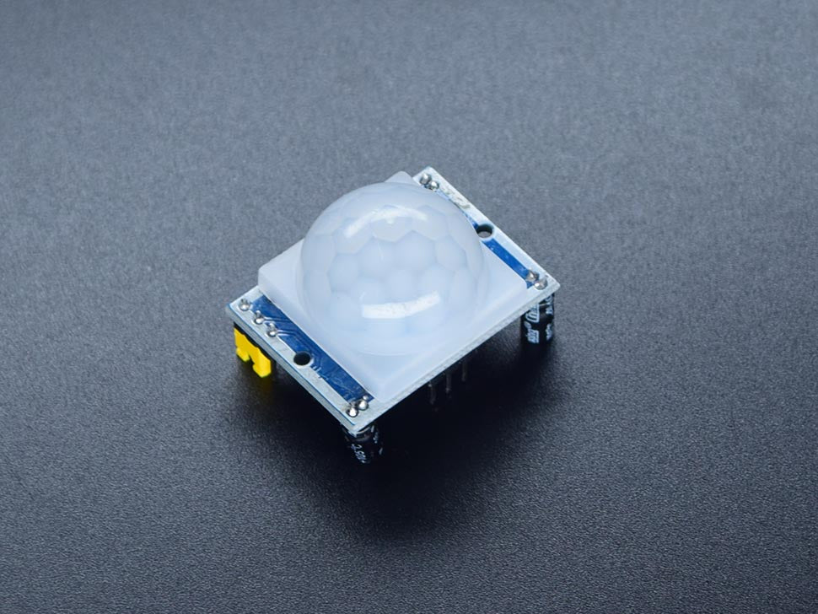
Note. Image from Circuitrocks (n.d.-c).
The HC-SR501 is a passive infrared (PIR) sensor. It detects the modulation of infrared light as a warm body passes in front of its white dome lens and its output pin will be "high" when motion is detected. The sensitivity and output high time is determined by two trimmers on the board.
It is used by Smart-Bin to determine when someone approaches the bin. When the output on IO27 is high and the bin is available for opening, the bin beeps and the servo raise the lid and the user never has to touch it. The lid will close 5 seconds (user definable length) after movement ceases. During COLLECT mode motion sensing is suppressed and the lid remains open while the collector is operating.
Figure 47
BME680 Environmental Sensor
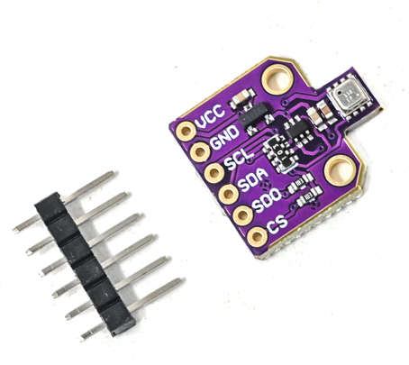
Note. Image from Robu.in (n.d.).
The BME680 is a single chip sensor for measuring temperature, humidity, VOC (volatile organic gases) and air pressure. Based on the gas reading, an estimated indoor air quality (IAQ) rating can be obtained. It is powered by 3.3V and communicates via I2C.
In Smart-Bin it monitors the air within the bin. When the temperature, humidity or estimated air quality goes over its limit, the firmware sounds an alarm and sends an alert, even if the bin isn't full yet, because a high temperature may mean a fire or hot material. It is located at I2C address 0x76 (SDO tied to ground).
The purpose of this is using the combination of temperature, humidity, and gas reading (IAQ) in order to determine by the collector or operator how much rotting trash is in the Smart-Bin for smell-sensitive areas. The IAQ value is an estimate from the gas reading, and it needs about 5 minutes after power-up to settle.
Figure 48
BMI160 Six-Axis Inertial Measurement Unit
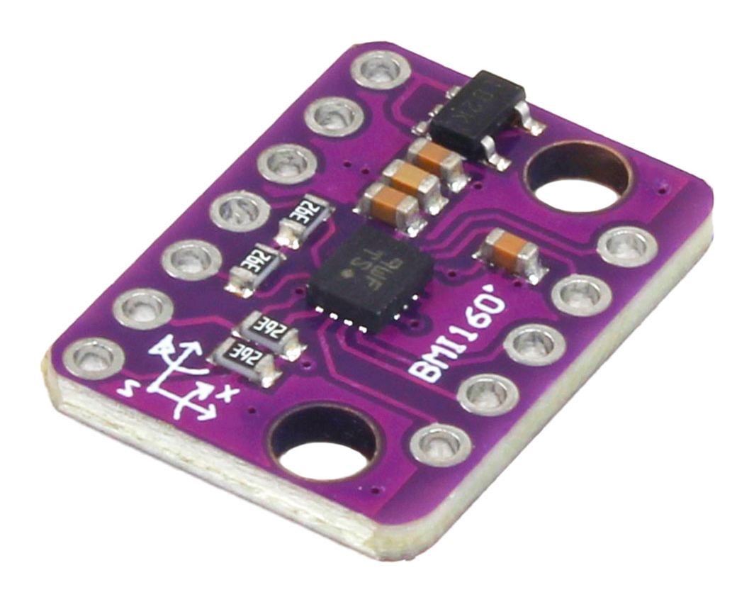
Note. Image from ElectroPeak (n.d.).
BMI160 is a 3-axis accelerometer and 3-axis gyroscopes integrated onto one chip. It is an I2C acceleration and rotation sensor that operates on 3.3V.
It is used by Smart-Bin for tamper detection. If the bin is tilted, the readings exceed the range limits and the firmware sets the Tamper alarm, activates the buzzer and prevents the lid opening. It is on the same I2C bus as the BME680 with the address 0x68 by shorting out SA0 to ground. The tamper check is paused during COLLECT mode.
Figure 49
HX711 Load Cell Amplifier and 5kg Load Cell
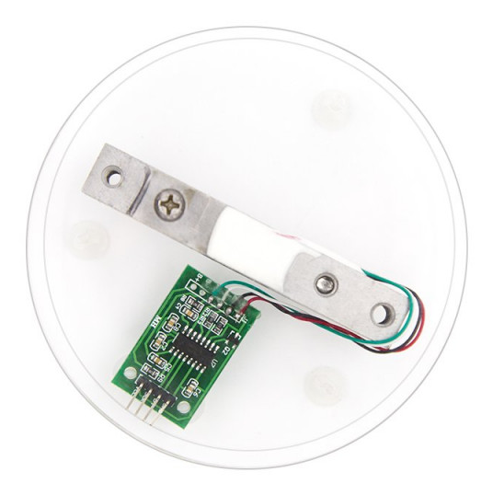
Note. The HX711 board and the 5kg load cell are shown on a display base. Image from ElectronicsComp.com (n.d.).
A load cell is a metal bar with strain gauges designed so that as the load is applied, the bar's resistance varies slightly. The bar here is a 5kg model, and has a very small voltage output, which is amplified and converted in the HX711 board by a 24 bit analog to digital converter. The result is read by the ESP32 using two pins: DT (IO32) and SCK (IO14).
The two together measure the garbage. Weight is a second check on the fill level: wet waste can be heavy before the bin is full, and a bin full of light waste can be tall without being heavy. The weight is displayed on the dashboard and the app, and stored to the cloud with every measurement.
Figure 50
SG90 Micro Servo Motor
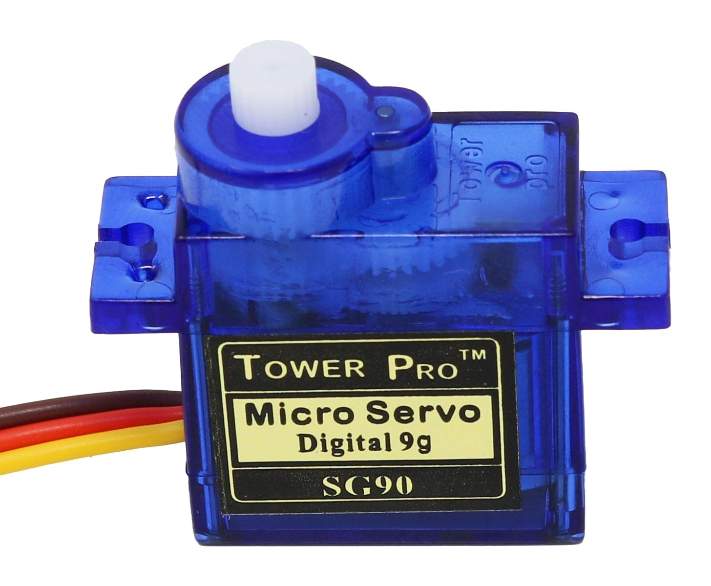
Note. Image from The Pi Hut (n.d.).
The SG90 is a small hobby servo which will rotate its output arm to a specific angle (roughly 180 degrees) depending on the width of a PWM pulse. Operates on approximately 5V and can be attached directly to the bin.
Servo is used to open and close the bin lid. It is managed by ESP32, it will open when it is detected people, or when the collector taps COLLECT, it will close after 5s (user settable) when people are not detected or the collector taps DONE. When the bin is locked, full or flagged for tampering, the firmware keeps the servo in the closed position.
Figure 51
2.4-in. TFT Touchscreen (ILI9341 With XPT2046 Touch Controller)
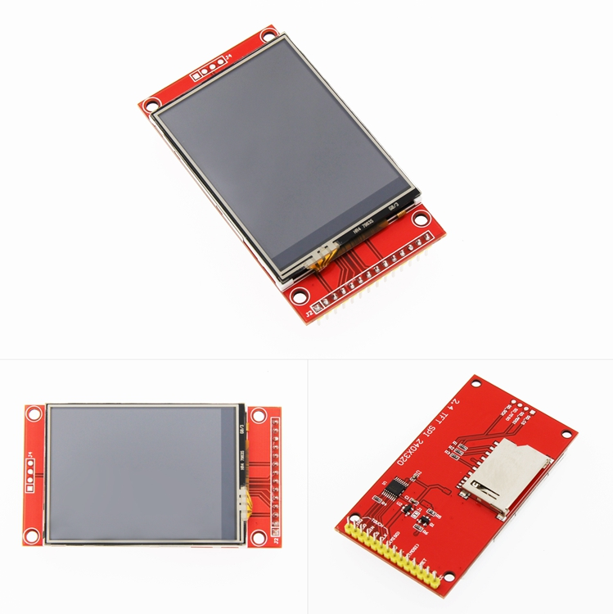
Note. Front, back, and angled views of the module. Image from LCDWIKI (n.d.).
This module is a 2.4 in., 240 × 320 color display driven by the ILI9341 controller over SPI. The same SPI bus also has a separate XPT2046 controller for the resistive touch layer on top. There is also an SD card slot on the board, which isn't used by Smart-Bin.
The bin's local screen is the display. It indicates the fill level, sensor readings and the bin status (LOCKED and TAMPER). The touch layer provides the collector with the buttons COLLECT, PIN and DONE, making it possible to empty a bin without the app.
Figure 52
KY-016 RGB LED Module
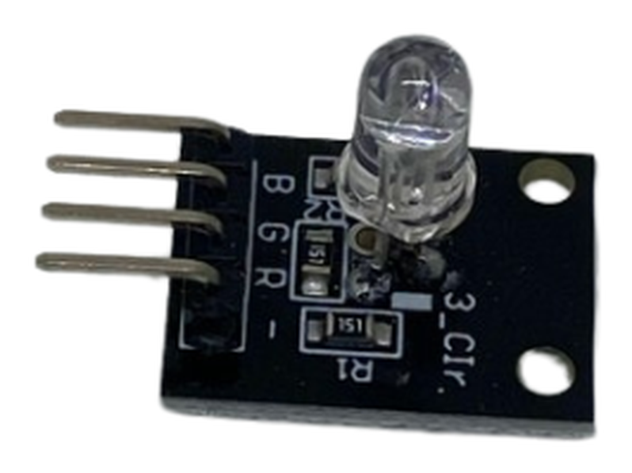
Note. Image from Circuitrocks (n.d.-d).
The KY-016 is a small board with a common-cathode RGB LED, a small package containing the red, green and blue chips. When the three colors are combined, other colors are created such as amber (red + green). A 1kΩ resistor is used for each colour to control the current.
The fill level is indicated on the LED, green if there is room in the bin, amber when it is filling up and red when the bin is full or a warning is triggered. It is driven from IO25, IO26 and IO33 and turns green again after the collector taps DONE.
Figure 53
Passive Buzzer Module (MH-FMD)
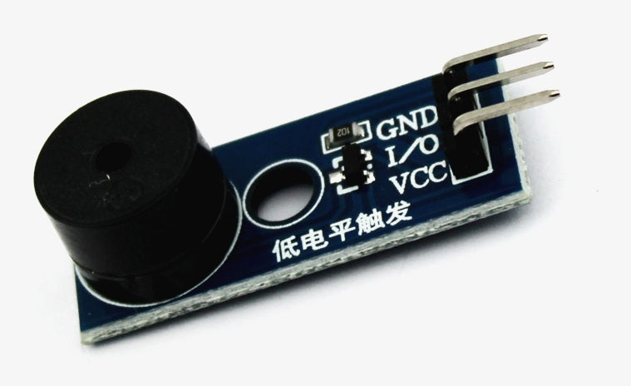
Note. Image from QuartzComponents (n.d.).
Passive buzzer: No built-in oscillator so it only buzzes if it is pulsed by the controller with a changing signal. This will allow the firmware to produce various tones and patterns, rather than just a single beep.
It is used by Smart-Bin for sound feedback from IO4. It beeps when lid is opened, alerts user if the BME680 senses high temp or humidity or poor air quality, and activates the siren if BMI160 senses tampering. It remains quiet while in COLLECT mode.
Figure 54
18650-Battery Shields for Bin A (4-Cell) and Bin B (2-Cell)
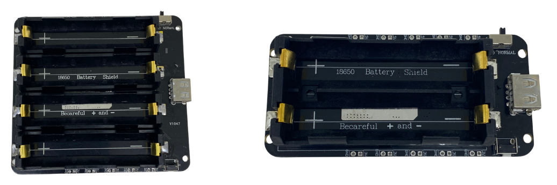
Note. Left: four-cell shield used in Bin A (Circuitrocks, n.d.-b). Right: two-cell shield used in Bin B (Circuitrocks, n.d.-a).
The 18650-battery shield comprises lithium-ion 18650 cells which will provide the electricity needed and convert its voltage to a regulated 5V output. It also features a charging USB port for the cells. Bin A are equipped with a four-cell V9 shield (5V/3A), while Bin B are equipped with a two-cell shield.
The shield supplies power to the entire bin, without the need for a wall outlet, which allows a bin to be set anywhere that Wi-Fi is available. It is placed in a closed compartment and connected to the 5V of the ESP32 which provides 3.3V for the sensors. As mentioned in the schematic, the battery should not be connected during code upload via USB.

III. TESTING, RESULTS, AND CONCLUSION

3.1 Test Cases
[Introduce the test cases here. Each specific objective is tested below.]

Specific Objective 1: Sensor Monitoring and Detection
[Insert test cases TC1.1 to TC1.6 here.]

Specific Objective 2: Real-Time Monitoring and Alerts
[Insert test cases TC2.1 to TC2.6 here.]

Specific Objective 3: Bin Control and Collection Prioritization
[Insert test cases TC3.1 to TC3.6 here.]

3.2 Results and Discussion
[Present and discuss the test results here.]

3.3 Conclusion
[Write the conclusion here.]

3.4 Recommendations
[Write the recommendations here.]

REFERENCES
Aasish, V. G., Mari Shankar, C., & Shanmugasundaram, M. (2025). FreeRTOS based smart waste management system. In 2025 Innovations in Power and Advanced Computing Technologies (i-PACT) (pp. 1–7). IEEE. https://doi.org/10.1109/i-PACT65952.2025.11307820
Abdullahi, A., Mohammed, A., Bonet, M. U., El-Suleiman, A., Ahmad, R. B., & Chollom, T. D. (2024). Development of a smart waste management system with automatic bin lid control for smart city environment. EAI Endorsed Transactions on Smart Cities, 7(3). https://doi.org/10.4108/eetsc.4385
Alnanih, R., Elrefaei, L., & Al-Ahwal, A. (2025). Advancing sustainability through an IoT-driven smart waste management system with software engineering integration. Sustainability, 17(21), Article 9803. https://doi.org/10.3390/su17219803
Alnuaimi, A. N., Aydin, R., & Al-Shihabi, S. (2024). Optimizing municipal solid waste collection using smart bins: A case study in United Arab Emirates. In 2024 IEEE International Conference on Technology Management, Operations and Decisions (ICTMOD) (pp. 1–6). IEEE. https://doi.org/10.1109/ICTMOD63116.2024.10878234
Alourani, A., Ashraf, M. U., & Aloraini, M. (2025). Smart waste management and classification system using advanced IoT and AI technologies. PeerJ Computer Science, 11, Article e2777. https://doi.org/10.7717/peerj-cs.2777
Asido, D. (2024, January 19). Baguio students develop smart garbage bins. The Post. https://thepost.net.ph/news/campus/baguio-students-develop-smart-garbage-bins/
Awotayo, M. M., & Dodo, U. A. (2026). Design and implementation of an IoT-based smart bin for real-time fill level monitoring. Journal of Science Technology and Education, 14(1), 344–351. https://www.researchgate.net/publication/400748751
Ayyanagoudar, A., Mohankar, A., Gharte, J., Pasnsare, P., Ainapure, B., & Appasani, B. (2024). A smart bin with real-time monitoring and garbage level tracking using IoT. In 2024 11th International Conference on Reliability, Infocom Technologies and Optimization (Trends and Future Directions) (ICRITO) (pp. 1–7). IEEE. https://doi.org/10.1109/ICRITO61523.2024.10522263
Azmi, A. Z., Sahar, N. M., & Islam, M. T. (2024). Smart waste management system using LoRa technology. E3S Web of Conferences, 599, Article 04007. https://doi.org/10.1051/e3sconf/202459904007
Bahga, A., & Madisetti, V. (2014). Internet of things: A hands-on approach.
Balachandran, N., & Talavera, O. (2023). Apparatus and method for waste monitoring and analysis (U.S. Patent No. 11,788,877). U.S. Patent and Trademark Office. https://patents.google.com/patent/US11788877B2
Banciu, C., Florea, A., & Popa, M. (2025). IoT-enabled waste collection: Route optimization and environmental impact reduction using smart technologies. In 2025 29th International Conference on System Theory, Control and Computing (ICSTCC) (pp. 782–788). IEEE. https://doi.org/10.1109/ICSTCC66753.2025.11240462
Bigbelly. (n.d.). CLEAN software. Retrieved October 19, 2026, from https://bigbelly.com/products/clean-software
Bosch Sensortec. (n.d.). BME680 gas sensor (Document No. BST-BME680-DS001) [Data sheet]. Retrieved October 19, 2026, from https://www.bosch-sensortec.com/media/boschsensortec/downloads/datasheets/bst-bme680-ds001.pdf
Brown, W. J. (2006). Compactor service and monitoring system (U.S. Patent No. 7,145,450). U.S. Patent and Trademark Office. https://patents.google.com/patent/US7145450B2
Circuitrocks. (n.d.-a). 2 channel 18650-battery holder protection board. Retrieved October 15, 2026, from https://circuit.rocks/products/2-channel-18650-battery-holder-protection-board
Circuitrocks. (n.d.-b). 4 channel 18650-battery holder protection board. Retrieved October 15, 2026, from https://circuit.rocks/products/4-channel-18650-battery-holder-protection-board
Circuitrocks. (n.d.-c). HC-SR501 PIR motion sensor module. Retrieved October 15, 2026, from https://circuit.rocks/products/pir-motion-sensor-module-digital
Circuitrocks. (n.d.-d). KY-016 RGB 3 color full-color LED module. Retrieved October 15, 2026, from https://circuit.rocks/products/ky-016-rgb-3-color-full-color-led-module
Compology. (n.d.). Image-based container monitoring built for waste. Retrieved October 19, 2026, from https://compology.com/
Devitt, S., & Walsh, B. (2021). Techniques for optimally sensing full containers (U.S. Patent No. 11,054,545). U.S. Patent and Trademark Office. https://patents.google.com/patent/US11054545B2
Di Giugno, M., Giovanelli, F., Tiraboschi, S., & Villa, P. (2016). Measuring device, container means and system for monitoring and managing container means (European Patent No. 2516974). European Patent Office. https://patents.google.com/patent/EP2516974B1
Ecological Solid Waste Management Act of 2000, Republic Act No. 9003 (2001). https://lawphil.net/statutes/repacts/ra2001/ra_9003_2001.html
Ecube Labs. (n.d.). Waste analytics platform: CleanCityNetworks (CCN). Retrieved October 19, 2026, from https://www.ecubelabs.com/waste-analytics-platform/
ElectronicsComp.com. (n.d.). 5 kg load cell with HX711 module shell and 4P DuPont wire kit. Retrieved October 15, 2026, from https://www.electronicscomp.com/5-kg-load-cell-with-hx711-module-shell-and-4p-dupont-wire-kit
ElectroPeak. (n.d.). GY-BMI160 module 6DOF 6 axis angular velocity. Retrieved October 15, 2026, from https://electropeak.com/gy-bmi160-module-6dof-6-axis-angular-velocity
Enache, B.-A., Banica, C.-K., & Bogdan, A. G. (2024). Intelligent trash level detection for sustainable urban waste management. The Scientific Bulletin of Electrical Engineering Faculty, 24(1), 56–59. https://doi.org/10.2478/sbeef-2024-0010
Evreka. (2020). Fill level sensor. Retrieved October 19, 2026, from https://evreka.co/solutions/fill-level-sensor/
Gajula, R., Karanam, M., Vakkapatla, D. C., Endrapu, K. R., Raju, V. V. R., Reddy, S. B., Aljanabi, S. O., Koli, S., & Mahajan, S. (2025). Sustainable waste management solution: ESP32-powered smart bin. AIP Conference Proceedings, 3263(1), Article 140006. https://doi.org/10.1063/5.0261359
González, G. E., Escobar, E. R., Carvajal, I. I., & Bento, A. C. (2024). Smart trash bins: Integration of IoT with AI for efficient waste management. In 2024 IEEE International Humanitarian Technologies Conference (IHTC) (pp. 1–6). IEEE. https://doi.org/10.1109/IHTC61819.2024.10855147
Greenwalt, M. (2020, June 2). Bin-e creates contactless smart bin. Waste360. https://www.waste360.com/recycling/bin-e-creates-contactless-smart-bin
Gupta, S., Gautam, R., & Muneer, A. (2025). IoT-based e-tracking system for waste management. In 2025 12th International Conference on Reliability, Infocom Technologies and Optimization (Trends and Future Directions) (ICRITO) (pp. 1–6). IEEE. https://doi.org/10.1109/ICRITO66076.2025.11241930
Ishaq, A., Mohammad, S. J., Bello, A. D., Wada, S. A., Adebayo, A., & Jagun, Z. T. (2025). Smart waste bin monitoring using IoT for sustainable biomedical waste management. Environmental Science and Pollution Research, 32(32), 19434–19449. https://doi.org/10.1007/s11356-023-30240-1
Karthi, S. P., Aravind, A., Dharineesh, V., Dhayanidhi, J. V., & Dinesh Kumar, J. R. (2025). IoT enabled smart dustbin with RFID-based access control and Blynk integration. In 2025 IEEE First International Conference on Innovations in Engineering and Next-Generation Technologies for Sustainability (ICINVENTS). IEEE. https://doi.org/10.1109/ICINVENTS64613.2025.11402326
Kekäläinen, F. (2018). Method and system for monitoring and communicating fill rate of container (U.S. Patent No. 9,930,429). U.S. Patent and Trademark Office. https://patents.google.com/patent/US9930429B2
Kekalainen, F., & Engstrom, J. (2014). Smart waste collection system and method (International Patent Application Publication No. WO 2014/079586 A1). World Intellectual Property Organization. https://patents.google.com/patent/WO2014079586A1
Kekalainen, F., & Engstrom, J. (2018). Sensor device for smart waste collection systems and method (U.S. Patent No. 9,927,278). U.S. Patent and Trademark Office. https://patents.google.com/patent/US9927278B2
Keller, J. R., Redmond, M. O., & Mirza, S. A. (2024). System and method for measuring the fill level of a trash can using a sensor (U.S. Patent No. 12,125,361). U.S. Patent and Trademark Office. https://patents.google.com/patent/US12125361B2
Kumar, K. R., Pavan, O. S., Azeez, S. A., Suresh, C. V., Sree, K. R., & Reddy, P. U. (2025). IoT enabled route optimization for smart waste management using machine learning. i-manager's Journal on IoT and Smart Automation, 3(2), 11-23. https://doi.org/10.26634/jiot.3.2.21684
Kurani, H. B. (2023). Smart waste bin sensor device and methods for waste management system (U.S. Patent No. 11,702,280). U.S. Patent and Trademark Office. https://patents.google.com/patent/US11702280B2
Kuzhin, M. F., Joshi, A., Mittal, V., Khatkar, M., & Guven, U. (2024). Optimizing waste management through IoT and analytics: A case study using the Waste Management Optimization Test. BIO Web of Conferences, 86, Article 01090. https://doi.org/10.1051/bioconf/20248601090
LCDWIKI. (n.d.). 2.4inch SPI module ILI9341 SKU:MSP2402. Retrieved October 15, 2026, from https://www.lcdwiki.com/2.4inch_SPI_Module_ILI9341_SKU:MSP2402
Leones, J. R. (2025, March 3). Philippines ministerial statement [Paper presentation]. High-Level 12th Regional 3R and Circular Economy Forum in Asia and the Pacific, Jaipur, India. https://uncrd.un.org/sites/uncrd.un.org/files/12th3r_ps1-philippines.pdf
Maulida, A., Fayzalmi, C. S., Anaam, F. A. C., Ardiansyah, D., Gunawan, M. A., & Ridwan, N. (2025). Design of IoT-based smart trash bin monitoring using ESP32 and Firebase. Jurnal Komputer, Teknologi Informasi dan Sistem Informasi (JUKTISI), 4(2), 420-428. https://doi.org/10.62712/juktisi.v4i2.420
Mehta, H., Deriya, V., Sankhe, D., Kanani, P., Pandya, G., & Shelke, V. (2025). Smart bins, smarter cities: IoT-driven waste collection with real-time sensing and methane mapping. Mathematical Modelling of Engineering Problems, 12(6), 2110–2122. https://doi.org/10.18280/mmep.120626
Mehta, S., & Rathour, A. (2024). Innovative waste management: The efficiency of IoT-enabled smart bins. In 2024 7th International Conference on Circuit Power and Computing Technologies (ICCPCT) (pp. 467–471). IEEE. https://doi.org/10.1109/ICCPCT61902.2024.10672653
Mugaruka, O. M., Kala, J. R., Ndikumagenge, J., van Schadewijk, R., & Nibitanga, R. (2026). Design of an IoT sensor-based network architecture for waste collection in Bukavu city (DRC). Discover Internet of Things, 6(1), Article 168. https://doi.org/10.1007/s43926-026-00479-4
Mullaney, G. (2016). Refuse container with weight indicator and danger alerting (U.S. Patent No. 9,347,821). U.S. Patent and Trademark Office. https://patents.google.com/patent/US9347821B1
Muthukumar, K., Siddarth, T., Udhayakumar, K., & Saratha, M. (2024). Smart bin: AI-based waste segregation with monitoring system. International Journal of Innovative Research in Technology, 11(6), 1293–1298. https://ijirt.org/Article?manuscript=169606
Neumann, R. H., & Allison, C. B. (1991). Automated trash management system (U.S. Patent No. 5,016,197). U.S. Patent and Trademark Office. https://patents.google.com/patent/US5016197A
Nordsense. (n.d.). Intelligent routing. Retrieved October 19, 2026, from https://nordsense.com/intelligent-routing/
Philippine Statistics Authority. (2026). Highlights of the Compendium of Philippine Environment Statistics 2016–2025, Component 3: Residuals. https://psa.gov.ph/statistics/environment-statistics/highlights/component-3-residuals
Poss, J., Satwicz, J., Richmond, B., & Taylor, M. (2006). Solar powered compaction apparatus (U.S. Patent No. 7,124,680). U.S. Patent and Trademark Office. https://patents.google.com/patent/US7124680B2
QuartzComponents. (n.d.). Passive buzzer module with PCB. Retrieved October 15, 2026, from https://quartzcomponents.com/products/passive-buzzer-module
Rathnayake, R. M. P. M. D., Chanaka, T. M. M., Dabare, P. T. R., & Hewagamage, K. P. (2024). IoT-enabled dual-sensing smart waste management system: Enhancing urban cleanliness and sustainability in smart cities. In 2024 8th SLAAI International Conference on Artificial Intelligence (SLAAI-ICAI). IEEE. https://doi.org/10.1109/SLAAI-ICAI63667.2024.10844960
Robu.in. (n.d.). BME680 digital temperature humidity pressure sensor CJMCU-680 high altitude sensor module development board. Retrieved October 15, 2026, from https://robu.in/product/bme680-digital-temperature-humidity-pressure-sensor-cjmcu-680-high-altitude-sensor-module-development-board/
Saad, A. M., Jul, B. O., Basalamah, A., & Sayuti, S. (2023). IoT-based smart dustbin prototype. PROtek: Jurnal Ilmiah Teknik Elektro, 10(2), 120–125. https://doi.org/10.33387/protk.v10i2.6035
Sadikin, F. R., Hikmawati, E., & Aulia, S. (2025). TrashTrack: A smart waste monitoring system with constraint-based greedy algorithm for optimized collection routes. In 2025 IEEE International Conference on Artificial Intelligence for Learning and Optimization (ICoAILO) (pp. 262–268). IEEE. https://doi.org/10.1109/ICoAILO66760.2025.11155998
Sait, S., Aliyu, F. M., Bukar, S., Maina, B. S., & Lawal, D. U. (2025). Waste bin collection and monitoring method using waste bin sensors (U.S. Patent No. 12,450,575). U.S. Patent and Trademark Office. https://patents.google.com/patent/US12450575B1
Salleh, A., Mohamad, N. R., & Hashim, N. M. Z. (2024). Optimizing waste collection efficiency by NodeMCU enabled ultrasonic trash can surveillance and ThingSpeak dashboards. International Journal of Latest Technology in Engineering, Management & Applied Science, 12(12), 19-26. https://doi.org/10.51583/ijltemas.2023.121202
Sensoneo. (n.d.). Waste management system. Retrieved October 19, 2026, from https://www.sensoneo.com/products/waste-management-system/
Shahabdeen, J. A. (2016). Smart garbage bin (U.S. Patent Application Publication No. 2016/0176630 A1). U.S. Patent and Trademark Office. https://patents.google.com/patent/US20160176630A1
Shaharil, M. H. F., & Po’ad, F. A. (2024). Arduino-based smart dustbin with ultrasonic sensor for efficient waste management. Evolution in Electrical and Electronic Engineering, 5(2), 92–97. https://periodical.uthm.edu.my/index.php/eeee/article/view/17147
Shahibollah, R. A., Fadzal, N., Fadzal, A. N., Omar, S., Jaafar, A. N., & Ahmad, N. (2025). IoT-enabled smart dustbin for real-time waste monitoring and scalable hygiene management. In 2025 IEEE 16th Control and System Graduate Research Colloquium (ICSGRC) (pp. 75–80). IEEE. https://doi.org/10.1109/ICSGRC65918.2025.11159745
Shin, H. (2016). Inputting device for quantity and weight loss of food garbage container (Korean Patent No. 10-1581944). Korean Intellectual Property Office. https://patents.google.com/patent/KR101581944B1
Sigmanortec. (n.d.). ESP32-DevKitC ESP32-WROOM-32D WiFi BT 38P development board. Retrieved October 15, 2026, from https://sigmanortec.ro/en/esp32-devkitc-development-board-esp32-wroom-32d-38p
SparkFun Electronics. (n.d.). Ultrasonic distance sensor - 5V (HC-SR04). Retrieved October 15, 2026, from https://www.sparkfun.com/ultrasonic-distance-sensor-hc-sr04.html
Thangam, S., Gurupriya, M., Yadav, C. S. K., Harshith, M., & Kumar, M. S. (2024). A smart waste management system using ESP8266. In 2024 4th International Conference on Sustainable Expert Systems (ICSES) (pp. 1–5). IEEE. https://doi.org/10.1109/ICSES63445.2024.10762967
The Pi Hut. (n.d.). TowerPro servo motor - SG90 analog. Retrieved October 15, 2026, from https://thepihut.com/products/towerpro-servo-motor-sg90-analog
United Nations Department of Economic and Social Affairs. (n.d.). Goal 11: Make cities and human settlements inclusive, safe, resilient and sustainable. https://sdgs.un.org/goals/goal11
Wang, X., Chen, J., & Lin, Z. (2020). Trash can having sensing flip lid having settable sensing distance and control method therefor (European Patent No. 3 620 405 A1). European Patent Office. https://patents.google.com/patent/EP3620405A1
Wang, X., Zhang, Y., & Wang, Z. (2020). Garbage bin intelligent control ware and garbage bin supervisory systems (Chinese Patent No. CN111559590A). China National Intellectual Property Administration. https://patents.google.com/patent/CN111559590A
World Bank. (2022). An assessment of municipal solid waste plans, collection, recycling and disposal of Metro Manila (East Asia and Pacific Region: Marine Plastics Series). https://documents1.worldbank.org/curated/en/099125007222250938/pdf/P170994059e8e308c0a3ec02e0c4f57778b.pdf
Yan, S., & Chen, J. (2021). Smart city garbage management system (Chinese Patent No. CN 109324552 B). China National Intellectual Property Administration. https://patents.google.com/patent/CN109324552B
Yang, F., & Sandor, J. (2010). Trash can with power operated lid (U.S. Patent No. 7,781,995). U.S. Patent and Trademark Office. https://patents.google.com/patent/US7781995B2
Yang, S., Liao, D., Li, R., & Yu, Y. (2020). Capacity automated inspection garbage bin with infrared induction function (Chinese Patent No. CN 210504152 U). China National Intellectual Property Administration. https://patents.google.com/patent/CN210504152U
Yogesh, H. M., Shivalingappa, Suman, M., Vinodh, B., & Malini, V. L. (2025). IoT-enhanced smart dustbin with real-time weight and level monitoring using ESP32. International Journal of Advanced Research in Science, Communication and Technology, 5(10), 227-231. https://doi.org/10.48175/ijarsct-28841

APPENDICES

Appendix A
Gantt Chart
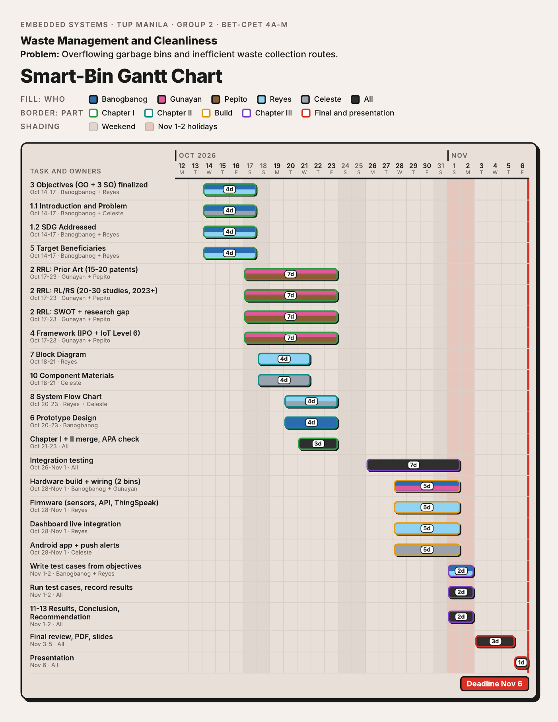

Appendix B
Bill of Materials of the Smart-Bin Prototype
Component | Qty | Unit price | Amount
ESP32 DevKit V1 (38-pin, WROOM-32D) | 2 | ₱250.00 | ₱500.00
HC-SR04 ultrasonic sensor | 2 | ₱45.00 | ₱90.00
HC-SR501 PIR motion sensor | 2 | ₱55.00 | ₱110.00
SG90 micro servo motor (180°) | 2 | ₱65.00 | ₱130.00
2.4-in. TFT touch display (ILI9341 + XPT2046) | 2 | ₱280.00 | ₱560.00
BMI160 six-axis inertial sensor module | 2 | ₱80.00 | ₱160.00
BME680 environmental sensor | 2 | ₱400.00 | ₱800.00
HX711 load cell amplifier board | 2 | ₱60.00 | ₱120.00
5kg straight bar load cell | 2 | ₱120.00 | ₱240.00
KY-016 RGB LED module (common cathode) | 2 | ₱8.00 | ₱16.00
MH-FMD passive buzzer module | 2 | ₱12.00 | ₱24.00
18650 battery shield, 4-cell (Bin A) | 1 | ₱310.00 | ₱310.00
18650 battery shield, 2-cell (Bin B) | 1 | ₱206.00 | ₱206.00
18650 Li-ion cell, 3.7V 2500mAh | 6 | ₱203.00 | ₱1,218.00
Ceramic capacitor 100nF (pack of 10) | 2 | ₱75.00 | ₱150.00
Electrolytic capacitor 10µF (pack of 10) | 1 | ₱39.00 | ₱39.00
Electrolytic capacitor 1000µF (pack of 10) | 1 | ₱165.00 | ₱165.00
Resistor 1kΩ (pack of 10) | 1 | ₱19.00 | ₱19.00
Resistor 2.2kΩ (pack of 10) | 1 | ₱19.00 | ₱19.00
Resistor 10kΩ (pack of 10) | 1 | ₱19.00 | ₱19.00
Total |  |  | ₱4,895.00
Note. Quantities apply to both bins. The prices from the ESP32 to the buzzer are the market prices of the group as of their check in October 2026.

Appendix C
User Interface Screens
[Include images of the touchscreen, Web dashboard and Android app here. Number them Figure C1, Figure C2 and so on, with the bold label and the italic title above each image.]

Appendix D
Source Code
This appendix lists the firmware that runs on both Smart-Bin ESP32 boards. It is the firmware folder of the main branch of the group's repository, https://github.com/GenReyes/Smart-Bin-Embedded-Systems, as of October 24, 2026 (commit 1984c11), with comments added to explain what each part does and where to look when debugging. SmartBin.ino starts the modules, and each pair of .h and .cpp files is one module: shared state, sensors, control of the lid and alarms, buzzer, local Wi-Fi API, cloud (Firebase and ThingSpeak), Bluetooth Wi-Fi setup, and the touchscreen. The last two listings are the Firebase security rules and the script that packs the web dashboard into the firmware.
Two files are not listed. secrets.h holds the Wi-Fi password and the cloud keys and is kept out of the repository; secrets.example.h shows its layout. dashboard_gz.h is generated by embed_dashboard.py and holds the compressed web dashboard as a byte array. The Android app and the web dashboard are in the same repository.
firmware/SmartBin/SmartBin.ino
1 // ============================================================================
2 // SmartBin.ino - entry point
3 // Starts every module in a fixed order, then hands control to FreeRTOS tasks.
4 // The Arduino loop() is not used: it deletes itself, so all work happens in
5 // the tasks created below. If the board resets in a loop, open the Serial
6 // Monitor at 115200 baud; the first line printed here shows the bin ID and
7 // firmware version, and a crash before it points to a module's init().
8 // ============================================================================
9 // Smart-Bin ESP32 firmware. Group 2, BET-CpET 4A-M, TUP Manila.
10 // Before uploading: copy secrets.example.h to secrets.h and fill it in,
11 // and set BIN_NUMBER in config.h (1 for Bin A, 2 for Bin B).
12
13 #include "config.h"
14 #include "state.h"
15 #include "sensors.h"
16 #include "control.h"
17 #include "buzzer.h"
18 #include "net.h"
19 #include "cloud.h"
20 #include "ui.h"
21
22 void setup() {
23 Serial.begin(115200);
24 delay(200);
25 Serial.printf("\nSmart-Bin %s firmware v%s\n", BIN_ID, FW_VERSION);
26
27 // Order matters: the state module creates the mutex and queues every other
28 // module uses, so it must run first. The UI comes next so the screen shows
29 // the boot page while the sensors are still being probed.
30 stateInit();
31 uiInit();
32 buzzerInit();
33 controlInit();
34 sensorsInit();
35 netInit();
36
37 // Task layout: name, stack bytes, priority, core. Core 1 runs the time
38 // critical work (control has the highest priority so the lid and alarms
39 // react first); core 0 runs the slow network jobs next to the Wi-Fi stack.
40 // A "stack canary" or "stack overflow" reset names the task whose stack
41 // size here is too small.
42 xTaskCreatePinnedToCore(uiTask, "ui", 8192, nullptr, 2, &hUi, 1);
43 xTaskCreatePinnedToCore(cloudTask, "cloud", 12288, nullptr, 1, &hCloud, 0);
44 xTaskCreatePinnedToCore(pushTask, "push", 4096, nullptr, 2, &hPush, 0);
45 xTaskCreatePinnedToCore(controlTask, "control", 4096, nullptr, 4, &hControl, 1);
46 xTaskCreatePinnedToCore(sensorTask, "sensor", 4096, nullptr, 3, &hSensor, 1);
47
48 // Interrupts only wake a task; no work is done inside the ISR itself.
49 attachInterrupt(digitalPinToInterrupt(PIN_PIR), isrPir, CHANGE);
50 attachInterrupt(digitalPinToInterrupt(PIN_TOUCH_IRQ), isrTouch, FALLING);
51 #if USE_IMU_INT
52 pinMode(PIN_IMU_INT, INPUT);
53 #endif
54
55 // The local web server starts before Wi-Fi joins so it is ready the moment
56 // an IP address is given (see onWifiEvent in net.cpp).
57 startWebServer();
58 wifiConnect();
59 }
60
61 // Not used. Deleting the loop task frees its stack for the FreeRTOS tasks.
62 void loop() { vTaskDelete(nullptr); }
firmware/SmartBin/config.h
1 // ============================================================================
2 // config.h - build-time settings for one bin
3 // Pins, timing constants and the Bluetooth UUIDs. Values that users may
4 // change at run time (thresholds, PIN, sounds) live in struct Cal in state.h
5 // instead and are saved in flash.
6 // ============================================================================
7 #pragma once
8 #include <Arduino.h>
9
10 // Which bin this board is: 1 = Bin A (bin01), 2 = Bin B (bin02).
11 // Change BIN_NUMBER before flashing the second board. Both bins running the
12 // same number will overwrite each other's data in Firebase and ThingSpeak.
13 #ifndef BIN_NUMBER
14 #define BIN_NUMBER 1
15 #endif
16
17 #define FW_VERSION "1.0.0"
18
19 // Pins, from the Implementation Plan v2 pin table.
20 // GPIO 34 to 39 are input only on the ESP32, which is why the input lines
21 // SPI MISO 35, touch IRQ 36 and IMU INT 34 sit there. The buzzer is on GPIO 4,
22 // not GPIO 12: GPIO 12 is a boot strapping pin, and with the buzzer holding it
23 // high the ESP32 would not boot.
24 constexpr int PIN_TRIG = 5;
25 constexpr int PIN_ECHO = 18;
26 constexpr int PIN_BUZZER = 4;
27 constexpr int PIN_SERVO = 13;
28 constexpr int PIN_HX_SCK = 14;
29 constexpr int PIN_HX_DT = 32;
30 constexpr int PIN_TOUCH_CS = 15;
31 constexpr int PIN_TFT_DC = 16;
32 constexpr int PIN_TFT_CS = 17;
33 constexpr int PIN_SPI_MOSI = 19;
34 constexpr int PIN_SPI_SCK = 23;
35 constexpr int PIN_SPI_MISO = 35;
36 constexpr int PIN_TOUCH_IRQ = 36;
37 constexpr int PIN_SDA = 21;
38 constexpr int PIN_SCL = 22;
39 constexpr int PIN_LED_R = 25;
40 constexpr int PIN_LED_G = 26;
41 constexpr int PIN_LED_B = 33;
42 constexpr int PIN_PIR = 27;
43 constexpr int PIN_IMU_INT = 34; // optional BMI160 INT1 wire; set USE_IMU_INT to 1 once it is wired
44
45 // Hardware polarity switches. If the LED shows the wrong colors or the buzzer
46 // is silent while the Serial log says it should sound, flip these.
47 #define USE_IMU_INT 0
48 #define BUZZER_ACTIVE_LOW 0 // 1 for "low level trigger" modules
49 #define LED_ACTIVE_LOW 0 // 1 for a common-anode RGB LED
50
51 // Touch calibration (raw XPT2046 values at the screen edges). Print raw values
52 // with TOUCH_DEBUG 1, press the four corners, and copy the numbers here.
53 #define TOUCH_DEBUG 0
54 constexpr int TS_RAW_X0 = 3800, TS_RAW_X1 = 300; // raw x at screen x = 0 and x = 239
55 constexpr int TS_RAW_Y0 = 3800, TS_RAW_Y1 = 300; // raw y at screen y = 0 and y = 319
56 #define TS_SWAP_XY 0
57 constexpr uint8_t TFT_ROTATION = 2; // 0 = portrait 240 x 320
58
59 // Timing (ESP32 Integration Guide, sections 3 and 6A).
60 // All times are in milliseconds unless the name ends in _S. FB_ = Firebase,
61 // TS_ = ThingSpeak channel writes, TB_ = ThingSpeak TalkBack polling,
62 // BT_ = Bluetooth Wi-Fi setup. TS_MIN_GAP_MS keeps writes above the 15 s
63 // limit of the free ThingSpeak plan; a write sent faster than that returns 0.
64 constexpr uint32_t FB_WATCHED_MS = 5000;
65 constexpr uint32_t FB_IDLE_MS = 60000;
66 constexpr uint32_t FB_CMD_WATCHED_MS = 2000;
67 constexpr uint32_t FB_CMD_IDLE_MS = 10000;
68 constexpr uint32_t FB_WATCHERS_MS = 30000;
69 constexpr uint32_t FB_USAGE_MS = 600000;
70 constexpr uint32_t TS_WRITE_MS = 30000;
71 constexpr uint32_t TS_MIN_GAP_MS = 15500;
72 constexpr uint32_t TS_HEARTBEAT_MS = 300000;
73 constexpr uint32_t TB_WATCHED_MS = 5000;
74 constexpr uint32_t TB_IDLE_MS = 15000;
75 constexpr uint32_t CMD_MAX_AGE_MS = 60000;
76 constexpr uint32_t TAMPER_COUNTDOWN_S = 10;
77 constexpr uint32_t TAMPER_ALARM_EVERY_MS = 2000; // latched tamper siren repeats this often
78 constexpr uint32_t SCREEN_TIMEOUT_MS = 30000;
79 constexpr uint32_t BT_IDLE_OFF_MS = 300000;
80 constexpr uint32_t BT_CODE_MS = 60000;
81 constexpr uint32_t BT_LOCKOUT_MS = 60000;
82 // 10 GiB, the monthly download quota of the Firebase free plan. Used only to
83 // estimate usage; Firebase does not report it to the device.
84 constexpr uint64_t FB_MONTH_LIMIT = 10737418240ULL;
85
86 // 0 = always use the fast "someone is watching" pace. Set to 1 once the app writes
87 // /sb/watchers (Integration Guide 6A); the dashboard already does.
88 #define FB_REQUIRE_WATCHERS 0
89
90 // Bluetooth service used by the app and dashboard for Wi-Fi setup. These must
91 // match the UUIDs in the Android app (data/Ble.kt) and the web dashboard.
92 #define BT_SVC_UUID "b1a70001-5c2e-4f8a-9d33-0a9c2b6f17c1"
93 #define BT_SSID_UUID "b1a70002-5c2e-4f8a-9d33-0a9c2b6f17c1"
94 #define BT_PASS_UUID "b1a70003-5c2e-4f8a-9d33-0a9c2b6f17c1"
95 #define BT_CTRL_UUID "b1a70004-5c2e-4f8a-9d33-0a9c2b6f17c1"
96 #define BT_STAT_UUID "b1a70005-5c2e-4f8a-9d33-0a9c2b6f17c1"
97 #define BT_SCAN_UUID "b1a70006-5c2e-4f8a-9d33-0a9c2b6f17c1"
98
99 // Names derived from BIN_NUMBER. BIN_HOST gives http://smartbin-01.local on
100 // networks that support mDNS.
101 #if BIN_NUMBER == 1
102 #define BIN_ID "bin01"
103 #define BIN_LABEL "BIN 01"
104 #define BIN_HOST "smartbin-01"
105 #define BIN_BLE_NAME "SmartBin-01"
106 #else
107 #define BIN_ID "bin02"
108 #define BIN_LABEL "BIN 02"
109 #define BIN_HOST "smartbin-02"
110 #define BIN_BLE_NAME "SmartBin-02"
111 #endif
firmware/SmartBin/secrets.example.h
1 // ============================================================================
2 // secrets.example.h - template for secrets.h
3 // The firmware includes "secrets.h", not this file. A build error saying
4 // secrets.h is missing means this copy step was skipped.
5 // ============================================================================
6 #pragma once
7
8 // Copy this file to secrets.h in the same folder and fill it in.
9 // secrets.h is git-ignored. Never commit real keys, passwords or the Collect PIN.
10
11 // Wi-Fi (2.4 GHz only). Can also be changed later from WI-FI SETUP on the touchscreen.
12 #define WIFI_SSID "your-wifi-name"
13 #define WIFI_PASSWORD "your-wifi-password"
14
15 // Firebase Realtime Database. Empty = Firebase off (local Wi-Fi only).
16 // See firmware/README.md section 4. The bin signs in with its own account,
17 // for example bin01@your-project.test.
18 #define FIREBASE_URL "" // https://<project>-default-rtdb.asia-southeast1.firebasedatabase.app
19 #define FIREBASE_API_KEY "" // AIza... (Project settings > Web API key)
20 #define FIREBASE_EMAIL ""
21 #define FIREBASE_PASSWORD ""
22
23 // ThingSpeak, one channel per bin. Empty = ThingSpeak off. See firmware/README.md section 5.
24 #define THINGSPEAK_SERVER "https://api.thingspeak.com"
25 #define THINGSPEAK_WRITE_KEY_BIN_A ""
26 #define THINGSPEAK_WRITE_KEY_BIN_B ""
27 #define THINGSPEAK_TALKBACK_ID_BIN_A ""
28 #define THINGSPEAK_TALKBACK_KEY_BIN_A ""
29 #define THINGSPEAK_TALKBACK_ID_BIN_B ""
30 #define THINGSPEAK_TALKBACK_KEY_BIN_B ""
31
32 // Default Collect PIN (4 digits). It can be changed later from the dashboard or app.
33 #define COLLECT_PIN "0000"
firmware/SmartBin/state.h
1 // ============================================================================
2 // state.h - shared data model
3 // Every task reads and writes the same BinState (st), calibration (cal) and
4 // simulation (sim) objects. Always wrap access in lockState()/unlockState(),
5 // or take a copy with snapshot()/calSnapshot()/simSnapshot(). Reading st
6 // without the lock can show half-updated values on the screen or dashboard.
7 // ============================================================================
8 #pragma once
9 #include <Arduino.h>
10 #include <ArduinoJson.h>
11 #include "config.h"
12
13 // The one status shown everywhere. Priority, highest first, is decided in
14 // controlTask: CALIBRATING > COLLECTING > TAMPER > LOCKED > OK.
15 enum BinStatus : uint8_t { ST_OK = 0, ST_LOCKED, ST_TAMPER, ST_COLLECTING, ST_CALIBRATING };
16 extern const char* const STATUS_NAMES[5];
17
18 // User settings, saved in flash as one binary blob ("cal"). Distances are in
19 // cm, weights in grams, temperatures in deg C, gas_th is the IAQ index limit,
20 // quiet_from/quiet_to are minutes after midnight (local time, UTC+8).
21 // Adding or reordering a field changes sizeof(Cal), and loadCal() then
22 // ignores the old saved blob and falls back to these defaults.
23 struct Cal {
24 float d_empty = 30, d_full = 5, fill_th = 80, temp_th = 40, hum_th = 85, gas_th = 200, tilt_th = 30, weight_cap = 4500;
25 uint8_t auto_lock = 0;
26 int16_t servo_closed = 0, servo_open = 90;
27 uint16_t collect_pin = 0;
28 uint16_t pir_hold_s = 5, buzz_s = 2;
29 float temp_off = -2, hum_off = 0, press_off = 0;
30 uint8_t buzz_on = 1, buzz_vol = 2, buzz_ui = 1, buzz_lid = 0;
31 uint16_t buzz_repeat_s = 30;
32 uint8_t quiet_on = 0;
33 uint16_t quiet_from = 1320, quiet_to = 360;
34 };
35
36 // Raw XPT2046 readings at the screen edges, set by the touch calibration.
37 struct TouchCal {
38 uint8_t swap = TS_SWAP_XY;
39 int16_t x0 = TS_RAW_X0, x1 = TS_RAW_X1, y0 = TS_RAW_Y0, y1 = TS_RAW_Y1;
40 };
41 extern TouchCal touchCal;
42 extern bool touchCalCustom;
43 void saveTouchCal();
44 void loadTouchCal();
45 void resetTouchCal();
46
47 // Simulation overrides for testing without real waste. mask bits:
48 // 1 fill, 2 weight, 4 gas, 8 temperature and humidity, 16 tilt (tamper),
49 // 32 motion, 64 lid. A set bit replaces that sensor's value in the view.
50 struct Sim {
51 uint8_t mask = 0;
52 float fill = 60, weight = 2000, gas = 120, temp = 28, humidity = 60;
53 bool tamper = false, motion = false, lid = false;
54 };
55
56 // One set of sensor values. iaq_acc is the air-quality accuracy:
57 // 0 warming up, 1 low, 2 medium, 3 high.
58 struct Reading {
59 float fill = 0, distance_cm = 0, weight_g = 0, temp = 0, temp_raw = 0, humidity = 0, pressure = 0, iaq = 0, tilt = 0, gas_k = 0;
60 uint8_t iaq_acc = 0;
61 bool motion = false;
62 };
63
64 struct LastCmd {
65 char cmd[20] = "";
66 uint64_t ts = 0;
67 bool ok = false;
68 };
69
70 // The live state of the bin. raw holds sensor values, v holds what users see
71 // (raw with simulation applied by recomputeView()). The ok* flags are false
72 // while a sensor is not answering; they drive the "faults" list in the JSON.
73 struct BinState {
74 Reading raw; // what the sensors read
75 Reading v; // what everyone sees (raw with simulation applied)
76 bool lidOpen = false;
77 BinStatus status = ST_OK;
78 bool locked = false, collecting = false, calibrating = false, autoLocked = false;
79 uint8_t tamperPhase = 0; // 0 none, 1 countdown, 2 latched
80 uint32_t tamperStartMs = 0;
81 bool okHC = false, okHX = false, okBME = false, okIMU = false;
82 bool booting = true;
83 bool wifi = false, cloudOk = false, tsOk = false, btOn = false;
84 int rssi = 0;
85 uint32_t lidCloseAtMs = 0; // 0 = no countdown; lid holds while motion is high
86 bool alarmFull = false, alarmEnv = false, buzzerOn = false;
87 uint32_t buzzerUntilMs = 0;
88 float fillRatePerHour = 0;
89 uint8_t calSteps = 0; // bit 0 tare, bit 1 empty distance, bit 2 full distance
90 uint32_t doneAtMs = 0; // when COLLECT_DONE ran, for the A5 screen
91 LastCmd last;
92 uint32_t version = 0;
93 uint32_t calVersion = 0;
94 };
95
96 // Where a command came from. Results are written back only for Firebase
97 // commands (they carry a ref key); screen commands skip some beeps because
98 // the screen already gave feedback.
99 enum CmdSource : uint8_t { SRC_LOCAL = 0, SRC_SCREEN, SRC_FIREBASE, SRC_TALKBACK };
100
101 struct Command {
102 char cmd[20];
103 float grams;
104 char sound[16];
105 uint8_t src;
106 char ref[28];
107 };
108
109 struct CmdResult {
110 char cmd[20];
111 bool ok;
112 char why[40];
113 uint8_t src;
114 char ref[28];
115 uint64_t ts;
116 };
117
118 struct AlertEv {
119 char kind[10];
120 char sev[10];
121 char title[40];
122 char meta[72];
123 };
124
125 // Task notification bits. A task waits on these with xTaskNotifyWait, so one
126 // notify wakes it immediately instead of waiting for its next timeout.
127 enum : uint32_t {
128 EV_PIR = 1 << 0, EV_TOUCH = 1 << 1, EV_IMU = 1 << 2, EV_STATE = 1 << 3, EV_CMD = 1 << 4,
129 EV_CAL = 1 << 5, EV_WIFI = 1 << 6, EV_ALERT = 1 << 7, EV_RESULT = 1 << 8, EV_BT = 1 << 9,
130 };
131
132 extern BinState st;
133 extern Cal cal;
134 extern Sim sim;
135 extern SemaphoreHandle_t stLock;
136 extern QueueHandle_t cmdQueue, resultQueue, alertQueue;
137 extern TaskHandle_t hControl, hSensor, hUi, hCloud, hPush;
138
139 // Network and cloud credentials. Loaded from flash, falling back to the
140 // values in secrets.h when nothing has been saved yet.
141 struct NetCfg {
142 String ssid, pass;
143 String fbUrl, fbKey, fbEmail, fbPass;
144 String tsServer, tsWriteKey, tbId, tbKey;
145 };
146 extern NetCfg net;
147
148 // --- Lock, copy and publish ---
149 // publish() bumps st.version and wakes the UI, cloud and push tasks.
150 // Call it after any change that users should see.
151 void stateInit();
152 void lockState();
153 void unlockState();
154 BinState snapshot();
155 Cal calSnapshot();
156 Sim simSnapshot();
157 void publish(uint32_t extraBits = 0);
158 void notifyAll(uint32_t bits);
159
160 // --- Flash storage (Preferences namespace "smartbin") ---
161 void saveCal();
162 void loadCal();
163 void saveNet();
164 void loadNet();
165 uint8_t loadTheme();
166 void saveTheme(uint8_t dark);
167 void saveHx(int32_t offset, float scale);
168 bool loadHx(int32_t& offset, float& scale);
169 void saveGasBaseline(float g);
170 float loadGasBaseline();
171 void saveImuRef(float x, float y, float z);
172 bool loadImuRef(float& x, float& y, float& z);
173
174 // --- JSON for the local API, live events and Firebase ---
175 void calToJson(const Cal& c, JsonObject o);
176 bool calFromJson(JsonObjectConst o, Cal& c);
177 void statusToJson(const BinState& s, const Cal& c, const Sim& sm, JsonObject o, bool withCal, bool forCloud);
178 String statusJson(bool withCal = true, bool forCloud = false);
179 String localIp();
180
181 // --- Commands and alerts ---
182 // sendCommand() only queues; controlTask runs it. validateCommand() is also
183 // called by the web server first so it can answer 400/409 right away.
184 bool sendCommand(const char* cmd, uint8_t src, float grams = 0, const char* sound = nullptr, const char* ref = nullptr);
185 bool validateCommand(const char* cmd, const BinState& s, String& why);
186 void raiseAlert(const char* kind, const char* sev, const char* title, const char* meta);
187
188 // --- Time. nowMs() returns 0 until SNTP has set the clock. ---
189 uint64_t nowMs();
190 bool clockSet();
191 int localMinuteOfDay();
192 void monthKeyUtc(char* out, size_t n);
firmware/SmartBin/state.cpp
1 // ============================================================================
2 // state.cpp - shared state, flash storage, JSON and command plumbing
3 // ============================================================================
4 #include "state.h"
5 #include "sensors.h"
6 #include <Preferences.h>
7 #include <WiFi.h>
8 #include <sys/time.h>
9 #include "secrets.h"
10
11 const char* const STATUS_NAMES[5] = {"OK", "LOCKED", "TAMPER", "COLLECTING", "CALIBRATING"};
12
13 BinState st;
14 Cal cal;
15 Sim sim;
16 NetCfg net;
17 SemaphoreHandle_t stLock;
18 QueueHandle_t cmdQueue, resultQueue, alertQueue;
19 TaskHandle_t hControl = nullptr, hSensor = nullptr, hUi = nullptr, hCloud = nullptr, hPush = nullptr;
20
21 // Preferences (NVS flash) is not safe to use from two tasks at once, so every
22 // access goes through prefsBegin()/prefsEnd(), which hold prefsLock.
23 static Preferences prefs;
24 static SemaphoreHandle_t prefsLock;
25
26 // Queue depths are small on purpose: if a queue is full, sendCommand()
27 // fails and the caller reports "Busy" instead of blocking a task.
28 void stateInit() {
29 stLock = xSemaphoreCreateMutex();
30 prefsLock = xSemaphoreCreateMutex();
31 cmdQueue = xQueueCreate(8, sizeof(Command));
32 resultQueue = xQueueCreate(8, sizeof(CmdResult));
33 alertQueue = xQueueCreate(8, sizeof(AlertEv));
34 cal.collect_pin = (uint16_t)atoi(COLLECT_PIN);
35 loadCal();
36 loadTouchCal();
37 loadNet();
38 }
39
40 void lockState() { xSemaphoreTake(stLock, portMAX_DELAY); }
41 void unlockState() { xSemaphoreGive(stLock); }
42
43 BinState snapshot() {
44 lockState();
45 BinState s = st;
46 unlockState();
47 return s;
48 }
49
50 Cal calSnapshot() {
51 lockState();
52 Cal c = cal;
53 unlockState();
54 return c;
55 }
56
57 Sim simSnapshot() {
58 lockState();
59 Sim s = sim;
60 unlockState();
61 return s;
62 }
63
64 // Wakes the three tasks that display or send state. A handle is null until
65 // its task has been created in setup().
66 void notifyAll(uint32_t bits) {
67 TaskHandle_t hs[] = {hUi, hCloud, hPush};
68 for (TaskHandle_t h : hs)
69 if (h) xTaskNotify(h, bits, eSetBits);
70 }
71
72 void publish(uint32_t extraBits) {
73 lockState();
74 st.version++;
75 unlockState();
76 notifyAll(EV_STATE | extraBits);
77 }
78
79 static void prefsBegin(bool ro) {
80 xSemaphoreTake(prefsLock, portMAX_DELAY);
81 prefs.begin("smartbin", ro);
82 }
83 static void prefsEnd() {
84 prefs.end();
85 xSemaphoreGive(prefsLock);
86 }
87
88 // Calibration is stored as a raw struct. loadCal() only accepts a blob of the
89 // exact current size, so a firmware with a changed Cal struct starts from
90 // defaults instead of reading garbage.
91 void saveCal() {
92 Cal c = calSnapshot();
93 prefsBegin(false);
94 prefs.putBytes("cal", &c, sizeof(c));
95 prefsEnd();
96 }
97
98 void loadCal() {
99 prefsBegin(true);
100 if (prefs.getBytesLength("cal") == sizeof(Cal)) prefs.getBytes("cal", &cal, sizeof(Cal));
101 prefsEnd();
102 }
103
104 TouchCal touchCal;
105 bool touchCalCustom = false;
106
107 void saveTouchCal() {
108 prefsBegin(false);
109 prefs.putBytes("touch", &touchCal, sizeof(touchCal));
110 prefsEnd();
111 touchCalCustom = true;
112 }
113
114 void loadTouchCal() {
115 prefsBegin(true);
116 if (prefs.getBytesLength("touch") == sizeof(TouchCal)) {
117 prefs.getBytes("touch", &touchCal, sizeof(TouchCal));
118 touchCalCustom = true;
119 }
120 prefsEnd();
121 }
122
123 void resetTouchCal() {
124 touchCal = TouchCal();
125 prefsBegin(false);
126 prefs.remove("touch");
127 prefsEnd();
128 touchCalCustom = false;
129 }
130
131 // Wi-Fi and Firebase settings changed from the screen, Bluetooth setup or
132 // /api/cloud are kept here and survive a reflash of the same partition.
133 void saveNet() {
134 prefsBegin(false);
135 prefs.putString("ssid", net.ssid);
136 prefs.putString("pass", net.pass);
137 prefs.putString("fbUrl", net.fbUrl);
138 prefs.putString("fbKey", net.fbKey);
139 prefs.putString("fbEmail", net.fbEmail);
140 prefs.putString("fbPass", net.fbPass);
141 prefsEnd();
142 }
143
144 // ThingSpeak keys come only from secrets.h; each bin picks its own channel.
145 void loadNet() {
146 prefsBegin(true);
147 net.ssid = prefs.getString("ssid", WIFI_SSID);
148 net.pass = prefs.getString("pass", WIFI_PASSWORD);
149 net.fbUrl = prefs.getString("fbUrl", FIREBASE_URL);
150 net.fbKey = prefs.getString("fbKey", FIREBASE_API_KEY);
151 net.fbEmail = prefs.getString("fbEmail", FIREBASE_EMAIL);
152 net.fbPass = prefs.getString("fbPass", FIREBASE_PASSWORD);
153 prefsEnd();
154 net.tsServer = THINGSPEAK_SERVER;
155 #if BIN_NUMBER == 1
156 net.tsWriteKey = THINGSPEAK_WRITE_KEY_BIN_A;
157 net.tbId = THINGSPEAK_TALKBACK_ID_BIN_A;
158 net.tbKey = THINGSPEAK_TALKBACK_KEY_BIN_A;
159 #else
160 net.tsWriteKey = THINGSPEAK_WRITE_KEY_BIN_B;
161 net.tbId = THINGSPEAK_TALKBACK_ID_BIN_B;
162 net.tbKey = THINGSPEAK_TALKBACK_KEY_BIN_B;
163 #endif
164 if (net.tsWriteKey.startsWith("WRITE_KEY")) net.tsWriteKey = "";
165 }
166
167 uint8_t loadTheme() {
168 prefsBegin(true);
169 uint8_t t = prefs.getUChar("theme", 0);
170 prefsEnd();
171 return t;
172 }
173
174 void saveTheme(uint8_t dark) {
175 prefsBegin(false);
176 prefs.putUChar("theme", dark);
177 prefsEnd();
178 }
179
180 void saveHx(int32_t offset, float scale) {
181 prefsBegin(false);
182 prefs.putInt("hxOff", offset);
183 prefs.putFloat("hxScale", scale);
184 prefsEnd();
185 }
186
187 // Load-cell offset and scale from the last TARE and CAL_WEIGHT. Returns false
188 // when the scale was never calibrated (weights will then be rough).
189 bool loadHx(int32_t& offset, float& scale) {
190 prefsBegin(true);
191 bool has = prefs.isKey("hxScale");
192 offset = prefs.getInt("hxOff", 0);
193 scale = prefs.getFloat("hxScale", 420.0f);
194 prefsEnd();
195 return has;
196 }
197
198 void saveGasBaseline(float g) {
199 prefsBegin(false);
200 prefs.putFloat("gasBase", g);
201 prefsEnd();
202 }
203
204 float loadGasBaseline() {
205 prefsBegin(true);
206 float g = prefs.getFloat("gasBase", 0);
207 prefsEnd();
208 return g;
209 }
210
211 void saveImuRef(float x, float y, float z) {
212 float v[3] = {x, y, z};
213 prefsBegin(false);
214 prefs.putBytes("imuRef", v, sizeof(v));
215 prefsEnd();
216 }
217
218 bool loadImuRef(float& x, float& y, float& z) {
219 float v[3];
220 prefsBegin(true);
221 bool ok = prefs.getBytesLength("imuRef") == sizeof(v) && prefs.getBytes("imuRef", v, sizeof(v)) == sizeof(v);
222 prefsEnd();
223 if (ok) { x = v[0]; y = v[1]; z = v[2]; }
224 return ok;
225 }
226
227 // Round to 1 or 2 decimals so the JSON stays short and readable.
228 static double r1(float v) { return round(v * 10.0) / 10.0; }
229 static double r2(float v) { return round(v * 100.0) / 100.0; }
230
231 void calToJson(const Cal& c, JsonObject o) {
232 o["d_empty"] = r1(c.d_empty);
233 o["d_full"] = r1(c.d_full);
234 o["fill_th"] = r1(c.fill_th);
235 o["temp_th"] = r1(c.temp_th);
236 o["hum_th"] = r1(c.hum_th);
237 o["gas_th"] = r1(c.gas_th);
238 o["tilt_th"] = r1(c.tilt_th);
239 o["weight_cap"] = r1(c.weight_cap);
240 o["auto_lock"] = c.auto_lock;
241 o["servo_closed"] = c.servo_closed;
242 o["servo_open"] = c.servo_open;
243 o["collect_pin"] = c.collect_pin;
244 o["pir_hold_s"] = c.pir_hold_s;
245 o["buzz_s"] = c.buzz_s;
246 o["temp_off"] = r1(c.temp_off);
247 o["hum_off"] = r1(c.hum_off);
248 o["press_off"] = r1(c.press_off);
249 o["buzz_on"] = c.buzz_on;
250 o["buzz_vol"] = c.buzz_vol;
251 o["buzz_ui"] = c.buzz_ui;
252 o["buzz_lid"] = c.buzz_lid;
253 o["buzz_repeat_s"] = c.buzz_repeat_s;
254 o["quiet_on"] = c.quiet_on;
255 o["quiet_from"] = c.quiet_from;
256 o["quiet_to"] = c.quiet_to;
257 }
258
259 // Reads one numeric key, accepts numbers or numeric strings, and clamps it to
260 // [lo, hi]. Out-of-range values are clamped, not rejected, so a typo cannot
261 // push the bin into an unusable setting.
262 template <typename T>
263 static bool take(JsonObjectConst o, const char* k, T& dst, float lo, float hi) {
264 JsonVariantConst v = o[k];
265 if (v.isNull() || !(v.is<float>() || v.is<int>() || v.is<const char*>())) return false;
266 float f = v.is<const char*>() ? atof(v.as<const char*>()) : v.as<float>();
267 if (isnan(f)) return false;
268 f = constrain(f, lo, hi);
269 dst = (T)f;
270 return true;
271 }
272
273 // Applies any known calibration keys. Returns false when the request had none
274 // (the API then answers 400). The empty distance must stay larger than the
275 // full distance or the fill formula divides by zero or goes negative.
276 bool calFromJson(JsonObjectConst o, Cal& c) {
277 bool any = false;
278 any |= take(o, "d_empty", c.d_empty, 5, 200);
279 any |= take(o, "d_full", c.d_full, 1, 100);
280 any |= take(o, "fill_th", c.fill_th, 10, 100);
281 any |= take(o, "temp_th", c.temp_th, 10, 85);
282 any |= take(o, "hum_th", c.hum_th, 10, 100);
283 any |= take(o, "gas_th", c.gas_th, 50, 500);
284 any |= take(o, "tilt_th", c.tilt_th, 5, 90);
285 any |= take(o, "weight_cap", c.weight_cap, 100, 50000);
286 any |= take(o, "auto_lock", c.auto_lock, 0, 1);
287 any |= take(o, "servo_closed", c.servo_closed, 0, 180);
288 any |= take(o, "servo_open", c.servo_open, 0, 180);
289 any |= take(o, "collect_pin", c.collect_pin, 0, 9999);
290 any |= take(o, "pir_hold_s", c.pir_hold_s, 1, 120);
291 any |= take(o, "buzz_s", c.buzz_s, 0, 60);
292 any |= take(o, "temp_off", c.temp_off, -20, 20);
293 any |= take(o, "hum_off", c.hum_off, -30, 30);
294 any |= take(o, "press_off", c.press_off, -100, 100);
295 any |= take(o, "buzz_on", c.buzz_on, 0, 1);
296 any |= take(o, "buzz_vol", c.buzz_vol, 1, 3);
297 any |= take(o, "buzz_ui", c.buzz_ui, 0, 1);
298 any |= take(o, "buzz_lid", c.buzz_lid, 0, 1);
299 any |= take(o, "buzz_repeat_s", c.buzz_repeat_s, 10, 300);
300 any |= take(o, "quiet_on", c.quiet_on, 0, 1);
301 any |= take(o, "quiet_from", c.quiet_from, 0, 1439);
302 any |= take(o, "quiet_to", c.quiet_to, 0, 1439);
303 if (c.d_full >= c.d_empty) c.d_full = c.d_empty - 1;
304 return any;
305 }
306
307 String localIp() { return WiFi.isConnected() ? WiFi.localIP().toString() : String(""); }
308
309 // Builds the status object used by /api/status, the live event stream and
310 // Firebase. A sensor's values are left out while it is faulty (and not
311 // simulated), so the apps show "--" instead of stale numbers.
312 void statusToJson(const BinState& s, const Cal& c, const Sim& sm, JsonObject o, bool withCal, bool forCloud) {
313 const Reading& v = s.v;
314 bool hc = s.okHC || (sm.mask & 1), hx = s.okHX || (sm.mask & 2), bme = s.okBME || (sm.mask & 12) == 12;
315 o["id"] = BIN_ID;
316 o["name"] = BIN_LABEL;
317 if (hc) {
318 o["fill"] = r1(v.fill);
319 o["distance_cm"] = r1(v.distance_cm);
320 }
321 if (hx) o["weight_g"] = (long)lround(v.weight_g);
322 if (bme || (sm.mask & 8)) {
323 o["temp"] = r2(v.temp);
324 o["temp_raw"] = r2(v.temp_raw);
325 o["humidity"] = r1(v.humidity);
326 }
327 if (s.okBME) o["pressure"] = r1(v.pressure);
328 if (s.okBME) o["gas_k"] = r1(v.gas_k);
329 if (s.okBME && v.iaq_acc == 0 && !(sm.mask & 4)) o["iaq_warm_s"] = airWarmLeft();
330 if (s.okBME || (sm.mask & 4)) {
331 o["iaq"] = (long)lround(v.iaq);
332 o["iaq_acc"] = v.iaq_acc;
333 }
334 o["tilt"] = r1(v.tilt);
335 o["motion"] = v.motion;
336 o["lid"] = s.lidOpen ? "OPEN" : "CLOSED";
337 o["status"] = STATUS_NAMES[s.status];
338 o["sim_mask"] = sm.mask;
339 if (s.tamperPhase) o["tamper_phase"] = s.tamperPhase == 1 ? "COUNTDOWN" : "LATCHED";
340 JsonArray f = o["faults"].to<JsonArray>();
341 if (!s.okHC) f.add("HC-SR04");
342 if (!s.okHX) f.add("HX711");
343 if (!s.okBME) f.add("BME680");
344 if (!s.okIMU) f.add("BMI160");
345 if (withCal) calToJson(c, o["cal"].to<JsonObject>());
346 if (withCal) {
347 JsonObject t = o["touch"].to<JsonObject>();
348 t["swap"] = touchCal.swap;
349 t["x0"] = touchCal.x0;
350 t["x1"] = touchCal.x1;
351 t["y0"] = touchCal.y0;
352 t["y1"] = touchCal.y1;
353 t["custom"] = touchCalCustom;
354 }
355 if (s.last.cmd[0]) {
356 JsonObject lc = o["last_cmd"].to<JsonObject>();
357 lc["cmd"] = s.last.cmd;
358 lc["ts"] = s.last.ts;
359 lc["ok"] = s.last.ok;
360 }
361 o["uptime_s"] = (uint32_t)(millis() / 1000);
362 o["rssi"] = s.rssi;
363 o["fw"] = FW_VERSION;
364 // ".sv": "timestamp" asks Firebase to fill in its own server time.
365 if (forCloud) {
366 o["local_ip"] = localIp();
367 o["ts"][".sv"] = "timestamp";
368 }
369 }
370
371 String statusJson(bool withCal, bool forCloud) {
372 lockState();
373 BinState s = st;
374 Cal c = cal;
375 Sim sm = sim;
376 unlockState();
377 JsonDocument doc;
378 statusToJson(s, c, sm, doc.to<JsonObject>(), withCal, forCloud);
379 String out;
380 serializeJson(doc, out);
381 return out;
382 }
383
384 // Every command the bin accepts. The apps send these exact strings.
385 static const char* const KNOWN[] = {"LOCK", "UNLOCK", "CLEAR_TAMPER", "COLLECT", "COLLECT_DONE", "CALIBRATE_START",
386 "CALIBRATE_END", "TARE", "CAL_WEIGHT", "RESET_GAS", "BUZZ_TEST",
387 "TOUCH_CAL", "TOUCH_CAL_RESET"};
388
389 // Rejects commands that would conflict with the current state. The "why"
390 // text is shown to the user, so keep it short.
391 bool validateCommand(const char* cmd, const BinState& s, String& why) {
392 bool known = false;
393 for (const char* k : KNOWN)
394 if (!strcmp(k, cmd)) known = true;
395 if (!known) { why = "Unknown command"; return false; }
396 if (!strcmp(cmd, "COLLECT")) {
397 if (s.calibrating) { why = "Calibrating"; return false; }
398 if (s.tamperPhase) { why = "TAMPER active"; return false; }
399 }
400 if (!strcmp(cmd, "LOCK") && s.collecting) { why = "Collection in progress"; return false; }
401 if (!strcmp(cmd, "CALIBRATE_START") && s.collecting) { why = "Collection in progress"; return false; }
402 if ((!strcmp(cmd, "TARE") || !strcmp(cmd, "CAL_WEIGHT")) && !s.okHX) { why = "Load cell not answering"; return false; }
403 if (!strcmp(cmd, "RESET_GAS") && !s.okBME) { why = "BME680 not answering"; return false; }
404 return true;
405 }
406
407 // Queues a command for controlTask and wakes it. Waits at most 50 ms for a
408 // free slot; false means the queue was full.
409 bool sendCommand(const char* cmd, uint8_t src, float grams, const char* sound, const char* ref) {
410 Command c{};
411 strlcpy(c.cmd, cmd, sizeof(c.cmd));
412 c.grams = grams;
413 c.src = src;
414 if (sound) strlcpy(c.sound, sound, sizeof(c.sound));
415 if (ref) strlcpy(c.ref, ref, sizeof(c.ref));
416 if (xQueueSend(cmdQueue, &c, pdMS_TO_TICKS(50)) != pdTRUE) return false;
417 if (hControl) xTaskNotify(hControl, EV_CMD, eSetBits);
418 return true;
419 }
420
421 // Queues an alert for cloudTask, which logs it to Serial as "[alert] ..." and
422 // posts it to Firebase. If alerts never reach the app, check the Serial log
423 // for these lines first, then the Firebase rules.
424 void raiseAlert(const char* kind, const char* sev, const char* title, const char* meta) {
425 AlertEv a{};
426 strlcpy(a.kind, kind, sizeof(a.kind));
427 strlcpy(a.sev, sev, sizeof(a.sev));
428 strlcpy(a.title, title, sizeof(a.title));
429 strlcpy(a.meta, meta, sizeof(a.meta));
430 xQueueSend(alertQueue, &a, 0);
431 if (hCloud) xTaskNotify(hCloud, EV_ALERT, eSetBits);
432 }
433
434 // The clock counts as set once it is past November 2023 (Unix 1700000000).
435 bool clockSet() { return time(nullptr) > 1700000000; }
436
437 // Philippine time is UTC+8 with no daylight saving, so a fixed offset is used.
438 int localMinuteOfDay() {
439 if (!clockSet()) return -1;
440 return (int)(((uint64_t)time(nullptr) + 8 * 3600ULL) / 60ULL % 1440ULL);
441 }
442
443 // Converts today's date to "YYYY-MM" without the C time library (civil-from-
444 // days algorithm). Used as the key for the monthly Firebase usage counter.
445 void monthKeyUtc(char* out, size_t n) {
446 out[0] = 0;
447 if (!clockSet()) return;
448 int64_t z = (int64_t)(time(nullptr) / 86400) + 719468;
449 int64_t era = z / 146097;
450 int64_t doe = z - era * 146097;
451 int64_t yoe = (doe - doe / 1460 + doe / 36524 - doe / 146096) / 365;
452 int64_t doy = doe - (365 * yoe + yoe / 4 - yoe / 100);
453 int64_t mp = (5 * doy + 2) / 153;
454 int m = (int)(mp < 10 ? mp + 3 : mp - 9);
455 int y = (int)(yoe + era * 400 + (m <= 2));
456 snprintf(out, n, "%04d-%02d", y, m);
457 }
458
459 uint64_t nowMs() {
460 if (!clockSet()) return 0;
461 struct timeval tv;
462 gettimeofday(&tv, nullptr);
463 return (uint64_t)tv.tv_sec * 1000ULL + tv.tv_usec / 1000;
464 }
firmware/SmartBin/sensors.h
1 // ============================================================================
2 // sensors.h - sensor task and calibration requests
3 // The request* functions only set a flag; sensorTask does the actual work on
4 // its next pass, so they are safe to call from any task.
5 // ============================================================================
6 #pragma once
7 #include <Arduino.h>
8
9 void sensorsInit();
10 void sensorTask(void*);
11 void recomputeView();
12
13 void requestTare();
14 void requestCalWeight(float grams);
15 void requestGasReset();
16 void requestImuReference();
17 int airWarmLeft();
firmware/SmartBin/sensors.cpp
1 // ============================================================================
2 // sensors.cpp - reads every sensor and keeps st.raw up to date
3 // HC-SR04 ultrasonic -> distance and fill % every 200 ms
4 // BMI160 accelerometer -> tilt in degrees every 200 ms (raw I2C)
5 // HX711 load cell -> weight in grams whenever a sample is ready
6 // BME680 -> temp, humidity, pressure, gas, IAQ every 3 s
7 // A sensor that stops answering sets its ok* flag to false; controlTask turns
8 // that into a "Sensor not answering" alert and the screen shows "--".
9 // ============================================================================
10 #include "sensors.h"
11 #include "state.h"
12 #include "buzzer.h"
13 #include <Wire.h>
14 #include <Adafruit_BME680.h>
15 #include <HX711.h>
16
17 static Adafruit_BME680 bme(&Wire);
18 static uint8_t imuAddr = 0;
19
20 // --- BMI160 over raw I2C (no library) ---
21 // Register map from the BMI160 datasheet: 0x00 CHIP_ID (0xD1), 0x03 PMU
22 // status, 0x12 accel data, 0x40 ACC_CONF, 0x41 ACC_RANGE, 0x7E CMD.
23 static bool imuWrite(uint8_t reg, uint8_t val) {
24 Wire.beginTransmission(imuAddr);
25 Wire.write(reg);
26 Wire.write(val);
27 return Wire.endTransmission() == 0;
28 }
29
30 static bool imuRead(uint8_t reg, uint8_t* buf, uint8_t len) {
31 Wire.beginTransmission(imuAddr);
32 Wire.write(reg);
33 if (Wire.endTransmission(false) != 0) return false;
34 if (Wire.requestFrom(imuAddr, len) != len) return false;
35 for (uint8_t i = 0; i < len; i++) buf[i] = Wire.read();
36 return true;
37 }
38
39 // Finds the BMI160 at 0x68 or 0x69 (depends on the SDO pin), soft-resets it,
40 // sets 100 Hz / +-2 g and switches the accelerometer to normal mode. Returns
41 // false if the chip ID is wrong or the accelerometer never powers up; the
42 // boot screen then shows BMI160 FAIL. Check SDA 21 / SCL 22 wiring first.
43 static bool imuStart() {
44 const uint8_t addrs[2] = {0x68, 0x69};
45 uint8_t id = 0;
46 for (uint8_t a : addrs) {
47 imuAddr = a;
48 if (imuRead(0x00, &id, 1) && id == 0xD1) break;
49 id = 0;
50 }
51 if (id != 0xD1) return false;
52 imuWrite(0x7E, 0xB6);
53 delay(100);
54 imuWrite(0x40, 0x28);
55 imuWrite(0x41, 0x03);
56 for (int i = 0; i < 3; i++) {
57 imuWrite(0x7E, 0x11);
58 delay(10);
59 uint8_t pmu = 0;
60 if (imuRead(0x03, &pmu, 1) && ((pmu >> 4) & 3) == 1) return true;
61 }
62 return false;
63 }
64
65 // Reads X, Y, Z acceleration as signed 16-bit values (little endian).
66 static bool imuAccel(int16_t a[3]) {
67 uint8_t d[6];
68 if (!imuRead(0x12, d, 6)) return false;
69 a[0] = (int16_t)(d[1] << 8 | d[0]);
70 a[1] = (int16_t)(d[3] << 8 | d[2]);
71 a[2] = (int16_t)(d[5] << 8 | d[4]);
72 return true;
73 }
74 static HX711 scale;
75
76 // Flags set by the request* functions and cleared here after the work is done.
77 static volatile bool reqTare = false, reqCalW = false, reqGas = false, reqImuRef = false;
78 static volatile float reqGrams = 0;
79
80 // Load cell: grams = (raw - hxOffset) / hxScale. 420 is a rough default for a
81 // 5 kg bar until CAL_WEIGHT is run with a known weight.
82 static int32_t hxOffset = 0;
83 static float hxScale = 420.0f;
84 static float imuRef[3] = {0, 0, 1};
85
86 // Highest gas resistance seen in clean air. IAQ is computed against it, so a
87 // bad baseline (e.g. warmed up next to garbage) makes the air look clean.
88 // RESET_GAS clears it and restarts the warm-up.
89 static float gasBaseline = 0;
90 static uint32_t gasStartMs = 0;
91 static bool baselineFromNvs = false;
92
93 void requestTare() { reqTare = true; }
94 void requestCalWeight(float grams) { reqGrams = grams; reqCalW = true; }
95 void requestGasReset() { reqGas = true; }
96 void requestImuReference() { reqImuRef = true; }
97
98 // Seconds left in the BME680 warm-up: 5 min on first start, 2 min when a
99 // baseline was saved earlier. The screen shows this countdown as "Air (warm)".
100 int airWarmLeft() {
101 uint32_t burn = baselineFromNvs ? 120 : 300;
102 uint32_t age = (millis() - gasStartMs) / 1000;
103 return age < burn ? (int)(burn - age) : 0;
104 }
105
106 // Builds st.v from st.raw plus the simulation overrides. The caller must hold
107 // the state lock. With a fill override, the distance is worked backwards so
108 // the dashboard's distance and fill stay consistent.
109 void recomputeView() {
110 Reading v = st.raw;
111 const Sim& s = sim;
112 const Cal& c = cal;
113 if (s.mask & 1) {
114 v.fill = constrain(s.fill, 0, 100);
115 v.distance_cm = c.d_empty - v.fill / 100.0f * (c.d_empty - c.d_full);
116 }
117 if (s.mask & 2) v.weight_g = s.weight;
118 if (s.mask & 4) {
119 v.iaq = s.gas;
120 v.iaq_acc = 3;
121 }
122 if (s.mask & 8) {
123 v.temp = s.temp;
124 v.temp_raw = s.temp - c.temp_off;
125 v.humidity = s.humidity;
126 }
127 if (s.mask & 16) v.tilt = s.tamper ? max(c.tilt_th + 8.0f, 38.0f) : 0.0f;
128 if (s.mask & 32) v.motion = s.motion;
129 st.v = v;
130 }
131
132 // Probes each sensor once at boot. A sensor that fails here is retried by
133 // sensorTask, so a loose wire that reconnects comes back without a reset.
134 void sensorsInit() {
135 Wire.begin(PIN_SDA, PIN_SCL);
136 Wire.setClock(100000);
137
138 pinMode(PIN_TRIG, OUTPUT);
139 digitalWrite(PIN_TRIG, LOW);
140 pinMode(PIN_ECHO, INPUT);
141
142 // The BME680 address is 0x76 or 0x77 depending on its SDO pin; both are tried.
143 // Heater 320 deg C for 150 ms is the Adafruit default for gas readings.
144 bool bmeOk = bme.begin(0x76) || bme.begin(0x77);
145 if (bmeOk) {
146 bme.setTemperatureOversampling(BME680_OS_8X);
147 bme.setHumidityOversampling(BME680_OS_2X);
148 bme.setPressureOversampling(BME680_OS_4X);
149 bme.setIIRFilterSize(BME680_FILTER_SIZE_3);
150 bme.setGasHeater(320, 150);
151 }
152
153 bool imuOk = imuStart();
154 float x, y, z;
155 if (loadImuRef(x, y, z)) { imuRef[0] = x; imuRef[1] = y; imuRef[2] = z; }
156
157 scale.begin(PIN_HX_DT, PIN_HX_SCK);
158 loadHx(hxOffset, hxScale);
159 if (fabsf(hxScale) < 0.001f) hxScale = 420.0f;
160
161 gasBaseline = loadGasBaseline();
162 baselineFromNvs = gasBaseline > 0;
163 gasStartMs = millis();
164
165 lockState();
166 st.okBME = bmeOk;
167 st.okIMU = imuOk;
168 unlockState();
169 }
170
171 // Median of up to 5 values. Throws away single bad ultrasonic echoes.
172 static float median5(float* a, int n) {
173 float b[5];
174 for (int i = 0; i < n; i++) b[i] = a[i];
175 for (int i = 1; i < n; i++)
176 for (int j = i; j > 0 && b[j - 1] > b[j]; j--) { float t = b[j]; b[j] = b[j - 1]; b[j - 1] = t; }
177 return b[n / 2];
178 }
179
180 // Estimated IAQ index (0 good .. 500 bad) from gas resistance and humidity.
181 // This is not Bosch's BSEC algorithm: 25% of the score comes from humidity
182 // distance to 40% RH, 75% from gas resistance compared with the clean-air
183 // baseline. Accuracy rises from 1 to 3 over the 30 minutes after warm-up. Returns NaN
184 // during warm-up, and the old IAQ value is kept.
185 static float iaqFrom(float gasOhm, float hum, uint8_t& acc) {
186 uint32_t age = (millis() - gasStartMs) / 1000;
187 uint32_t burn = baselineFromNvs ? 120 : 300;
188 if (age < burn) {
189 if (gasOhm > gasBaseline) gasBaseline = gasOhm;
190 acc = 0;
191 return NAN;
192 }
193 if (gasOhm > gasBaseline) gasBaseline = gasOhm;
194 else gasBaseline = gasBaseline * 0.99995f + gasOhm * 0.00005f;
195 acc = age < burn + 600 ? 1 : age < burn + 1800 ? 2 : 3;
196 const float humBase = 40.0f, humWeight = 0.25f;
197 float hOff = hum - humBase;
198 float humScore = hOff > 0 ? (100.0f - humBase - hOff) / (100.0f - humBase) * humWeight * 100.0f
199 : (humBase + hOff) / humBase * humWeight * 100.0f;
200 float gOff = gasBaseline - gasOhm;
201 float gasScore = gOff > 0 ? (gasOhm / gasBaseline) * (100.0f - humWeight * 100.0f) : 100.0f - humWeight * 100.0f;
202 float quality = constrain(humScore + gasScore, 0.0f, 100.0f);
203 return (100.0f - quality) * 5.0f;
204 }
205
206 // Runs on core 1, priority 3. Wakes every 50 ms or on EV_IMU. Each block below
207 // has its own timer so one slow sensor does not hold up the others.
208 void sensorTask(void*) {
209 float dist[5];
210 int distN = 0, distI = 0, echoMiss = 0;
211 float hxBuf[5];
212 int hxN = 0, hxI = 0;
213 int32_t tareAcc = 0;
214 int64_t calAcc = 0;
215 int tareN = 0, calN = 0;
216 uint32_t lastTrig = 0, lastImu = 0, lastHxOk = millis(), lastEnv = 0, envReadyAt = 0, lastRate = 0, lastBaseSave = millis();
217 bool envPending = false;
218 int bmeFail = 0, imuFail = 0, sameCount = 0;
219 int16_t lastA[3] = {0, 0, 0};
220 float tiltF = 0;
221 float rateBuf[31];
222 int rateN = 0;
223 uint8_t lastAcc = 0;
224 bool firstEnv = false;
225 Reading pub;
226 bool pubFaults[4] = {false, false, false, false};
227 uint32_t bootStart = millis();
228
229 for (;;) {
230 uint32_t ev = 0;
231 xTaskNotifyWait(0, UINT32_MAX, &ev, pdMS_TO_TICKS(50));
232 uint32_t now = millis();
233 Cal c = calSnapshot();
234 bool changed = false;
235
236 // --- Ultrasonic fill level ---
237 // 10 us trigger pulse, echo timeout 25 ms (about 4 m). us / 58 = cm.
238 // Readings outside 2..400 cm are ignored. After 10 missed echoes in a row
239 // the sensor is marked faulty. If fill stays at 0 or 100, check the
240 // empty/full distances in the calibration, not the sensor.
241 if (now - lastTrig >= 200) {
242 lastTrig = now;
243 digitalWrite(PIN_TRIG, HIGH);
244 delayMicroseconds(10);
245 digitalWrite(PIN_TRIG, LOW);
246 unsigned long us = pulseIn(PIN_ECHO, HIGH, 25000);
247 if (us > 0) {
248 float cm = us / 58.0f;
249 if (cm >= 2 && cm <= 400) {
250 dist[distI] = cm;
251 distI = (distI + 1) % 5;
252 if (distN < 5) distN++;
253 echoMiss = 0;
254 }
255 } else if (++echoMiss > 10) {
256 distN = 0;
257 }
258 bool ok = distN >= 3;
259 float d = ok ? median5(dist, distN) : 0;
260 float fill = ok ? constrain((c.d_empty - d) / (c.d_empty - c.d_full) * 100.0f, 0.0f, 100.0f) : 0;
261 lockState();
262 if (st.okHC != ok) { st.okHC = ok; changed = true; }
263 st.raw.distance_cm = d;
264 st.raw.fill = fill;
265 unlockState();
266 }
267
268 // --- Tilt from the accelerometer ---
269 // Tilt is the angle between the current gravity vector and the reference
270 // saved at calibration. 25 identical readings in a row (5 s) mean the
271 // chip has frozen, so it is restarted. A 0.6/0.4 low-pass filter stops a
272 // single bump from starting the tamper countdown.
273 if ((ev & EV_IMU) || now - lastImu >= 200) {
274 lastImu = now;
275 int16_t a[3] = {0, 0, 0};
276 bool ok = imuAccel(a) && (a[0] || a[1] || a[2]);
277 if (ok && a[0] == lastA[0] && a[1] == lastA[1] && a[2] == lastA[2]) {
278 if (++sameCount >= 25) {
279 sameCount = 0;
280 ok = false;
281 imuFail = 10;
282 imuStart();
283 }
284 } else {
285 sameCount = 0;
286 }
287 if (ok) {
288 memcpy(lastA, a, sizeof(lastA));
289 imuFail = 0;
290 float x = a[0], y = a[1], z = a[2];
291 float m = sqrtf(x * x + y * y + z * z);
292 if (m > 1) {
293 x /= m; y /= m; z /= m;
294 if (reqImuRef) {
295 reqImuRef = false;
296 imuRef[0] = x; imuRef[1] = y; imuRef[2] = z;
297 saveImuRef(x, y, z);
298 }
299 float dot = constrain(x * imuRef[0] + y * imuRef[1] + z * imuRef[2], -1.0f, 1.0f);
300 float deg = acosf(dot) * 57.29578f;
301 tiltF = tiltF * 0.6f + deg * 0.4f;
302 }
303 } else if (++imuFail > 10) {
304 tiltF = 0;
305 }
306 lockState();
307 bool okNow = imuFail <= 10;
308 if (st.okIMU != okNow) { st.okIMU = okNow; changed = true; }
309 st.raw.tilt = tiltF;
310 unlockState();
311 }
312
313 // --- Load cell ---
314 // TARE and CAL_WEIGHT average 10 raw samples before saving. The weight is
315 // a moving average of 5 samples; anything under 5 g counts as 0. No sample
316 // for 1.5 s marks the HX711 faulty (check DT 32 / SCK 14 and the 5V supply).
317 if (scale.is_ready()) {
318 long raw = scale.read();
319 lastHxOk = now;
320 if (reqTare) {
321 tareAcc += raw;
322 if (++tareN >= 10) {
323 hxOffset = tareAcc / tareN;
324 tareAcc = 0; tareN = 0; reqTare = false; hxN = 0;
325 saveHx(hxOffset, hxScale);
326 buzz(T_CAL_STEP);
327 }
328 } else if (reqCalW) {
329 calAcc += raw;
330 if (++calN >= 10) {
331 float avg = (float)calAcc / calN;
332 if (reqGrams > 0 && fabsf(avg - hxOffset) > 10) hxScale = (avg - hxOffset) / reqGrams;
333 calAcc = 0; calN = 0; reqCalW = false; hxN = 0;
334 saveHx(hxOffset, hxScale);
335 buzz(T_CAL_STEP);
336 }
337 }
338 hxBuf[hxI] = (raw - hxOffset) / hxScale;
339 hxI = (hxI + 1) % 5;
340 if (hxN < 5) hxN++;
341 float sum = 0;
342 for (int i = 0; i < hxN; i++) sum += hxBuf[i];
343 float g = sum / hxN;
344 if (fabsf(g) < 5) g = 0;
345 lockState();
346 if (!st.okHX) { st.okHX = true; changed = true; }
347 st.raw.weight_g = g;
348 unlockState();
349 } else if (now - lastHxOk > 1500) {
350 lockState();
351 if (st.okHX) { st.okHX = false; changed = true; }
352 unlockState();
353 }
354
355 // --- Gas baseline reset (RESET_GAS command) ---
356 if (reqGas) {
357 reqGas = false;
358 gasBaseline = 0;
359 baselineFromNvs = false;
360 gasStartMs = now;
361 saveGasBaseline(0);
362 }
363
364 // --- BME680, non-blocking ---
365 // beginReading() starts a measurement and returns when it will be ready,
366 // so the task never sleeps through the 150 ms heater cycle. Three failed
367 // starts in a row mark the sensor faulty and re-run bme.begin().
368 if (!envPending && now - lastEnv >= 3000) {
369 lastEnv = now;
370 envReadyAt = bme.beginReading();
371 envPending = envReadyAt != 0;
372 if (!envPending && ++bmeFail >= 3) {
373 lockState();
374 if (st.okBME) { st.okBME = false; changed = true; }
375 unlockState();
376 if (bme.begin(0x76) || bme.begin(0x77)) bme.setGasHeater(320, 150);
377 }
378 }
379 if (envPending && now >= envReadyAt) {
380 envPending = false;
381 if (bme.endReading()) {
382 bmeFail = 0;
383 firstEnv = true;
384 uint8_t acc = 0;
385 float hum = constrain(bme.humidity + c.hum_off, 0.0f, 100.0f);
386 float iaq = bme.gas_resistance > 0 ? iaqFrom(bme.gas_resistance, hum, acc) : NAN;
387 lockState();
388 if (!st.okBME) { st.okBME = true; changed = true; }
389 st.raw.temp_raw = bme.temperature;
390 st.raw.temp = bme.temperature + c.temp_off;
391 st.raw.humidity = hum;
392 st.raw.pressure = bme.pressure / 100.0f + c.press_off;
393 st.raw.gas_k = bme.gas_resistance / 1000.0f;
394 if (!isnan(iaq)) st.raw.iaq = constrain(iaq, 0.0f, 500.0f);
395 st.raw.iaq_acc = acc;
396 unlockState();
397 // First usable IAQ after warm-up: beep once and tell the apps.
398 if (acc >= 1 && lastAcc == 0) {
399 buzz(T_AIR_READY);
400 char meta[72];
401 snprintf(meta, sizeof(meta), "%s air quality readings have started", BIN_LABEL);
402 raiseAlert("sensor", "success", "Air sensor ready", meta);
403 }
404 lastAcc = acc;
405 // Save the baseline at most once an hour to spare the flash.
406 if (acc >= 3 && now - lastBaseSave > 3600000UL) {
407 lastBaseSave = now;
408 saveGasBaseline(gasBaseline);
409 }
410 } else if (++bmeFail >= 3) {
411 lockState();
412 if (st.okBME) { st.okBME = false; changed = true; }
413 unlockState();
414 }
415 }
416
417 // --- Fill rate for the "Full in ~x h" estimate ---
418 // One sample a minute, up to 30 minutes. A drop of more than 5% means the
419 // bin was emptied, so the history restarts. Needs 5 samples (4 min).
420 if (now - lastRate >= 60000 || lastRate == 0) {
421 lastRate = now;
422 lockState();
423 float f = st.v.fill;
424 bool ok = st.okHC || (sim.mask & 1);
425 unlockState();
426 if (ok) {
427 if (rateN && f < rateBuf[rateN - 1] - 5) rateN = 0;
428 if (rateN == 31) { memmove(rateBuf, rateBuf + 1, 30 * sizeof(float)); rateN = 30; }
429 rateBuf[rateN++] = f;
430 float rate = rateN >= 5 ? (rateBuf[rateN - 1] - rateBuf[0]) / ((rateN - 1) / 60.0f) : 0;
431 lockState();
432 st.fillRatePerHour = rate > 0.05f ? rate : 0;
433 unlockState();
434 }
435 }
436
437 lockState();
438 // Leave the boot screen once the BME680 answered (or is known faulty) and
439 // at least 3.5 s have passed.
440 if (st.booting && (firstEnv || !st.okBME) && now - bootStart > 3500) {
441 st.booting = false;
442 changed = true;
443 }
444 recomputeView();
445 const Reading& v = st.v;
446 bool faults[4] = {st.okHC, st.okHX, st.okBME, st.okIMU};
447 // Publish only on a real change (1% fill, 20 g, 0.2 C, ...). This keeps the
448 // live dashboard and Firebase from being flooded by sensor noise.
449 if (fabsf(v.fill - pub.fill) >= 1 || fabsf(v.weight_g - pub.weight_g) >= 20 || fabsf(v.temp - pub.temp) >= 0.2f ||
450 fabsf(v.humidity - pub.humidity) >= 1 || fabsf(v.iaq - pub.iaq) >= 5 || fabsf(v.tilt - pub.tilt) >= 1 ||
451 fabsf(v.pressure - pub.pressure) >= 0.5f || v.iaq_acc != pub.iaq_acc || memcmp(faults, pubFaults, sizeof(faults)))
452 changed = true;
453 if (changed) {
454 pub = v;
455 memcpy(pubFaults, faults, sizeof(faults));
456 }
457 unlockState();
458 if (changed) {
459 publish();
460 if (hControl) xTaskNotify(hControl, EV_STATE, eSetBits);
461 }
462 }
463 }
firmware/SmartBin/control.h
1 // control.h - lid, LED, alarms and the command runner (controlTask).
2 #pragma once
3 #include <Arduino.h>
4
5 void controlInit();
6 void controlTask(void*);
7 void isrPir();
firmware/SmartBin/control.cpp
1 // ============================================================================
2 // control.cpp - decides what the bin does
3 // Runs every command from cmdQueue, works out the status, moves the lid,
4 // drives the RGB LED and raises the full / tamper / environment / sensor
5 // alarms. Priority 4 on core 1, the highest of all tasks, so the lid and
6 // alarms react even while the screen or cloud is busy.
7 // ============================================================================
8 #include "control.h"
9 #include "state.h"
10 #include "sensors.h"
11 #include "buzzer.h"
12 #include "ui.h"
13 #include <ESP32Servo.h>
14
15 static Servo lid;
16 static int lidAngle = -1;
17
18 // PIR interrupt. Only wakes controlTask; the pin itself is read in the task.
19 void IRAM_ATTR isrPir() {
20 BaseType_t woke = pdFALSE;
21 if (hControl) xTaskNotifyFromISR(hControl, EV_PIR, eSetBits, &woke);
22 portYIELD_FROM_ISR(woke);
23 }
24
25 // LED colors (see updateLed): blue = Bluetooth setup, blinking red = tamper
26 // or full alarm, cyan = calibrating, green = collecting or OK, magenta =
27 // locked, yellow = 50% full or more.
28 static void led(bool r, bool g, bool b) {
29 digitalWrite(PIN_LED_R, r ^ LED_ACTIVE_LOW);
30 digitalWrite(PIN_LED_G, g ^ LED_ACTIVE_LOW);
31 digitalWrite(PIN_LED_B, b ^ LED_ACTIVE_LOW);
32 }
33
34 // The servo uses LEDC timer 0 at 50 Hz with 500..2400 us pulses (SG90).
35 // The lid is driven closed at boot so a reset never leaves it open.
36 void controlInit() {
37 pinMode(PIN_LED_R, OUTPUT);
38 pinMode(PIN_LED_G, OUTPUT);
39 pinMode(PIN_LED_B, OUTPUT);
40 led(false, false, true);
41 pinMode(PIN_PIR, INPUT);
42 ESP32PWM::allocateTimer(0);
43 lid.setPeriodHertz(50);
44 lid.attach(PIN_SERVO, 500, 2400);
45 Cal c = calSnapshot();
46 lid.write(c.servo_closed);
47 lidAngle = c.servo_closed;
48 }
49
50 static void setLid(int angle) {
51 if (angle == lidAngle) return;
52 lid.write(angle);
53 lidAngle = angle;
54 }
55
56 // Records the outcome of a command. For commands from Firebase the result is
57 // queued so cloudTask can write it to /sb/results/<ref>, which is how the app
58 // knows its button press worked. A failed command from a remote source beeps.
59 static void finish(const Command& c, bool ok, const char* why) {
60 lockState();
61 strlcpy(st.last.cmd, c.cmd, sizeof(st.last.cmd));
62 st.last.ts = nowMs();
63 st.last.ok = ok;
64 unlockState();
65 if (c.src == SRC_FIREBASE && c.ref[0]) {
66 CmdResult r{};
67 strlcpy(r.cmd, c.cmd, sizeof(r.cmd));
68 r.ok = ok;
69 strlcpy(r.why, why ? why : "", sizeof(r.why));
70 r.src = c.src;
71 strlcpy(r.ref, c.ref, sizeof(r.ref));
72 r.ts = nowMs();
73 xQueueSend(resultQueue, &r, 0);
74 }
75 if (!ok && c.src != SRC_SCREEN) buzz(T_CMD_FAIL);
76 publish(EV_RESULT);
77 }
78
79 // Runs one command. State changes happen under the lock; sounds and alerts
80 // come after it is released, because buzz() takes the same lock (the mutex
81 // is not recursive, so calling it while holding the lock would hang the task).
82 static void runCommand(const Command& c) {
83 BinState s = snapshot();
84 String why;
85 if (!validateCommand(c.cmd, s, why)) {
86 finish(c, false, why.c_str());
87 return;
88 }
89 const char* k = c.cmd;
90 char meta[72];
91 lockState();
92 if (!strcmp(k, "LOCK")) {
93 st.locked = true;
94 st.autoLocked = false;
95 } else if (!strcmp(k, "UNLOCK")) {
96 st.locked = false;
97 st.autoLocked = false;
98 } else if (!strcmp(k, "CLEAR_TAMPER")) {
99 st.tamperPhase = 0;
100 } else if (!strcmp(k, "COLLECT")) {
101 st.collecting = true;
102 // Collection finishing also releases an automatic (full-bin) lock, but not
103 // a lock that a person set.
104 } else if (!strcmp(k, "COLLECT_DONE")) {
105 if (st.collecting) st.doneAtMs = millis();
106 st.collecting = false;
107 if (st.autoLocked) { st.locked = false; st.autoLocked = false; }
108 } else if (!strcmp(k, "CALIBRATE_START")) {
109 st.calibrating = true;
110 st.calSteps = 0;
111 } else if (!strcmp(k, "CALIBRATE_END")) {
112 st.calibrating = false;
113 } else if (!strcmp(k, "TARE")) {
114 st.calSteps |= 1;
115 }
116 unlockState();
117
118 if (!strcmp(k, "LOCK")) {
119 buzz(T_LOCK);
120 snprintf(meta, sizeof(meta), "%s locked", BIN_LABEL);
121 raiseAlert("lock", "info", "Bin locked", meta);
122 } else if (!strcmp(k, "UNLOCK")) {
123 buzz(T_UNLOCK);
124 snprintf(meta, sizeof(meta), "%s is open for use again", BIN_LABEL);
125 raiseAlert("lock", "success", "Bin unlocked", meta);
126 } else if (!strcmp(k, "CLEAR_TAMPER")) {
127 buzz(T_TAMPER_SETTLED);
128 } else if (!strcmp(k, "COLLECT")) {
129 if (c.src != SRC_SCREEN) buzz(T_PIN_OK);
130 snprintf(meta, sizeof(meta), "%s pickup started", BIN_LABEL);
131 raiseAlert("pickup", "info", "Collection started", meta);
132 } else if (!strcmp(k, "COLLECT_DONE")) {
133 buzz(T_DONE);
134 snprintf(meta, sizeof(meta), "%s is back to normal", BIN_LABEL);
135 raiseAlert("pickup", "success", "Collection complete", meta);
136 } else if (!strcmp(k, "CALIBRATE_START")) {
137 requestImuReference();
138 buzz(T_CAL_START);
139 snprintf(meta, sizeof(meta), "%s is being calibrated", BIN_LABEL);
140 raiseAlert("setup", "info", "Calibration started", meta);
141 } else if (!strcmp(k, "CALIBRATE_END")) {
142 buzz(c.src == SRC_SCREEN ? T_CAL_CANCEL : T_SAVED);
143 } else if (!strcmp(k, "TARE")) {
144 requestTare();
145 } else if (!strcmp(k, "CAL_WEIGHT")) {
146 requestCalWeight(c.grams > 0 ? c.grams : 500);
147 } else if (!strcmp(k, "RESET_GAS")) {
148 requestGasReset();
149 buzz(T_CAL_STEP);
150 } else if (!strcmp(k, "TOUCH_CAL")) {
151 uiStartTouchCal();
152 } else if (!strcmp(k, "TOUCH_CAL_RESET")) {
153 uiResetTouchCal();
154 } else if (!strcmp(k, "BUZZ_TEST")) {
155 if (!buzzByName(c.sound[0] ? c.sound : "full")) {
156 finish(c, false, "Unknown sound");
157 return;
158 }
159 }
160 finish(c, true, nullptr);
161 }
162
163 // Called every 100 ms. The first matching state wins.
164 static void updateLed(const BinState& s, const Cal& c, uint32_t now) {
165 bool blink = (now / 500) % 2;
166 if (s.btOn) led(false, false, true);
167 else if (s.tamperPhase) led(blink, false, false);
168 else if (s.calibrating) led(false, true, true);
169 else if (s.collecting) led(false, true, false);
170 else if (s.status == ST_LOCKED) led(true, false, true);
171 else if (s.alarmFull) led(blink, false, false);
172 else if (s.v.fill >= 50) led(true, true, false);
173 else led(false, true, false);
174 }
175
176 // Wakes every 100 ms, on PIR change, on a new command or on a sensor update.
177 void controlTask(void*) {
178 uint32_t lastTick = 0, lastWave = 0, lastFullBuzz = 0, lastEnvBuzz = 0, lastTamperTick = 0;
179 bool prevFull = false, prevEnv = false, prevHC = true, prevHX = true, prevBME = true;
180 bool prevMotion = false, firstPass = true;
181 BinStatus prevStatus = ST_OK;
182 uint8_t prevMask = 0;
183
184 for (;;) {
185 uint32_t ev = 0;
186 xTaskNotifyWait(0, UINT32_MAX, &ev, pdMS_TO_TICKS(100));
187
188 Command c;
189 // Drain all waiting commands before evaluating the state.
190 while (xQueueReceive(cmdQueue, &c, 0) == pdTRUE) runCommand(c);
191
192 uint32_t now = millis();
193 Cal cl = calSnapshot();
194 bool pir = digitalRead(PIN_PIR);
195 bool changed = false;
196 char meta[72];
197
198 lockState();
199 st.raw.motion = pir;
200 recomputeView();
201 bool motion = st.v.motion;
202 bool hcOk = st.okHC || (sim.mask & 1);
203 // Alarms are ignored while collecting or calibrating, otherwise opening
204 // the bin to empty it would set them off.
205 bool fullNow = hcOk && st.v.fill >= cl.fill_th && !st.collecting && !st.calibrating;
206 bool tiltBad = (st.okIMU || (sim.mask & 16)) && st.v.tilt > cl.tilt_th && !st.collecting && !st.calibrating;
207
208 // --- Tamper state machine ---
209 // 0 none -> 1 countdown (TAMPER_COUNTDOWN_S, beeps each second) -> 2 latched.
210 // Going back under the tilt limit during the countdown cancels it. Once
211 // latched it stays on until CLEAR_TAMPER, even if the bin is set upright.
212 // The lock is released around buzz() because buzz() takes it itself.
213 if (tiltBad && st.tamperPhase == 0) {
214 st.tamperPhase = 1;
215 st.tamperStartMs = now;
216 changed = true;
217 } else if (!tiltBad && st.tamperPhase == 1) {
218 st.tamperPhase = 0;
219 changed = true;
220 unlockState();
221 buzz(T_TAMPER_SETTLED);
222 lockState();
223 } else if (st.tamperPhase == 1 && now - st.tamperStartMs >= TAMPER_COUNTDOWN_S * 1000) {
224 st.tamperPhase = 2;
225 changed = true;
226 snprintf(meta, sizeof(meta), "%s was moved or tilted (%.0f deg)", BIN_LABEL, st.v.tilt);
227 unlockState();
228 raiseAlert("tamper", "critical", "Tamper detected", meta);
229 lockState();
230 }
231
232 // Optional auto-lock when full (setting "auto_lock"). Off by default.
233 if (cl.auto_lock && fullNow && !st.locked && !st.collecting && !st.tamperPhase) {
234 st.locked = true;
235 st.autoLocked = true;
236 changed = true;
237 snprintf(meta, sizeof(meta), "%s locked itself at %.0f%%", BIN_LABEL, st.v.fill);
238 unlockState();
239 buzz(T_LOCK);
240 raiseAlert("lock", "info", "Bin locked", meta);
241 lockState();
242 }
243
244 // One status, highest priority first.
245 BinStatus status = st.calibrating ? ST_CALIBRATING : st.collecting ? ST_COLLECTING
246 : st.tamperPhase ? ST_TAMPER : st.locked ? ST_LOCKED : ST_OK;
247 if (status != st.status) { st.status = status; changed = true; }
248
249 // --- Lid decision ---
250 // Collecting: open. Locked, tamper or calibrating: closed. Lid simulated:
251 // follow the simulation. Otherwise motion opens the lid, and it closes
252 // pir_hold_s seconds after the last motion. If the lid opens and closes by
253 // itself, check the PIR's own delay knob (it should be at minimum).
254 bool wantOpen;
255 if (status == ST_COLLECTING) {
256 wantOpen = true;
257 st.lidCloseAtMs = 0;
258 } else if (status != ST_OK) {
259 wantOpen = false;
260 st.lidCloseAtMs = 0;
261 } else if (sim.mask & 64) {
262 wantOpen = sim.lid;
263 st.lidCloseAtMs = 0;
264 } else if (motion) {
265 wantOpen = true;
266 st.lidCloseAtMs = 0;
267 } else if (st.lidOpen && st.lidCloseAtMs == 0) {
268 st.lidCloseAtMs = now + cl.pir_hold_s * 1000UL;
269 wantOpen = true;
270 } else if (st.lidOpen && (int32_t)(now - st.lidCloseAtMs) < 0) {
271 wantOpen = true;
272 } else {
273 wantOpen = false;
274 st.lidCloseAtMs = 0;
275 }
276 bool lidChanged = wantOpen != st.lidOpen;
277 if (lidChanged) { st.lidOpen = wantOpen; changed = true; }
278 if (motion != prevMotion) changed = true;
279
280 // Environment alarm: temperature or humidity over its limit, or IAQ over
281 // gas_th once the air sensor has warmed up.
282 st.alarmFull = fullNow && status == ST_OK;
283 bool gasOk = st.okBME || (sim.mask & 4);
284 bool envBad = !st.collecting && !st.calibrating &&
285 (((st.okBME || (sim.mask & 8)) && (st.v.temp >= cl.temp_th || st.v.humidity >= cl.hum_th)) ||
286 (gasOk && st.v.iaq_acc >= 1 && st.v.iaq >= cl.gas_th));
287 st.alarmEnv = envBad;
288 st.buzzerOn = buzzerBusy() && (st.alarmFull || st.tamperPhase || envBad);
289 BinState s = st;
290 unlockState();
291
292 // Hardware is touched only after the lock is released.
293 setLid(s.lidOpen ? cl.servo_open : cl.servo_closed);
294 if (lidChanged) buzz(s.lidOpen ? T_LID_OPEN : T_LID_CLOSE);
295 if (motion && !prevMotion && (s.status == ST_LOCKED || s.status == ST_TAMPER) && now - lastWave > 5000) {
296 lastWave = now;
297 buzz(T_LOCKED_WAVE);
298 }
299 prevMotion = motion;
300
301 // Countdown beeps change pitch for the last 3 seconds; the latched siren
302 // repeats every TAMPER_ALARM_EVERY_MS.
303 if (s.tamperPhase == 1 && now - lastTamperTick >= 1000) {
304 lastTamperTick = now;
305 uint32_t left = TAMPER_COUNTDOWN_S - min<uint32_t>(TAMPER_COUNTDOWN_S, (now - s.tamperStartMs) / 1000);
306 buzz(left <= 3 ? T_TAMPER_TICK_END : T_TAMPER_TICK);
307 changed = true;
308 }
309 if (s.tamperPhase == 2 && now - lastTamperTick >= TAMPER_ALARM_EVERY_MS) {
310 lastTamperTick = now;
311 buzz(T_TAMPER_LATCHED);
312 }
313
314 // Full alarm: alert once on the rising edge, then repeat the beep every
315 // buzz_repeat_s seconds. buzzerUntilMs drives the BUZZER row on screen.
316 if (s.alarmFull && (!prevFull || now - lastFullBuzz >= cl.buzz_repeat_s * 1000UL)) {
317 if (!prevFull) {
318 snprintf(meta, sizeof(meta), "%s is at %.0f%%", BIN_LABEL, s.v.fill);
319 raiseAlert("full", "critical", "Fill threshold passed", meta);
320 }
321 lastFullBuzz = now;
322 buzz(T_FULL);
323 lockState();
324 st.buzzerUntilMs = now + max<uint32_t>(cl.buzz_s, 1) * 1000UL;
325 unlockState();
326 }
327 prevFull = s.alarmFull;
328
329 // Environment alarm repeats every 5 minutes while it lasts.
330 if (envBad && (!prevEnv || now - lastEnvBuzz >= 300000)) {
331 if (!prevEnv) {
332 if (s.v.temp >= cl.temp_th) snprintf(meta, sizeof(meta), "%s at %.1f C, limit %.0f", BIN_LABEL, s.v.temp, cl.temp_th);
333 else if (s.v.humidity >= cl.hum_th) snprintf(meta, sizeof(meta), "%s at %.0f%%, limit %.0f%%", BIN_LABEL, s.v.humidity, cl.hum_th);
334 else snprintf(meta, sizeof(meta), "%s index %.0f, limit %.0f", BIN_LABEL, s.v.iaq, cl.gas_th);
335 raiseAlert("sensor", "warning", "Reading over its limit", meta);
336 }
337 lastEnvBuzz = now;
338 buzz(T_ENV_OVER);
339 } else if (!envBad && prevEnv) {
340 buzz(T_ENV_OK);
341 }
342 prevEnv = envBad;
343
344 // Sensor lost / back alerts. The first pass after boot only records the
345 // starting state and plays the boot sound (OK or FAULT).
346 if (!firstPass && !s.booting) {
347 const bool oks[3] = {s.okHC, s.okHX, s.okBME};
348 bool* prevs[3] = {&prevHC, &prevHX, &prevBME};
349 const char* names[3] = {"HC-SR04", "HX711", "BME680"};
350 for (int i = 0; i < 3; i++) {
351 if (oks[i] == *prevs[i]) continue;
352 *prevs[i] = oks[i];
353 buzz(oks[i] ? T_SENSOR_BACK : T_SENSOR_LOST);
354 snprintf(meta, sizeof(meta), "%s: %s %s", BIN_LABEL, names[i], oks[i] ? "answers again" : "stopped answering");
355 raiseAlert("sensor", oks[i] ? "success" : "warning", oks[i] ? "Sensor back" : "Sensor not answering", meta);
356 }
357 } else if (!s.booting) {
358 prevHC = s.okHC; prevHX = s.okHX; prevBME = s.okBME;
359 firstPass = false;
360 buzz(s.okHC && s.okHX && s.okBME && s.okIMU ? T_BOOT_OK : T_BOOT_FAULT);
361 }
362
363 // Sound when simulation is switched on or off from the dashboard.
364 Sim sm = simSnapshot();
365 if ((sm.mask != 0) != (prevMask != 0)) buzz(sm.mask ? T_SIM_ON : T_SIM_OFF);
366 prevMask = sm.mask;
367
368 if (s.status != prevStatus) {
369 prevStatus = s.status;
370 changed = true;
371 }
372 if (now - lastTick >= 100) {
373 lastTick = now;
374 updateLed(s, cl, now);
375 }
376 if (changed) publish();
377 }
378 }
firmware/SmartBin/buzzer.h
1 // buzzer.h - every sound the bin makes. The Tune order must match TUNES[]
2 // in buzzer.cpp (a static_assert checks the count).
3 #pragma once
4 #include <Arduino.h>
5
6 enum Tune : uint8_t {
7 T_KEY, T_PIN_KEY, T_PIN_DEL, T_CANCEL, T_THEME_LIGHT, T_THEME_DARK, T_OPEN, T_PIN_OK, T_PIN_WRONG, T_DONE,
8 T_BOOT_OK, T_BOOT_FAULT, T_LID_OPEN, T_LID_CLOSE, T_LOCKED_WAVE, T_LOCK, T_UNLOCK, T_CAL_START, T_CAL_STEP,
9 T_SAVED, T_SIM_ON, T_SIM_OFF, T_CAL_CANCEL, T_AIR_READY, T_BACK_MAIN,
10 T_FULL, T_TAMPER_TICK, T_TAMPER_TICK_END, T_TAMPER_LATCHED, T_ENV_OVER, T_SENSOR_LOST, T_TAMPER_SETTLED,
11 T_ENV_OK, T_SENSOR_BACK,
12 T_WIFI_UP, T_WIFI_LOST, T_CLOUD_DOWN, T_CLOUD_UP, T_CMD_FAIL,
13 T_BT_WAIT, T_BT_CODE, T_BT_PAIRED, T_BT_WRONG, T_BT_STOPPED, T_BT_JOINED, T_BT_JOIN_FAIL, T_BT_OFF, T_BT_AUTO_OFF,
14 T_COUNT
15 };
16
17 void buzzerInit();
18 void buzz(Tune t);
19 bool buzzByName(const char* name);
20 bool buzzerBusy();
firmware/SmartBin/buzzer.cpp
1 // ============================================================================
2 // buzzer.cpp - non-blocking sound player
3 // buzz() drops a tune ID into a one-slot queue; buzzerTask plays it with LEDC
4 // PWM on GPIO 4. Callers never wait for a sound to finish.
5 // ============================================================================
6 #include "buzzer.h"
7 #include "state.h"
8
9 // A note is a frequency in Hz and a length in ms. hz 0 is a rest. With hzEnd
10 // set the pitch slides from hz to hzEnd (used for the tamper siren).
11 // pri: higher can interrupt lower. kind decides which mute setting applies.
12 struct Note { uint16_t hz, ms, hzEnd; };
13 struct TuneDef { const char* name; const Note* n; uint8_t len; uint8_t pri; uint8_t kind; };
14 enum : uint8_t { K_UI = 0, K_LID, K_EVENT, K_CAL, K_ALARM };
15
16 // --- Tune data. Names match the sound names used by the apps and dashboard. ---
17 static const Note n_key[] = {{2400, 15}};
18 static const Note n_pin_key[] = {{2600, 12}};
19 static const Note n_pin_del[] = {{2000, 15}};
20 static const Note n_cancel[] = {{2300, 30}, {1800, 45}};
21 static const Note n_theme_light[] = {{2300, 35}, {2700, 50}};
22 static const Note n_theme_dark[] = {{2000, 35}, {1700, 50}};
23 static const Note n_open[] = {{1800, 30}, {2300, 40}};
24 static const Note n_pin_ok[] = {{1600, 60}, {1900, 60}, {2200, 60}, {1900, 60}, {2200, 120}};
25 static const Note n_pin_wrong[] = {{1700, 60}, {0, 30}, {1700, 60}, {0, 30}, {1500, 150}};
26 static const Note n_done[] = {{1800, 70}, {2100, 70}, {2400, 70}, {2800, 200}};
27 static const Note n_boot_ok[] = {{1600, 70}, {1900, 70}, {2200, 70}, {2800, 180}};
28 static const Note n_boot_fault[] = {{1600, 70}, {1900, 70}, {0, 40}, {1700, 100}, {0, 60}, {1500, 210}};
29 static const Note n_lid_open[] = {{1800, 25}, {2200, 30}};
30 static const Note n_lid_close[] = {{2200, 25}, {1800, 30}};
31 static const Note n_locked_wave[] = {{1600, 60}, {0, 40}, {1500, 120}};
32 static const Note n_lock[] = {{2000, 40}, {0, 20}, {1600, 120}};
33 static const Note n_unlock[] = {{1600, 40}, {0, 20}, {2000, 120}};
34 static const Note n_cal_start[] = {{2300, 40}, {0, 50}, {2300, 40}, {0, 50}, {2300, 40}, {0, 50}, {2700, 120}};
35 static const Note n_cal_step[] = {{2400, 40}};
36 static const Note n_saved[] = {{2200, 60}, {2600, 100}};
37 static const Note n_sim_on[] = {{1600, 60}, {1800, 60}, {2000, 60}, {2300, 140}};
38 static const Note n_sim_off[] = {{2300, 60}, {2000, 60}, {1800, 60}, {1600, 140}};
39 static const Note n_cal_cancel[] = {{2400, 40}, {0, 40}, {1900, 120}};
40 static const Note n_air_ready[] = {{2000, 40}, {2400, 70}};
41 static const Note n_back_main[] = {{2400, 30}, {2000, 50}};
42 static const Note n_full[] = {{2000, 180}, {0, 80}, {2000, 180}, {0, 80}, {2000, 180}, {0, 200}, {2600, 420}};
43 static const Note n_tamper_tick[] = {{2000, 60}};
44 static const Note n_tamper_tick_end[] = {{2400, 60}};
45 static const Note n_tamper[] = {{1600, 340, 2800}, {2800, 340, 1600}, {1600, 340, 2800}, {2800, 340, 1600}};
46 static const Note n_env_over[] = {{2400, 120}, {1900, 120}, {2400, 120}, {1900, 260}};
47 static const Note n_sensor_lost[] = {{1900, 100}, {0, 60}, {1500, 210}};
48 static const Note n_tamper_settled[] = {{1900, 60}, {2300, 60}, {2600, 120}};
49 static const Note n_env_ok[] = {{2600, 50}, {2200, 100}};
50 static const Note n_sensor_back[] = {{1500, 80}, {2000, 150}};
51 static const Note n_wifi_up[] = {{1800, 70}, {2200, 70}, {2700, 150}};
52 static const Note n_wifi_lost[] = {{2700, 90}, {2200, 90}, {1800, 190}};
53 static const Note n_cloud_down[] = {{2200, 60}, {0, 30}, {2400, 60}, {0, 30}, {1900, 130}};
54 static const Note n_cloud_up[] = {{1900, 60}, {0, 30}, {2400, 60}, {0, 30}, {2700, 120}};
55 static const Note n_cmd_fail[] = {{1900, 80}, {0, 30}, {1700, 80}, {0, 30}, {1500, 200}};
56 static const Note n_bt_wait[] = {{1800, 30}, {0, 30}, {1800, 30}, {2300, 60}};
57 static const Note n_bt_code[] = {{2400, 30}, {0, 60}, {2400, 30}};
58 static const Note n_bt_paired[] = {{2300, 40}, {2800, 40}, {2300, 40}, {2800, 140}};
59 static const Note n_bt_wrong[] = {{1800, 50}, {0, 25}, {1800, 50}, {1500, 140}};
60 static const Note n_bt_stopped[] = {{2200, 180}, {0, 50}, {1500, 320}};
61 static const Note n_bt_joined[] = {{1700, 60}, {2000, 60}, {2400, 60}, {2800, 180}};
62 static const Note n_bt_join_fail[] = {{1600, 70}, {0, 40}, {1500, 120}};
63 static const Note n_bt_off[] = {{2300, 50}, {1800, 50}, {0, 25}, {1500, 140}};
64 static const Note n_bt_auto_off[] = {{2300, 50}, {1800, 50}, {0, 25}, {1500, 60}, {0, 60}, {1500, 60}};
65
66 // Name, notes, note count, priority (0 low .. 5 alarm), kind.
67 static const TuneDef TUNES[] = {
68 {"key", n_key, sizeof(n_key) / sizeof(Note), 0, K_UI},
69 {"pin_key", n_pin_key, sizeof(n_pin_key) / sizeof(Note), 0, K_UI},
70 {"pin_del", n_pin_del, sizeof(n_pin_del) / sizeof(Note), 0, K_UI},
71 {"cancel", n_cancel, sizeof(n_cancel) / sizeof(Note), 0, K_UI},
72 {"theme_light", n_theme_light, sizeof(n_theme_light) / sizeof(Note), 0, K_UI},
73 {"theme_dark", n_theme_dark, sizeof(n_theme_dark) / sizeof(Note), 0, K_UI},
74 {"open", n_open, sizeof(n_open) / sizeof(Note), 0, K_UI},
75 {"pin_ok", n_pin_ok, sizeof(n_pin_ok) / sizeof(Note), 3, K_EVENT},
76 {"pin_wrong", n_pin_wrong, sizeof(n_pin_wrong) / sizeof(Note), 3, K_EVENT},
77 {"done", n_done, sizeof(n_done) / sizeof(Note), 3, K_EVENT},
78 {"boot_ok", n_boot_ok, sizeof(n_boot_ok) / sizeof(Note), 1, K_EVENT},
79 {"boot_fault", n_boot_fault, sizeof(n_boot_fault) / sizeof(Note), 4, K_EVENT},
80 {"lid_open", n_lid_open, sizeof(n_lid_open) / sizeof(Note), 0, K_LID},
81 {"lid_close", n_lid_close, sizeof(n_lid_close) / sizeof(Note), 0, K_LID},
82 {"locked_wave", n_locked_wave, sizeof(n_locked_wave) / sizeof(Note), 2, K_EVENT},
83 {"lock", n_lock, sizeof(n_lock) / sizeof(Note), 3, K_EVENT},
84 {"unlock", n_unlock, sizeof(n_unlock) / sizeof(Note), 3, K_EVENT},
85 {"cal_start", n_cal_start, sizeof(n_cal_start) / sizeof(Note), 2, K_CAL},
86 {"cal_step", n_cal_step, sizeof(n_cal_step) / sizeof(Note), 1, K_CAL},
87 {"saved", n_saved, sizeof(n_saved) / sizeof(Note), 2, K_CAL},
88 {"sim_on", n_sim_on, sizeof(n_sim_on) / sizeof(Note), 2, K_EVENT},
89 {"sim_off", n_sim_off, sizeof(n_sim_off) / sizeof(Note), 2, K_EVENT},
90 {"cal_cancel", n_cal_cancel, sizeof(n_cal_cancel) / sizeof(Note), 2, K_CAL},
91 {"air_ready", n_air_ready, sizeof(n_air_ready) / sizeof(Note), 1, K_EVENT},
92 {"back_main", n_back_main, sizeof(n_back_main) / sizeof(Note), 1, K_EVENT},
93 {"full", n_full, sizeof(n_full) / sizeof(Note), 5, K_ALARM},
94 {"tamper_tick", n_tamper_tick, sizeof(n_tamper_tick) / sizeof(Note), 5, K_ALARM},
95 {"tamper_tick_end", n_tamper_tick_end, sizeof(n_tamper_tick_end) / sizeof(Note), 5, K_ALARM},
96 {"tamper", n_tamper, sizeof(n_tamper) / sizeof(Note), 5, K_ALARM},
97 {"env_over", n_env_over, sizeof(n_env_over) / sizeof(Note), 4, K_ALARM},
98 {"sensor_lost", n_sensor_lost, sizeof(n_sensor_lost) / sizeof(Note), 4, K_EVENT},
99 {"tamper_settled", n_tamper_settled, sizeof(n_tamper_settled) / sizeof(Note), 4, K_EVENT},
100 {"env_ok", n_env_ok, sizeof(n_env_ok) / sizeof(Note), 2, K_EVENT},
101 {"sensor_back", n_sensor_back, sizeof(n_sensor_back) / sizeof(Note), 3, K_EVENT},
102 {"wifi_up", n_wifi_up, sizeof(n_wifi_up) / sizeof(Note), 2, K_EVENT},
103 {"wifi_lost", n_wifi_lost, sizeof(n_wifi_lost) / sizeof(Note), 3, K_EVENT},
104 {"cloud_down", n_cloud_down, sizeof(n_cloud_down) / sizeof(Note), 2, K_EVENT},
105 {"cloud_up", n_cloud_up, sizeof(n_cloud_up) / sizeof(Note), 2, K_EVENT},
106 {"cmd_fail", n_cmd_fail, sizeof(n_cmd_fail) / sizeof(Note), 3, K_EVENT},
107 {"bt_wait", n_bt_wait, sizeof(n_bt_wait) / sizeof(Note), 1, K_EVENT},
108 {"bt_code", n_bt_code, sizeof(n_bt_code) / sizeof(Note), 2, K_EVENT},
109 {"bt_paired", n_bt_paired, sizeof(n_bt_paired) / sizeof(Note), 3, K_EVENT},
110 {"bt_wrong", n_bt_wrong, sizeof(n_bt_wrong) / sizeof(Note), 3, K_EVENT},
111 {"bt_stopped", n_bt_stopped, sizeof(n_bt_stopped) / sizeof(Note), 4, K_EVENT},
112 {"bt_joined", n_bt_joined, sizeof(n_bt_joined) / sizeof(Note), 3, K_EVENT},
113 {"bt_join_fail", n_bt_join_fail, sizeof(n_bt_join_fail) / sizeof(Note), 3, K_EVENT},
114 {"bt_off", n_bt_off, sizeof(n_bt_off) / sizeof(Note), 2, K_EVENT},
115 {"bt_auto_off", n_bt_auto_off, sizeof(n_bt_auto_off) / sizeof(Note), 1, K_EVENT},
116 };
117
118 static_assert(sizeof(TUNES) / sizeof(TUNES[0]) == T_COUNT, "tune table and enum differ");
119
120 // playing holds the priority of the tune now sounding, 0xFF when silent.
121 static QueueHandle_t q;
122 static volatile uint8_t playing = 0xFF;
123 static constexpr uint8_t CH = 6, RES = 10;
124
125 // Volume 1/2/3 maps to PWM duty 100/256/512 of 1023 (50% is the loudest a
126 // passive buzzer gets).
127 static uint16_t duty() {
128 uint8_t v = calSnapshot().buzz_vol;
129 uint16_t d = v >= 3 ? 512 : v == 2 ? 256 : 100;
130 return BUZZER_ACTIVE_LOW ? (1023 - d) : d;
131 }
132
133 static void silence() {
134 ledcWriteTone(PIN_BUZZER, 0);
135 ledcWrite(PIN_BUZZER, BUZZER_ACTIVE_LOW ? 1023 : 0);
136 }
137
138 static void tone(uint16_t hz) {
139 ledcWriteTone(PIN_BUZZER, hz);
140 ledcWrite(PIN_BUZZER, duty());
141 }
142
143 // Quiet hours, which may wrap past midnight (e.g. 22:00 to 06:00).
144 static bool quietNow(const Cal& c) {
145 int m = localMinuteOfDay();
146 if (!c.quiet_on || m < 0) return false;
147 return c.quiet_from <= c.quiet_to ? (m >= c.quiet_from && m < c.quiet_to) : (m >= c.quiet_from || m < c.quiet_to);
148 }
149
150 // Plays one tune at a time. A new tune waiting in the queue cuts the current
151 // one short at the next note.
152 static void buzzerTask(void*) {
153 uint8_t id;
154 for (;;) {
155 if (xQueueReceive(q, &id, portMAX_DELAY) != pdTRUE) continue;
156 const TuneDef& t = TUNES[id];
157 playing = t.pri;
158 for (uint8_t i = 0; i < t.len; i++) {
159 if (uxQueueMessagesWaiting(q)) break;
160 const Note& n = t.n[i];
161 if (!n.hz) {
162 silence();
163 vTaskDelay(pdMS_TO_TICKS(n.ms));
164 } else if (n.hzEnd) {
165 for (uint16_t s = 0; s < n.ms; s += 10) {
166 tone(n.hz + (int32_t)(n.hzEnd - n.hz) * s / n.ms);
167 vTaskDelay(pdMS_TO_TICKS(10));
168 }
169 } else {
170 tone(n.hz);
171 vTaskDelay(pdMS_TO_TICKS(n.ms));
172 }
173 }
174 silence();
175 playing = 0xFF;
176 }
177 }
178
179 // 2 kHz carrier, 10-bit resolution, LEDC channel 6.
180 void buzzerInit() {
181 ledcAttachChannel(PIN_BUZZER, 2000, RES, CH);
182 silence();
183 q = xQueueCreate(1, sizeof(uint8_t));
184 xTaskCreatePinnedToCore(buzzerTask, "buzzer", 2048, nullptr, 2, nullptr, 1);
185 }
186
187 // Filters, in order: master switch, UI and lid sound switches, quiet hours
188 // (only priority-5 alarms play), alarms muted while collecting, only
189 // calibration and UI sounds while calibrating, and no interrupting a
190 // higher-priority tune. If a sound never plays, check these settings first.
191 void buzz(Tune id) {
192 if (id >= T_COUNT || !q) return;
193 const TuneDef& t = TUNES[id];
194 Cal c = calSnapshot();
195 BinState s = snapshot();
196 if (!c.buzz_on) return;
197 if (t.kind == K_UI && !c.buzz_ui) return;
198 if (t.kind == K_LID && !c.buzz_lid) return;
199 if (quietNow(c) && t.pri < 5) return;
200 if (s.collecting && t.kind == K_ALARM) return;
201 if (s.calibrating && t.kind != K_CAL && t.kind != K_UI) return;
202 if (playing != 0xFF && t.pri < playing) return;
203 uint8_t v = id;
204 xQueueOverwrite(q, &v);
205 }
206
207 // Used by BUZZ_TEST from the apps. Skips all filters so the test always plays.
208 bool buzzByName(const char* name) {
209 for (uint8_t i = 0; i < T_COUNT; i++)
210 if (!strcmp(TUNES[i].name, name)) {
211 uint8_t v = i;
212 if (q) xQueueOverwrite(q, &v);
213 return true;
214 }
215 return false;
216 }
217
218 bool buzzerBusy() { return playing != 0xFF; }
firmware/SmartBin/net.h
1 // net.h - Wi-Fi, the local web server (dashboard + REST API) and live events.
2 #pragma once
3 #include <Arduino.h>
4
5 void netInit();
6 void wifiConnect();
7 void startWebServer();
8 void pushTask(void*);
firmware/SmartBin/net.cpp
1 // ============================================================================
2 // net.cpp - Wi-Fi station, mDNS, SNTP and the local HTTP API
3 // Local API (port 80, CORS open so the dashboard file can be opened anywhere):
4 // GET / the web dashboard (gzipped, from dashboard_gz.h)
5 // GET /api/status full status JSON including calibration
6 // GET /api/events Server-Sent Events: "status" on change, "ping" every 10 s
7 // POST /api/command {"cmd": "LOCK", "grams": 500, "sound": "full"}
8 // POST /api/calibrate any Cal keys, e.g. {"fill_th": 80}
9 // POST /api/simulate {"mask": 3, "values": {"fill": 90}}
10 // POST /api/cloud {"url", "key", "email", "pass"} for Firebase
11 // Quick test from a laptop on the same network:
12 // curl http://smartbin-01.local/api/status
13 // ============================================================================
14 #include "net.h"
15 #include "state.h"
16 #include "sensors.h"
17 #include "buzzer.h"
18 #include <WiFi.h>
19 #include <ESPmDNS.h>
20 #include <ESPAsyncWebServer.h>
21 #include <AsyncJson.h>
22 #include <esp_sntp.h>
23
24 // dashboard_gz.h is generated by tools/embed_dashboard.py. Without it the bin
25 // still builds and serves a small fallback page.
26 #if __has_include("dashboard_gz.h")
27 #include "dashboard_gz.h"
28 #define HAVE_DASHBOARD 1
29 #else
30 #define HAVE_DASHBOARD 0
31 #endif
32
33 static AsyncWebServer server(80);
34 static AsyncEventSource events("/api/events");
35 static bool everConnected = false;
36
37 // Wi-Fi callback, runs in the Wi-Fi event task. On GOT_IP it starts mDNS
38 // (smartbin-0x.local), starts SNTP time once, beeps and prints the address:
39 // [wifi] 192.168.1.23 http://smartbin-01.local
40 // If that line never appears, the SSID or password is wrong or the network
41 // is 5 GHz only (the ESP32 supports 2.4 GHz only).
42 static void onWifiEvent(arduino_event_id_t event, arduino_event_info_t) {
43 if (event == ARDUINO_EVENT_WIFI_STA_GOT_IP) {
44 lockState();
45 st.wifi = true;
46 st.rssi = WiFi.RSSI();
47 unlockState();
48 MDNS.end();
49 if (MDNS.begin(BIN_HOST)) MDNS.addService("http", "tcp", 80);
50 if (!esp_sntp_enabled()) {
51 esp_sntp_setoperatingmode(ESP_SNTP_OPMODE_POLL);
52 esp_sntp_setservername(0, "pool.ntp.org");
53 esp_sntp_setservername(1, "time.google.com");
54 esp_sntp_init();
55 }
56 buzz(T_WIFI_UP);
57 everConnected = true;
58 Serial.printf("[wifi] %s http://%s.local\n", WiFi.localIP().toString().c_str(), BIN_HOST);
59 publish(EV_WIFI);
60 } else if (event == ARDUINO_EVENT_WIFI_STA_DISCONNECTED) {
61 bool was;
62 lockState();
63 was = st.wifi;
64 st.wifi = false;
65 unlockState();
66 if (was) {
67 buzz(T_WIFI_LOST);
68 Serial.println("[wifi] lost");
69 publish(EV_WIFI);
70 }
71 }
72 }
73
74 // persistent(false): the ESP32 SDK does not store credentials; this firmware
75 // keeps them in its own Preferences (see saveNet).
76 void netInit() {
77 WiFi.persistent(false);
78 WiFi.mode(WIFI_STA);
79 WiFi.setHostname(BIN_HOST);
80 WiFi.setAutoReconnect(true);
81 WiFi.onEvent(onWifiEvent);
82 }
83
84 // Uses the saved network, or the one in secrets.h. Auto-reconnect handles drops.
85 void wifiConnect() {
86 if (net.ssid.length() == 0 || net.ssid == "your-wifi-name") {
87 Serial.println("[wifi] no network set; use WI-FI SETUP on the touchscreen");
88 return;
89 }
90 WiFi.begin(net.ssid.c_str(), net.pass.c_str());
91 }
92
93 static void sendJson(AsyncWebServerRequest* r, int code, const String& body) {
94 AsyncWebServerResponse* res = r->beginResponse(code, "application/json", body);
95 res->addHeader("Cache-Control", "no-store");
96 r->send(res);
97 }
98
99 // The status the bin will have after the command runs, returned at once so
100 // the dashboard can update its button without waiting for the next event.
101 static const char* expectStatus(const char* cmd, const BinState& s) {
102 if (!strcmp(cmd, "LOCK")) return "LOCKED";
103 if (!strcmp(cmd, "COLLECT")) return "COLLECTING";
104 if (!strcmp(cmd, "CALIBRATE_START")) return "CALIBRATING";
105 if (!strcmp(cmd, "UNLOCK") || !strcmp(cmd, "CLEAR_TAMPER") || !strcmp(cmd, "COLLECT_DONE") || !strcmp(cmd, "CALIBRATE_END"))
106 return s.tamperPhase && strcmp(cmd, "CLEAR_TAMPER") ? "TAMPER" : (s.locked && strcmp(cmd, "UNLOCK") && !s.autoLocked) ? "LOCKED" : "OK";
107 return STATUS_NAMES[s.status];
108 }
109
110 // POST /api/command. 400 = unknown command, 409 = not allowed right now (the
111 // body says why), 503 = command queue full.
112 static void handleCommand(AsyncWebServerRequest* r, JsonVariant& j) {
113 const char* cmd = j["cmd"] | "";
114 BinState s = snapshot();
115 String why;
116 JsonDocument out;
117 out["cmd"] = cmd;
118 if (!validateCommand(cmd, s, why)) {
119 out["ok"] = false;
120 out["why"] = why;
121 String b;
122 serializeJson(out, b);
123 sendJson(r, why == "Unknown command" ? 400 : 409, b);
124 return;
125 }
126 if (!sendCommand(cmd, SRC_LOCAL, j["grams"] | 0.0f, j["sound"] | (const char*)nullptr)) {
127 sendJson(r, 503, "{\"ok\":false,\"why\":\"Busy, try again\"}");
128 return;
129 }
130 out["ok"] = true;
131 out["status"] = expectStatus(cmd, s);
132 String b;
133 serializeJson(out, b);
134 sendJson(r, 200, b);
135 }
136
137 // POST /api/calibrate. Sending d_empty or d_full during calibration ticks
138 // the matching step on the bin's calibration screen.
139 static void handleCalibrate(AsyncWebServerRequest* r, JsonVariant& j) {
140 if (!j.is<JsonObject>()) { sendJson(r, 400, "{\"ok\":false,\"why\":\"Send a JSON object\"}"); return; }
141 JsonObjectConst o = j.as<JsonObjectConst>();
142 lockState();
143 Cal c = cal;
144 bool any = calFromJson(o, c);
145 if (any) {
146 cal = c;
147 if (!o["d_empty"].isNull()) st.calSteps |= 2;
148 if (!o["d_full"].isNull()) st.calSteps |= 4;
149 st.calVersion++;
150 recomputeView();
151 }
152 bool calibrating = st.calibrating;
153 unlockState();
154 if (!any) { sendJson(r, 400, "{\"ok\":false,\"why\":\"No known calibration keys\"}"); return; }
155 saveCal();
156 buzz(calibrating ? T_CAL_STEP : T_SAVED);
157 publish(EV_CAL);
158 sendJson(r, 200, "{\"ok\":true}");
159 }
160
161 // POST /api/simulate. mask 0 turns simulation off. Values not sent keep their
162 // previous simulated value.
163 static void handleSimulate(AsyncWebServerRequest* r, JsonVariant& j) {
164 lockState();
165 sim.mask = (uint8_t)(j["mask"] | 0) & 0x7F;
166 JsonObjectConst v = j["values"].as<JsonObjectConst>();
167 if (!v.isNull()) {
168 sim.fill = v["fill"] | sim.fill;
169 sim.weight = v["weight"] | sim.weight;
170 sim.gas = v["gas"] | sim.gas;
171 sim.temp = v["temp"] | sim.temp;
172 sim.humidity = v["humidity"] | sim.humidity;
173 if (!v["tamper"].isNull()) sim.tamper = v["tamper"].as<bool>();
174 if (!v["motion"].isNull()) sim.motion = v["motion"].as<bool>();
175 if (!v["lid"].isNull()) sim.lid = v["lid"].as<bool>() || (v["lid"].is<const char*>() && !strcmp(v["lid"], "OPEN"));
176 }
177 recomputeView();
178 unlockState();
179 if (hControl) xTaskNotify(hControl, EV_STATE, eSetBits);
180 publish();
181 sendJson(r, 200, "{\"ok\":true}");
182 }
183
184 // POST /api/cloud. Saves Firebase settings and tells cloudTask to sign in
185 // again. An empty URL turns Firebase off.
186 static void handleCloud(AsyncWebServerRequest* r, JsonVariant& j) {
187 String url = j["url"] | "", key = j["key"] | "", email = j["email"] | "", pass = j["pass"] | "";
188 url.trim();
189 while (url.endsWith("/")) url.remove(url.length() - 1);
190 if (url.length() && !url.startsWith("https://") && !url.startsWith("http://")) {
191 sendJson(r, 400, "{\"ok\":false,\"why\":\"The database URL starts with https://\"}");
192 return;
193 }
194 net.fbUrl = url;
195 net.fbKey = key;
196 net.fbEmail = email;
197 net.fbPass = pass;
198 saveNet();
199 if (hCloud) xTaskNotify(hCloud, EV_WIFI, eSetBits);
200 sendJson(r, 200, "{\"ok\":true}");
201 }
202
203 // The extra CORS header allows the dashboard, opened from a public page,
204 // to call a bin on the private network (Chrome's Private Network Access).
205 void startWebServer() {
206 DefaultHeaders::Instance().addHeader("Access-Control-Allow-Origin", "*");
207 DefaultHeaders::Instance().addHeader("Access-Control-Allow-Methods", "GET, POST, OPTIONS");
208 DefaultHeaders::Instance().addHeader("Access-Control-Allow-Headers", "Content-Type, X-SB-Op");
209 DefaultHeaders::Instance().addHeader("Access-Control-Allow-Private-Network", "true");
210
211 server.on("/api/status", HTTP_GET, [](AsyncWebServerRequest* r) { sendJson(r, 200, statusJson(true, false)); });
212
213 auto add = [](const char* uri, ArJsonRequestHandlerFunction fn) {
214 AsyncCallbackJsonWebHandler* h = new AsyncCallbackJsonWebHandler(uri, fn);
215 h->setMethod(HTTP_POST);
216 h->setMaxContentLength(1024);
217 server.addHandler(h);
218 };
219 add("/api/command", handleCommand);
220 add("/api/calibrate", handleCalibrate);
221 add("/api/simulate", handleSimulate);
222 add("/api/cloud", handleCloud);
223
224 // A new live-event client gets the full status at once; 3000 is the
225 // reconnect delay in ms suggested to the browser.
226 events.onConnect([](AsyncEventSourceClient* c) { c->send(statusJson(true, false).c_str(), "status", millis(), 3000); });
227 server.addHandler(&events);
228
229 server.on("/", HTTP_GET, [](AsyncWebServerRequest* r) {
230 #if HAVE_DASHBOARD
231 AsyncWebServerResponse* res = r->beginResponse(200, "text/html", DASHBOARD_GZ, DASHBOARD_GZ_LEN);
232 res->addHeader("Content-Encoding", "gzip");
233 r->send(res);
234 #else
235 r->send(200, "text/html",
236 "<!doctype html><meta name=viewport content='width=device-width'><title>" BIN_LABEL "</title>"
237 "<body style='font-family:sans-serif;padding:24px'><h1>" BIN_LABEL "</h1>"
238 "<p>The dashboard is not built into this firmware. Open <a href='/api/status'>/api/status</a>, or run "
239 "tools/embed_dashboard.py and upload again.</p>");
240 #endif
241 });
242
243 server.onNotFound([](AsyncWebServerRequest* r) {
244 if (r->method() == HTTP_OPTIONS) r->send(204);
245 else sendJson(r, 404, "{\"ok\":false,\"why\":\"Not found\"}");
246 });
247 server.begin();
248 }
249
250 // Sends a "status" event to all live dashboards when st.version changes, at
251 // most every 250 ms, and a "ping" every 10 s so browsers notice a dead link.
252 // Also refreshes the Wi-Fi signal strength every 5 s.
253 void pushTask(void*) {
254 uint32_t lastSent = 0, lastPush = 0, lastPing = 0, lastRssi = 0;
255 for (;;) {
256 uint32_t ev = 0;
257 xTaskNotifyWait(0, UINT32_MAX, &ev, pdMS_TO_TICKS(250));
258 uint32_t now = millis();
259 if (now - lastRssi > 5000 && WiFi.isConnected()) {
260 lastRssi = now;
261 lockState();
262 st.rssi = WiFi.RSSI();
263 unlockState();
264 }
265 if (!events.count()) continue;
266 lockState();
267 uint32_t v = st.version;
268 unlockState();
269 if (v != lastSent && now - lastPush >= 250) {
270 events.send(statusJson(true, false).c_str(), "status", now);
271 lastSent = v;
272 lastPush = now;
273 }
274 if (now - lastPing >= 10000) {
275 lastPing = now;
276 events.send("1", "ping", now);
277 }
278 }
279 }
firmware/SmartBin/cloud.h
1 // cloud.h - Firebase and ThingSpeak (runs as cloudTask on core 0).
2 #pragma once
3 #include <Arduino.h>
4
5 void cloudTask(void*);
6 bool cloudFirebaseOn();
firmware/SmartBin/cloud.cpp
1 // ============================================================================
2 // cloud.cpp - Firebase Realtime Database and ThingSpeak over HTTPS (REST)
3 // Firebase paths used (rules in firmware/firebase.rules.json):
4 // sb/bins/<id>/status status JSON (PUT on change, at least every 60 s)
5 // sb/bins/<id>/cal calibration (PUT when it changes)
6 // sb/commands/<id>/<k> commands from the app: read, then deleted
7 // sb/results/<k> result of each command, written back by the bin
8 // sb/alerts/<id> alert log, trimmed to the newest 50
9 // sb/watchers app/dashboard heartbeats (who is looking)
10 // sb/usage estimated monthly download, shared by both bins
11 // ThingSpeak fields: 1 fill %, 2 weight g, 3 temp C, 4 humidity %, 5 IAQ,
12 // 6 pressure hPa, 7 tilt deg, 8 flags (1 motion + 2 lid open + 4 x status).
13 // Serial log tags: [firebase], [thingspeak], [talkback], [alert].
14 // ============================================================================
15 #include "cloud.h"
16 #include "state.h"
17 #include "buzzer.h"
18 #include <WiFi.h>
19 #include <WiFiClientSecure.h>
20 #include <HTTPClient.h>
21 #include <vector>
22 #include <algorithm>
23
24 // One HTTP client per service, each with its own retry timer, so a slow
25 // ThingSpeak does not delay Firebase.
26 struct Svc {
27 WiFiClientSecure tls;
28 WiFiClient plain;
29 HTTPClient http;
30 uint32_t retryAt = 0;
31 uint8_t fails = 0;
32 };
33
34 static Svc fb, ts, auth;
35 static String idToken;
36 static uint32_t tokenUntil = 0;
37 static bool fbOk = false;
38 static int watchers = 0;
39 static uint64_t monthBytes = 0;
40 static String monthKey;
41 static float usageFraction = 0;
42
43 bool cloudFirebaseOn() { return net.fbUrl.length() && net.fbKey.length() && net.fbEmail.length() && net.fbPass.length(); }
44
45 // One HTTP request with keep-alive. Returns the HTTP code, or a negative
46 // value for a connection error (no Wi-Fi, DNS, TLS handshake).
47 static int request(Svc& s, const String& url, const char* method, const String& body, String* out,
48 const char* ctype = "application/json") {
49 Client& c = url.startsWith("https://") ? (Client&)s.tls : (Client&)s.plain;
50 s.http.setReuse(true);
51 s.http.setTimeout(8000);
52 s.http.setConnectTimeout(6000);
53 if (!s.http.begin((NetworkClient&)c, url)) return -1;
54 if (body.length()) s.http.addHeader("Content-Type", ctype);
55 int code = s.http.sendRequest(method, (uint8_t*)body.c_str(), body.length());
56 if (out) *out = code > 0 ? s.http.getString() : String();
57 else if (code > 0) s.http.getString();
58 s.http.end();
59 return code;
60 }
61
62 // After a failure, wait 5, 15, 30 then 60 s before the next try and close the
63 // connection so the next attempt starts fresh.
64 static void backoff(Svc& s) {
65 static const uint16_t steps[] = {5, 15, 30, 60};
66 s.retryAt = millis() + steps[min<uint8_t>(s.fails, 3)] * 1000UL;
67 if (s.fails < 10) s.fails++;
68 s.tls.stop();
69 s.plain.stop();
70 }
71
72 static bool due(const Svc& s) { return (int32_t)(millis() - s.retryAt) >= 0; }
73
74 // Tracks whether Firebase is reachable; the change beeps, logs and shows on
75 // the Info screen as "Firebase OK" or "NOT SENDING".
76 static void setFbOk(bool ok) {
77 if (ok == fbOk) return;
78 fbOk = ok;
79 lockState();
80 st.cloudOk = ok;
81 unlockState();
82 buzz(ok ? T_CLOUD_UP : T_CLOUD_DOWN);
83 Serial.printf("[firebase] %s\n", ok ? "reachable" : "cannot be reached");
84 publish();
85 }
86
87 // URL-encodes keys and tokens for query strings.
88 static String enc(const String& s) {
89 String o;
90 const char* hex = "0123456789ABCDEF";
91 for (size_t i = 0; i < s.length(); i++) {
92 char ch = s[i];
93 if (isalnum((unsigned char)ch) || ch == '-' || ch == '_' || ch == '.' || ch == '~') o += ch;
94 else { o += '%'; o += hex[(ch >> 4) & 15]; o += hex[ch & 15]; }
95 }
96 return o;
97 }
98
99 // Email/password sign-in through Firebase Auth's REST API. The ID token lasts
100 // about an hour; it is renewed 5 minutes early. A "sign-in failed (400)" line
101 // usually means a wrong API key, email or password, or that Email/Password
102 // sign-in is not enabled in the Firebase console. The http:// branch is for
103 // the local mock server used in testing.
104 static bool signIn() {
105 String url = net.fbUrl.startsWith("http://")
106 ? net.fbUrl + "/__auth/signInWithPassword?key=" + enc(net.fbKey)
107 : "https://identitytoolkit.googleapis.com/v1/accounts:signInWithPassword?key=" + enc(net.fbKey);
108 JsonDocument d;
109 d["email"] = net.fbEmail;
110 d["password"] = net.fbPass;
111 d["returnSecureToken"] = true;
112 String body, resp;
113 serializeJson(d, body);
114 auth.http.setReuse(false);
115 Client& c = url.startsWith("https://") ? (Client&)auth.tls : (Client&)auth.plain;
116 auth.http.setTimeout(10000);
117 if (!auth.http.begin((NetworkClient&)c, url)) return false;
118 auth.http.addHeader("Content-Type", "application/json");
119 int code = auth.http.POST(body);
120 if (code > 0) resp = auth.http.getString();
121 auth.http.end();
122 auth.tls.stop();
123 if (code != 200) {
124 Serial.printf("[firebase] sign-in failed (%d) %s\n", code, resp.substring(0, 120).c_str());
125 return false;
126 }
127 JsonDocument r;
128 if (deserializeJson(r, resp)) return false;
129 idToken = r["idToken"] | "";
130 uint32_t secs = atoi(r["expiresIn"] | "3600");
131 tokenUntil = millis() + (secs > 400 ? secs - 300 : secs) * 1000UL;
132 return idToken.length() > 0;
133 }
134
135 static String fbUrl(const String& path, const String& query = "") {
136 return net.fbUrl + "/" + path + ".json?auth=" + enc(idToken) + query;
137 }
138
139 // Every Firebase call goes through here: signs in when needed, retries once
140 // on 401 (expired token), backs off on network or 5xx errors. Writes are
141 // counted to estimate monthly download (each write is downloaded once per
142 // app or dashboard watching).
143 static int fbCall(const char* method, const String& path, const String& body, String* out, const String& query = "",
144 bool count = true) {
145 if (!idToken.length() || (int32_t)(millis() - tokenUntil) >= 0) {
146 if (!signIn()) {
147 backoff(fb);
148 setFbOk(false);
149 return -1;
150 }
151 }
152 int code = request(fb, fbUrl(path, query), method, body, out);
153 if (code == 401) {
154 idToken = "";
155 code = request(fb, fbUrl(path, query), method, body, out);
156 }
157 if (code <= 0 || code >= 500) {
158 backoff(fb);
159 setFbOk(false);
160 return code;
161 }
162 fb.fails = 0;
163 setFbOk(code < 400);
164 if (count && (!strcmp(method, "PUT") || !strcmp(method, "PATCH") || !strcmp(method, "POST")))
165 monthBytes += (uint64_t)body.length() * max(1, watchers);
166 return code;
167 }
168
169 static String currentMonth() {
170 char b[12];
171 monthKeyUtc(b, sizeof(b));
172 return b;
173 }
174
175 // Restores this month's byte count after a reboot.
176 static void loadUsage() {
177 String out;
178 if (fbCall("GET", String("sb/usage/by_bin/") + BIN_ID, "", &out, "", false) != 200) return;
179 JsonDocument d;
180 if (deserializeJson(d, out) || !d.is<JsonObject>()) return;
181 String m = d["month"] | "";
182 monthKey = currentMonth();
183 if (m == monthKey) monthBytes = d["bytes"] | (uint64_t)0;
184 }
185
186 // Saves this bin's count, then sums both bins and publishes the shared
187 // usage level (ok / warn 70% / near 90% / bad 100%) for the apps to show.
188 static void writeUsage() {
189 String m = currentMonth();
190 if (!m.length()) return;
191 if (m != monthKey) { monthKey = m; monthBytes = 0; }
192 JsonDocument me;
193 me["month"] = m;
194 me["bytes"] = monthBytes;
195 String b;
196 serializeJson(me, b);
197 fbCall("PUT", String("sb/usage/by_bin/") + BIN_ID, b, nullptr, "", false);
198 String out;
199 if (fbCall("GET", "sb/usage/by_bin", "", &out, "", false) != 200) return;
200 JsonDocument all;
201 if (deserializeJson(all, out)) return;
202 uint64_t total = 0;
203 for (JsonPair p : all.as<JsonObject>())
204 if (m == (p.value()["month"] | "")) total += p.value()["bytes"] | (uint64_t)0;
205 usageFraction = (float)((double)total / (double)FB_MONTH_LIMIT);
206 JsonDocument u;
207 u["month"] = m;
208 u["bytes_month"] = total;
209 u["down_bytes"] = total;
210 u["limit_bytes"] = FB_MONTH_LIMIT;
211 u["fraction"] = round(usageFraction * 10000.0) / 10000.0;
212 u["level"] = usageFraction >= 1 ? "bad" : usageFraction >= 0.9 ? "near" : usageFraction >= 0.7 ? "warn" : "ok";
213 u["estimate"] = true;
214 b = "";
215 serializeJson(u, b);
216 fbCall("PATCH", "sb/usage", b, nullptr, "", false);
217 }
218
219 // Counts apps/dashboards that sent a heartbeat in the last 30 s. Uses the
220 // "ts" index when the clock is set; falls back to reading the whole list.
221 static void readWatchers() {
222 String out;
223 int code = -1;
224 if (clockSet()) {
225 uint64_t since = nowMs() - 30000ULL;
226 code = fbCall("GET", "sb/watchers", "", &out, "&orderBy=%22ts%22&startAt=" + String((unsigned long long)since), false);
227 }
228 if (code != 200) code = fbCall("GET", "sb/watchers", "", &out, "", false);
229 if (code != 200) return;
230 JsonDocument d;
231 if (deserializeJson(d, out) || !d.is<JsonObject>()) { watchers = 0; return; }
232 int n = 0;
233 uint64_t now = nowMs();
234 for (JsonPair p : d.as<JsonObject>()) {
235 uint64_t t = p.value()["ts"] | (uint64_t)0;
236 if (!now || (t && now - t <= 30000ULL)) n++;
237 }
238 watchers = n;
239 }
240
241 // Reads queued commands and deletes each one first, so a command never runs
242 // twice after a reboot. Only LOCK, UNLOCK and COLLECT are accepted from the
243 // cloud; calibration and simulation need the bin's own Wi-Fi. Commands older
244 // than CMD_MAX_AGE_MS are refused, so a lost phone cannot replay old taps.
245 static void pollCommands() {
246 String out;
247 if (fbCall("GET", String("sb/commands/") + BIN_ID, "", &out, "", false) != 200) return;
248 if (out == "null" || out.length() < 3) return;
249 JsonDocument d;
250 if (deserializeJson(d, out) || !d.is<JsonObject>()) return;
251 uint64_t now = nowMs();
252 for (JsonPair p : d.as<JsonObject>()) {
253 String key = p.key().c_str();
254 const char* cmd = p.value()["cmd"] | "";
255 uint64_t t = p.value()["ts"] | (uint64_t)0;
256 fbCall("DELETE", String("sb/commands/") + BIN_ID + "/" + key, "", nullptr, "", false);
257 bool stale = now && t && now > t && now - t > CMD_MAX_AGE_MS;
258 bool allowed = !strcmp(cmd, "LOCK") || !strcmp(cmd, "UNLOCK") || !strcmp(cmd, "COLLECT");
259 if (stale || !allowed) {
260 JsonDocument r;
261 r["ok"] = false;
262 r["cmd"] = cmd;
263 r["why"] = stale ? "Too old, ignored" : "Needs the bin's Wi-Fi";
264 r["ts"][".sv"] = "timestamp";
265 String b;
266 serializeJson(r, b);
267 fbCall("PUT", "sb/results/" + key, b, nullptr);
268 continue;
269 }
270 Serial.printf("[firebase] command %s\n", cmd);
271 if (!sendCommand(cmd, SRC_FIREBASE, 0, nullptr, key.c_str())) {
272 JsonDocument r;
273 r["ok"] = false;
274 r["cmd"] = cmd;
275 r["why"] = "Busy";
276 String b;
277 serializeJson(r, b);
278 fbCall("PUT", "sb/results/" + key, b, nullptr);
279 }
280 }
281 }
282
283 // Writes queued command results to sb/results/<ref>.
284 static void flushResults() {
285 CmdResult r;
286 while (xQueueReceive(resultQueue, &r, 0) == pdTRUE) {
287 if (!r.ref[0]) continue;
288 JsonDocument d;
289 d["ok"] = r.ok;
290 d["cmd"] = r.cmd;
291 if (r.why[0]) d["why"] = r.why;
292 d["ts"][".sv"] = "timestamp";
293 String b;
294 serializeJson(d, b);
295 fbCall("PUT", String("sb/results/") + r.ref, b, nullptr);
296 }
297 }
298
299 // Posts queued alerts (POST makes a time-ordered key). Always logged to Serial.
300 static void flushAlerts(bool fbOn) {
301 AlertEv a;
302 while (xQueueReceive(alertQueue, &a, 0) == pdTRUE) {
303 Serial.printf("[alert] %s: %s (%s)\n", a.title, a.meta, a.sev);
304 if (!fbOn) continue;
305 JsonDocument d;
306 d["kind"] = a.kind;
307 d["sev"] = a.sev;
308 d["title"] = a.title;
309 d["meta"] = a.meta;
310 d["ts"][".sv"] = "timestamp";
311 String b;
312 serializeJson(d, b);
313 fbCall("POST", String("sb/alerts/") + BIN_ID, b, nullptr);
314 }
315 }
316
317 // Keeps the newest 50 alerts. Keys made by POST sort by time, so the lowest
318 // keys are the oldest.
319 static void trimAlerts() {
320 String out;
321 if (fbCall("GET", String("sb/alerts/") + BIN_ID, "", &out, "&shallow=true", false) != 200) return;
322 JsonDocument d;
323 if (deserializeJson(d, out) || !d.is<JsonObject>()) return;
324 JsonObject o = d.as<JsonObject>();
325 int n = o.size();
326 if (n <= 50) return;
327 std::vector<String> keys;
328 for (JsonPair p : o) keys.push_back(p.key().c_str());
329 std::sort(keys.begin(), keys.end());
330 for (int i = 0; i < n - 50; i++) fbCall("DELETE", String("sb/alerts/") + BIN_ID + "/" + keys[i], "", nullptr, "", false);
331 }
332
333 // What was last sent to a service, used to skip uploads when nothing changed.
334 struct Sent {
335 float fill = -100, weight = -1000, temp = -100, hum = -100, iaq = -100, tilt = -100;
336 uint8_t status = 255, tamper = 255, acc = 255;
337 bool lid = false, motion = false, full = false, env = false;
338 uint8_t faults = 255;
339 };
340
341 static uint8_t faultBits(const BinState& s) { return (!s.okHC) | (!s.okHX << 1) | (!s.okBME << 2) | (!s.okIMU << 3); }
342
343 // A change in status, lid, tamper, alarms or faults: sent right away.
344 static bool importantChange(const Sent& a, const BinState& s) {
345 return a.status != s.status || a.lid != s.lidOpen || a.tamper != s.tamperPhase || a.full != s.alarmFull ||
346 a.env != s.alarmEnv || a.faults != faultBits(s);
347 }
348
349 // Sensor drift above the same steps used in sensorTask: sent on the slower pace.
350 static bool minorChange(const Sent& a, const BinState& s) {
351 const Reading& v = s.v;
352 return fabsf(a.fill - v.fill) >= 1 || fabsf(a.weight - v.weight_g) >= 20 || fabsf(a.temp - v.temp) >= 0.2f ||
353 fabsf(a.hum - v.humidity) >= 1 || fabsf(a.iaq - v.iaq) >= 5 || fabsf(a.tilt - v.tilt) >= 1 ||
354 a.motion != v.motion || a.acc != v.iaq_acc;
355 }
356
357 static void remember(Sent& a, const BinState& s) {
358 a.fill = s.v.fill; a.weight = s.v.weight_g; a.temp = s.v.temp; a.hum = s.v.humidity; a.iaq = s.v.iaq;
359 a.tilt = s.v.tilt; a.status = s.status; a.tamper = s.tamperPhase; a.acc = s.v.iaq_acc; a.lid = s.lidOpen;
360 a.motion = s.v.motion; a.full = s.alarmFull; a.env = s.alarmEnv; a.faults = faultBits(s);
361 }
362
363 // One ThingSpeak channel update. The reply is the entry number; "0" means the
364 // write was refused (wrong key, or less than 15 s since the last write).
365 static bool tsWrite(const BinState& s) {
366 const Reading& v = s.v;
367 int flags = (v.motion ? 1 : 0) + (s.lidOpen ? 2 : 0) + 4 * s.status;
368 String url = net.tsServer + "/update?api_key=" + enc(net.tsWriteKey) + "&field1=" + String(v.fill, 1) +
369 "&field2=" + String(v.weight_g, 0) + "&field3=" + String(v.temp, 2) + "&field4=" + String(v.humidity, 1) +
370 "&field5=" + String(v.iaq, 0) + "&field6=" + String(v.pressure, 1) + "&field7=" + String(v.tilt, 1) +
371 "&field8=" + String(flags) + "&status=" + enc(localIp());
372 String out;
373 int code = request(ts, url, "GET", "", &out);
374 out.trim();
375 bool ok = code == 200 && out != "0";
376 if (code <= 0 || code >= 500) backoff(ts);
377 else ts.fails = 0;
378 lockState();
379 st.tsOk = ok;
380 unlockState();
381 if (!ok) Serial.printf("[thingspeak] write failed (%d) %s\n", code, out.c_str());
382 return ok;
383 }
384
385 static Svc tb;
386
387 // ThingSpeak TalkBack: takes the next queued command (LOCK, UNLOCK or COLLECT).
388 static void talkBack() {
389 String url = net.tsServer + "/talkbacks/" + enc(net.tbId) + "/commands/execute.json";
390 String out;
391 int code = request(tb, url, "POST", "api_key=" + enc(net.tbKey), &out, "application/x-www-form-urlencoded");
392 if (code <= 0 || code >= 500) { backoff(tb); return; }
393 tb.fails = 0;
394 if (code != 200 || out.length() < 3) return;
395 JsonDocument d;
396 if (deserializeJson(d, out)) return;
397 String cmd = d["command_string"] | "";
398 cmd.trim();
399 cmd.toUpperCase();
400 if (cmd == "LOCK" || cmd == "UNLOCK" || cmd == "COLLECT") {
401 Serial.printf("[talkback] command %s\n", cmd.c_str());
402 sendCommand(cmd.c_str(), SRC_TALKBACK);
403 }
404 }
405
406 // Main cloud loop, every 500 ms or when woken. Paused while Wi-Fi is down or
407 // Bluetooth setup is running (the radio is shared), in which case alerts are
408 // only printed to Serial.
409 void cloudTask(void*) {
410 for (Svc* s : {&fb, &ts, &auth, &tb}) {
411 // The server certificate is not checked (no CA bundle on the board). The
412 // traffic is still encrypted.
413 s->tls.setInsecure();
414 s->tls.setHandshakeTimeout(12);
415 }
416 Sent fbSent, tsSent;
417 uint32_t lastStatus = 0, lastCmd = 0, lastWatch = 0, lastUsage = 0, lastTrim = 0, lastTs = 0, lastTb = 0, lastCalVer = 0;
418 bool usageLoaded = false, wasConnected = false;
419 bool calSent = false;
420
421 for (;;) {
422 uint32_t ev = 0;
423 xTaskNotifyWait(0, UINT32_MAX, &ev, pdMS_TO_TICKS(500));
424 // New network or new Firebase settings: sign in again from scratch.
425 if (ev & EV_WIFI) {
426 idToken = "";
427 fb.retryAt = 0;
428 fb.fails = 0;
429 calSent = false;
430 }
431 BinState s = snapshot();
432 bool online = WiFi.isConnected() && !s.btOn;
433 bool fbOn = cloudFirebaseOn();
434 if (!online) {
435 if (wasConnected) {
436 for (Svc* x : {&fb, &ts, &tb}) { x->tls.stop(); x->plain.stop(); }
437 }
438 wasConnected = false;
439 AlertEv a;
440 while (xQueueReceive(alertQueue, &a, 0) == pdTRUE) Serial.printf("[alert] %s: %s\n", a.title, a.meta);
441 continue;
442 }
443 wasConnected = true;
444 uint32_t now = millis();
445
446 // --- Firebase ---
447 // Status pace: right away on an important change, every 5 s on minor
448 // changes while someone watches (15 s above 90% of the free quota,
449 // 60 s at 100%), and a 60 s heartbeat otherwise.
450 if (fbOn && due(fb)) {
451 if (!usageLoaded && clockSet()) {
452 usageLoaded = true;
453 loadUsage();
454 }
455 flushResults();
456 flushAlerts(true);
457
458 if (now - lastWatch >= FB_WATCHERS_MS || lastWatch == 0) {
459 lastWatch = now;
460 readWatchers();
461 }
462 bool watched = watchers > 0 || !FB_REQUIRE_WATCHERS;
463 uint32_t every = !watched ? FB_IDLE_MS : usageFraction >= 0.9f ? 15000 : FB_WATCHED_MS;
464 if (usageFraction >= 1.0f) every = FB_IDLE_MS;
465 bool imp = importantChange(fbSent, s);
466 bool minor = minorChange(fbSent, s);
467 if (imp || (minor && now - lastStatus >= every) || now - lastStatus >= FB_IDLE_MS || lastStatus == 0) {
468 String body = statusJson(false, true);
469 if (fbCall("PUT", String("sb/bins/") + BIN_ID + "/status", body, nullptr) == 200) {
470 remember(fbSent, s);
471 lastStatus = now;
472 }
473 }
474 if (!calSent || s.calVersion != lastCalVer) {
475 JsonDocument d;
476 calToJson(calSnapshot(), d.to<JsonObject>());
477 String b;
478 serializeJson(d, b);
479 if (fbCall("PUT", String("sb/bins/") + BIN_ID + "/cal", b, nullptr) == 200) {
480 calSent = true;
481 lastCalVer = s.calVersion;
482 }
483 }
484 if (now - lastCmd >= (watched ? FB_CMD_WATCHED_MS : FB_CMD_IDLE_MS)) {
485 lastCmd = now;
486 pollCommands();
487 }
488 if (now - lastUsage >= FB_USAGE_MS || lastUsage == 0) {
489 lastUsage = now;
490 writeUsage();
491 }
492 if (now - lastTrim >= 600000 || lastTrim == 0) {
493 lastTrim = now;
494 trimAlerts();
495 }
496 } else if (!fbOn) {
497 flushAlerts(false);
498 CmdResult r;
499 while (xQueueReceive(resultQueue, &r, 0) == pdTRUE) {}
500 }
501
502 // --- ThingSpeak: every 30 s on change, 15.5 s on an alarm edge, and a
503 // 5 minute heartbeat so the charts never show a gap. ---
504 if (net.tsWriteKey.length() && due(ts)) {
505 bool alertEdge = s.alarmFull != tsSent.full || s.tamperPhase != tsSent.tamper || s.status != tsSent.status;
506 uint32_t since = now - lastTs;
507 bool write = lastTs == 0 || (alertEdge && since >= TS_MIN_GAP_MS) ||
508 (since >= TS_WRITE_MS && (minorChange(tsSent, s) || importantChange(tsSent, s))) || since >= TS_HEARTBEAT_MS;
509 if (write) {
510 lastTs = now;
511 if (tsWrite(s)) remember(tsSent, s);
512 }
513 }
514
515 // --- TalkBack polling every 5 s (15 s when nobody watches) ---
516 if (net.tbId.length() && net.tbKey.length() && due(tb)) {
517 uint32_t every = (fbOn && watchers == 0 && FB_REQUIRE_WATCHERS) ? TB_IDLE_MS : TB_WATCHED_MS;
518 if (now - lastTb >= every) {
519 lastTb = now;
520 talkBack();
521 }
522 }
523 }
524 }
firmware/SmartBin/ble_setup.h
1 // ble_setup.h - Bluetooth LE Wi-Fi setup (started from WI-FI SETUP on the screen).
2 #pragma once
3 #include <Arduino.h>
4
5 enum BtPhase : uint8_t { BT_IDLE = 0, BT_WAIT, BT_CODE, BT_LOCKOUT, BT_PAIRED, BT_CONN, BT_OK, BT_FAIL, BT_OFF };
6
7 struct BtView {
8 BtPhase phase;
9 uint32_t code;
10 uint32_t phaseMs; // millis() when the phase began
11 uint32_t offAtMs; // millis() when Bluetooth switches itself off
12 char ssid[33];
13 char why[40];
14 char ip[16];
15 uint8_t netCount;
16 char nets[6][33];
17 int8_t rssi[6];
18 };
19
20 void bleStart();
21 void bleStop(bool fromRemote);
22 BtView bleView();
23 void bleRetry();
firmware/SmartBin/ble_setup.cpp
1 // ============================================================================
2 // ble_setup.cpp - give the bin a new Wi-Fi network over Bluetooth LE
3 // Flow: WI-FI SETUP + Collect PIN on the screen -> advertise "SmartBin-0x" ->
4 // the phone or laptop connects -> the bin shows a 6-digit passkey -> user
5 // types it -> paired -> app writes SSID and password, then 1 to CTRL -> the
6 // bin tries to join for up to 15 s and reports on STAT. Three wrong passkeys
7 // stop pairing for 60 s. Bluetooth turns itself off after 5 minutes idle.
8 // Characteristics (UUIDs in config.h): SSID w, PASS w, CTRL w (1 join, 2 stop),
9 // STAT read/notify JSON, SCAN read JSON of the 6 strongest networks.
10 // ============================================================================
11 #include "ble_setup.h"
12 #include "state.h"
13 #include "buzzer.h"
14 #include <WiFi.h>
15 #include <NimBLEDevice.h>
16
17 // view is read by the UI task and written by BLE callbacks, so vLock guards it.
18 static SemaphoreHandle_t vLock;
19 static BtView view;
20 static volatile bool running = false, stopReq = false, stopRemote = false, joinReq = false, retryReq = false;
21 static String newSsid, newPass;
22 static uint8_t wrongCodes = 0;
23 static volatile bool codeShown = false;
24 static NimBLEServer* server = nullptr;
25 static NimBLECharacteristic *chStat = nullptr, *chScan = nullptr;
26 static uint16_t connHandle = 0xFFFF;
27 static TaskHandle_t hBle = nullptr;
28
29 // Changes the setup phase and wakes the UI task to redraw the BT screen.
30 static void setPhase(BtPhase p) {
31 xSemaphoreTake(vLock, portMAX_DELAY);
32 view.phase = p;
33 view.phaseMs = millis();
34 xSemaphoreGive(vLock);
35 if (hUi) xTaskNotify(hUi, EV_BT, eSetBits);
36 }
37
38 BtView bleView() {
39 if (!vLock) { BtView v{}; return v; }
40 xSemaphoreTake(vLock, portMAX_DELAY);
41 BtView v = view;
42 xSemaphoreGive(vLock);
43 return v;
44 }
45
46 static void notifyStat(const String& json) {
47 if (!chStat) return;
48 chStat->setValue(json);
49 chStat->notify();
50 }
51
52 // Connection and pairing callbacks from the NimBLE stack.
53 class ServerCb : public NimBLEServerCallbacks {
54 void onConnect(NimBLEServer*, NimBLEConnInfo& info) override {
55 connHandle = info.getConnHandle();
56 codeShown = false;
57 xSemaphoreTake(vLock, portMAX_DELAY);
58 view.offAtMs = millis() + BT_IDLE_OFF_MS;
59 xSemaphoreGive(vLock);
60 }
61 void onDisconnect(NimBLEServer*, NimBLEConnInfo&, int) override {
62 connHandle = 0xFFFF;
63 BtPhase p = bleView().phase;
64 if (p == BT_CODE || p == BT_PAIRED) setPhase(BT_WAIT);
65 if (p != BT_LOCKOUT && p != BT_OFF && running) NimBLEDevice::startAdvertising();
66 }
67 // Called when the phone asks to pair: pick a random 6-digit code, show it
68 // on the screen and return it to the stack.
69 uint32_t onPassKeyDisplay() override {
70 uint32_t code = esp_random() % 1000000;
71 xSemaphoreTake(vLock, portMAX_DELAY);
72 view.code = code;
73 xSemaphoreGive(vLock);
74 codeShown = true;
75 setPhase(BT_CODE);
76 buzz(T_BT_CODE);
77 return code;
78 }
79 void onAuthenticationComplete(NimBLEConnInfo& info) override {
80 if (info.isEncrypted() && info.isAuthenticated()) {
81 wrongCodes = 0;
82 setPhase(BT_PAIRED);
83 buzz(T_BT_PAIRED);
84 return;
85 }
86 server->disconnect(info.getConnHandle());
87 // Only a code that was shown and then typed wrong counts. A phone or laptop that
88 // still remembers an old pairing fails here without any code, and that must not
89 // use up the 3 tries.
90 bool counted = codeShown;
91 codeShown = false;
92 if (!counted) {
93 setPhase(BT_WAIT);
94 return;
95 }
96 if (++wrongCodes >= 3) {
97 NimBLEDevice::stopAdvertising();
98 setPhase(BT_LOCKOUT);
99 buzz(T_BT_STOPPED);
100 } else {
101 setPhase(BT_WAIT);
102 buzz(T_BT_WRONG);
103 }
104 }
105 };
106
107 // Writes from the app. Every write pushes the auto-off time back 5 minutes.
108 class CharCb : public NimBLECharacteristicCallbacks {
109 void onWrite(NimBLECharacteristic* c, NimBLEConnInfo&) override {
110 std::string v = c->getValue();
111 NimBLEUUID u = c->getUUID();
112 if (u == NimBLEUUID(BT_SSID_UUID)) newSsid = String(v.c_str());
113 else if (u == NimBLEUUID(BT_PASS_UUID)) newPass = String(v.c_str());
114 else if (u == NimBLEUUID(BT_CTRL_UUID) && v.size()) {
115 uint8_t b = (uint8_t)v[0];
116 if (b == 1 || b == '1') joinReq = true;
117 else if (b == 2 || b == '2') { stopRemote = true; stopReq = true; }
118 }
119 xSemaphoreTake(vLock, portMAX_DELAY);
120 view.offAtMs = millis() + BT_IDLE_OFF_MS;
121 xSemaphoreGive(vLock);
122 }
123 // The SCAN value is built fresh on each read from the last Wi-Fi scan.
124 void onRead(NimBLECharacteristic* c, NimBLEConnInfo&) override {
125 if (c != chScan) return;
126 BtView v = bleView();
127 JsonDocument d;
128 JsonArray a = d.to<JsonArray>();
129 for (int i = 0; i < v.netCount; i++) {
130 JsonObject o = a.add<JsonObject>();
131 o["ssid"] = v.nets[i];
132 o["rssi"] = v.rssi[i];
133 }
134 String s;
135 serializeJson(d, s);
136 c->setValue(s);
137 }
138 };
139
140 static ServerCb serverCb;
141 static CharCb charCb;
142
143 // Keeps the 6 strongest unique network names from the last async scan,
144 // strongest first.
145 static void collectScan() {
146 int n = WiFi.scanComplete();
147 if (n < 0) return;
148 struct Net { String s; int r; };
149 Net best[6];
150 int k = 0;
151 for (int i = 0; i < n; i++) {
152 String s = WiFi.SSID(i);
153 if (!s.length()) continue;
154 bool dup = false;
155 for (int j = 0; j < k; j++) if (best[j].s == s) dup = true;
156 if (dup) continue;
157 int r = WiFi.RSSI(i);
158 if (k < 6) best[k++] = {s, r};
159 else {
160 int w = 0;
161 for (int j = 1; j < 6; j++) if (best[j].r < best[w].r) w = j;
162 if (r > best[w].r) best[w] = {s, r};
163 }
164 }
165 for (int i = 0; i < k; i++)
166 for (int j = i + 1; j < k; j++)
167 if (best[j].r > best[i].r) { Net t = best[i]; best[i] = best[j]; best[j] = t; }
168 xSemaphoreTake(vLock, portMAX_DELAY);
169 view.netCount = k;
170 for (int i = 0; i < k; i++) {
171 strlcpy(view.nets[i], best[i].s.c_str(), sizeof(view.nets[i]));
172 view.rssi[i] = best[i].r;
173 }
174 xSemaphoreGive(vLock);
175 WiFi.scanDelete();
176 }
177
178 // Tries the new network for 15 s. On success it is saved and the IP is sent
179 // to the app; on failure the bin goes back to its old network. "Wrong
180 // password" and "Network not found" come from the ESP32's own status codes.
181 static void doJoin() {
182 String ssid = newSsid, pass = newPass;
183 xSemaphoreTake(vLock, portMAX_DELAY);
184 strlcpy(view.ssid, ssid.c_str(), sizeof(view.ssid));
185 xSemaphoreGive(vLock);
186 setPhase(BT_CONN);
187 notifyStat("{\"state\":\"CONNECTING\"}");
188 String oldSsid = net.ssid, oldPass = net.pass;
189 WiFi.disconnect(false, false);
190 vTaskDelay(pdMS_TO_TICKS(200));
191 WiFi.begin(ssid.c_str(), pass.c_str());
192 uint32_t t0 = millis();
193 wl_status_t s = WL_IDLE_STATUS;
194 while (millis() - t0 < 15000) {
195 s = WiFi.status();
196 if (s == WL_CONNECTED || s == WL_CONNECT_FAILED || s == WL_NO_SSID_AVAIL) break;
197 vTaskDelay(pdMS_TO_TICKS(250));
198 }
199 if (s == WL_CONNECTED) {
200 net.ssid = ssid;
201 net.pass = pass;
202 saveNet();
203 String ip = WiFi.localIP().toString();
204 xSemaphoreTake(vLock, portMAX_DELAY);
205 strlcpy(view.ip, ip.c_str(), sizeof(view.ip));
206 view.offAtMs = millis() + BT_IDLE_OFF_MS;
207 xSemaphoreGive(vLock);
208 setPhase(BT_OK);
209 buzz(T_BT_JOINED);
210 notifyStat("{\"state\":\"CONNECTED\",\"ip\":\"" + ip + "\",\"ssid\":\"" + ssid + "\"}");
211 return;
212 }
213 const char* why = s == WL_NO_SSID_AVAIL ? "Network not found" : s == WL_CONNECT_FAILED ? "Wrong password" : "Could not join";
214 xSemaphoreTake(vLock, portMAX_DELAY);
215 strlcpy(view.why, why, sizeof(view.why));
216 xSemaphoreGive(vLock);
217 setPhase(BT_FAIL);
218 buzz(T_BT_JOIN_FAIL);
219 notifyStat(String("{\"state\":\"FAILED\",\"why\":\"") + why + "\"}");
220 WiFi.disconnect(false, false);
221 if (oldSsid.length()) WiFi.begin(oldSsid.c_str(), oldPass.c_str());
222 }
223
224 // Stops advertising and releases the whole BLE stack (deinit(true) frees its
225 // memory). cloudTask resumes once st.btOn is false again.
226 static void shutdown(bool remote, bool automatic) {
227 NimBLEDevice::stopAdvertising();
228 NimBLEDevice::deinit(true);
229 server = nullptr;
230 chStat = chScan = nullptr;
231 running = false;
232 lockState();
233 st.btOn = false;
234 unlockState();
235 publish();
236 if (remote || automatic) {
237 setPhase(BT_OFF);
238 buzz(automatic ? T_BT_AUTO_OFF : T_BT_OFF);
239 } else {
240 setPhase(BT_IDLE);
241 }
242 }
243
244 // Watches for stop, timeout, join and retry requests every 200 ms, refreshes
245 // the scan every 30 s, and deletes itself when Bluetooth turns off.
246 static void bleTask(void*) {
247 uint32_t lastScan = 0;
248 for (;;) {
249 vTaskDelay(pdMS_TO_TICKS(200));
250 uint32_t now = millis();
251 if (stopReq) {
252 bool remote = stopRemote;
253 stopReq = false;
254 stopRemote = false;
255 shutdown(remote, false);
256 break;
257 }
258 BtView v = bleView();
259 if ((int32_t)(now - v.offAtMs) >= 0 && v.phase != BT_CONN) {
260 shutdown(false, true);
261 break;
262 }
263 if (joinReq) {
264 joinReq = false;
265 doJoin();
266 }
267 if (retryReq) {
268 retryReq = false;
269 setPhase(connHandle != 0xFFFF ? BT_PAIRED : BT_WAIT);
270 }
271 if (v.phase == BT_CODE && now - v.phaseMs >= BT_CODE_MS && connHandle != 0xFFFF) {
272 server->disconnect(connHandle);
273 setPhase(BT_WAIT);
274 }
275 if (v.phase == BT_LOCKOUT && now - v.phaseMs >= BT_LOCKOUT_MS) {
276 wrongCodes = 0;
277 setPhase(BT_WAIT);
278 NimBLEDevice::startAdvertising();
279 buzz(T_BT_WAIT);
280 }
281 collectScan();
282 if (now - lastScan > 30000 && v.phase != BT_CONN && WiFi.scanComplete() != WIFI_SCAN_RUNNING) {
283 lastScan = now;
284 WiFi.scanNetworks(true);
285 }
286 }
287 hBle = nullptr;
288 vTaskDelete(nullptr);
289 }
290
291 // Security: bonding, MITM protection and secure connections, with the bin as
292 // a display-only device. Every characteristic needs an encrypted,
293 // authenticated link, so nothing can be written before the passkey step.
294 void bleStart() {
295 if (!vLock) vLock = xSemaphoreCreateMutex();
296 if (running) return;
297 running = true;
298 wrongCodes = 0;
299 stopReq = false;
300 stopRemote = false;
301 joinReq = false;
302 retryReq = false;
303 xSemaphoreTake(vLock, portMAX_DELAY);
304 memset(&view, 0, sizeof(view));
305 view.offAtMs = millis() + BT_IDLE_OFF_MS;
306 xSemaphoreGive(vLock);
307 setPhase(BT_WAIT);
308 lockState();
309 st.btOn = true;
310 unlockState();
311 publish();
312
313 NimBLEDevice::init(BIN_BLE_NAME);
314 NimBLEDevice::setSecurityAuth(true, true, true);
315 NimBLEDevice::setSecurityIOCap(BLE_HS_IO_DISPLAY_ONLY);
316 server = NimBLEDevice::createServer();
317 server->setCallbacks(&serverCb, false);
318 NimBLEService* svc = server->createService(BT_SVC_UUID);
319 const uint32_t W = NIMBLE_PROPERTY::WRITE | NIMBLE_PROPERTY::WRITE_ENC | NIMBLE_PROPERTY::WRITE_AUTHEN;
320 const uint32_t R = NIMBLE_PROPERTY::READ | NIMBLE_PROPERTY::READ_ENC | NIMBLE_PROPERTY::READ_AUTHEN;
321 svc->createCharacteristic(BT_SSID_UUID, W)->setCallbacks(&charCb);
322 svc->createCharacteristic(BT_PASS_UUID, W)->setCallbacks(&charCb);
323 svc->createCharacteristic(BT_CTRL_UUID, W)->setCallbacks(&charCb);
324 chStat = svc->createCharacteristic(BT_STAT_UUID, R | NIMBLE_PROPERTY::NOTIFY);
325 chStat->setValue("{\"state\":\"WAITING\"}");
326 chScan = svc->createCharacteristic(BT_SCAN_UUID, R);
327 chScan->setCallbacks(&charCb);
328 server->start();
329 NimBLEAdvertising* adv = NimBLEDevice::getAdvertising();
330 adv->setName(BIN_BLE_NAME);
331 adv->addServiceUUID(BT_SVC_UUID);
332 adv->enableScanResponse(true);
333 adv->start();
334 WiFi.scanNetworks(true);
335 buzz(T_BT_WAIT);
336 xTaskCreatePinnedToCore(bleTask, "ble", 6144, nullptr, 1, &hBle, 0);
337 }
338
339 // Asks bleTask to shut Bluetooth down on its next pass.
340 void bleStop(bool fromRemote) {
341 if (!running) return;
342 stopRemote = fromRemote;
343 stopReq = true;
344 }
345
346 void bleRetry() { retryReq = true; }
firmware/SmartBin/ui.h
1 // ui.h - 2.4-inch ILI9341 touchscreen (240 x 320, portrait) and its task.
2 #pragma once
3 #include <Arduino.h>
4
5 void uiInit();
6 void uiTask(void*);
7 void isrTouch();
8 void uiStartTouchCal();
9 void uiResetTouchCal();
firmware/SmartBin/ui.cpp
1 // ============================================================================
2 // ui.cpp - touchscreen user interface
3 // uiTask (core 1, priority 2) redraws about every 100 ms. Each screen is drawn
4 // by one draw*() function; pickScreen() decides which one is shown.
5 // To avoid flicker, nothing is redrawn unless it changed: every widget passes
6 // a short "signature" string to dirty(), and only a different signature
7 // triggers a redraw. If part of a screen does not update, its signature is
8 // probably missing the value that changed.
9 // Touches are matched against the hit boxes that buttons register while they
10 // are drawn (addHit), so a button that is not drawn cannot be pressed.
11 // ============================================================================
12 #include "ui.h"
13 #include "state.h"
14 #include "buzzer.h"
15 #include "ble_setup.h"
16 #include "sensors.h"
17 #include <SPI.h>
18 #include <WiFi.h>
19 #include <Adafruit_GFX.h>
20 #include <Adafruit_ILI9341.h>
21 #include <XPT2046_Touchscreen.h>
22 #include <Fonts/FreeSans9pt7b.h>
23 #include <Fonts/FreeSansBold9pt7b.h>
24 #include <Fonts/FreeSansBold12pt7b.h>
25 #include <Fonts/FreeSansBold18pt7b.h>
26 #include <Fonts/FreeSansBold24pt7b.h>
27
28 // The display and the touch controller share one SPI bus (separate CS pins).
29 static Adafruit_ILI9341 tft(&SPI, PIN_TFT_DC, PIN_TFT_CS, -1);
30 static XPT2046_Touchscreen touch(PIN_TOUCH_CS);
31
32 // Touch IRQ (GPIO 36, active low). Wakes uiTask so a press is read within
33 // 30 ms instead of waiting for the next 100 ms frame.
34 void IRAM_ATTR isrTouch() {
35 BaseType_t woke = pdFALSE;
36 if (hUi) xTaskNotifyFromISR(hUi, EV_TOUCH, eSetBits, &woke);
37 portYIELD_FROM_ISR(woke);
38 }
39
40 // Converts a web color 0xRRGGBB to the display's 16-bit RGB565.
41 static constexpr uint16_t C(uint32_t rgb) {
42 return (uint16_t)(((rgb >> 8) & 0xF800) | ((rgb >> 5) & 0x07E0) | ((rgb >> 3) & 0x001F));
43 }
44
45 // Color palette: background, surface, border, text, the five level colors
46 // (green, amber, red, purple, teal), blue, cyan, the text colors used on top
47 // of each, light tints, and dim/rule grays. Colors match the dashboard and app.
48 struct Pal {
49 uint16_t bg, surf, bd, tx, tx2, g, a, r, p, t, bl, cy, on_g, on_a, on_r, on_p, on_t, on_bl, on_cy, tg, ta, tr, tp, tt, dim, rule;
50 };
51 static const Pal LIGHT = {C(0xF5F0EB), C(0xFFFFFF), C(0x1A1A1A), C(0x1A1A1A), C(0x6B635B), C(0x1E8E3E), C(0xD98A1F),
52 C(0xD93025), C(0x7A45B5), C(0x0D8A8A), C(0x1A62C4), C(0x0E7F9E), C(0xFFFFFF), C(0x1A1A1A),
53 C(0xFFFFFF), C(0xFFFFFF), C(0xFFFFFF), C(0xFFFFFF), C(0xFFFFFF), C(0xCADCC8), C(0xEFDCC2),
54 C(0xEFCAC3), C(0xDCCEE0), C(0xC7DCD8), C(0xB5AFA9), C(0xC6C2BE)};
55 static const Pal DARK = {C(0x2A2520), C(0x3A3530), C(0xE8E0D8), C(0xEFE7DC), C(0xA89E94), C(0x4FBF6E), C(0xE8A94A),
56 C(0xFF6B5E), C(0xB98BE8), C(0x3FC7C2), C(0x79AEF5), C(0x5FD0E8), C(0x13100D), C(0x13100D),
57 C(0x13100D), C(0x13100D), C(0x13100D), C(0x13100D), C(0x13100D), C(0x324731), C(0x544229),
58 C(0x59342E), C(0x493B4C), C(0x2F4944), C(0x6E6862), C(0x5E5852)};
59 static const Pal* P = &LIGHT;
60 static uint8_t darkTheme = 0;
61
62 // Level colors: LG green (OK), LA amber (filling), LR red (full/alarm),
63 // LP purple (locked), LT teal (system).
64 enum Lv : uint8_t { LG, LA, LR, LP, LT };
65 static uint16_t fillOf(Lv k) { const uint16_t v[] = {P->g, P->a, P->r, P->p, P->t}; return v[k]; }
66 static uint16_t onOf(Lv k) { const uint16_t v[] = {P->on_g, P->on_a, P->on_r, P->on_p, P->on_t}; return v[k]; }
67 static uint16_t tintOf(Lv k) { const uint16_t v[] = {P->tg, P->ta, P->tr, P->tp, P->tt}; return v[k]; }
68
69 // Fonts from smallest to largest. CAP[] is each font's cap height in pixels,
70 // used to center text vertically.
71 enum Ft : uint8_t { F_TINY = 0, F_SR, F_S, F_M, F_L, F_XL };
72 static const GFXfont* const FONTS[] = {nullptr, &FreeSans9pt7b, &FreeSansBold9pt7b, &FreeSansBold12pt7b,
73 &FreeSansBold18pt7b, &FreeSansBold24pt7b};
74 static const uint8_t CAP[] = {7, 13, 13, 17, 25, 34};
75
76 static Ft fontFor(int px, bool regular = false) {
77 if (px <= 12) return F_TINY;
78 if (px <= 17) return regular ? F_SR : F_S;
79 if (px <= 24) return F_M;
80 if (px <= 36) return F_L;
81 return F_XL;
82 }
83
84 static void useFont(Ft f, uint8_t mag) {
85 tft.setFont(FONTS[f]);
86 tft.setTextSize(mag);
87 tft.setTextWrap(false);
88 }
89
90 // Width of a string in pixels for a given font.
91 static int textW(const char* s, Ft f, uint8_t mag = 1) {
92 useFont(f, mag);
93 int16_t x1, y1;
94 uint16_t w, h;
95 tft.getTextBounds(s, 0, 50, &x1, &y1, &w, &h);
96 return f == F_TINY ? (int)strlen(s) * 6 * mag : (int)w + x1;
97 }
98
99 // Draws text in a box w pixels wide; px is the wanted text height. If the
100 // text does not fit it steps down to a smaller font. align: 'l', 'c', 'r'.
101 static void txt(int x, int y, int w, const char* s, int px, uint16_t col, char align = 'l', bool regular = false, uint8_t mag = 1) {
102 Ft f = fontFor(px, regular);
103 int tw = textW(s, f, mag);
104 while (tw > w && f > F_TINY) {
105 f = (Ft)(f - 1);
106 if (f == F_SR && !regular) f = F_TINY;
107 tw = textW(s, f, mag);
108 }
109 int cx = align == 'c' ? x + (w - tw) / 2 : align == 'r' ? x + w - tw : x;
110 useFont(f, mag);
111 tft.setTextColor(col);
112 if (f == F_TINY) tft.setCursor(cx, y + (px - 7 * mag) / 2);
113 else tft.setCursor(cx, y + (px + CAP[f] * mag) / 2);
114 tft.print(s);
115 }
116
117 // Like txt() but cuts long text and adds "..", for Wi-Fi names.
118 static void txtFit(int x, int y, int w, const char* s, int px, uint16_t col, char align = 'l', bool regular = false) {
119 char b[40];
120 strlcpy(b, s, sizeof(b));
121 Ft f = fontFor(px, regular);
122 size_t n = strlen(b);
123 if (textW(b, f) > w) {
124 while (n > 2) {
125 b[--n] = 0;
126 char t[44];
127 snprintf(t, sizeof(t), "%s..", b);
128 if (textW(t, f) <= w) { strlcpy(b, t, sizeof(b)); break; }
129 }
130 }
131 txt(x, y, w, b, px, col, align, regular);
132 }
133
134 // Word-wraps centered text over several lines lh pixels apart.
135 static void wrapTxt(int x, int y, int w, const char* s, int px, uint16_t col, int lh) {
136 char line[64] = "", word[40];
137 const char* p = s;
138 int ly = y;
139 while (*p) {
140 int n = 0;
141 while (*p == ' ') p++;
142 while (*p && *p != ' ' && n < 39) word[n++] = *p++;
143 word[n] = 0;
144 if (!n) break;
145 char test[104];
146 snprintf(test, sizeof(test), "%s%s%s", line, line[0] ? " " : "", word);
147 if (textW(test, fontFor(px, true)) > w && line[0]) {
148 txt(x, ly, w, line, px, col, 'c', true);
149 ly += lh;
150 strlcpy(line, word, sizeof(line));
151 } else {
152 strlcpy(line, test, sizeof(line));
153 }
154 }
155 if (line[0]) txt(x, ly, w, line, px, col, 'c', true);
156 }
157
158 // --- Drawing helpers in the app's neo-brutalist style: thick dark border
159 // and a hard offset shadow. ---
160 static void frame(int x, int y, int w, int h, uint16_t fill, int border, uint16_t bd) {
161 tft.fillRect(x, y, w, h, bd);
162 tft.fillRect(x + border, y + border, w - 2 * border, h - 2 * border, fill);
163 }
164
165 static void box(int x, int y, int w, int h, uint16_t fill, int border = 3, int shadow = 0) {
166 if (shadow) tft.fillRect(x + shadow, y + shadow, w, h, P->bd);
167 frame(x, y, w, h, fill, border, P->bd);
168 }
169
170 static void thick(int x0, int y0, int x1, int y1, int t, uint16_t c) {
171 for (int dx = -(t / 2); dx <= t / 2; dx++)
172 for (int dy = -(t / 2); dy <= t / 2; dy++) tft.drawLine(x0 + dx, y0 + dy, x1 + dx, y1 + dy, c);
173 }
174
175 static void arc(int cx, int cy, int r, int a0, int a1, int t, uint16_t c) {
176 for (int a = a0; a <= a1; a += 4) {
177 float rad = a * DEG_TO_RAD;
178 tft.fillCircle(cx + cosf(rad) * r, cy + sinf(rad) * r, t / 2, c);
179 }
180 }
181
182 // Line icons drawn with thick lines on a 24 x 24 grid scaled to size s.
183 enum Icon : uint8_t { I_BIN, I_LIDOPEN, I_SPEAKER, I_LOCK, I_TRI, I_CHECK, I_X, I_BT, I_TRUCK, I_SUN, I_MOON, I_RING, I_WIFI };
184
185 static void icon(Icon k, int x, int y, int s, uint16_t c, uint16_t bgc, int phase = 0) {
186 float u = s / 24.0f;
187 int t = max(2, (int)(s / 9));
188 auto X = [&](float v) { return x + (int)(v * u); };
189 auto Y = [&](float v) { return y + (int)(v * u); };
190 switch (k) {
191 case I_BIN:
192 thick(X(5), Y(8), X(19), Y(8), t, c);
193 thick(X(3), Y(8), X(21), Y(8), t, c);
194 thick(X(5), Y(8), X(6.4), Y(20), t, c);
195 thick(X(19), Y(8), X(17.6), Y(20), t, c);
196 thick(X(6.4), Y(20), X(17.6), Y(20), t, c);
197 thick(X(9), Y(4.5), X(15), Y(4.5), t, c);
198 break;
199 case I_LIDOPEN:
200 thick(X(6), Y(11), X(18), Y(11), t, c);
201 thick(X(6), Y(11), X(7.2), Y(20), t, c);
202 thick(X(18), Y(11), X(16.8), Y(20), t, c);
203 thick(X(7.2), Y(20), X(16.8), Y(20), t, c);
204 thick(X(3.5), Y(8.5), X(16.5), Y(4.3), t, c);
205 break;
206 case I_SPEAKER:
207 tft.fillTriangle(X(3), Y(12), X(12), Y(5.5), X(12), Y(18.5), c);
208 tft.fillRect(X(3), Y(9.5), (int)(5 * u), (int)(5 * u) + 1, c);
209 if (phase != 1) arc(X(13), Y(12), (int)(4 * u), -45, 45, t, c);
210 if (phase != 2) arc(X(13), Y(12), (int)(8 * u), -50, 50, t, c);
211 break;
212 case I_LOCK:
213 frame(X(4.5), Y(10.5), (int)(15 * u), (int)(10.5 * u), bgc, t, c);
214 arc(X(12), Y(8.5), (int)(4 * u), 180, 360, t, c);
215 thick(X(8), Y(8.5), X(8), Y(10.5), t, c);
216 thick(X(16), Y(8.5), X(16), Y(10.5), t, c);
217 thick(X(12), Y(14.5), X(12), Y(17.5), t, c);
218 break;
219 case I_TRI:
220 thick(X(12), Y(3.2), X(22), Y(20.5), t, c);
221 thick(X(22), Y(20.5), X(2), Y(20.5), t, c);
222 thick(X(2), Y(20.5), X(12), Y(3.2), t, c);
223 thick(X(12), Y(9.5), X(12), Y(14.5), t + 1, c);
224 tft.fillCircle(X(12), Y(17.3), t, c);
225 break;
226 case I_CHECK:
227 thick(X(4), Y(12.5), X(9), Y(17.5), t + 1, c);
228 thick(X(9), Y(17.5), X(20), Y(6.5), t + 1, c);
229 break;
230 case I_X:
231 thick(X(6), Y(6), X(18), Y(18), t + 1, c);
232 thick(X(18), Y(6), X(6), Y(18), t + 1, c);
233 break;
234 case I_BT:
235 thick(X(7), Y(7.5), X(17), Y(16.5), t, c);
236 thick(X(17), Y(16.5), X(12), Y(21), t, c);
237 thick(X(12), Y(21), X(12), Y(3), t, c);
238 thick(X(12), Y(3), X(17), Y(7.5), t, c);
239 thick(X(17), Y(7.5), X(7), Y(16.5), t, c);
240 break;
241 case I_TRUCK:
242 frame(X(2), Y(7), (int)(11 * u), (int)(9 * u), bgc, max(2, t - 1), c);
243 thick(X(13), Y(10), X(18), Y(10), t - 1, c);
244 thick(X(18), Y(10), X(21.5), Y(13), t - 1, c);
245 thick(X(21.5), Y(13), X(21.5), Y(16), t - 1, c);
246 thick(X(13), Y(16), X(21.5), Y(16), t - 1, c);
247 tft.fillCircle(X(6.5), Y(18.5), (int)(2.2 * u), c);
248 tft.fillCircle(X(17), Y(18.5), (int)(2.2 * u), c);
249 break;
250 case I_SUN:
251 tft.fillCircle(X(12), Y(12), (int)(4.5 * u), c);
252 for (int a = 0; a < 360; a += 45) {
253 float r = a * DEG_TO_RAD;
254 thick(X(12 + cosf(r) * 7), Y(12 + sinf(r) * 7), X(12 + cosf(r) * 9.5f), Y(12 + sinf(r) * 9.5f), max(1, t - 1), c);
255 }
256 break;
257 case I_MOON:
258 tft.fillCircle(X(11), Y(12.5), (int)(8.5 * u), c);
259 tft.fillCircle(X(15.5), Y(8.5), (int)(7 * u), bgc);
260 break;
261 case I_RING:
262 for (int a = 0; a < 360; a += 40) arc(X(12), Y(12), (int)(9 * u), a + phase, a + phase + 22, t + 1, c);
263 break;
264 case I_WIFI:
265 arc(X(12), Y(20), (int)(5 * u), 220, 320, t, c);
266 arc(X(12), Y(20), (int)(10 * u), 220, 320, t, c);
267 tft.fillCircle(X(12), Y(20), t, c);
268 break;
269 }
270 }
271
272 // Button IDs used by the touch handler (onPress). B_K0..B_K9 are PIN keys.
273 enum BtnId : uint8_t {
274 B_NONE = 0, B_COLLECT, B_INFO, B_THEME, B_DONE, B_DONE_BACK, B_CAL_CANCEL, B_BACK, B_WIFI_SETUP, B_BT_CANCEL,
275 B_BT_DONE, B_BT_RETRY, B_PIN_CANCEL, B_K0, B_K1, B_K2, B_K3, B_K4, B_K5, B_K6, B_K7, B_K8, B_K9, B_KDEL, B_KOK
276 };
277 struct Hit { int16_t x, y, w, h; uint8_t id; };
278 static Hit hits[24];
279 static uint8_t hitN = 0;
280 static void addHit(int x, int y, int w, int h, uint8_t id) {
281 for (uint8_t i = 0; i < hitN; i++)
282 if (hits[i].id == id && hits[i].x == x && hits[i].y == y) return;
283 if (hitN < 24) hits[hitN++] = {(int16_t)x, (int16_t)y, (int16_t)w, (int16_t)h, id};
284 }
285
286 // A button: shadowed box, optional icon, label. If the label and icon do not
287 // fit, the icon shrinks and is dropped last.
288 static void btn(int x, int y, int w, int h, const char* label, uint16_t fill, uint16_t on, int px, int ic, int isz, uint8_t id,
289 bool pressed = false) {
290 int o = pressed ? 4 : 0;
291 if (pressed) tft.fillRect(x, y, w + 4, h + 4, P->bg == fill ? P->surf : P->bg);
292 box(x + o, y + o, w, h, fill, 3, pressed ? 0 : 4);
293 int lw = textW(label, fontFor(px));
294 int gap = 5;
295 while (ic >= 0 && lw + isz + gap > w - 12 && isz > 14) {
296 isz -= 2;
297 gap = 3;
298 }
299 if (ic >= 0 && lw + isz + gap > w - 12) ic = -1;
300 int tw = lw + (ic >= 0 ? isz + gap : 0);
301 int sx = x + o + (w - tw) / 2;
302 if (ic >= 0) {
303 icon((Icon)ic, sx, y + o + (h - isz) / 2, isz, on, fill);
304 sx += isz + gap;
305 }
306 txt(sx, y + o + (h - px) / 2, x + o + w - 6 - sx, label, px, on);
307 if (id) addHit(x, y, w + 4, h + 4, id);
308 }
309
310 static void chip(int x, int y, int w, int h, const char* label, uint16_t fill, uint16_t on, int px = 12, bool sh = false, int border = 2) {
311 if (sh) tft.fillRect(x + 3, y + 3, w, h, P->bd);
312 frame(x, y, w, h, fill, border, P->bd);
313 txt(x + 2, y + (h - px) / 2, w - 4, label, px, on, 'c');
314 }
315
316 // FNV-1a hash of a widget signature.
317 static uint32_t hashOf(const char* s) {
318 uint32_t h = 2166136261u;
319 while (*s) { h ^= (uint8_t)*s++; h *= 16777619u; }
320 return h;
321 }
322
323 // wcache holds the last signature hash of each widget slot (id 0..39).
324 // fullDraw forces every widget to redraw, used after a screen is cleared.
325 static bool fullDraw = true;
326 static uint32_t wcache[40];
327 static bool dirty(uint8_t id, const char* sig) {
328 uint32_t h = hashOf(sig);
329 if (fullDraw || wcache[id] != h) { wcache[id] = h; return true; }
330 return false;
331 }
332
333 // Screens and overlays. Overlays (Info, PIN, Bluetooth) sit above the normal
334 // screens and close by themselves after SCREEN_TIMEOUT_MS without a touch.
335 enum Screen : uint8_t { S_BOOT, S_CAL, S_MAIN, S_URGENT, S_PIN, S_COLLECT, S_DONE, S_TAMPER, S_LOCKED, S_INFO, S_BT, S_TOUCHCAL };
336 enum Overlay : uint8_t { O_NONE, O_INFO, O_PIN, O_BT };
337 static Screen cur = S_BOOT;
338 static Overlay overlay = O_NONE;
339 static uint32_t overlayMs = 0;
340 static bool pinForBt = false;
341 static char pinBuf[5] = "";
342 static uint32_t pinWrongUntil = 0;
343 static uint32_t doneShownAt = 0;
344 static uint32_t lastTouchMs = 0;
345 static uint8_t blink = 0, spin = 0;
346 static uint32_t lastAnim = 0;
347
348 static const char* lidText(bool open) { return open ? "LID: OPEN" : "LID: CLOSED"; }
349
350 // Top bar: bin name, Info and theme buttons, optional BACK button and the lid chip.
351 static void topBar(const BinState& s, bool icons, int lidMode, const char* extraBack = nullptr) {
352 char sig[48];
353 snprintf(sig, sizeof(sig), "%d%d%d", icons, lidMode, darkTheme);
354 if (dirty(0, sig)) {
355 tft.fillRect(0, 0, 240, 34, P->surf);
356 tft.fillRect(0, 34, 240, 3, P->bd);
357 int nw = icons ? 60 : lidMode >= 0 ? 130 : 150;
358 txt(8, 9, nw, BIN_LABEL, 16, P->tx);
359 if (icons) {
360 tft.fillRect(76, 6, 26, 26, P->bd);
361 frame(74, 4, 26, 26, P->bg, 2, P->bd);
362 txt(74, 10, 26, "i", 14, P->tx, 'c');
363 addHit(0, 0, 72, 34, B_INFO);
364 addHit(72, 0, 30, 34, B_INFO);
365 tft.fillRect(106, 6, 26, 26, P->bd);
366 frame(104, 4, 26, 26, P->bg, 2, P->bd);
367 icon(darkTheme ? I_MOON : I_SUN, 107, 7, 20, P->tx, P->bg);
368 addHit(102, 0, 34, 34, B_THEME);
369 }
370 if (extraBack) {
371 frame(168, 4, 64, 26, P->bg, 2, P->bd);
372 txt(168, 11, 64, extraBack, 12, P->tx, 'c');
373 addHit(160, 0, 80, 34, B_BACK);
374 }
375 }
376 if (lidMode >= 0) {
377 snprintf(sig, sizeof(sig), "lid%d%d", lidMode, darkTheme);
378 if (dirty(1, sig)) {
379 bool open = lidMode == 1;
380 chip(142, 6, 90, 22, lidText(open), open ? P->a : P->bg, open ? P->on_a : P->tx);
381 }
382 }
383 }
384
385 // Status chips under the top bar: WI-FI/OFFLINE, MOTION, SIM, CAL.
386 static void drawChips(const BinState& s, const Sim& sm, uint16_t tint) {
387 char sig[24];
388 snprintf(sig, sizeof(sig), "%d%d%d%d%d", s.wifi, s.v.motion, sm.mask != 0, s.calibrating, darkTheme);
389 if (!dirty(2, sig)) return;
390 tft.fillRect(0, 40, 240, 24, tint);
391 int wx;
392 if (s.wifi) { chip(8, 42, 52, 20, "WI-FI", P->g, P->on_g); wx = 66; }
393 else { chip(8, 42, 70, 20, "OFFLINE", P->r, P->on_r); wx = 84; }
394 addHit(4, 38, wx - 4, 28, B_INFO);
395 if (s.v.motion) chip(wx, 42, 62, 20, "MOTION", P->cy, P->on_cy);
396 else chip(wx, 42, 62, 20, "MOTION", P->surf, P->dim);
397 int sx = wx + 68;
398 if (sm.mask) chip(sx, 42, 40, 20, "SIM", P->p, P->on_p);
399 else chip(sx, 42, 40, 20, "SIM", P->surf, P->dim);
400 if (s.calibrating) chip(sx + 46, 42, 40, 20, "CAL", P->t, P->on_t);
401 else chip(sx + 46, 42, 40, 20, "CAL", P->surf, P->dim);
402 }
403
404 // Vertical fill bar with marks at 50% and at the fill threshold.
405 static void fillBar(int x, int y, int w, int h, float pct, uint16_t col, float th) {
406 box(x, y, w, h, P->surf, 3, 0);
407 int inner = h - 6;
408 int fh = (int)roundf(inner * constrain(pct, 0.0f, 100.0f) / 100.0f);
409 if (fh > 0) {
410 tft.fillRect(x + 3, y + 3 + inner - fh, w - 6, fh, col);
411 tft.fillRect(x + 3, y + 3 + inner - fh, w - 6, min(2, fh), P->bd);
412 }
413 for (float t : {50.0f, th}) {
414 int ty = y + 3 + (int)roundf(inner * (1 - t / 100.0f));
415 tft.fillRect(x, ty - 1, w, 2, P->bd);
416 }
417 }
418
419 // One sensor row: label and value. Turns red when over its limit and shows
420 // "--" with a "!" when the sensor is faulty.
421 static void reading(uint8_t id, int y, const char* label, const char* value, bool alarm, bool fault, int dot, uint16_t rowBg) {
422 char sig[64];
423 snprintf(sig, sizeof(sig), "%s|%d%d%d%d", value, alarm, fault, dot, darkTheme);
424 if (!dirty(id, sig)) return;
425 tft.fillRect(52, y - 2, 188, 22, rowBg);
426 if (fault) {
427 txt(56, y + 2, 90, label, 13, P->tx2, 'l', true);
428 frame(178, y + 1, 12, 15, rowBg, 2, P->tx2);
429 txt(178, y + 2, 12, "!", 12, P->tx2, 'c');
430 txt(196, y + 1, 36, "--", 15, P->tx2, 'r');
431 return;
432 }
433 if (alarm) {
434 tft.fillRect(57, y + 2, 180, 18, P->bd);
435 frame(54, y - 1, 180, 18, P->r, 2, P->bd);
436 txt(60, y + 2, 90, label, 13, P->on_r, 'l', true);
437 txt(120, y + 1, 106, value, 15, P->on_r, 'r');
438 return;
439 }
440 txt(56, y + 2, 90, label, 13, P->tx2, 'l', true);
441 int vw = textW(value, fontFor(15));
442 if (dot >= 0) tft.fillRect(232 - vw - 15, y + 5, 9, 9, fillOf((Lv)dot));
443 txt(110, y + 1, 122, value, 15, P->tx, 'r');
444 }
445
446 // A row with a shrinking progress line (lid closing, buzzer time left).
447 static void timerRow(uint8_t id, int y, int ic, const char* label, float frac, uint16_t col, uint16_t rowBg) {
448 char sig[48];
449 snprintf(sig, sizeof(sig), "%s|%d|%d", label, (int)(frac * 50), darkTheme);
450 if (!dirty(id, sig)) return;
451 frame(8, y, 224, 20, P->surf, 2, P->bd);
452 icon((Icon)ic, 11, y + 2, 14, P->tx, P->surf);
453 txt(29, y + 3, 200, label, 12, P->tx);
454 tft.fillRect(10, y + 15, 220, 3, P->bg);
455 tft.fillRect(10, y + 15, (int)(220 * constrain(frac, 0.0f, 1.0f)), 3, col);
456 }
457
458 static void clearRow(uint8_t id, int y, int h, uint16_t bgc) {
459 if (dirty(id, "none")) tft.fillRect(0, y, 240, h, bgc);
460 }
461
462 // Bottom row: bin status box and the COLLECT button.
463 static void bottomRow(const char* status, uint16_t fill, uint16_t on, int px) {
464 char sig[40];
465 snprintf(sig, sizeof(sig), "%s%d", status, darkTheme);
466 if (!dirty(3, sig)) return;
467 tft.fillRect(8 + 4, 274 + 4, 112, 36, P->bd);
468 frame(8, 274, 112, 36, fill, 3, P->bd);
469 txt(10, 274 + 11, 108, status, px, on, 'c');
470 btn(128, 270, 104, 44, "COLLECT", P->surf, P->tx, 15, I_TRUCK, 20, B_COLLECT);
471 }
472
473 // "Full in ~x h" text from the fill rate. Hidden above 72 h or when unknown.
474 static void fmtTtf(const BinState& s, const Cal& c, char* out, size_t n) {
475 out[0] = 0;
476 if (s.fillRatePerHour <= 0 || s.v.fill >= c.fill_th) return;
477 float h = (c.fill_th - s.v.fill) / s.fillRatePerHour;
478 if (h > 72) return;
479 if (h < 1) snprintf(out, n, "Full in ~%d min", max(1, (int)roundf(h * 60)));
480 else snprintf(out, n, "Full in ~%.1f h", h);
481 }
482
483 static void lidRows(const BinState& s, const Cal& c, uint32_t now, int y, uint16_t rowBg, uint8_t id) {
484 char label[40];
485 if (s.lidOpen && s.v.motion && s.status == ST_OK) {
486 timerRow(id, y, I_LIDOPEN, "LID HOLDING (motion)", 1, P->cy, rowBg);
487 } else if (s.lidOpen && s.lidCloseAtMs) {
488 float left = max<int32_t>(0, (int32_t)(s.lidCloseAtMs - now)) / 1000.0f;
489 snprintf(label, sizeof(label), "LID CLOSES IN %.1f s", left);
490 timerRow(id, y, I_LIDOPEN, label, left / max(1, (int)c.pir_hold_s), P->cy, rowBg);
491 }
492 }
493
494 static bool lidRowActive(const BinState& s) { return s.lidOpen && (s.v.motion || s.lidCloseAtMs) && s.status == ST_OK; }
495 static bool buzzRowActive(const BinState& s, uint32_t now) { return s.buzzerOn || (int32_t)(s.buzzerUntilMs - now) > 0; }
496
497 static void buzzRow(const BinState& s, const Cal& c, uint32_t now, int y, uint16_t rowBg, uint8_t id) {
498 char label[32];
499 int32_t left = (int32_t)(s.buzzerUntilMs - now);
500 if (left > 0) {
501 snprintf(label, sizeof(label), "BUZZER %.1f s", left / 1000.0f);
502 timerRow(id, y, I_SPEAKER, label, left / (max(1, (int)c.buzz_s) * 1000.0f), P->r, rowBg);
503 } else {
504 timerRow(id, y, I_SPEAKER, "BUZZER ON", 1, P->r, rowBg);
505 }
506 }
507
508 // --- Main screen: fill level, weight, temperature, humidity, air ---
509 // The background tint follows the level: green under 50%, amber from 50%,
510 // red at the fill threshold.
511 static void drawMain(const BinState& s, const Cal& c, const Sim& sm, uint32_t now) {
512 bool hcFault = !(s.okHC || (sm.mask & 1));
513 int fill = (int)roundf(s.v.fill);
514 Lv lvl = fill >= c.fill_th ? LR : fill >= 50 ? LA : LG;
515 uint16_t tint = tintOf(lvl);
516 char sig[64];
517 snprintf(sig, sizeof(sig), "main%d%d", lvl, darkTheme);
518 if (dirty(4, sig)) {
519 fullDraw = true;
520 tft.fillScreen(tint);
521 }
522 topBar(s, true, s.lidOpen ? 1 : 0);
523 drawChips(s, sm, tint);
524
525 snprintf(sig, sizeof(sig), "%d|%d|%d|%.0f", fill, hcFault, darkTheme, c.fill_th);
526 if (dirty(5, sig)) {
527 tft.fillRect(8, 66, 224, 78, tint);
528 fillBar(10, 68, 36, 150, hcFault ? 0 : fill, fillOf(lvl), c.fill_th);
529 txt(56, 68, 100, "FILL LEVEL", 12, P->tx2);
530 if (hcFault) {
531 chip(150, 64, 82, 20, "NO READING", P->surf, P->tx2, 11);
532 txt(56, 82, 176, "--", 56, P->tx);
533 } else {
534 chip(172, 64, 60, 20, fill >= c.fill_th ? "FULL" : fill >= 50 ? "FILLING" : "OK", fillOf(lvl), onOf(lvl));
535 char n[8];
536 snprintf(n, sizeof(n), "%d", fill);
537 txt(56, 82, 176, n, 56, P->tx);
538 int nw = textW(n, F_XL);
539 txt(56 + nw + 2, 98, 40, "%", 26, P->tx);
540 }
541 }
542
543 char val[24];
544 bool hx = s.okHX || (sm.mask & 2), bme = s.okBME || (sm.mask & 8), bmeGas = s.okBME || (sm.mask & 4), gasOk = bmeGas && s.v.iaq_acc > 0;
545 snprintf(val, sizeof(val), "%.2f kg", s.v.weight_g / 1000.0f);
546 reading(6, 146, "Weight", val, hx && s.v.weight_g >= c.weight_cap, !hx, -1, tint);
547 snprintf(val, sizeof(val), "%.1f C", s.v.temp);
548 reading(7, 164, "Temperature", val, bme && s.v.temp >= c.temp_th, !bme, -1, tint);
549 snprintf(val, sizeof(val), "%d%%", (int)roundf(s.v.humidity));
550 reading(8, 182, "Humidity", val, bme && s.v.humidity >= c.hum_th, !bme, -1, tint);
551 float gp = s.v.iaq / max(1.0f, c.gas_th) * 100;
552 Lv al = gp >= 80 ? LR : gp >= 50 ? LA : LG;
553 snprintf(val, sizeof(val), "%s %d", gp >= 80 ? "Poor" : gp >= 50 ? "Moderate" : "Good", (int)roundf(s.v.iaq));
554 // During BME680 warm-up the Air row shows the countdown and the raw gas
555 // resistance in kOhm instead of an index.
556 if (bmeGas && s.v.iaq_acc == 0) {
557 int left = airWarmLeft();
558 if (left > 0) snprintf(val, sizeof(val), "%d:%02d %.0fk", left / 60, left % 60, s.v.gas_k);
559 else if (s.v.gas_k > 0) snprintf(val, sizeof(val), "Starting %.0fk", s.v.gas_k);
560 else strcpy(val, "No gas reading");
561 reading(9, 200, "Air (warm)", val, false, false, -1, tint);
562 }
563 else reading(9, 200, "Air", val, gasOk && gp >= 100, !gasOk, al, tint);
564
565 // Up to two timer rows (lid, buzzer); otherwise the "Full in" line.
566 bool lr = lidRowActive(s), br = buzzRowActive(s, now);
567 if (lr && br) {
568 lidRows(s, c, now, 222, tint, 10);
569 buzzRow(s, c, now, 244, tint, 11);
570 } else if (lr || br) {
571 if (lr) lidRows(s, c, now, 224, tint, 10);
572 else buzzRow(s, c, now, 224, tint, 10);
573 clearRow(11, 244, 22, tint);
574 } else {
575 char t[32];
576 fmtTtf(s, c, t, sizeof(t));
577 snprintf(sig, sizeof(sig), "ttf%s%d", hcFault ? "" : t, darkTheme);
578 if (dirty(10, sig)) {
579 tft.fillRect(0, 220, 240, 26, tint);
580 if (!hcFault && t[0]) txt(8, 230, 224, t, 13, P->tx);
581 }
582 clearRow(11, 246, 22, tint);
583 }
584 if (hcFault) bottomRow("BIN: ?", P->surf, P->tx2, 14);
585 else bottomRow(fill >= c.fill_th ? "BIN: FULL" : "BIN: OK", fillOf(lvl), onOf(lvl), 14);
586 }
587
588 // --- Urgent screen: shown when fill passes the threshold ---
589 // Blinking border and speaker icon every 500 ms.
590 static void drawUrgent(const BinState& s, const Cal& c, const Sim& sm, uint32_t now) {
591 char sig[48];
592 snprintf(sig, sizeof(sig), "urg%d", darkTheme);
593 if (dirty(4, sig)) {
594 fullDraw = true;
595 tft.fillScreen(P->r);
596 }
597 topBar(s, true, s.lidOpen ? 1 : 0);
598 if (fullDraw) {
599 txt(12, 46, 170, "URGENT", 40, P->on_r);
600 txt(12, 98, 200, "FILL LEVEL", 12, P->on_r);
601 txt(12, 196, 216, "Bin is almost full.", 16, P->on_r, 'l', true);
602 txt(12, 216, 216, "Collect it now!", 20, P->on_r);
603 }
604 snprintf(sig, sizeof(sig), "%d%d", (int)roundf(s.v.fill), sm.mask != 0);
605 if (dirty(5, sig)) {
606 tft.fillRect(10, 112, 176, 82, P->r);
607 char n[8];
608 snprintf(n, sizeof(n), "%d", (int)roundf(s.v.fill));
609 txt(12, 112, 160, n, 80, P->on_r, 'l', false, 2);
610 int nw = textW(n, F_XL, 2);
611 txt(14 + nw, 146, 50, "%", 36, P->on_r);
612 tft.fillRect(186, 94, 50, 26, P->r);
613 if (sm.mask) chip(188, 96, 44, 20, "SIM", P->p, P->on_p);
614 }
615 snprintf(sig, sizeof(sig), "b%d", blink);
616 if (dirty(12, sig)) {
617 uint16_t bc = blink ? P->bd : P->r;
618 for (int i = 0; i < 5; i++) tft.drawRect(i, 37 + i, 240 - 2 * i, 283 - 2 * i, bc);
619 tft.fillRect(190, 46, 38, 38, P->r);
620 if (blink) icon(I_SPEAKER, 190, 46, 38, P->on_r, P->r);
621 }
622 bool lr = lidRowActive(s), br = buzzRowActive(s, now);
623 if (br) buzzRow(s, c, now, 244, P->r, 10);
624 else if (lr) lidRows(s, c, now, 244, P->r, 10);
625 else clearRow(10, 242, 24, P->r);
626 bottomRow("BIN: FULL", P->surf, P->tx, 14);
627 }
628
629 // --- Collect PIN keypad. Also used to unlock WI-FI SETUP. ---
630 // A wrong PIN shows the red banner for 1.6 s.
631 static void drawPin(uint32_t now) {
632 bool wrong = (int32_t)(pinWrongUntil - now) > 0;
633 char sig[24];
634 snprintf(sig, sizeof(sig), "pin%d%d", wrong, darkTheme);
635 if (dirty(4, sig)) {
636 fullDraw = true;
637 tft.fillScreen(P->bg);
638 tft.fillRect(0, 0, 240, 34, P->surf);
639 tft.fillRect(0, 34, 240, 3, P->bd);
640 frame(6, 4, 84, 26, P->r, 2, P->bd);
641 icon(I_X, 13, 10, 13, P->on_r, P->r);
642 txt(30, 11, 56, "CANCEL", 12, P->on_r);
643 addHit(0, 0, 96, 36, B_PIN_CANCEL);
644 txt(98, 9, 134, "COLLECT PIN", 16, P->tx, 'r');
645 const char* keys[] = {"1", "2", "3", "4", "5", "6", "7", "8", "9", "<", "0", "OK"};
646 const uint8_t ids[] = {B_K1, B_K2, B_K3, B_K4, B_K5, B_K6, B_K7, B_K8, B_K9, B_KDEL, B_K0, B_KOK};
647 for (int i = 0; i < 12; i++) {
648 int r = i / 3, cc = i % 3;
649 bool ok = i == 11;
650 btn(8 + cc * 76, 98 + r * 46, 68, 42, keys[i], ok ? P->g : P->surf, ok ? P->on_g : P->tx, 22, -1, 0, ids[i]);
651 }
652 if (wrong) {
653 frame(8, 288, 224, 26, P->r, 3, P->bd);
654 txt(8, 294, 224, "WRONG PIN. Try again.", 14, P->on_r, 'c');
655 for (int i = 0; i < 5; i++) tft.drawRect(i, 37 + i, 240 - 2 * i, 283 - 2 * i, P->r);
656 } else {
657 txt(8, 296, 224, "4 digits, then OK", 13, P->tx2, 'c', true);
658 }
659 }
660 int n = wrong ? 4 : strlen(pinBuf);
661 snprintf(sig, sizeof(sig), "%d", n);
662 if (dirty(5, sig)) {
663 for (int i = 0; i < 4; i++) {
664 box(20 + i * 52, 46, 44, 40, P->surf, 3, 3);
665 if (i < n) tft.fillCircle(20 + i * 52 + 22, 66, 6, P->tx);
666 }
667 }
668 }
669
670 // --- Collecting screen: lid held open until DONE ---
671 static void drawCollect(uint32_t now) {
672 char sig[24];
673 snprintf(sig, sizeof(sig), "col%d", darkTheme);
674 if (dirty(4, sig)) {
675 fullDraw = true;
676 tft.fillScreen(P->g);
677 BinState s = snapshot();
678 topBar(s, false, 1);
679 icon(I_LIDOPEN, 88, 84, 64, P->on_g, P->g);
680 const char* rows[] = {"Lid: open", "Motion: ignored", "Tamper: paused", "Alerts: muted"};
681 for (int i = 0; i < 4; i++) {
682 tft.fillRect(28, 172 + i * 22, 9, 9, P->on_g);
683 txt(44, 164 + i * 22, 180, rows[i], 16, P->on_g, 'l', true);
684 }
685 btn(8, 262, 224, 48, "DONE", P->surf, P->tx, 22, I_CHECK, 24, B_DONE);
686 }
687 char dots[24];
688 int d = (now / 300) % 4;
689 snprintf(dots, sizeof(dots), "COLLECTING%.*s", d, "...");
690 if (dirty(5, dots)) {
691 tft.fillRect(0, 44, 240, 34, P->g);
692 txt(8, 48, 224, dots, 26, P->on_g, 'c');
693 }
694 }
695
696 // --- Collection complete: goes back to the main screen after 30 s ---
697 static void drawDone(uint32_t now) {
698 char sig[24];
699 snprintf(sig, sizeof(sig), "done%d", darkTheme);
700 if (dirty(4, sig)) {
701 fullDraw = true;
702 tft.fillScreen(P->tg);
703 BinState s = snapshot();
704 topBar(s, false, 0);
705 txt(8, 50, 224, "COLLECTION", 22, P->tx, 'c');
706 txt(8, 76, 224, "COMPLETE", 22, P->tx, 'c');
707 box(84, 108, 72, 72, P->g, 3, 4);
708 icon(I_CHECK, 94, 118, 52, P->on_g, P->g);
709 btn(8, 198, 224, 56, "DONE", P->g, P->on_g, 26, -1, 0, B_DONE_BACK);
710 }
711 int left = 30 - (int)((now - doneShownAt) / 1000);
712 if (left < 0) left = 0;
713 snprintf(sig, sizeof(sig), "%d", left);
714 if (dirty(5, sig)) {
715 char t[48];
716 snprintf(t, sizeof(t), "Back to the main screen in %d s", left);
717 tft.fillRect(0, 264, 240, 20, P->tg);
718 txt(8, 266, 224, t, 13, P->tx, 'c', true);
719 frame(8, 286, 224, 16, P->surf, 2, P->bd);
720 tft.fillRect(10, 288, 220 * left / 30, 12, P->g);
721 }
722 }
723
724 // --- Tamper screen: countdown, then latched until reset from the dashboard ---
725 static void drawTamper(const BinState& s, const Cal& c, uint32_t now) {
726 bool latched = s.tamperPhase == 2;
727 char sig[24];
728 snprintf(sig, sizeof(sig), "tmp%d%d", latched, darkTheme);
729 if (dirty(4, sig)) {
730 fullDraw = true;
731 tft.fillScreen(P->r);
732 txt(8, 82, 224, latched ? "TAMPER LATCHED" : "TAMPER DETECTED", 22, P->on_r, 'c');
733 txt(8, 112, 224, "Bin moved or tilted", 15, P->on_r, 'c', true);
734 if (latched) {
735 box(16, 160, 208, 84, P->surf, 3, 4);
736 txt(16, 176, 208, "RESET ON", 22, P->tx, 'c');
737 txt(16, 204, 208, "DASHBOARD", 22, P->tx, 'c');
738 txt(8, 252, 224, "Stays on until it is cleared", 13, P->on_r, 'c', true);
739 } else {
740 txt(8, 236, 224, "SECONDS, CLEARS IF STABLE", 12, P->on_r, 'c');
741 }
742 tft.fillRect(53, 279, 140, 32, P->bd);
743 frame(50, 276, 140, 32, P->surf, 3, P->bd);
744 icon(I_SPEAKER, 70, 281, 22, P->tx, P->surf);
745 txt(98, 284, 90, latched ? "ALARM ON" : "ALARM", 15, P->tx);
746 }
747 char t[24];
748 snprintf(t, sizeof(t), "Tilt: %.0f deg", s.v.tilt);
749 if (dirty(5, t)) {
750 tft.fillRect(8, 130, 224, 20, P->r);
751 txt(8, 132, 224, t, 15, P->on_r, 'c', true);
752 }
753 if (!latched) {
754 int left = (int)TAMPER_COUNTDOWN_S - (int)((now - s.tamperStartMs) / 1000);
755 if (left < 0) left = 0;
756 snprintf(t, sizeof(t), "%d", left);
757 if (dirty(6, t)) {
758 tft.fillRect(8, 150, 224, 84, P->r);
759 txt(8, 152, 224, t, 84, P->on_r, 'c', false, 2);
760 }
761 float frac = 1.0f - (now - s.tamperStartMs) / (TAMPER_COUNTDOWN_S * 1000.0f);
762 snprintf(t, sizeof(t), "%d", (int)(frac * 52));
763 if (dirty(7, t)) {
764 frame(16, 254, 208, 14, P->surf, 2, P->bd);
765 tft.fillRect(18, 256, (int)(204 * constrain(frac, 0.0f, 1.0f)), 10, P->bd);
766 }
767 }
768 snprintf(t, sizeof(t), "%d", blink);
769 if (dirty(12, t)) {
770 tft.fillRect(88, 16, 64, 58, P->r);
771 icon(I_TRI, 88 + (blink ? 2 : -2), 14, 60, P->on_r, P->r);
772 uint16_t bc = blink ? P->bd : P->r;
773 for (int i = 0; i < 8; i++) tft.drawRect(i, i, 240 - 2 * i, 320 - 2 * i, bc);
774 }
775 }
776
777 // --- Locked screen: lid stays closed, unlock from the app or dashboard ---
778 static void drawLocked(const BinState& s) {
779 char sig[24];
780 snprintf(sig, sizeof(sig), "lock%d", darkTheme);
781 if (dirty(4, sig)) {
782 fullDraw = true;
783 tft.fillScreen(P->p);
784 icon(I_LOCK, 80, 46, 80, P->on_p, P->p);
785 txt(8, 134, 224, "LOCKED", 40, P->on_p, 'c');
786 txt(8, 184, 224, "Lid stays closed.", 15, P->on_p, 'c', true);
787 txt(8, 204, 224, "Motion is ignored.", 15, P->on_p, 'c', true);
788 frame(8, 228, 224, 34, P->surf, 3, P->bd);
789 txt(8, 238, 224, "Unlock on the app or dashboard.", 13, P->tx, 'c');
790 }
791 topBar(s, true, 0);
792 bottomRow("BIN: LOCKED", P->surf, P->tx, 13);
793 }
794
795 // --- Boot screen: progress bar and the result of each sensor check ---
796 // A FAIL row here matches a "faults" entry in /api/status.
797 static void drawBoot(const BinState& s, uint32_t now) {
798 if (dirty(4, "boot")) {
799 fullDraw = true;
800 tft.fillScreen(P->t);
801 box(16, 18, 208, 66, P->surf, 3, 4);
802 icon(I_BIN, 28, 30, 38, P->tx, P->surf);
803 txt(76, 30, 140, "SMART", 20, P->tx);
804 txt(76, 54, 140, "BIN", 20, P->tx);
805 frame(16, 100, 208, 18, P->surf, 3, P->bd);
806 }
807 tft.fillRect(19, 103, min(202, (int)(now / 20)), 12, P->bd);
808 const char* names[] = {"HC-SR04", "BME680", "HX711", "BMI160"};
809 bool ok[] = {s.okHC, s.okBME, s.okHX, s.okIMU};
810 for (int i = 0; i < 4; i++) {
811 char sig[24];
812 bool done = now > 1500u + i * 500u;
813 snprintf(sig, sizeof(sig), "%d%d%d", i, done, ok[i]);
814 if (!dirty(5 + i, sig)) continue;
815 int y = 136 + i * 26;
816 tft.fillRect(16, y, 210, 22, P->t);
817 txt(20, y + 3, 120, names[i], 14, P->on_t);
818 if (!done) chip(168, y, 52, 18, "...", P->surf, P->tx);
819 else if (ok[i]) chip(168, y, 52, 18, "OK", P->surf, P->tx);
820 else chip(168, y, 52, 18, "FAIL", P->r, P->on_r);
821 }
822 char ip[40];
823 snprintf(ip, sizeof(ip), "IP: %s", s.wifi ? localIp().c_str() : "joining Wi-Fi...");
824 if (dirty(9, ip)) {
825 box(16, 252, 208, 56, P->surf, 3, 4);
826 txt(26, 261, 190, ip, 16, P->tx);
827 txt(26, 284, 190, "Firmware v" FW_VERSION, 13, P->tx2, 'l', true);
828 }
829 }
830
831 // --- Calibration screen: three steps ticked by TARE, d_empty and d_full ---
832 static void drawCal(const BinState& s, const Cal& c, uint32_t now) {
833 if (dirty(4, darkTheme ? "cal1" : "cal0")) {
834 fullDraw = true;
835 tft.fillScreen(P->t);
836 frame(8, 222, 224, 44, P->surf, 3, P->bd);
837 txt(8, 228, 224, "Keep the bin empty and", 13, P->tx, 'c');
838 txt(8, 245, 224, "do not touch it.", 13, P->tx, 'c');
839 btn(60, 268, 120, 42, "CANCEL", P->r, P->on_r, 15, -1, 0, B_CAL_CANCEL);
840 }
841 topBar(s, false, 0);
842 char sig[40];
843 snprintf(sig, sizeof(sig), "CALIBRATING%.*s", (int)((now / 300) % 4), "...");
844 if (dirty(5, sig)) {
845 tft.fillRect(0, 44, 240, 34, P->t);
846 txt(8, 48, 224, "CALIBRATING", 26, P->on_t, 'c');
847 }
848 snprintf(sig, sizeof(sig), "%d", spin);
849 if (dirty(6, sig)) {
850 tft.fillRect(90, 80, 60, 60, P->t);
851 icon(I_RING, 92, 82, 56, P->on_t, P->t, spin * 15);
852 }
853 char rows[3][24];
854 strcpy(rows[0], "Weight zero");
855 snprintf(rows[1], 24, "Empty: %.0f cm", c.d_empty);
856 snprintf(rows[2], 24, "Full: %.0f cm", c.d_full);
857 for (int i = 0; i < 3; i++) {
858 bool ok = s.calSteps & (1 << i);
859 char rs[40];
860 snprintf(rs, sizeof(rs), "%s%d", rows[i], ok);
861 if (!dirty(7 + i, rs)) continue;
862 int y = 150 + i * 24;
863 tft.fillRect(16, y, 210, 22, P->t);
864 txt(20, y + 4, 140, rows[i], 15, P->on_t, 'l', true);
865 chip(168, y, 52, 20, ok ? "OK" : "...", P->surf, P->tx);
866 }
867 }
868
869 static String uptimeText() {
870 uint32_t m = millis() / 60000;
871 char b[24];
872 if (m < 60) snprintf(b, sizeof(b), "%lu m", (unsigned long)m);
873 else snprintf(b, sizeof(b), "%lu h %lu m", (unsigned long)(m / 60), (unsigned long)(m % 60));
874 return b;
875 }
876
877 extern bool cloudFirebaseOn();
878
879 // --- Info screen: IP address, Wi-Fi, signal, cloud, Bluetooth, firmware,
880 // uptime. First place to look when the bin does not show up online. ---
881 static void drawInfo(const BinState& s) {
882 if (dirty(4, darkTheme ? "info1" : "info0")) {
883 fullDraw = true;
884 tft.fillScreen(P->bg);
885 btn(8, 266, 164, 44, "WI-FI SETUP", P->bl, P->on_bl, 15, I_BT, 20, B_WIFI_SETUP);
886 box(180, 266, 52, 44, P->surf, 3, 4);
887 icon(darkTheme ? I_MOON : I_SUN, 194, 275, 24, P->tx, P->surf);
888 addHit(176, 262, 64, 58, B_THEME);
889 }
890 topBar(s, false, -1, "BACK");
891 String ip = s.wifi ? localIp() : String("Not connected");
892 if (dirty(5, ip.c_str())) {
893 box(8, 46, 224, 66, P->surf, 3, 4);
894 txt(18, 54, 200, "IP ADDRESS", 12, P->tx2);
895 txt(18, 72, 204, ip.c_str(), 27, P->tx);
896 }
897 char rows[6][2][28];
898 strcpy(rows[0][0], "Wi-Fi");
899 strlcpy(rows[0][1], s.wifi ? WiFi.SSID().c_str() : net.ssid.c_str(), 28);
900 strcpy(rows[1][0], "Signal");
901 if (s.wifi) snprintf(rows[1][1], 28, "%d dBm", s.rssi);
902 else strcpy(rows[1][1], "--");
903 strcpy(rows[2][0], "Cloud");
904 strcpy(rows[2][1], !cloudFirebaseOn() ? "OFF" : s.cloudOk ? "Firebase OK" : "NOT SENDING");
905 strcpy(rows[3][0], "Bluetooth");
906 strcpy(rows[3][1], s.btOn ? "ON" : "OFF");
907 strcpy(rows[4][0], "Firmware");
908 strcpy(rows[4][1], "v" FW_VERSION);
909 strcpy(rows[5][0], "Uptime");
910 strlcpy(rows[5][1], uptimeText().c_str(), 28);
911 for (int i = 0; i < 6; i++) {
912 char sig[40];
913 snprintf(sig, sizeof(sig), "%s", rows[i][1]);
914 if (!dirty(6 + i, sig)) continue;
915 int y = 124 + i * 23;
916 tft.fillRect(8, y, 224, 20, P->bg);
917 txt(10, y + 3, 90, rows[i][0], 13, P->tx2, 'l', true);
918 txt(100, y + 2, 130, rows[i][1], 15, P->tx, 'r');
919 tft.drawFastHLine(8, y + 20, 224, P->rule);
920 }
921 }
922
923 static void btTop() {
924 tft.fillRect(0, 0, 240, 34, P->bl);
925 tft.fillRect(0, 34, 240, 3, P->bd);
926 txt(8, 9, 170, "WI-FI SETUP", 16, P->on_bl);
927 chip(190, 8, 42, 18, "BT", P->surf, P->tx);
928 }
929
930 static void mmss(char* b, size_t n, int32_t ms) {
931 if (ms < 0) ms = 0;
932 int s = ms / 1000;
933 snprintf(b, n, "%d:%02d", s / 60, s % 60);
934 }
935
936 // --- Bluetooth Wi-Fi setup screens, one layout per phase (see ble_setup.cpp) ---
937 static void drawBt(uint32_t now) {
938 BtView v = bleView();
939 char sig[64];
940 snprintf(sig, sizeof(sig), "bt%d%d%s%lu%d", v.phase, darkTheme, v.ip, (unsigned long)v.code, v.netCount);
941 bool cancel = v.phase != BT_OK && v.phase != BT_FAIL && v.phase != BT_OFF;
942 if (dirty(4, sig)) {
943 fullDraw = true;
944 tft.fillScreen(P->bg);
945 btTop();
946 if (cancel) btn(8, 266, 224, 44, "CANCEL", P->r, P->on_r, 15, -1, 0, B_BT_CANCEL);
947 switch (v.phase) {
948 case BT_IDLE:
949 case BT_WAIT:
950 txt(8, 120, 224, BIN_BLE_NAME, 22, P->tx, 'c');
951 wrapTxt(16, 152, 208, "On the dashboard or app press PAIR A BIN and pick this name.", 13, P->tx2, 17);
952 break;
953 case BT_CODE: {
954 txt(8, 46, 224, "PAIRING CODE", 14, P->tx2, 'c');
955 box(8, 66, 224, 72, P->surf, 3, 4);
956 char code[12];
957 snprintf(code, sizeof(code), "%03lu %03lu", (unsigned long)(v.code / 1000), (unsigned long)(v.code % 1000));
958 txt(8, 76, 224, code, 46, P->tx, 'c');
959 wrapTxt(16, 146, 208, "Type it in the pairing window that pops up on the laptop or phone.", 13, P->tx2, 17);
960 txt(8, 242, 224, "3 wrong codes stop pairing for 60 s.", 12, P->tx2, 'c');
961 break;
962 }
963 case BT_LOCKOUT:
964 box(8, 48, 224, 130, P->r, 3, 4);
965 txt(16, 62, 208, "PAIRING STOPPED", 22, P->on_r, 'c');
966 txt(16, 98, 208, "3 wrong codes", 20, P->on_r, 'c');
967 wrapTxt(16, 192, 208, "Only someone who can see this screen can pair. The phone that tried was turned away.", 13, P->tx2, 17);
968 break;
969 case BT_PAIRED:
970 box(96, 44, 48, 48, P->g, 3, 4);
971 icon(I_CHECK, 102, 50, 36, P->on_g, P->g);
972 txt(8, 98, 224, "PAIRED", 22, P->tx, 'c');
973 wrapTxt(16, 126, 208, "Pick the network on the dashboard.", 13, P->tx2, 17);
974 for (int i = 0; i < min<int>(v.netCount, 3); i++) {
975 int y = 168 + i * 27;
976 frame(8, y, 224, 23, P->surf, 2, P->bd);
977 txtFit(14, y + 4, 156, v.nets[i], 13, P->tx);
978 char r[12];
979 snprintf(r, sizeof(r), "%d dBm", v.rssi[i]);
980 txt(172, y + 4, 54, r, 12, P->tx2, 'r');
981 }
982 break;
983 case BT_CONN:
984 txt(8, 128, 224, "CONNECTING...", 22, P->tx, 'c');
985 box(24, 166, 192, 34, P->surf, 3, 3);
986 txtFit(32, 174, 176, v.ssid, 16, P->tx, 'c');
987 txt(20, 214, 200, "Password received.", 13, P->tx2, 'c', true);
988 break;
989 case BT_OK:
990 box(8, 48, 224, 140, P->g, 3, 4);
991 txt(16, 58, 208, "CONNECTED", 22, P->on_g, 'c');
992 txt(16, 88, 208, "IP ADDRESS", 12, P->on_g, 'c');
993 txt(16, 102, 208, v.ip, 28, P->on_g, 'c');
994 txtFit(16, 140, 208, v.ssid, 14, P->on_g, 'c', true);
995 txt(16, 162, 208, "Type it in the dashboard.", 13, P->on_g, 'c', true);
996 wrapTxt(16, 200, 208, "Bluetooth turns off by itself in 5 minutes.", 13, P->tx2, 17);
997 btn(8, 266, 224, 44, "DONE", P->surf, P->tx, 18, I_CHECK, 20, B_BT_DONE);
998 break;
999 case BT_FAIL:
1000 box(8, 48, 224, 126, P->r, 3, 4);
1001 txt(16, 62, 208, "FAILED", 28, P->on_r, 'c');
1002 txt(16, 102, 208, v.why, 20, P->on_r, 'c');
1003 txt(16, 132, 208, "Check it and try again.", 14, P->on_r, 'c', true);
1004 wrapTxt(16, 190, 208, "Other reasons: network not found, or a 5 GHz network.", 13, P->tx2, 17);
1005 btn(8, 266, 108, 44, "RETRY", P->bl, P->on_bl, 16, -1, 0, B_BT_RETRY);
1006 btn(124, 266, 108, 44, "CANCEL", P->surf, P->tx, 16, -1, 0, B_BT_CANCEL);
1007 break;
1008 case BT_OFF:
1009 box(84, 60, 72, 72, P->surf, 3, 4);
1010 icon(I_CHECK, 94, 70, 52, P->tx, P->surf);
1011 txt(8, 150, 224, "BLUETOOTH OFF", 24, P->tx, 'c');
1012 txt(20, 184, 200, "Setup finished. Wi-Fi stays on.", 14, P->tx2, 'c', true);
1013 txt(8, 262, 224, "Back to the main screen", 12, P->tx2, 'c');
1014 break;
1015 }
1016 }
1017 // Parts of the BT screens that change every second (countdowns, spinner).
1018 char t[32], mm[12];
1019 switch (v.phase) {
1020 case BT_IDLE:
1021 case BT_WAIT:
1022 snprintf(sig, sizeof(sig), "%d%d", blink, (int)((v.offAtMs - now) / 1000));
1023 if (dirty(5, sig)) {
1024 tft.fillRect(84, 44, 76, 76, P->bg);
1025 int o = blink ? 0 : 2;
1026 box(88 + o, 48 + o, 64 - 2 * o, 64 - 2 * o, P->surf, 3, 4);
1027 icon(I_BT, 96 + o, 56 + o, 48 - 2 * o, P->bl, P->surf);
1028 mmss(mm, sizeof(mm), (int32_t)(v.offAtMs - now));
1029 snprintf(t, sizeof(t), "BT OFF IN %s", mm);
1030 tft.fillRect(20, 220, 204, 36, P->bg);
1031 box(24, 222, 192, 30, P->surf, 3, 3);
1032 txt(32, 229, 176, t, 14, P->tx, 'c');
1033 }
1034 break;
1035 case BT_CODE:
1036 mmss(mm, sizeof(mm), (int32_t)(v.phaseMs + BT_CODE_MS - now));
1037 if (dirty(5, mm)) {
1038 snprintf(t, sizeof(t), "NEW CODE IN %s", mm);
1039 tft.fillRect(20, 202, 204, 34, P->bg);
1040 box(24, 204, 192, 28, P->surf, 3, 3);
1041 txt(32, 210, 176, t, 14, P->tx, 'c');
1042 }
1043 break;
1044 case BT_LOCKOUT:
1045 mmss(mm, sizeof(mm), (int32_t)(v.phaseMs + BT_LOCKOUT_MS - now));
1046 if (dirty(5, mm)) {
1047 snprintf(t, sizeof(t), "Try again in %s", mm);
1048 tft.fillRect(12, 128, 216, 40, P->r);
1049 txt(8, 134, 224, t, 16, P->on_r, 'c', true);
1050 }
1051 break;
1052 case BT_CONN:
1053 snprintf(sig, sizeof(sig), "%d", spin);
1054 if (dirty(5, sig)) {
1055 tft.fillRect(86, 48, 68, 68, P->bg);
1056 icon(I_RING, 88, 50, 64, P->bl, P->bg, spin * 15);
1057 }
1058 break;
1059 case BT_OFF: {
1060 int32_t left = (int32_t)(v.phaseMs + 1500 - now);
1061 snprintf(sig, sizeof(sig), "%d", max<int32_t>(0, left / 100));
1062 if (dirty(5, sig)) {
1063 frame(60, 282, 120, 12, P->surf, 2, P->bd);
1064 tft.fillRect(62, 284, 116 * max<int32_t>(0, left) / 1500, 8, P->bd);
1065 }
1066 if (left <= 0) overlay = O_NONE;
1067 break;
1068 }
1069 default:
1070 break;
1071 }
1072 }
1073
1074 // --- Touch calibration ---
1075 // Four crosses at the corners. Each press is averaged over at least 3 samples.
1076 // Started by the TOUCH_CAL command or by holding the screen for 5 s.
1077 static volatile bool tcReq = false, tcResetReq = false;
1078 static bool tcActive = false, tcWaitUp = false;
1079 static uint8_t tcStep = 0;
1080 static uint32_t tcLastMs = 0, tcDoneMs = 0;
1081 static long tcSx = 0, tcSy = 0;
1082 static int tcN = 0;
1083 static int tcRaw[4][2];
1084 static const int TC_X[4] = {20, 219, 20, 219};
1085 static const int TC_Y[4] = {20, 20, 299, 299};
1086
1087 void uiStartTouchCal() {
1088 tcReq = true;
1089 if (hUi) xTaskNotify(hUi, EV_STATE, eSetBits);
1090 }
1091
1092 void uiResetTouchCal() {
1093 tcResetReq = true;
1094 if (hUi) xTaskNotify(hUi, EV_STATE, eSetBits);
1095 }
1096
1097 // Calibration screen: cross for the current step, or "TOUCH SAVED".
1098 static void drawTouchCal() {
1099 char sig[16];
1100 snprintf(sig, sizeof(sig), "tc%d%d", tcStep, darkTheme);
1101 if (!dirty(4, sig)) return;
1102 fullDraw = true;
1103 tft.fillScreen(P->bg);
1104 if (tcStep < 4) {
1105 txt(8, 112, 224, "TOUCH CALIBRATION", 16, P->tx, 'c');
1106 char b[32];
1107 snprintf(b, sizeof(b), "Press the cross %d of 4", tcStep + 1);
1108 txt(8, 142, 224, b, 14, P->tx, 'c', true);
1109 wrapTxt(20, 170, 200, "Press firmly on the center, then let go. Wait 30 s to cancel.", 13, P->tx2, 17);
1110 int x = TC_X[tcStep], y = TC_Y[tcStep];
1111 tft.drawFastHLine(x - 14, y, 29, P->r);
1112 tft.drawFastVLine(x, y - 14, 29, P->r);
1113 tft.drawCircle(x, y, 7, P->r);
1114 } else {
1115 txt(8, 120, 224, "TOUCH SAVED", 22, P->tx, 'c');
1116 txt(8, 160, 224, "Buttons should line up now", 14, P->tx2, 'c', true);
1117 }
1118 }
1119
1120 // Which screen to show, highest priority first: touch calibration, boot,
1121 // calibration, Bluetooth, Info/PIN overlays, collection complete, tamper,
1122 // collecting, locked, urgent, main.
1123 static Screen pickScreen(const BinState& s, const Cal& c, const Sim& sm, uint32_t now) {
1124 if (tcActive) return S_TOUCHCAL;
1125 if (s.booting) return S_BOOT;
1126 if (s.calibrating) return S_CAL;
1127 if (overlay == O_BT) return S_BT;
1128 if ((overlay == O_INFO || overlay == O_PIN) && now - overlayMs > SCREEN_TIMEOUT_MS) {
1129 overlay = O_NONE;
1130 buzz(T_BACK_MAIN);
1131 }
1132 if (overlay == O_INFO) return S_INFO;
1133 if (overlay == O_PIN) return S_PIN;
1134 if (doneShownAt && !s.collecting) {
1135 if (now - doneShownAt < 30000) return S_DONE;
1136 doneShownAt = 0;
1137 buzz(T_BACK_MAIN);
1138 }
1139 if (s.tamperPhase) return S_TAMPER;
1140 if (s.collecting) return S_COLLECT;
1141 if (s.status == ST_LOCKED) return S_LOCKED;
1142 if ((s.okHC || (sm.mask & 1)) && s.v.fill >= c.fill_th) return S_URGENT;
1143 return S_MAIN;
1144 }
1145
1146 // Clears the widget cache and hit boxes whenever the screen changes, then
1147 // draws the current screen.
1148 static void render(uint32_t now) {
1149 BinState s = snapshot();
1150 Cal c = calSnapshot();
1151 Sim sm = simSnapshot();
1152 if (s.doneAtMs && !doneShownAt && now - s.doneAtMs < 2000) doneShownAt = s.doneAtMs;
1153 Screen want = pickScreen(s, c, sm, now);
1154 if (want != cur) {
1155 cur = want;
1156 memset(wcache, 0, sizeof(wcache));
1157 hitN = 0;
1158 }
1159 fullDraw = false;
1160 switch (cur) {
1161 case S_BOOT: drawBoot(s, now); break;
1162 case S_CAL: drawCal(s, c, now); break;
1163 case S_MAIN: drawMain(s, c, sm, now); break;
1164 case S_URGENT: drawUrgent(s, c, sm, now); break;
1165 case S_PIN: drawPin(now); break;
1166 case S_COLLECT: drawCollect(now); break;
1167 case S_DONE: drawDone(now); break;
1168 case S_TAMPER: drawTamper(s, c, now); break;
1169 case S_LOCKED: drawLocked(s); break;
1170 case S_INFO: drawInfo(s); break;
1171 case S_BT: drawBt(now); break;
1172 case S_TOUCHCAL: drawTouchCal(); break;
1173 }
1174 }
1175
1176 static void resetScreen() {
1177 memset(wcache, 0, sizeof(wcache));
1178 hitN = 0;
1179 }
1180
1181 static void openOverlay(Overlay o) {
1182 overlay = o;
1183 overlayMs = millis();
1184 resetScreen();
1185 }
1186
1187 // What each button does. PIN digits are collected here; OK compares them with
1188 // the Collect PIN from the calibration settings.
1189 static void onPress(uint8_t id) {
1190 BinState s = snapshot();
1191 if (id >= B_K0 && id <= B_K9) {
1192 if (strlen(pinBuf) < 4) {
1193 size_t n = strlen(pinBuf);
1194 pinBuf[n] = '0' + (id - B_K0);
1195 pinBuf[n + 1] = 0;
1196 }
1197 pinWrongUntil = 0;
1198 buzz(T_PIN_KEY);
1199 overlayMs = millis();
1200 return;
1201 }
1202 switch (id) {
1203 case B_COLLECT:
1204 pinForBt = false;
1205 pinBuf[0] = 0;
1206 buzz(T_OPEN);
1207 openOverlay(O_PIN);
1208 break;
1209 case B_INFO:
1210 buzz(T_OPEN);
1211 openOverlay(O_INFO);
1212 break;
1213 case B_THEME:
1214 darkTheme = !darkTheme;
1215 P = darkTheme ? &DARK : &LIGHT;
1216 saveTheme(darkTheme);
1217 buzz(darkTheme ? T_THEME_DARK : T_THEME_LIGHT);
1218 resetScreen();
1219 break;
1220 case B_BACK:
1221 case B_PIN_CANCEL:
1222 buzz(T_CANCEL);
1223 pinBuf[0] = 0;
1224 openOverlay(O_NONE);
1225 break;
1226 case B_KDEL: {
1227 size_t n = strlen(pinBuf);
1228 if (n) pinBuf[n - 1] = 0;
1229 buzz(T_PIN_DEL);
1230 overlayMs = millis();
1231 break;
1232 }
1233 case B_KOK: {
1234 char want[8];
1235 snprintf(want, sizeof(want), "%04u", calSnapshot().collect_pin);
1236 if (strlen(pinBuf) == 4 && !strcmp(pinBuf, want)) {
1237 pinBuf[0] = 0;
1238 if (pinForBt) {
1239 buzz(T_OPEN);
1240 openOverlay(O_BT);
1241 bleStart();
1242 } else {
1243 buzz(T_PIN_OK);
1244 openOverlay(O_NONE);
1245 sendCommand("COLLECT", SRC_SCREEN);
1246 }
1247 } else {
1248 pinBuf[0] = 0;
1249 pinWrongUntil = millis() + 1600;
1250 buzz(T_PIN_WRONG);
1251 overlayMs = millis();
1252 }
1253 break;
1254 }
1255 case B_DONE:
1256 sendCommand("COLLECT_DONE", SRC_SCREEN);
1257 doneShownAt = millis();
1258 break;
1259 case B_DONE_BACK:
1260 doneShownAt = 0;
1261 buzz(T_BACK_MAIN);
1262 resetScreen();
1263 break;
1264 case B_CAL_CANCEL:
1265 sendCommand("CALIBRATE_END", SRC_SCREEN);
1266 break;
1267 case B_WIFI_SETUP:
1268 pinForBt = true;
1269 pinBuf[0] = 0;
1270 buzz(T_OPEN);
1271 openOverlay(O_PIN);
1272 break;
1273 case B_BT_CANCEL:
1274 buzz(T_CANCEL);
1275 bleStop(false);
1276 openOverlay(O_NONE);
1277 break;
1278 case B_BT_DONE:
1279 buzz(T_KEY);
1280 openOverlay(O_NONE);
1281 break;
1282 case B_BT_RETRY:
1283 buzz(T_KEY);
1284 bleRetry();
1285 resetScreen();
1286 break;
1287 }
1288 (void)s;
1289 }
1290
1291 // Reads the touch controller and maps raw values to screen pixels using the
1292 // saved calibration. Pressure z > 200 counts as a press. Set TOUCH_DEBUG to 1
1293 // in config.h to print raw values when the touch is offset.
1294 static bool readTouch(int& x, int& y, int& rawX, int& rawY) {
1295 if (!touch.touched()) return false;
1296 TS_Point p = touch.getPoint();
1297 rawX = p.x;
1298 rawY = p.y;
1299 int rx = p.x, ry = p.y;
1300 if (touchCal.swap) { rx = p.y; ry = p.x; }
1301 #if TOUCH_DEBUG
1302 Serial.printf("[touch] raw %d %d z %d\n", rx, ry, p.z);
1303 #endif
1304 x = constrain(map(rx, touchCal.x0, touchCal.x1, 0, 239), 0, 239);
1305 y = constrain(map(ry, touchCal.y0, touchCal.y1, 0, 319), 0, 319);
1306 return p.z > 200;
1307 }
1308
1309 static void tcBegin(uint32_t now) {
1310 tcActive = true;
1311 tcWaitUp = true;
1312 tcStep = 0;
1313 tcN = 0;
1314 tcSx = tcSy = 0;
1315 tcLastMs = now;
1316 overlay = O_NONE;
1317 resetScreen();
1318 buzz(T_CAL_START);
1319 }
1320
1321 static void tcEnd() {
1322 tcActive = false;
1323 resetScreen();
1324 }
1325
1326 // Works out the raw value at each screen edge from the four presses. If the
1327 // presses changed more along the other axis, the X and Y wires are swapped.
1328 // Presses less than 800 raw units apart are rejected (probably a missed press).
1329 static void tcFinish(uint32_t now) {
1330 float dxx = (tcRaw[1][0] + tcRaw[3][0]) / 2.0f - (tcRaw[0][0] + tcRaw[2][0]) / 2.0f;
1331 float dxy = (tcRaw[1][1] + tcRaw[3][1]) / 2.0f - (tcRaw[0][1] + tcRaw[2][1]) / 2.0f;
1332 bool sw = fabsf(dxy) > fabsf(dxx);
1333 float px[4], py[4];
1334 for (int i = 0; i < 4; i++) {
1335 px[i] = sw ? tcRaw[i][1] : tcRaw[i][0];
1336 py[i] = sw ? tcRaw[i][0] : tcRaw[i][1];
1337 }
1338 float left = (px[0] + px[2]) / 2, right = (px[1] + px[3]) / 2;
1339 float top = (py[0] + py[1]) / 2, bottom = (py[2] + py[3]) / 2;
1340 if (fabsf(right - left) < 800 || fabsf(bottom - top) < 800) {
1341 Serial.println("[touch] calibration rejected, presses too close together");
1342 buzz(T_CAL_CANCEL);
1343 raiseAlert("setup", "warning", "Touch calibration failed", "Presses were too close together. Try again.");
1344 tcEnd();
1345 return;
1346 }
1347 float kx = (right - left) / (TC_X[1] - TC_X[0]);
1348 float ky = (bottom - top) / (TC_Y[2] - TC_Y[0]);
1349 TouchCal t;
1350 t.swap = sw;
1351 t.x0 = lroundf(left - kx * TC_X[0]);
1352 t.x1 = lroundf(right + kx * (239 - TC_X[1]));
1353 t.y0 = lroundf(top - ky * TC_Y[0]);
1354 t.y1 = lroundf(bottom + ky * (319 - TC_Y[2]));
1355 touchCal = t;
1356 saveTouchCal();
1357 Serial.printf("[touch] saved swap %d x %d..%d y %d..%d\n", t.swap, t.x0, t.x1, t.y0, t.y1);
1358 buzz(T_SAVED);
1359 char meta[72];
1360 snprintf(meta, sizeof(meta), "%s touchscreen calibrated", BIN_LABEL);
1361 raiseAlert("setup", "success", "Touch calibrated", meta);
1362 publish(EV_CAL);
1363 tcStep = 4;
1364 tcDoneMs = now;
1365 }
1366
1367 // Touch calibration input: wait for release, collect samples while pressed,
1368 // store the average on release. Gives up after 30 s with no press.
1369 static void tcHandle(bool pressed, int rx, int ry, uint32_t now) {
1370 if (tcStep >= 4) {
1371 if (now - tcDoneMs > 2500) tcEnd();
1372 return;
1373 }
1374 if (tcWaitUp) {
1375 if (!pressed) tcWaitUp = false;
1376 tcLastMs = now;
1377 return;
1378 }
1379 if (pressed) {
1380 tcSx += rx;
1381 tcSy += ry;
1382 tcN++;
1383 tcLastMs = now;
1384 return;
1385 }
1386 if (tcN >= 3) {
1387 tcRaw[tcStep][0] = tcSx / tcN;
1388 tcRaw[tcStep][1] = tcSy / tcN;
1389 tcStep++;
1390 if (tcStep == 4) tcFinish(now);
1391 else buzz(T_CAL_STEP);
1392 }
1393 tcSx = tcSy = 0;
1394 tcN = 0;
1395 if (tcActive && tcStep < 4 && now - tcLastMs > 30000) {
1396 buzz(T_CAL_CANCEL);
1397 tcEnd();
1398 }
1399 }
1400
1401 // The touch CS is driven high before the display starts so the touch chip
1402 // stays off the bus. SPI at 40 MHz for the display.
1403 void uiInit() {
1404 SPI.begin(PIN_SPI_SCK, PIN_SPI_MISO, PIN_SPI_MOSI);
1405 pinMode(PIN_TOUCH_CS, OUTPUT);
1406 digitalWrite(PIN_TOUCH_CS, HIGH);
1407 tft.begin(40000000);
1408 tft.setRotation(TFT_ROTATION);
1409 touch.begin(SPI);
1410 touch.setRotation(TFT_ROTATION);
1411 darkTheme = loadTheme();
1412 P = darkTheme ? &DARK : &LIGHT;
1413 pinMode(PIN_TOUCH_IRQ, INPUT);
1414 tft.fillScreen(P->t);
1415 }
1416
1417 // Polls touch every 30 ms while pressed, 100 ms otherwise. A press is accepted
1418 // at most every 220 ms (debounce). Holding anywhere for 5 s opens touch
1419 // calibration, a way out when the touch is too far off to hit any button.
1420 void uiTask(void*) {
1421 bool down = false;
1422 uint32_t lastDraw = 0, holdSince = 0;
1423 for (;;) {
1424 uint32_t ev = 0;
1425 xTaskNotifyWait(0, UINT32_MAX, &ev, pdMS_TO_TICKS(down ? 30 : 100));
1426 uint32_t now = millis();
1427 if (now - lastAnim >= 500) {
1428 lastAnim = now;
1429 blink = !blink;
1430 }
1431 spin = (now / 120) % 24;
1432
1433 if (tcReq) {
1434 tcReq = false;
1435 tcBegin(now);
1436 }
1437 if (tcResetReq) {
1438 tcResetReq = false;
1439 resetTouchCal();
1440 buzz(T_SAVED);
1441 publish(EV_CAL);
1442 }
1443 {
1444 int x, y, rx = 0, ry = 0;
1445 bool pressed = readTouch(x, y, rx, ry);
1446 if (!pressed) holdSince = 0;
1447 else if (!holdSince) holdSince = now;
1448 if (tcActive) {
1449 tcHandle(pressed, rx, ry, now);
1450 down = pressed;
1451 holdSince = 0;
1452 } else if (pressed && holdSince && now - holdSince > 5000) {
1453 holdSince = 0;
1454 tcBegin(now);
1455 } else if (pressed && !down && now - lastTouchMs > 220) {
1456 down = true;
1457 lastTouchMs = now;
1458 // Last hit box first, so a box drawn on top wins.
1459 for (int i = hitN - 1; i >= 0; i--) {
1460 const Hit& h = hits[i];
1461 if (x >= h.x && x < h.x + h.w && y >= h.y && y < h.y + h.h) {
1462 if (h.id < B_K0 && h.id != B_KOK && h.id != B_KDEL) buzz(T_KEY);
1463 onPress(h.id);
1464 break;
1465 }
1466 }
1467 } else if (!pressed) {
1468 down = false;
1469 }
1470 }
1471 if ((ev & ~EV_TOUCH) || now - lastDraw >= 100) {
1472 lastDraw = now;
1473 render(now);
1474 }
1475 }
1476 }
firmware/firebase.rules.json
1 {
2 "rules": {
3 "sb_users": {
4 "$uid": {
5 ".read": "auth != null && auth.uid === $uid"
6 }
7 },
8 "sb": {
9 ".read": "auth != null && (root.child('sb_users').child(auth.uid).exists() || auth.token.email.matches(/^bin.*@/))",
10 "bins": {
11 "$b": {
12 ".write": "auth != null && auth.token.email.matches(/^bin.*@/)"
13 }
14 },
15 "commands": {
16 "$b": {
17 "$c": {
18 ".write": "auth != null && ((!data.exists() && root.child('sb_users').child(auth.uid).exists()) || (!newData.exists() && auth.token.email.matches(/^bin.*@/)))",
19 ".validate": "!newData.exists() || (newData.hasChildren(['cmd', 'ts']) && newData.child('cmd').isString())"
20 }
21 }
22 },
23 "results": {
24 "$r": {
25 ".write": "auth != null"
26 }
27 },
28 "alerts": {
29 "$b": {
30 ".write": "auth != null && auth.token.email.matches(/^bin.*@/)"
31 }
32 },
33 "watchers": {
34 ".indexOn": "ts",
35 "$w": {
36 ".write": "auth != null && root.child('sb_users').child(auth.uid).exists()"
37 }
38 },
39 "usage": {
40 ".write": "auth != null && auth.token.email.matches(/^bin.*@/)"
41 }
42 }
43 }
44 }
firmware/tools/embed_dashboard.py
1 #!/usr/bin/env python3
2 """Packs Web Dashboard/smartbin-dashboard.html into firmware/SmartBin/dashboard_gz.h
3 so each bin serves the dashboard at http://<bin-ip>/ . Run it again after changing the
4 dashboard, then upload the firmware.
5
6 python firmware/tools/embed_dashboard.py
7 """
8 import gzip
9 import pathlib
10
11 root = pathlib.Path(__file__).resolve().parents[2]
12 src = root / "Web Dashboard" / "smartbin-dashboard.html"
13 dst = root / "firmware" / "SmartBin" / "dashboard_gz.h"
14
15 data = gzip.compress(src.read_bytes(), compresslevel=9, mtime=0)
16 rows = [", ".join("0x%02x" % b for b in data[i:i + 20]) for i in range(0, len(data), 20)]
17 dst.write_text(
18 "#pragma once\n// Generated by firmware/tools/embed_dashboard.py from Web Dashboard/smartbin-dashboard.html. Do not edit.\n"
19 "#include <Arduino.h>\n"
20 "const size_t DASHBOARD_GZ_LEN = %d;\n"
21 "const uint8_t DASHBOARD_GZ[] PROGMEM = {\n %s\n};\n" % (len(data), ",\n ".join(rows)),
22 encoding="ascii",
23 )
24 print("%s: %d bytes of HTML -> %d bytes gzipped" % (dst.name, src.stat().st_size, len(data)))

